CHANGE OF PERSPECTIVE
COMMISSION STORY
BY CHALDEACHANGE
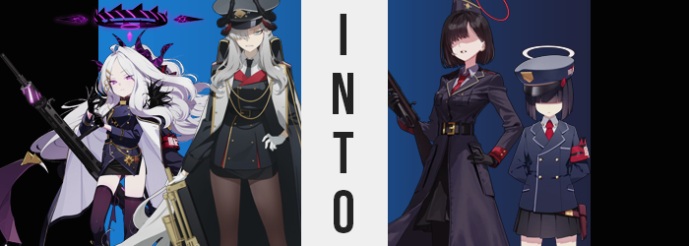

Makoto Hanuma, the chairwoman of the Gehenna Academy Student Council and president of the Pandemonium Society, reclined comfortably in her chair with a smirk upon her face.

She had just put into play her latest plan in the service of establishing absolute supremacy of the student council over the Prefect Team housed within the walls of the very same academy. As Makoto saw it, the chairwoman of the prefect team, Hina Sorasaki, had long since been a thorn in her side. The Prefect Team was an unnecessary blemish on the academy, an organization that did not need to exist when the school’s order could be maintained by Makoto alone.

She had made plenty of attempts to eliminate the organization in the past, and yet… All of them had ended in abject failure. There was just as likely of a chance that this one would as well. But Makoto had a good feeling for some reason. The words of the girl who had sold her the (assuredly non-poisonous) powder that would be delivered to Hina had sounded like a promising lead, at least.

“And through my own analysis I found it to be non-harmful. Which makes me wonder just how this substance will ‘weaken’ and ‘instill obedience’ in the naïve Hina.”

But she was certainly eager to find out.

“Ah, my morning tea. Good…” Hina sounded a little tired as she wandered over to her desk in the Prefect Team’s meeting room. It was a large, oaken desk that felt a little too big for her small and lithe form, but she appreciated the amount of space that it provided her even if she did have to stretch pretty far to grab documents here and there. While she sounded tired, though? She wasn’t really. The seventeen year old just had a lethargic personality that wasn’t especially energetic at any given moment. She would perk up a little, but only after having the tea that had been prepared for her.

Assuming no harmful substances had been added to it, anyways.

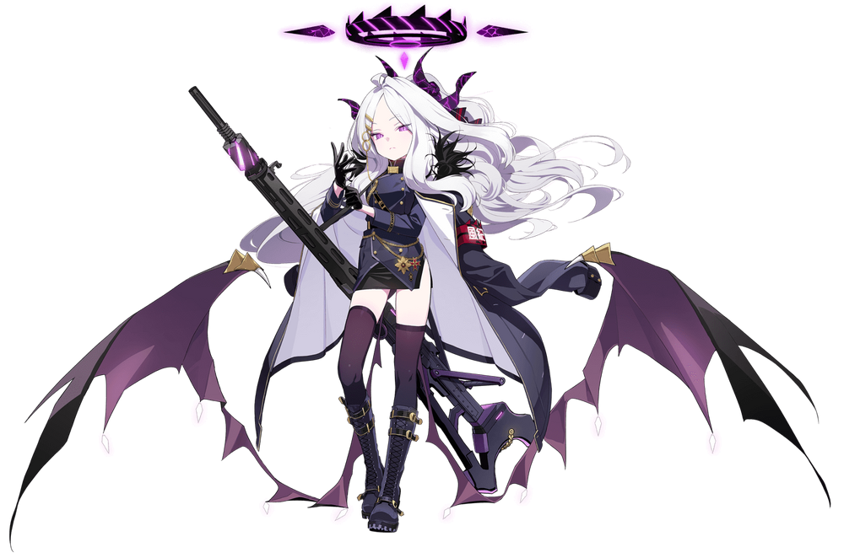
About ten minutes passed after Hina sat down. The Prefect Team’s leader often had reports to sort through first thing in the morning, and that day had been no exception. It was trivial work that boiled down to figuring out which reports had to be followed up on, and which ones were to be discarded. She always enjoyed drinking her tea while doing this, and by the time she stood up to get ready for her patrol? The entire cup had been polished off.

Enough time for a suspicious powder that may have been mixed into her morning beverage to begin its work. “Hm… If only I could be as great of a leader as Makoto.” It had certainly been a normal sentence that had left her lips, but it absolutely wasn’t the type of sentence that Hina would ever willfully mutter. “What… did I just say?” She loathed Makoto Hanuma for always trying to dismantle the Prefect Team, and yet from the bottom of her heart she was presently feeling…

Respect?

“…Did I not get enough sleep last night?” Hina shook her head from side to side. She did have some sleepless nights, but she couldn’t possibly fathom one having such an effect on her that she would even consider treating Makoto with any semblance of reverence. But what could the reason have been? The girl, naturally, didn’t have the foggiest idea. She didn’t know that Makoto had tricked the girl that made her tea into slipping a special ‘sweetener’ into her morning drink, and that this sudden impulse – and everything that came after – would be a product of consuming it.

The girl clicked her tongue. “I just need to get the thought out of my head. I need to think about other things… Like my obligations to Leader Makoto. Ack!?” She practically clicked her tongue after once again heaping the praise onto her own nemesis. It didn’t matter how much focus she tried to put into things, thoughts just kept leaning back to Makoto and how great she was.

Unfortunately for Hina, the complications that she was facing weren’t limited to her unusual thoughts alone. The vague, purple glow that permeated through her horns had seemingly dulled – predating the erosion of those horns. Little by little they appeared to shorten; the inches peeled off as black horn was whisked away into the void. It wasn’t long until they were nubs and then, after, utterly nonexistent.

The loss of her horns was only the first of many changes that would affect the parts of her body affixed to her skull, and along with that loss came loss of a different kind. This time it was focused on her hair for while the silver strands were usually so long and luscious? They were quick to unravel, almost as if her roots were wriggling back into her scalp. Hair that originally reached her thighs while hanging loose had pulled up to her chin, straightened, and had bangs that were parted on the left, while those that hung over her eyes were long and dense.

Over the seconds that followed? That silver darkened to a black.

“What would she think if she saw me so disheveled?” There was something about Hina’s voice now that sounded more affirming? That almost sleepy quality wasn’t there anymore, and she sounded more mature somehow. The reason for which immediately made itself clear, but with her thoughts still fixated on the Pandemonium Society’s leader, it wasn’t exactly apparent to her.

Nonetheless, she was growing. Despite being seventeen, Hina was a very short girl for her age. She was a mere 4’8”, and most of her peers towered over her. That didn’t make her any less intimidating, mind you. But that short stature that had plagued her since youth would soon be a thing of the past. Because her body was blooming like a flower. Or at least in the sense that she was growing.

Hina’s meager height shot upwards at the cost of her uniform’s custom fit design, because it only took a few seconds for her to shoot up past the five foot mark. This was already enough for her slitted pencil skirt to rise up, showing off the minimal amount of thigh that was usually exposed, much less lift the uniform’s top and coat to show off her navel. By the time she hit her peak, the 5’4” mark? Her arms stretched well out of her sleeves, and her black gloves hardly fit fingers that were now longer and thinner alike.

Such a sudden and grandiose change would typically warrant a reaction. But it didn’t. “Have I always been this close to my leader’s height? I almost feel honored to be so similar, but I suppose that has always been the case.” The way her voice sounded, and the way she spoke; it all made her sound like a different, more mature woman. But in actuality? She was still the same age. She was still a seventeen year old girl.

Even despite the fact that that her face had changed to likewise contribute to the idea that she might be older. It had begun with the purple of her eyes dulling to a plain, reddish brown beneath her lengthier bangs. But plain… That ended up becoming a trend when it came to her face’s appearance. Hina might have been youthful looking, but there had been little point in denying how exceptionally pretty she looked.

But what was once exceptional was becoming far less so. Her dulled eyes demonstrated this beyond merely their colors, for their shapes became droopier. Blemishes popped up here on there on a face that gradually thinned and gained inflated lips (which in turn did make her appear more mature), but a vaguely crooked nose also demonstrated that her new, droopy yet stern visage was much more flawed. That didn’t mean she wasn’t pretty, but it was a plain and imperfect beauty compared to how she had appeared before.

“Which begs the question… What am I doing here?” A room that she had once seen as her office now might as well have been foreign to the seventeen year old. Actually, she would go one step further and consider it ‘enemy territory’. That was how diluted her memories had become by the powder, her mental state becoming more and more like one of the generic soldiers that often served Pandemonium. But while this could have been her fate, it wasn’t yet ready to be served.

Because several more adjustments needed to be made. Hina did look taller, but the rest of her body hadn’t really grown to match and in terms of figure she was still closer to that of a child than anything else. But that wasn’t a truth that lingered for much longer, for weight graced her bosom and saw her small cups burgeon out to fuller, yet still unexceptional C-cups. And her ass and thighs perked up a little too. It all better suited her new height, but ‘average’ still seemed to be the theme of her new appearance.

Even so, even ‘average’ could be dressed up to look nice. Or, say, be placed into an appropriate uniform? The one she was wearing was stripped right off of her body. She wasn’t naked, left only in a bra and panties that curiously fit her new figure for a moment – at least until the rest of her attire shifted into a dark purple uniform jacket over a button-up white shirt, red tie, and black skirt. She now had black gloves that fit her, along with tights, boots, and even a hat. It was the uniform of the Pandemonium Society’s underlings.

And in one final act of erasure? Her exceptionally elaborate halo was robbed of its luster. Black and purple thinned into a single ring of boring red that floated behind her head.

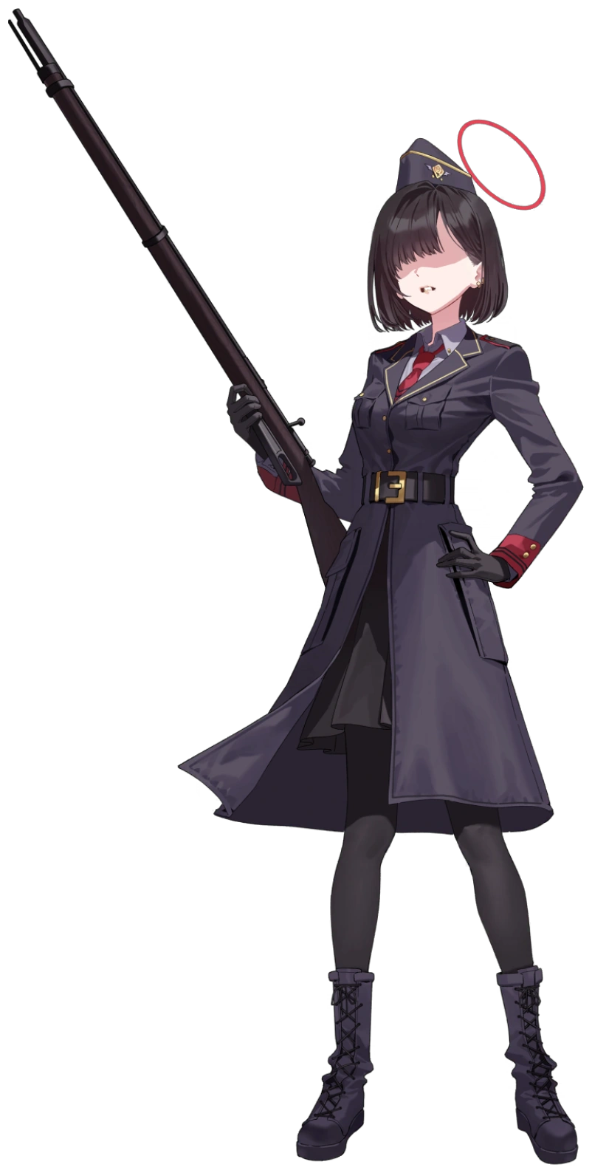
While Hina had been transforming, Makoto had been watching the entire process through a hidden camera she had installed in the prefect office that was streaming the sights to her phone. She hadn’t expected the powder to physically and mentally convert the girl into a generic Pandemonium team member under her command, but… She supposed that was a suitable outcome.

“Underling. You forgot to bring the envelope I asked you to deliver to the Prefect Team. You’re fortunate I came all this way to bring it to you.” She had seen her chance and taken it, stepping into the prefect office just as her rival’s transformation into a taller, bustier, but plainer form had finished in its entirety. She’d concocted a lie just for this very moment to see how deep the mental reprogramming ran.

It was on sight. The dark haired woman stood at attention immediately, and Makoto could make out the respect burning in the young woman’s eyes through her long bangs. “I apologize for my mistake, ma’am! Is there anything else you would like me to do for you to make up for it?” She also seemed to be terrified of being reprimanded. As she should have been if she was a loyal follower.

“I can think of a few things.”

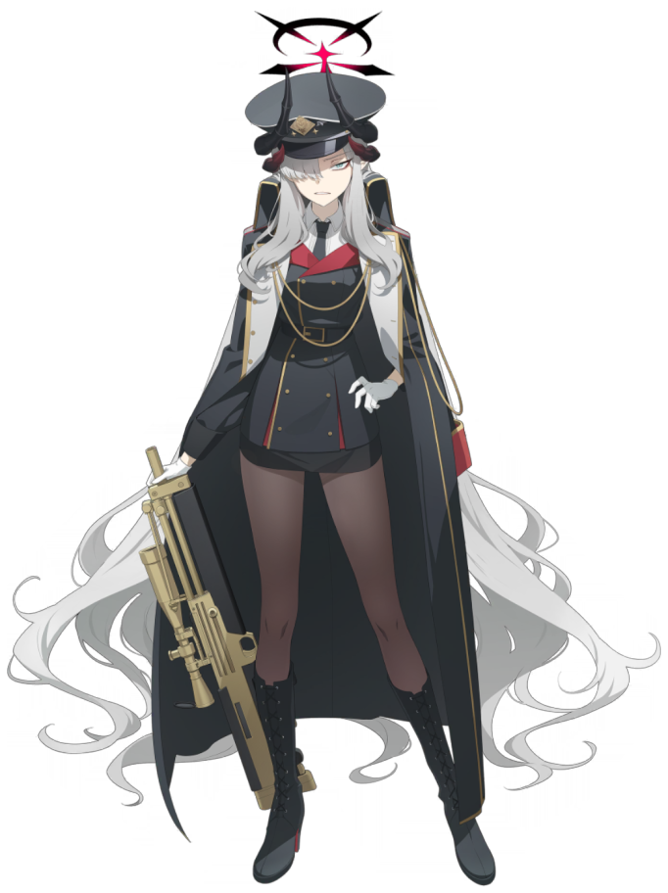
About thirty minutes had passed since Makoto had internally declared her victory over the Prefect Team. How could it be seen any other way? After all, the team’s previous chairwoman had become a shell of her previous self – a lackey dedicated to the Pandemonium team’s cause that was fiercely loyal and willing to do anything that was asked of her. So, naturally?

Makoto had immediately saddled her with grunt work. First, she’d had Hina make her some team; an assignment that got low grades because it had tasted a little too bitter. Next? She’d forced her to clean the office. Now, the follower was out in the hallway sleeping. “Hm? What am I doing in the Pandemonium Society’s room? I should be in the Prefect—!?” What was she saying all of a sudden? “Wait. Oh no!”

She threw her hands on her desk and stood up with surprise. The powder she had used on Hina had come in two white pouches, but the second one was gone from her desk! Her tea had tasted like no sweetener had been added! So, did that mean that Hina had accidentally…

Yes!

“N-No! Don’t you dare do this to me! How could this happen!?” The moment she put two and two together, Makoto immediately lashed out and cursed her own fate. It was because the effects didn’t give her much of a break before kicking into high gear, and she could immediately tell that something had gone awry with her body. The fit of her uniform felt incorrect in a number of different places simultaneously.

Among those locations was the eighteen year old’s chest. The Pandemonium leader’s cups had been quite impressive and were certainly a little larger than the average size of girls her age in Gehenna. Or, at least, they had been. But by the time the woman managed to bring a hand to the chest where she sensed this looseness? It was already too late. “D-Damnit!” Her precious D-cups had been lost, leaving her with a pair that were on the larger end of the A-cup spectrum at best.

If that wasn’t already concerning enough, this wasn’t even the only place where she had lost weight. The thighs that so readily filled out her tights were sacrificed in a similar fashion to her breasts, and the nylon loosened around flesh that diminished and eroded the thickness of her upper legs. Before long there was only the slightest bit of pudge remaining. The bare minimum, in fact. Even her ass compressed against her rear as a result of this, and without any weight to really support? Her hips ended up narrowing in kind.

“M-My beautiful b-body!” It was alarming, but was it worth the stuttering? Makoto didn’t tend to trip over her own words, but it was becoming more and more common the more that she spoke. She uttered these words as her physical shape became even more bizarre. The woman had suffered so much loss, but she was receiving gains. They just weren’t good gains? Her waistline was growing broader, making it so that the inward pinch between her shoulders and hips was far vaguer. “B-But was I really that beautiful?”

The young woman stuttered again, this time confusion about… her own confusion. Making matters more confusing was the sound of her own voice. The way it hit her ear didn’t quite sound right, like it was both too high and too soft at the same time? But she had to put it out of mind for a moment. “U-Uwah!?” Because out of nowhere, Makoto felt a little unsteady on her feet.

It was almost like her center of gravity had changed. No, more like it was in a constant state of changing? She could vaguely sense as much, but she didn’t actually draw the conclusion that she needed to even despite the fact that it really should have been obvious. Her clumsy motions shouldn’t have been enough to disguise the fact that she was shrinking, but the sweetener’s ‘magic’ had worked its trick on her mind.

Her taller than average height of 5’7” dropped very substantially very quickly. Her limbs shortened, while hands and feet shrunk so that her gloves slid off of her fingers and fell onto the ground. Tights bunched up even more too, but that made sense since she had dropped as far down as 4’10” before her center of gravity returned to something much more stable. “Th-That was weird, wasn’t it? And I’m still not sure why I’m in this office…” She really didn’t want her leader, Hina, to get mad at her!

Eyes nervously flickered around the Pandemonium office, the familiarity with it that she’d had before becoming vaguer and vaguer. It almost didn’t look familiar at all now. But as she looked around? The teal in her eyes dulled to a plain, chestnut brown within a pair of eyes that seemed more… youthful? That was by design. Her drop in height had come with a three year loss, and she was now fifteen instead of eighteen.

And those facial features only came to appear even more youthful. Her face? Rounder. Her chin? Shorter. Chubbier cheeks gave her something of a soft babyface that was cute but had none of the alluring and serious beauty that Makoto’s face typically possessed. As had been the case with Hina, she was on the cusp of appearing far plainer even if she was plain in a cute way, with thinned lips and bigger eyes.

This was, in kind, reflected in her hair too. Makoto’s mane of silver had always seemed unmanageably long, reaching down to her feet in all of its cared for fluffiness. But it all shortened like an extended tape measure being rewound, hairs darkening to grey and then black by the time it reached her chin in a very straight bob. “Sh-Should I go?” The girl was having a hard time seeing, but only because her bangs had grown so long that they covered her eyes.

All that really remained of Makoto’s old life were her horns, and even those met an ill fate in the final stages of her transformation. The long, black growths on her head crumbled away, base and all, until there wasn’t a single unnecessary protrusion extending from her skull. In a related change? The red star in the center of her halo flickered in and out of existence until it didn’t exist at all, and the halo that remained thinned, lightened and split into two dark circled above her head.

Above a blue Prefect team hat that appeared on her head, matching with the rest of the uniform that now covered her small body. A white button-up shirt underneath a matching, blue jacket with a red tie and armband. Not to mention a short, pleated skirt and matching loafers. It wasn’t the most revealing of outfits, but it wasn’t like the teen had much to show off in the first place.
“I-I really shouldn’t be here…” With Makoto’s transformation into a Prefect Team member complete, the skittish and soft spoken girl found herself overwhelmed by her presence in the Pandemonium office. She wasn’t supposed to be there, and she would definitely get in trouble if she was seen there! She wasted no time scurrying out the office door and into the hall, where she bumped into the Pandemonium girl that had been fashioned out of Hina. Literally. The two collided. “I-I’m so sorry!”

But before the Pandemonium girl could respond, she had already run off. “She was kind of cute, but… N-No! A Pandemonium girl and a Prefect girl could never fall in love!” And she had an assignment! She had to finish sweeping the hallway posthaste in order to receive additional instructions (and hopefully praise) from her own leader!

But the two would fall in love. At a later date.

It was chaos that would reunite them, for both Pandemonium and the Prefect Teams had been stripped of their leaders. Makoto and Hina lived on as grunts, but neither of them could remember their past lives and couldn’t introduce themselves as anything but generic grunts anyways. Without anyone to uphold any disciplinary guidelines, order in Gehenna Academy wasted no time in falling. Anarchy was on the horizon, and new faces were forced to take up the mantles of the leaders they had lost before long.

Those two previous leaders had become so inconspicuous that they had mixed in with the sea of other plain grunts as this new leadership took over, but new leadership allowed the two groups to finally bury the hatchet and work together. Which allowed both grunts to meet once more, and one thing led to another, and… Well, they ended up being a cute little couple just as the resurgence finally began to calm down!

Now if only someone could do something about the strange sweetener vendors that had been popping up all over the city…

