OA 628

- RCV in Alaska

2020 Alaska Ballot Measure 2
https://www.elections.alaska.gov/petitions/19AKBE/19AKBE-TheBill.pdf

actually does 3 things, but we’re only going to talk about two right now.

First: Amended AS.15.15 to replace the closed primary with a “Top four nonpartisan open primary.”

Second,
A.S. § 15.15.350
Added
(c) All general elections shall be conducted by ranked-choice voting.
Yes that applies to the Presidential election!

-So the ballot lists the four candidates and then you can bubble “1st Choice, 2nd Choice, 3rd Choice, 4th Choice”

-what if you leave a bubble blank?
-what if you rank candidates tied?

“defeated candidate” defined in A.S. §15-80.010 as “last-place candidates are defeated until there are two candidates running at which point the candidate with the greatest number of votes is declared the winner of the election.”

(d) When counting ballots in a general election, the election board shall initially tabulate each validly cast ballot as one vote for the highest-ranked continuing candidate on that ballot or as an inactive ballot. If a candidate is highest-ranked on more than one-half of the active ballots, that candidate is elected and the tabulation is complete. Otherwise, tabulation proceeds in sequential rounds as follows:
(1) if two or fewer continuing candidates remain, the candidate with the greatest number of votes is elected and the tabulation is complete; otherwise, the tabulation continues under (2) of this subsection;
(2) if the candidate with the fewest votes is defeated, votes cast for the defeated candidate shall cease counting for the defeated candidate and shall be added to the totals of each ballot's next-highest-ranked continuing candidate or considered an inactive ballot under (g)(2) of this section, and a new round begins under (1) of this subsection.
(e) When counting general election ballots,
(1) a ballot containing an overvote shall be considered an inactive ballot once the overvote is encountered at the highest ranking for a continuing candidate;
(2) if a ballot skips a ranking, then the election board shall count the next ranking. If the next ranking is another skipped ranking, the ballot shall be considered an inactive ballot once the second skipped ranking is encountered; and
(3) in the event of a tie between the final two continuing candidates, the procedures in AS 15.15.460 and AS 15.20.430--15.20.530 shall apply to determine the winner of the general election; in the event of a tie between two candidates with the fewest votes, the tie shall be resolved by lot to determine which candidate is defeated.
(f) The election board may not count an inactive ballot for any candidate.
(g) In this section,
(1) “continuing candidate” means a candidate who has not been defeated;
(2) “inactive ballot” means a ballot that is no longer tabulated, either in whole or in part, by the division because it does not rank any continuing candidate, contains an overvote at the highest continuing ranking, or contains two or more sequential skipped rankings before its highest continuing ranking;
(3) “overvote” means an instance where a voter has assigned the same ranking to more than one candidate;
(4) “ranking” or “ranked” means the number assigned by a voter to a candidate to express the voter's choice for that candidate; a ranking of “1” is the highest ranking, followed by “2,” and then “3,” and so on;
(5) “round” means an instance of the sequence of voting tabulation in a general election;
(6) “skipped ranking” means a blank ranking on a ballot on which a voter has ranked another candidate at a subsequent ranking.

-after the ballot initiative passed, it was challenged in court
Young v. State, 502 P.2d 964 (Alaska 2022)

January of this year – Supreme Court said it was fine

The initiative at issue is Alaska's Better Elections Initiative (19AKBE), which proposed various changes to Alaska's election laws. As we summarized it in Meyer v. Alaskans for Better Elections (Alaskans for Better Elections I), the initiative would “most significantly change[ ] Alaska's election laws by: (1) replacing Alaska's current party-based primary system with an open, nonpartisan primary; (2) establishing ranked-choice voting in general elections; and pick up the pin (3) adopting new disclosure and disclaimer requirements for independent expenditure groups and their donors.”⁶

-power of ballot initiatives
-confine to one subject matter?

Then, a few months later, Alaska Congressman Don Young died
-have to have a special election

-Top 4 primary – 49 people ran

Sarah Palin (R) 27.0 43,601
Nicholas Begich (R) 19.1 30,861
Al Gross (Independent) 12.6 20,392
Mary Peltola (D) 10.1 16,265
Tara Sweeney (R) 5.9 9,560

We don’t know why Al Gross Dropped out.
https://dralgrossak.com/2022/06/21/notes-from-the-campaign-trail-june-21/

“It is with great hope for Alaska’s future that I have decided to end my campaign to become Alaska’s next Congressman. There are two outstanding Alaska Native women in this race who would both serve our state well, and I encourage my supporters to stay engaged and consider giving their first-place vote to whichever of them best matches their own values.”

???

Lawsuit: does Tara move up or does it stay blank? Courts say it stays blank.

Round 1 results
Mary Peltola 40.3 74,807 0
Sarah Palin 31.4 58,328 0
Nicholas Begich 28.3 52,504 0

So we go to round 2
He loses 52,504
Palin gets 27,659
Petola gets 16,399

44058
8,446 ballots that were disqualified (16%)

- Better Call Saul!

JTH Tax, LLC d/b/a Liberty Tax Service v. AMC Networks
https://openargs.com/wp-content/uploads/JTH-Tax-v.-AMC-Networks-complaint.pdf

Spoilers for Season 6, Episode 2 of BCS
-think about Los Pollos Hermanos
Intuitively, there’s a reason Gus Fring doesn’t own a bunch of Burger Kings
-why is that?

-trademarks, trade dress, and defamation

Paragraph 1: 1. This case arises out of Defendants’ intentional misuse of Liberty Tax’s famous
trademarks and trade dress in Episode 2, Season 6 (“Episode 2”) of their hit series, Better Call
Saul, which ironically premiered on Tax Day, April 18, 2022. In Episode 2, the eponymous, Saul
Goodman (aka Jimmy McGill), goes to “Sweet Liberty Tax Services,” which is operated by a
convicted felon and his wife, the Kettlemans. The show depicts “Sweet Liberty Tax Services” as
an actual Liberty Tax location by copying Liberty Tax’s registered trademarks and Statue of
Liberty-themed trade dress. At “Sweet Liberty Tax Service,” which is housed in a trailer in the
New Mexico desert, there is an inflatable Statue of Liberty outside, in addition to the office itself,
which is a moniker of the American Flag, and signage, “Sweet Liberty Tax Service.” On the
inside, there is a Statue of Liberty mural on the wall, along with numerous Lady Liberty’s [sp]
throughout the location. As fans of the series know, the Kettlemans are not running a legitimate
tax preparation business, but instead, are fraudulently stealing customer refunds, as revealed when
Saul’s wife, Kim Wexler, threatens to call the IRS to shut them down.

-defamation, trademark infringement, trade dress infringement
-INJUNCTIVE as well as economic relief – they want them to have to air “corrective advertising” that they approve of

WOW IS IT DEAD ON
Trade Dress
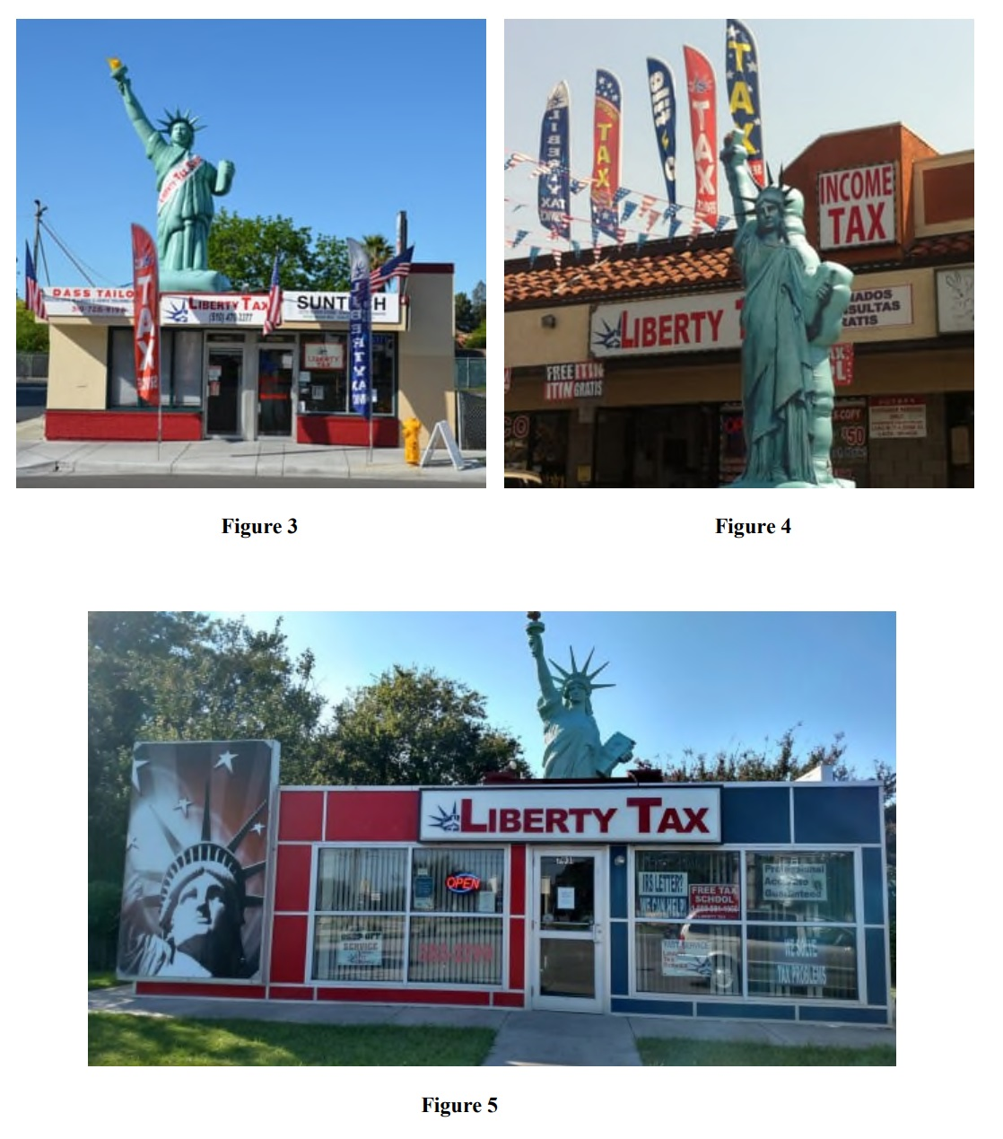

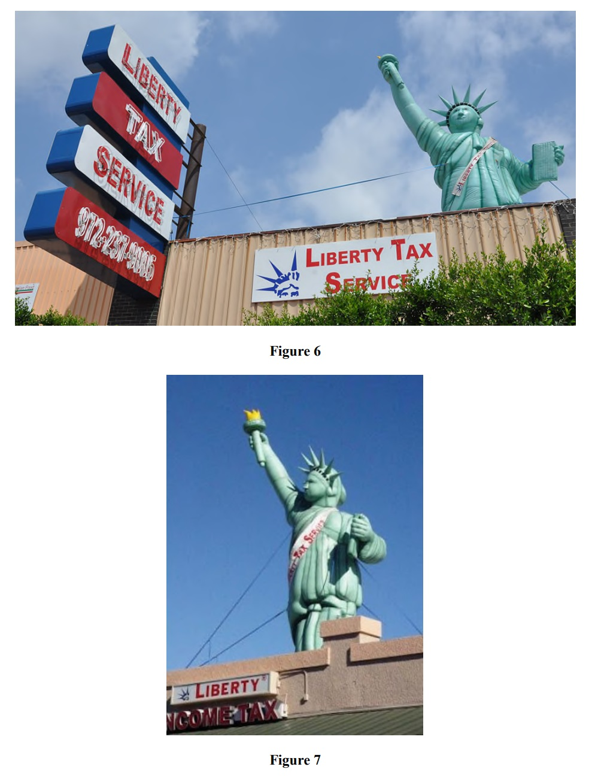
Trade Mark

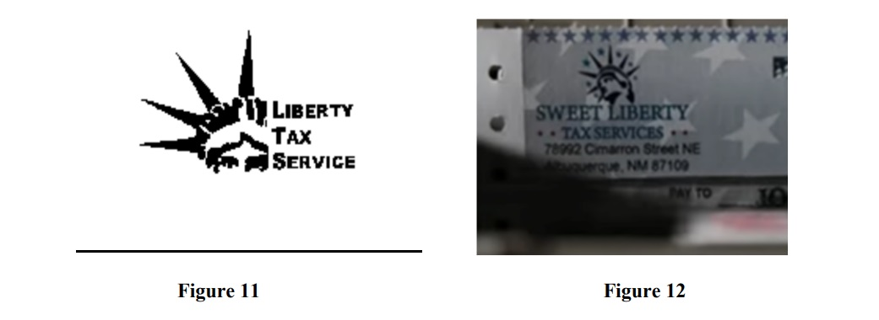

57. Liberty Tax sent a cease-and-desist letter to AMC dated April 27, 2022, and thereafter engaged in follow up communications with AMC and Sony, in which it put Defendants on notice that the Show infringed and tarnished Liberty Tax’s Trademarks and Trade Dress and that Liberty Tax objected to such depiction.

58. Upon information and belief, Defendants continue to engage in unauthorized use and disparagement of Liberty Tax’s Trademarks and Trade Dress by distributing Episode 2 on multiple media outlets, including on the AMC channel, AMC+, and Google TV.

Counts:
- Trademark infringement 15 U.S.C. § 1114
“likelihood of causing confusion, mistake, deception as to the affiliation, connection, or association with, or sponsorship or approval by, Liberty Tax”
- Trade Dress Infringement (same stat)
¶81: Defendants’ unlawful conduct was and is knowing, deliberate, willful, and in bad faith and done with the intent to trade on the goodwill and reputation of Liberty Tax and its Trade Dress and to deceive consumers into believing that Liberty Tax was endorsed or was otherwise connected with the Show
- Trademark and trade dress dilution, 15 USC 1125(c)

93. Defendants’ trade dress for “Sweet Liberty Tax Services,” including the Statute of Liberty and red, white, and blue motif, is the same or substantially similar to Liberty Tax’s Trade Dress, and is used by Defendants in connection with services identical to those for which Liberty Tax uses such Trade Dress.

94. On information and belief, Defendants acted in bad faith and intended that television viewers believe that the tax preparation operation depicted, “Sweet Liberty Tax Services,” is a Liberty Tax location. Television viewers may not be sufficiently sophisticated to recognize that Sweet Liberty Tax Services is not depicting an actual Liberty Tax Service location.

- Defamation
- Disparagement
- Injurious Falsehoods

120. Defendants made false and derogatory statements about Liberty Tax’s business in the Show, without privilege, including that Liberty Tax is operated by criminals and engages in crimes, fraud, theft, and other deceptive business practices.

Trade dress?
-packaging
-the elements of all of the various elements that are used to promote a product or a service, including packaging, displays, décor, environment, configuration of the product itself
-Must be inherently distinctive & misuse must cause consumer confusion, can’t be functional

-answer was due yesterday (Sep. 1)
-got a 30-day extension to answer or file a dispositive motion (Oct. 3)
-so we’ll be following

- Trump’s Motions

PAPERLESS Minute Entry for proceedings held before Judge Aileen M. Cannon: Motion Hearing held on September 1, 2022. The Court heard argument from the parties on 1 Motion for Judicial Oversight and Additional Relief. Investigative Team Status Report [ECF No. 39] and Detailed Property Inventory [ECF No. 39-1] to be unsealed. Order to follow. Total time in court: 105 minutes. Attorney Appearances: Lindsey Halligan, James M. Trusty, M. Evan Corcoran, Christopher Michael Kise, Jay Bratt, Juan Antonio Gonzalez, Julie Edelstein, Sophia Brill. Court Reporter: Diane Miller, 772-467-2337 / Diane_Miller@flsd.uscourts.gov. (ad) (Entered: 09/02/2022)

Here we go:
https://openargs.com/wp-content/uploads/Unsealed-status-report.pdf

-told you DOJ dared Trump to ask for it.
FN 1 notes that this is not the kind of information that would ordinarily be shared with the owner of a premises searched pursuant to a court-authorized criminal search warrant

The investigative team has reviewed the seized materials in furtherance of its ongoing investigation, evaluating the relevance and character of each item seized, and making preliminary determinations about investigative avenues suggested or warranted by the character and nature of the seized items. The seized materials will continue to be used to further the government's investigation, and the investigative team will continue to use and evaluate the seized materials as it takes further investigative steps, such as through additional witness interviews and grand jury practice. Additionally, all evidence pertaining to the seized items - including, but not limited to, the nature and manner in which they were stored, as well as any evidence with respect to particular documents or items of interest – will inform the government’s investigation. Thus, it is important to note, ''review'' of the seized materials is not a single investigative step but an ongoing process in this active criminal investigation. That said, the government can confirm for the Court that the investigative team has already examined every item seized (other than materials that remain subject to the filter protocols) even as its investigation and further review continues. The investigative team has been and will be continually mindful of the potential for attorney-client privilege issues and the filter protocols contained in the search warrant.

Then we have the 8-page inventory

[describe]

