PERSONA 3 ROYAL
BIG STORY #20
BY CHALDEACHANGE
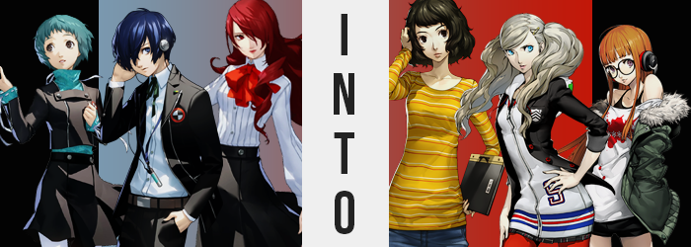

“How… did I end up here?”

It was strange enough to hear Makoto Yuki speak up unnecessarily, much less when there was no one else around to hear him. But these circumstances were both unplanned and exceptional. Had he blacked out momentarily? Only to find himself on the floor in a school bathroom of all places. Once he stood up he had no choice but to acknowledge it wasn’t even a bathroom in the school he should have been in… That line of thinking reignited his memories of the moments leading up to him blacking out in the first place.

Tartarus. It was a labyrinth that appeared during the Dark Hour, a secret hour that occurred every night where only those with Personas could walk and those that couldn’t were bound into coffins. Which was for the best because if they had been free to walk around then they wouldn’t have been able to survive with the dangerous Shadows lurking about.

The labyrinth itself was housed in a tower of uncertain fundamental origins. But if you were to talk about its origins more plainly? It was a Japanese high school that had its shape and size twisted by the Midnight Hour. The school that Makoto attended with the other members of SEES: Gekkoukan High School. It was their job to explore it and uncover its secrets and, as of late, it really felt like they had been making some headway.

Makoto had been exploring a new floor with Mitsuru Kirijo that night and had come across a strange find in a treasure chest. It resembled a video game box with only the letters and numbers ‘P5R’ on the cover. It looked like there were places for characters to fit on the cover art, but they were suspiciously vacant. An odd find, he brought it back to the lobby with Mitsuru to consult with their navigator, Fuuka Yamagishi about it.
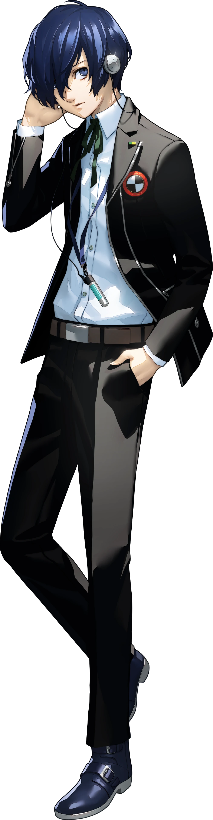
“That’s right… and then the box glowed.” It had glowed and sucked them up. And that was where his memories came to a stop so suddenly. There were things that happened that he hadn’t seen, such as the empty portraits in the box art beginning to fill in, but that was more or less the gist of how he ended up in the school bathroom. “But this isn’t even Gekkoukan…” He had to rule out being trapped in the tower when the Midnight Hour ended.

The feeling was hard to describe but it almost felt vaguely futuristic? Like he had been flung a short ways into the future somehow. That wasn’t all that off the mark, but in terms of concerns it quickly became one of the lesser ones. This was a girls’ bathroom. There were no urinals, only stalls. And it sounded like there were people out in the hall? So was he in an unfamiliar school in the middle of a school day?

A concerning development to be sure, but perhaps not as disturbing as what he noticed when his blue eyes met with the mirror oh so briefly.

Makoto’s eyes were, in fact, what had initially caught his attention – or at least the left one that wasn’t hidden by his bangs. He knew his own reflection well, and that of course included the color of his own gaze. Yet the underlying blue of his irises was far more vivid than it should have been, reflecting something closer to the blue of the sky than the blue of the ocean’s depths. “What…?”

He was understandably confused by the sight and lifted his bangs with his right hand to gaze at the other eye, moving closer to the mirror in the process. By the time he dropped his bangs though? His attention was fixed upon them instead. Their usual dark blue had been compromised by a lighter color as well… albeit one that was much more dramatically different. A platinum blonde.

Despite having just drawn close to the bathroom mirror, the sight of his own mane pushed Makoto to stumble back a few steps with surprise. It wasn’t just a couple of strands that had been altered in color – it was his entire head of hair. And before his very eyes he watched the length and style change, with bangs retaining their rightward sweep while also shortening to show both his eyes. Hair in the back and on the side almost grew impossibly long compared to its regular style, curling naturally as platinum blonde eventually reached just above his bum. It didn’t even need to grow as long as you might have expected to reach that point…

Because the boy had unknowingly shrunk two inches shorter.

A lot was happening at once, but he was too enamored with his own reflection to truly observe every single thing of note. Even in the moments that followed he was far too fixated on the sight of his own face. Was it slimmer than he remembered? Had his lips always been so full? His nose so small? And what about his sky blue eyes? Of course they had always been that color, but did they appear just a touch less Japanese than they had before? It all seemed downright feminine, and he couldn’t help but think there was hardly a shred of his old self in that reflection at all.

Which was an odd thing to think, wasn’t it? Hadn’t he always looked this way? Ever since she was a young girl she’d had that face. “…Huh!?” Was he a girl!? The voice that Makoto had cried out with certainly suggested as much, as did his overall body shape. Hidden by his Gekkoukan uniform as it was, it hadn’t been easy for him to take notice of it. Especially not since, because he had lost two inches of height, it was all baggier on him than ever.

But beneath his white, button-up shirt the curvature of his body had been altered. It took a much more pronounced inward dip between his stomach and chest, whereas hips had flared out a handful of inches combined so that his legs were farther apart. Slender on the whole, this showed even in shrunken hands and feet. Fingers were longer and daintier, but so were his nails. Not to mention they were painted.

“That’s a weird thing to think. Of course I’m a girl!” Her words sounded so certain because they were correct. It wasn’t done in a way that forced any discomfort upon the girl, but her sex did change just seconds before she felt the need to dissuade any uncertainty on her part. What existed between her legs wasn’t a piece of male equipment, and even mentally she had begun to see herself as a maiden. But Makoto’s acceptance of this spoke to how her mind was being rewired to accept a different life entirely.

It was a life where she was a quarter American, which explained her hair and the slightly off shapes of her eyes. It was a life where she worked part time as a model, showing off her sportier curves like her plump thighs and perky rear; traits that came into being rather promptly after her sex had changed. Her chest rose to the occasion in a literal sense too, pushing against her button-up shirt but not so much that it was terribly noticeable. Her breasts weren’t especially large, admittedly.

But their existence became much more obvious once Makoto’s outfit changed. In a flash it shifted into a different form while still clearly being a high school uniform. A white hoodie beneath an unbuttoned black blazer with a different school emblem on the breast – the hoodie also ran almost completely over a matching plaid skirt, which lapped over crimson tights that slid into heeled, brown boots. But her hair remained undone, something that seemingly bothered her greatly.
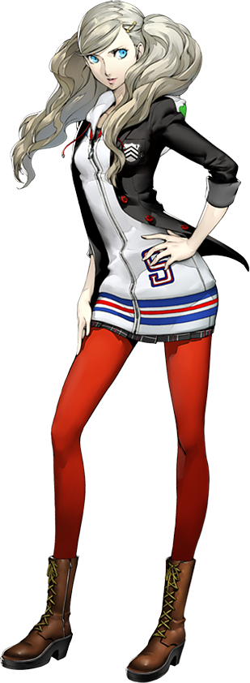
“Ugh, how did my hair even get so messy?” Thankfully for Ann Takamaki it hadn’t been difficult to sort out as she bound her blonde hair into twin tails with the hair ties that had magically appeared in her hand alongside her change in uniform. It was certainly better that her clothes now fit, but truthfully? She couldn’t at all remember them not fitting in the first place. She couldn’t remember being a boy, or coming from the past, or anything like that. Ann was just Ann through and through.

Her hair had been a pain point because it was first thing in the morning. Morning bell hadn’t even rung yet, and her hair had already ended up a mess? She didn’t want Ryuji or anyone to make fun of her, and so she’d taken a side trip into the bathroom even though the bell was going to ring at any moment now. “Great, I’m going to be called out for being late…” Which was the last thing she needed to start her day with, honestly. “Kawakami-sensei can be a real stickler sometimes!”

But hey, at least she’ll get called out with great hair!

Sometimes sacrifices had to be made!

“A-A classroom? And it must be early in the morning?” Fuuka Yamagishi was taking a very uncertain approach to understanding just what had happened to her after that unusual box had begun to glow. She didn’t claim to be an expert on video games, especially not since she had grown up in the 90s and 2000s and the box didn’t quick look like any game boxes she had ever seen before. All that really mattered was that it had glowed and now she was in that classroom.

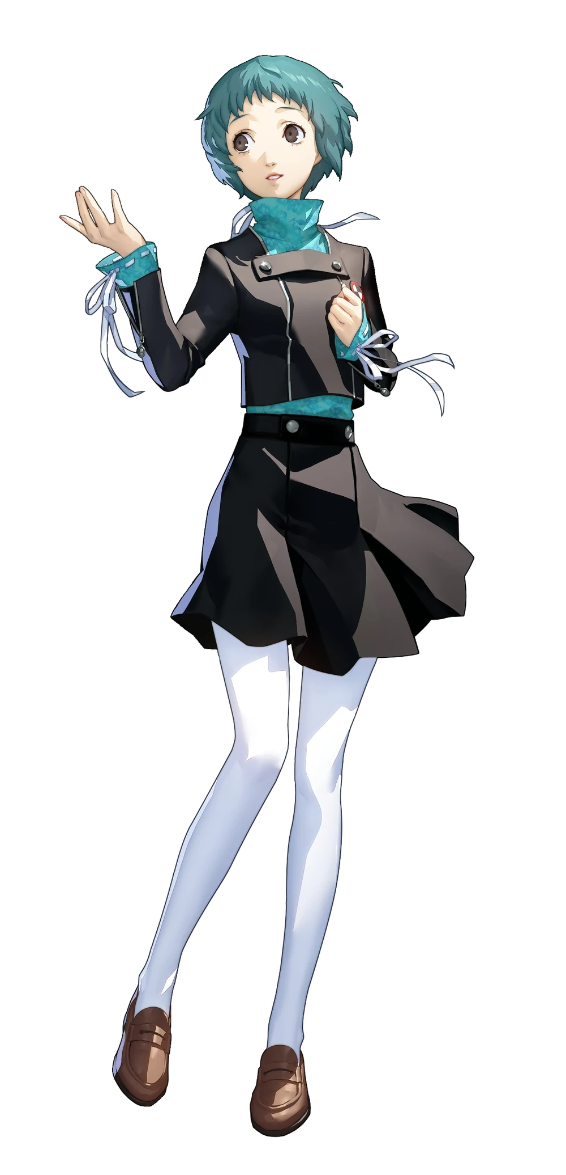
Listening, there were definitely students walking past the two doors in the hallway. None were coming into her room, and perhaps that was for the best because they likely would have been surprised to see a girl in a completely different uniform standing where the teacher normally did. She’d woken up on the teacher’s desk of all places, and that was strange on its own. “This certainly isn’t Gekkoukan… Should… Should I report to a faculty member?”

There would undoubtedly be problems if she did, but she had to gather information somehow. And yet considering this plan a little more deeply led to a very unusual thought crossing her mind.

Why would I report to myself?

Fuuka blinked, a little hung up on the rebuttal that has just crossed her mind. For her to think that she would have had to see herself as a faculty member of this school. Like a teacher? “I guess I am standing at the teacher’s desk…” Why did it feel right to stand there? She was much too young to be a teacher, wasn’t she? Well, she supposed being in her thirties wasn’t… “H-Huh!?”

That wasn’t right! She was a teenaged girl, not a woman in her thirties! …Though her changing appearance had already begun to cast doubt on that assertion. It was a little more subtle in its earliest moments though, with the girl’s skin seeming just a touch more worn, her hair a little coarser. It was in these moments that more than anything she noticed how tired she was. A yawn was released, her eyes felt heavy, and her body felt a little achier and heavier than it had been prior.

Dark bags that were drawn underneath Fuuka’s eyes drew attention to them, and if you had been staring you might have noticed the brown of her irises darkening several shades. Little by little it became more difficult to recognize her as the girl she had once been in the face. She already appeared older just on principle, but features were rearranged more generally. Lips swelled with a more upturned shapes and her nose pulled into a sharper hook. Her eyes narrowed, with brows above them darkening to a dark brown in kind.

“I feel so… tired?” The girl wasn’t sure why, but she also didn’t have a mirror handy like Makoto had during his own transformation. She couldn’t really perceive how the dark brown from thickened brows now bled into her head of teal green hair. Strand by strand this color replaced the old, but her hair also lengthened in kind to a chin length bob that was surprisingly messy and unkempt – likely a product of having to get up so early for work.

Right, work… “Work?” No, she was a student! She didn’t have a job! That was why she was… at school? “No, I’m a teacher here? I’m too old to be a student.” She responded to herself in a matter of fact way with a deepened voice that really communicated her growing exhaustion. Speaking of growing however, Fuuka’s five foot height was undergoing some adjustments. She sprung up to about 5’4”, with limbs and torso alike lengthening to reach this spec. It affected her hands and feet in kind, making shoes feel tight while her white tights were tugged down and her green turtleneck was untucked from her skirt.

Fuuka blinked and looked around. Surely she was seeing things, right? Was the desk smaller? She reached a hand up to scratch at the side of her head, a habit that was brand new because it belonged to the personality being forced upon her, and soon noticed her sleeves were tight around the shoulders, too. “Huh?” But it was fixed before she could think too hard about it.

The woman’s school uniform was gone, replaced by a yellow and orange striped long sleeved shirt overtop a long, jean skirt. She was also standing in beige heels like it was completely natural, but her new bra and panties? They did seem a touch too loose. Which wasn’t surprising because her figure hadn’t quite filled out despite growing taller. Ultimately, there wasn’t all that substantial of a growth to be seen.

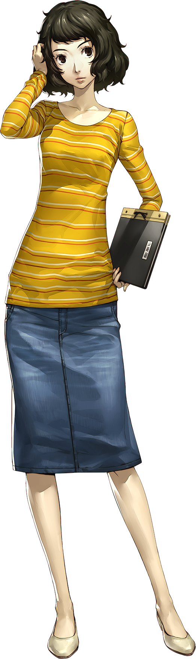
But it still happened. Her breasts swelled a pair of cup sizes within the bra. A bra that was definitely necessary since they lacked the tightness of a teenagers breasts. She was older after all, and thickened thighs and a plumper ass suffered from similar concerns. Her skin just wasn’t as tight as it had been, but it wasn’t that loose either.

“Another day, another lesson…” Flipping through a stack of notes in a binder on her desk, Sadayo Kawakami didn’t seem all that awake. How could she be? It was Wednesday morning and not only had she worked her teacher job the day before, but she’d worked as Becky in the evening too! Then when she had gotten off of her shift, her bus was broken down and taxis had been in short supply as well! It had taken her forever to get home!

The woman in her thirties stopped short of just collapsing outright on her desk, even though the idea of sleeping on it somehow struck a chord of recent familiarity that she couldn’t quite place. Some of her students had already slipped into the classroom while she was finishing getting everything ready, so it wouldn’t have been a good look if their sensei had a mental breakdown before class even started. “Sometimes I wish I could though…” Every day she had to wonder…

Why does adulting always have to be so hard?

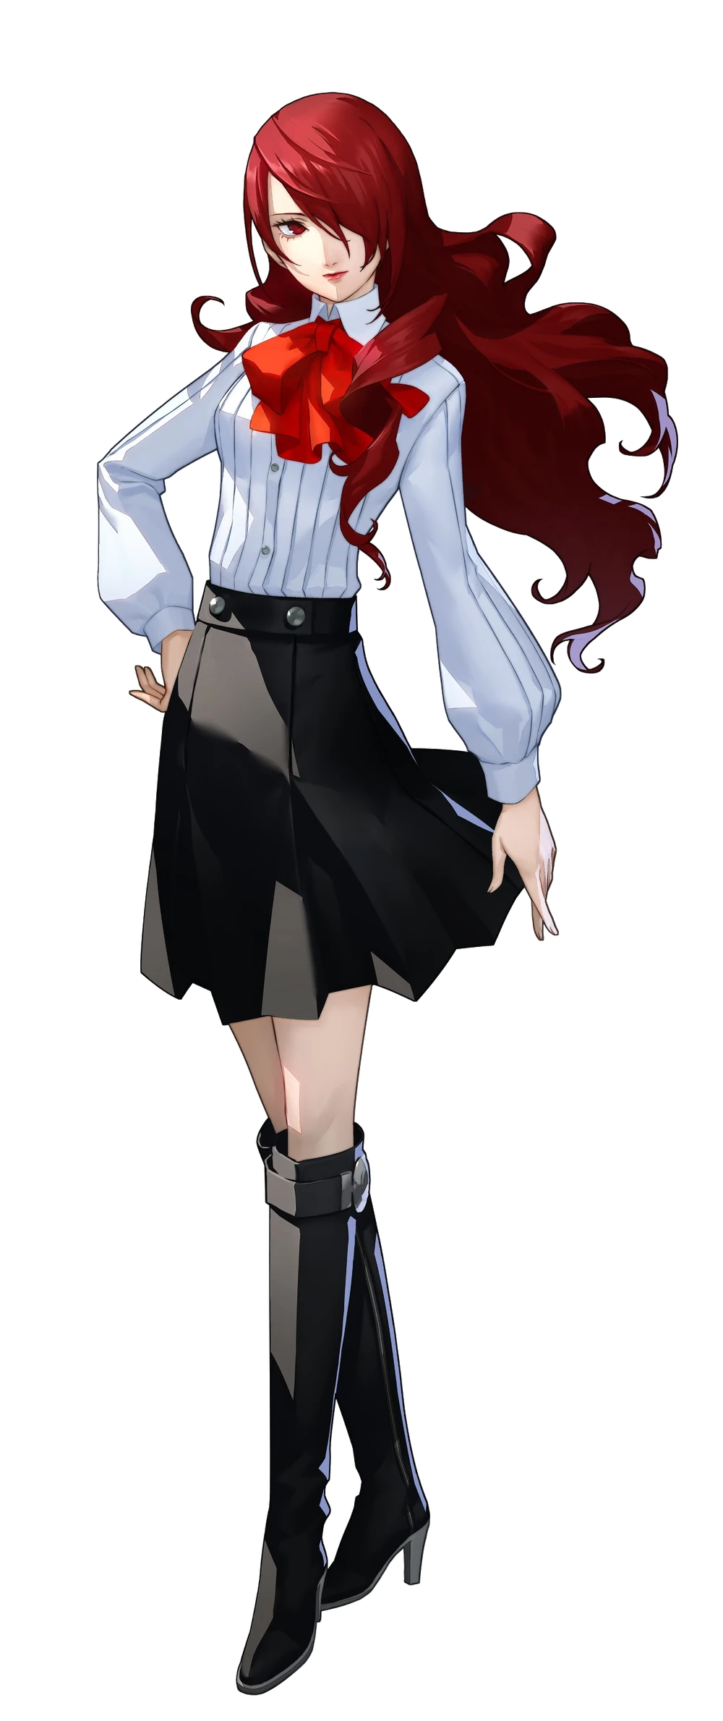
Unlike the other two, Mitsuru Kirijo didn’t find herself in a school setting at all. “Whose… bedroom is this?” She could recall the light and blacking out, but rather than wake up on a bathroom floor or a teacher’s desk, the girl had woken up on a comfortable albeit messy bed. She’d almost mistaken the room for a boy’s room with the computer in one corner and the anime and game figurines littered about, but upon seeing some panties scattered about she dismissed that thought. “This is probably an issue though…”

Something like this had never happened while exploring Tartarus before, and this wasn’t the Dark Hour. The blinds in the bedroom were closed but morning’s light could be seen peeking through the cracks. She could only assume she’d been warped somewhere else. “Or did someone find me unconscious and bring me here…?” That was a possibility but there was something about the room she was in. The tech…

It all felt a touch too… advanced? She was still in 2009, right?

Considering her ties to the Kirijo Group, if a computer of this technological marvel had been available to your average joe then she would have known about it. Its case had a clear side that she peered through, RGB lights captivating her. “Hm… As I thought, this is probably more advanced than anything in our building.” Nor had she seen a monitor quite as thin as the one that was right beside it.

So fixated on her surroundings, Mitsuru’s attention wasn’t pointed where it should have been. Inward. Because little by little her curves, which were considered above average for a girl of her age, were settling into forms that were a little more average. Because of the teen’s bra, for example, it was a touch difficult to make out through her button-up top, but the weight of her chest had experienced a significant reduction. Excess bled out of them, reducing her cups to very small B-cups at best.

And this lessening wasn’t even isolated to her bosom alone. The girl’s hips narrowed because there was less mass to accommodate. Both her ass and thighs were thinning, leaving these regions slenderer while still preserving their feminine shapeliness. While it seemed lacking against her 5’5” height, it all felt a little more reasonable as her body became shorter. It took just a few seconds for her to drop down to a meager 5’0”, a height upon which her smaller breasts and ass felt larger comparatively.

“H-Huh?” It wasn’t like Mitsuru to stutter regardless of how surprised she was but the realization she had come across had taken her off guard. Had… the desk always been so close to her eye level? What about the bed? “It must be a trick of my imagination…” She’d always been short, right? Yeah! That sounded right! “Why was I staring at my computer? I guess I need to dust it…” There had also been an odd voice crack while she began to think and address things in the room like they belonged to her.

Her smaller body was a lot less fit than it had been. Arms, legs, and her tummy had all softened and the weight of her Gekkoukan uniform, which had been thrown in disarray from her height loss, felt much heftier than it had. Her boots now came up to her thighs and her skirt overlapped them, whereas it was a struggle to keep her sleeves from swallowing her hands whole.

Continuing to look around her room, she found herself squinting. “Wait, where are my glasses?” Mitsuru had never worn glasses before and she certainly shouldn’t have known where to find a pair in this room, but she grabbed a pair of round frames from the nearby desk and slid them on like it was completely natural. Through the lenses you could see how her red eyes had lightened, mixed with a touch of blue to make them purple.

But her face overall… was off. She already appeared a couple of years younger, but that wasn’t even the draw. Her eyes seemed smaller in shape; lashes not as lush as they had once been. By design? Her nose shrunk closer to her face and her lips appeared to thin. Yet her face overall had a much rounder shape to it? One that better suited a hair style that had begun to straighten.

Strands of black emerged midst her head of red, but those blacks then turned a bright orange. Her straightened hair’s natural color was shifting to something dark, but that darkness was artificially painted over with orange hair dye. Strand, after strand, after strand. It didn’t grow much seeing as with her shortened height her hair already reached down to her ass, but her bangs shortened so that she had a straight cut across her forehead.

And then it hit her. “Huh? Wha—!? So drowsy…” A wave of fatigue that forced her movements to dance around clumsily. It was as if she had stayed up all night, and yet it had taken the form of a very bad sugar crash. Her bed looked so tempting! Around this time her uniform shifted, changing into a pair of short black shorts, a black tank top, and a white tee overtop with a reddish-pink decal on the front.

These clothes smelled dirty. So did the girl. Like she had been holed up inside the room for a long time without changing her clothes.

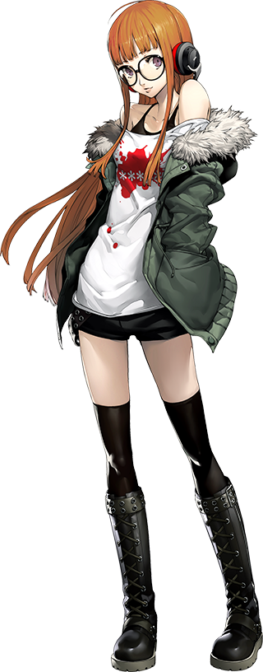
“Eugh… What time is it!?” Despite how awake Mitsuru had been when she had first risen in this bedroom, Futaba Sakura collapsed back onto her bed with her eyes heavy, making no effort to remove her glasses. She had been up late gaming and investigating the next target for the Phantom Thieves in equal measure, having only fallen asleep at 5am? But it was only around 8, so why had she gotten up!?

As always she had fallen asleep in the clothes she’d been wearing during the day – a bad habit that led to laundry being done more often than not for specific clothes. There was no internal debate about the hacker’s identity, no thoughts about who she might have been moments before. She couldn’t remember regardless, but ultimately it didn’t matter in the first place. “ZZZZZZZZZZZZZZZZ…”

Because she had conked right out again.

Meanwhile, back in Tartarus, Yukari Takebi and Aigis had gathered. “Huh? Weren’t we meeting here tonight?” Usually their leader and Mitsuru were present before everyone else. But they were the only two that had shown up. That’s when she noticed something on the floor. “A video game box?” One with three characters on it that she didn’t recognize.

…But there were still vacant spots on it.

