**Protons, Neutrons, and Electrons – Formula Sheet:**

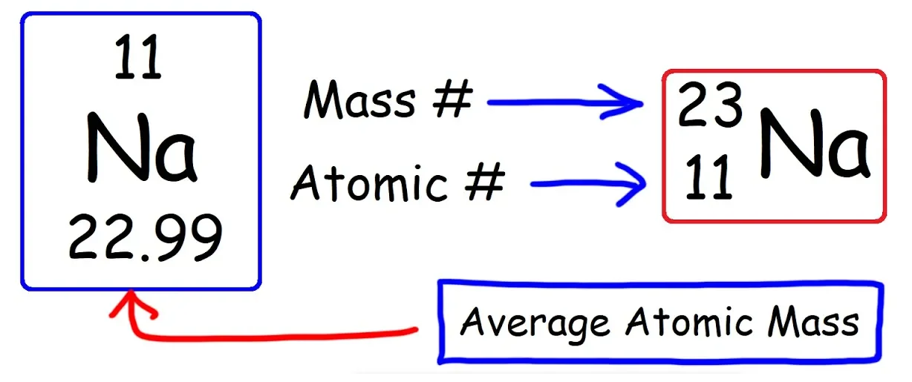

|  |  |
| --- | --- |
| **Number of Protons:** |  |
| **Number of Neutrons:** |  |
| **Number of Electrons:** |  |
| **Ion Charge:** |  |
| **Average Atomic Mass:** |  |