College Is Transformative: Family Weekend
by Soul-Controller

https://linktr.ee/soulcontroller

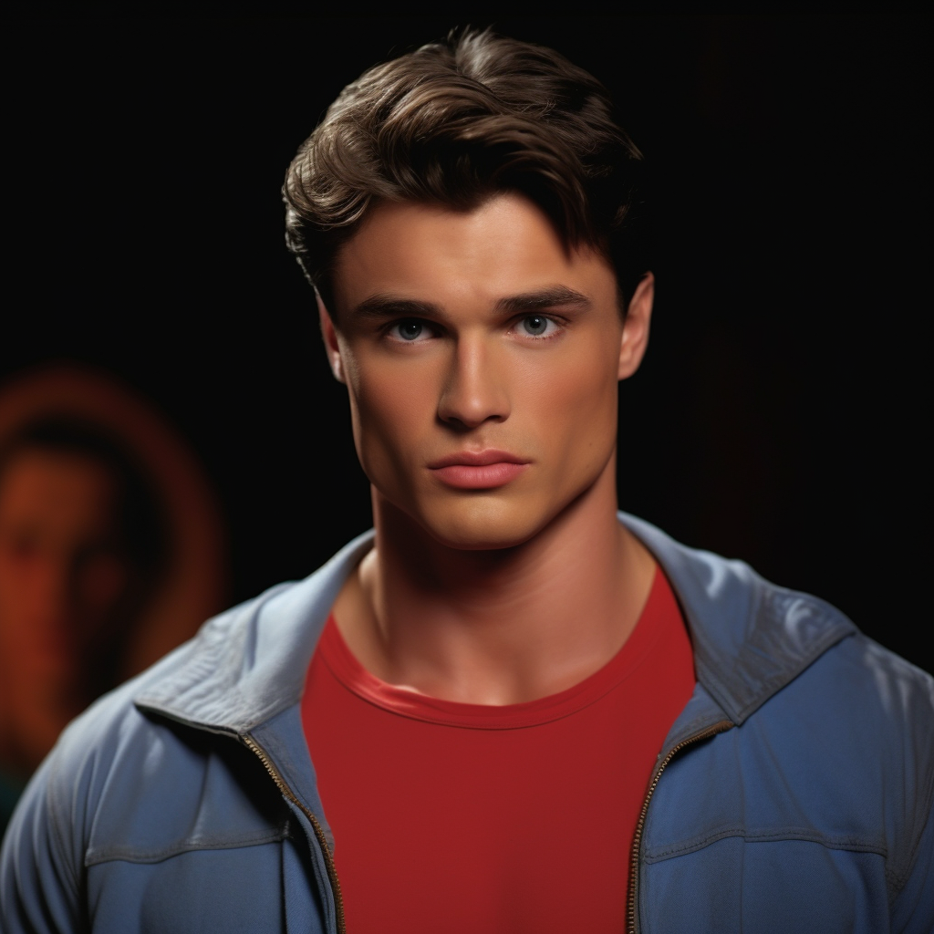
When it came to figuring out who the big man on campus was, it was a no-brainer that no one in either the student body or college faculty could compete with Chase Richards. Despite only being a 19-year-old college freshman, it seemed as though the man would be destined for success both in college and after graduation. Naturally charismatic, his impressive features only added to his magnetic charm, with his defined cheekbones, plump lips, and naturally wavy jet black hair making him someone that everyone desperately wanted to look at and talk with. Adding in his bulky muscular physique given his prowess as a wrestler, the all-American man seemed as though he was Superman ripped straight from the pages of the comics and brought to life.

Although Chase’s grades in high school hadn’t been the best, it was due to his state-championship winning performances over all four years of high school (plus a “modest” donation from his multi-millionaire businessman father) that had allowed him to secure a spot at Oak Point University. With his future all but guaranteed to take over his father’s company one day, the jock had opted to get a business degree to keep himself and his family swimming in cash.

Although Chase had initially planned on joining a fraternity when he first got accepted, it was his father Brian who had told the jock that he would be required to go through the first year of undergrad as similar to most of his fellow classmates as possible. Given the exorbitant amount of wealth that the kid was born into due to his early business moves back in the early 90s, Brian had made it a goal of his to make sure his son remained as humble as possible. He knew how wealth could corrupt the minds of men (he had seen it happen all too often with his fellow competitors who had gotten too ambitious and fallen into both financial and personal ruin), so Brian tried his best to keep his son reined in as best he could.

As a result, the jock had been given a limited allowance each month in his teen years before being forced to take on a part-time job to get a bit of work ethic ingrained into him. Now that his son was going to college though, Brian was adamant about the young man going through the roommate lottery system. The reason behind this being that the middle-aged man was hopeful that being surrounded by normal civilians rather than the snobby preppy kids kids Chase encountered at his private high school would be a formative time to help keep his son grounded and emphasize the life lesson he tried to teach his son - that money wasn’t all that mattered in the world.

Given the fact that his life was utterly perfect with no need to worry about common worries like other college students, Chase navigated through college life with a confident swagger. But just like Superman, the imposing athlete had his own kind of kryptonite, and for Chase, it came in the form of his roommate Tyler. The other man seemed to exist in a different world from the vibrant social circles that surrounded Chase. Rather than enjoying a good time going out and partying like normal college students, Tyler was a lanky nerd who would much rather stay in their dorm room playing fantasy video games and reading dorky books all night.

A testament to their extremely different lives, the duo’s shared dorm room was a study in contrasts, with Chase's athletic gear, protein powder tubs, and half-eaten pizza boxes strewn across one side while Tyler's books and tech gadgets claimed the other in a nice and tidy fashion. There were a few times where the jock had been alone in the room and attempted to snoop to figure out the quiet and awkward enigma that was Tyler, but this only caused Chase to grow more confused. Originally the man had thought that his roommate was just super studious and reading textbooks to get ahead in his courses or something, but after noticing some books peeking out from underneath his cot, the jock began to look through this secret collection and cackling over how nerdy they were. An Intro To Spellcasting? Natural Elixirs And How To Create Them? The Transfiguration Manual? I can’t believe it, the dude’s a total loser!

Although this was initially enough to make him want to steer clear from his roommate due to just how pathetic he was, Chase was given more reason to investigate over the course of that first month as a series of incidents began to occur that made the living space feel increasingly hostile. Firstly, Tyler was quite the night owl, as he would keep a bright lamp on to the late hours of the night reading more of those fantasy “manuals”. Although he had initially tried to move past this in hopes of keeping the peace and avoiding more interactions with his roommate, it quickly became too much to bear. Night after night, the room was bathed in the harsh fluorescent glow of Tyler's desk lamp, which was too bright no matter how the nerd attempted to angle it. As a result, Chase would toss and turn, muttering complaints under his breath, while Tyler, engrossed in his books, seemed oblivious or simply uninterested to remedy the situation.

As if these late-night reading and study sessions weren't enough, Chase became increasingly aware of another peculiar habit of his roommate. On more than one occasion, he caught Tyler stealing glances in his direction, particularly when he was in the midst of changing out of his sweaty workout clothes or getting ready for the day after his shower. Despite his immense physique and thus easy ability to intimidate the nerd so he stopped gawking at his body like a piece of meat, the man tried his best to remain calm. Back in high school he had gotten a bit too physical with a few of those homos with overly wandering eyes during gym class, which had resulted in his father offering a significant cash offer to keep things hushed and the young jock being forced to attend therapy. Although he had no real issues with gay men, it was the feeling of being objectified by them and having to deal with their lingering stares that always set him off.

One evening though, his restraint was finally broken after getting home and attempting to change out of his wrestling gear. Undergoing his first ever loss was humiliating enough, but then to start taking off his singlet and suddenly feeling the presence of eyes staring intensely at his broad back and buff and plump ass was enough to get the man to snap.

"Can I help you with something, Tyler?" Chase asked, irritation evident in his tone as he remained turned away from the nerd.

Tyler, startled by the question, stammered, "Oh, no, sorry. I was just... uh, lost in thought."

“Uh huh,” Chase replied, rolling his eyes as he finished pulling on a pair of athletic shorts and tank top. After making sure he was dressed enough, the jock finally turned to stare intensely at the nerd’s wide eyes. “I don’t care if you’re a fag or whatever, but if I feel you checking me out one more time, we’re gonna have problems. Got it?”

In response, a loud gulp came from Tyler’s throat as he attempted to speak. “I– I’m sorry Chase. Won’t happen again,” he exclaimed, nodding his head frantically before suddenly turning away and engrossing himself back into the book he had been reading.

At first, the confrontation seemed to work as Tyler’s lingering stares had immediately halted since that chat. In fact, the nerd now seemed to avoid direct eye contact entirely and although he certainly didn’t want to make the guy terrified of him (he only meant to put a little bit of fear into him to make sure the message was clear), Chase wasn’t necessarily opposed to having the man so afraid of him. This was especially true as Tyler began to offer his help in getting the duo’s laundry all done given his homebody nature. Although it certainly felt a bit awkward for Chase as the notion of Tyler doing his laundry made him feel like the equivalent of a housewife, the jock wasn’t willing to refuse such help. With the wrestling season ramping up in tandem with exams and big projects, Chase honestly didn’t care if the man sniffed his dirty singlets or jockstraps as long as it meant having one less thing to worry about!

However, issues began to arise once more when Chase would return home to his laundry resting all folded on his bed. In hopes of dropping off his backpack and changing quickly into his workout attire for wrestling practice, the folded tower of clothes initially seemed like an absolute blessing. But as he grabbed onto a compression shirt and a pair of athletic shorts, pulling them onto his muscular body caused anger to permeate through Chase’s mind and a frown to crease his forehead. The stretchy and shimmering clothes were now too small, as his shorts now rested above his upper thighs and his shrunken compression shirt revealed several inches of the jock’s exposed tanned cobblestone abs.

"Tyler!" Chase bellowed, his voice booming through the small room. "What the hell did you do to my clothes?"

Tyler, engrossed in a particularly interesting chapter in one of his books, looked up with a look of pure confusion and innocence. "What? I didn't do anything."

Chase scowled, his anger simmering just beneath the surface. "Look at me,” he cried out, pointing his bulky finger at his new attire. “My shit is way too small now! I look like a fucking idiot,” he exclaimed, pulling his finger away from himself to instead clench his hand into a tight fist. Knowing how eager Tyler was to sneak a peek at him changing, the man couldn’t help but stop himself from assuming the worst. “Did you shrink them on purpose?"

In response, Tyler rolled his eyes, clearly unamused by Chase's accusations. "I didn't do anything with your laundry, Chase. I did them at the same time as mine and mine all ended up fine. Did you think that maybe you’re just getting bigger because of all that takeout and other shit you’ve got scattered over the room?"

Chase, instantly furious at such an accusation, raised his voice. "Fuck you bro, that’s bullshit! I just weighed myself last week and I’m the same weight I’ve always been. This is all on you and you better fucking fix it. I’m not kidding dude, you better fix this, or I'll—"
To Chase’s shock, Tyler suddenly interrupted him, his tone now dripping in a bizarre and out of character bit of sarcasm as he chuckled. "You'll what? Beat me up? I don’t think that’s gonna be a good look for your reputation," he said, his lips pulling back into an amused smirk.

Chase clenched his jaw, the veins in his forehead pulsating with irritation. "Are you trying to get me to beat your ass or something? Is that what this is all about? You’ve got some weird homo fantasy about getting roughed up by some jock?"

“No, I’ve just got a low threshold for your bullshit anymore,” Tyler instantly retorted, seemingly ending his conversation by turning away from Chase and continuing to go back to reading.

Dumbfounded by the nerd’s sudden confidence, a quick glance at his phone revealed that he only had a few minutes left for him to get to practice. Knowing how Coach would annihilate him for being late, the man was left with no other choice but to leave. After snatching his gym bag and slinging it over his shoulder, Chase turned with a huff and stormed out of the room before slamming the door shut.

As Chase made his way to the wrestling practice, he seethed with frustration. The snug workout clothes clung to him uncomfortably, the shirt riding up to an almost comical length. To Chase’s absolute shock and confusion though, the too short and borderline skimpy attire was an immediate hit amongst the other students based on the longing stares he was receiving from gorgeous women on campus. Although arriving to practice caused his fellow wrestlers to give him shit about his new look, Chase found himself coming around to the idea as the same intense stares and longing continued from women on the way home. Before long, his attire for the day became the hot topic amongst students, with ladies fawning for him even more than before as even the school newspaper did a small piece on him discussing how “fashion forward” and “brave” his new look was.

Despite this though, he still found himself pissed at Tyler and eager to make his life a living hell. With his status as a sex symbol only increased by his new attire, the cramped dorm room became even more cramped as Chase would bring home random women in hopes of teaching the nerd a lesson. Just as he thought, the sight and sound of Chase pleasuring a woman and vice versa was enough to send the virginal Tyler running for the hills as he grabbed some of his books and other things before fleeing the room to spend the next few hours in one of the vacant meeting rooms in the residence hall.

In the aftermath of these late night hookups of Chase’s, the two roommates would often engage in a battle of words the day after as they yelled and harshly judged the other for how awful they seemed to each other. But on this chilly Friday morning in October, things finally reached a breaking point.

"Seriously, Chase? Are you really that fucking horny nonstop or are you just desperate to feel better about your shitty life?" Tyler's voice held a mix of frustration and disdain.

Chase shot him a nonchalant look. "What's it to you, Tyler? Mind your own goddamn business."

Tyler scoffed, a bitter smile playing on his lips. "My business is living in the same damn room as you, being unable to sleep because of your parade of one-night stands. It's pathetic, man."

Chase's eyes narrowed. "Well now you know how I felt with all your late night reading sessions with those nerdy ass fantasy books of yours. Like, casting spells and making potions? You’re such a fucking loser,” he dopily chuckled, feeling a twinge of amusement watching as Tyler’s stern face faltered for a moment and turned into a concerned look. With this look, the man decided to go for the jugular. “Tyler, you can be totally honest with me. Are you really that mad about the hookups? Or are you just jealous that you’ll never be able to get a stud like me to fuck you,” he inquired, bursting into a hearty fit of laughter.

In response, Tyler's expression turned icy and he began to clench his bony fists to try and contain his rage. "Well at least I'm not a shallow, heartless jerk who uses people and throws them away like yesterday's trash."

Chase chuckled, unfazed by Tyler's words. "Listen, Tyler, I don't need a fucking lecture from a loner like you. I've got a life to live."

Tyler's eyes blazed with anger. "And what kind of life is that, Chase? A never-ending cycle of workouts and meaningless hookups to make up for your poor excuse of a life? Believe me, once you’re out of here and in the real world, all of those looks and muscles of yours will fade and you’ll have nothing. You’ll be just as pathetic and lonely as me..."

Chase, losing his patience, retorted, "Yeah, I honestly doubt that. I’m set up for fucking life, bro. While you’ll be struggling to get a career higher than minimum wage, I’ll be working with my dad making millions of dollars a year."

Tyler's gaze remained steady, his voice calm and cold. "You may have money, but you’ll never be emotionally fulfilled,” he said, his lips pulling back into a smirk as he made his way over towards his desk and began to flip through the pages of a book. “Enjoy that superficial happiness of yours though, I’m sure it’s going to be a great time having to wonder if women actually like you for you or just want to be a part of your lavish lifestyle! Knowing how fucking stupid you are, I wouldn’t be surprised if you ruined your dad’s company. He’ll be so fucking disappointed and ashamed to have a son like you continuing his legacy…"

With that chilling declaration hanging in the air, Chase wanted so badly to rush across the room and begin throwing punches into his uncharacteristically smug roommate’s face. Disappointing his father and tarnishing the family legacy was the one sore spot in Chase’s mind, so Tyler bringing it up was the perfect way to get the man to react. But fearing disappointment and judgment again from his dad, the man opted to contain his rage as best he could. Luckily, he had wrestling practice soon so he instantly grabbed his gym bag and left the room without another word. Given the fact that a big match was coming up, he figured his coach wouldn’t mind him showing up early anyway to put in some hard work. Yet as Chase made his way to the gym and got changed into his practice attire, the words exchanged with Tyler continued to echo in his mind.

As he stepped onto the wrestling mat, the physical intensity of practice became a welcome avenue to release his anger from the emotional turmoil of the morning. So after spending the next hour and a half putting his all into unleashing his inner rage, Chase was understandably quite exhausted as he grabbed his bag from the locker room and began to exit the athletic facility.

Given how rough practice had been on top of his argument with Tyler, the jock couldn’t help but pray to the heavens that there was something that could salvage this annoying and exhausting day. To his shock though, this wish was granted as he suddenly found a special individual waiting for him outside the facility - his father Brian.

"Dad?! What are you doing here?" Chase exclaimed, his surprise evident in his voice not only from the shock of seeing his dad but from the brisk autumn air that wrapped around his sweaty and ill-covered body.
In response to his son’s shock, Brian couldn’t help but chuckle. "Surprise, champ! You didn’t think I’d actually miss Family Weekend right?"

Given his father’s busy schedule as the CEO of a multi-billion dollar company, Chase hadn’t even thought to ask much less assume that his father would consider showing up for such a trivial thing like Family Weekend. The Richards were notoriously known for being tough and incredibly resilient, so in all honesty, Chase was shocked that his dad even thought it was a worthy enough reason to charter a jet all the way out to his Midwestern prestige university. But as he saw his father standing there with the widest possible grin on his face, the jock was instantly realizing just how badly he missed him. College in general was a tough time for young adults, but having to deal with a terrible roommate situation on top of the normal stressors of college (especially those of college wrestling) had left Chase feeling utterly weak and helpless without him even noticing. As such, the man instantly rushed forward and wrapped his father in a tight embrace, deep chuckles escaping from his lips as he felt his father reciprocate the hug.

Often viewed as calm and collected, Chase was stuttering his words as his mind and body were a flurry of emotions. “I– I can’t believe you actually came. I missed you so much,” he began, leaning back so he could stare into his father’s vibrant blue eyes. As he did so, he couldn’t help but look at his father and notice just how great he looked.
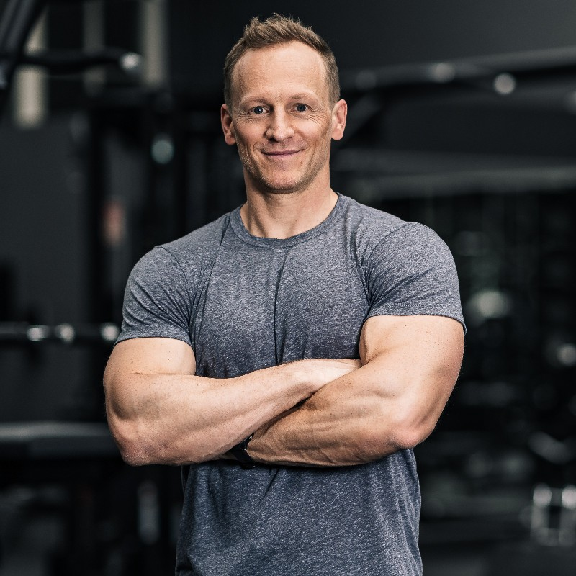
Unlike most dads, Brian Richards was a 44-year-old entrepreneur who was just as steadfast and motivated in the boardroom as he was in the gym. As a result, his rugged handsomeness had been perfectly paired with the solidly muscular physique that would make even some of Chase’s fellow wrestlers jealous!

Ever since he was a young boy, the importance of both physical and mental fitness had been passionately imparted onto Chase by his father. Although the reason behind his father’s sudden health kick was due to the sudden and tumultuous divorce from his wife and Chase’s mother, the older man realized everything was worth the hardship as it caused both men to not only grow stronger but closer as they bonded via their frequent workouts together. As a result, the duo were a dynamic force, conquering life with an intense fervor that left both men dominating in both their specific fields. Although one wouldn’t think a muscular physique would matter when it came to business deals, Brian couldn’t help but notice the newfound respect and attention he gained from clients and fellow partners as he provided intensely firm handshakes and looked inherently imposing due to his bulkier muscles. Despite this intense physique of his, the father remained incredibly modest with his appearance, never opting to showcase his barren arms or legs unless within the comfort of his own son during their workouts.

Yet as they bonded over their mutual love for fitness and living healthy lifestyles, it also caused their paths to divulge more and more frequently as Brian’s company continued to catapult to levels once thought to be unimaginable as Chase’s wrestling career took off. Despite the way life tried their best to keep them separated, the duo worked tenfold to make sure they both remained an active part in each other’s lives. Sometimes Chase would forgo wrestling practice or special team events in order to be by his father’s side for important business dinners, and the same could be said for Brian as he would send his second in command to handle business meetings so he could be front row in the sidelines to cheer his son on through every major championship possible.

As he looked at his dad though, he couldn’t help but wonder about the constraints of this surprise visit. “So, when do you have to leave? Are you just here for the night or something?”

Brian chuckled in response. “Nope, I’ll be here until my flight back on Sunday. I had my schedule cleared so I had nothing else to worry about besides spending time with my incredible kid!”

After taking a momentary pause, the father wrapped his son once more into a tight hug before realizing that they should probably get out of the chill autumn weather. “Say, how about we get in my car and go out for dinner? I’m sure we’ve got a lot of catching up to do,” he said.

Chase immediately nodded and allowed his father to lead him away from the athletic center and closer towards a nearby parking lot. Upon doing so, the jock found himself being taken to a sleek and expensive luxury sports car that seemed awesome yet extremely out of character for his reserved and image-conscious father. After raising an eyebrow at his father, Chase watched as his father instantly chuckled upon opening up the driver’s side door.

“Aw, don’t give me that! I just thought you’d want to be taken around in style for the next few days. Plus, I thought you might want to take it for a spin a few nights to show off to your friends,” Brian said with a wink before finally getting into the car.

Upon following suit and bucking up, the duo were off and traversing across the hectic crazy town that was incredibly busy due to the sudden influx of ill-prepared families visiting their kids who had no idea how to navigate such a large metropolitan city. Although this delay was a problem as in terms of delaying the duo’s food, it was also nice as it allowed them to chat for a while.

“So, how’s Oak Point treating you, kiddo? How are classes and everything going?” Brian inquired.

In response, Chase blushed in slight shame as he thought about how piss-poor his grades were due to the intense wrestling schedule he was under along with the issues involving Tyler. “Uh, it’s taking a bit to get used to but I’m sure I’ll get settled and into the groove of things again… although we both know that school isn’t really my forte,” he replied, punctuating his sentence with a nervous chuckle.

“True, you definitely got that from me,” Brian replied, with a slight frown of personal shame. “It was always such a struggle trying to stick to deadlines and get stuff done in time. I had way too much of an overactive imagination.”

Eager to change the subject though, Brian turned to his son and flashed a smile. “Well, how’s the wrestling going then? You like the coaches and your teammates?”

Getting the opportunity to talk about his favorite thing, Chase instantly beamed with pride. "Oh, it's going great, Dad. The coaches are great and my teammates are pretty cool. We’re doing really well so far, I think we’ve got a good shot of making it all the way to the end,” he stated, smiling as he saw his dad smile in pride. “I've been putting in the work, just like you taught me."

Stuck at a red light, Brian moved one hand away from the steering wheel to pat Chase a few times on the shoulder. "That's my boy. I would say I’m shocked or surprised, but I always knew that you had it in you!"

Upon lifting his arms up in hopes of reciprocating the action to his father, Chase’s face contorted into a look of disgust as he got a whiff of his own sweaty and musky aroma. Although he was sure that his father didn’t mind, the athlete was constantly craving his father’s approval and respect and thus decided it would probably be a good idea to change out of these clothes and at least hit his pits and body with some deodorant and cologne. So as they remained stuck at a red light, the man decided to ask his dad a question before it was too late.

“Hey uh, before we go to dinner, can we head back to the dorm? I smell nasty after practice, and if we’re going somewhere fancy I should probably freshen up and change into something more appropriate than this,” Chase stated, looking down at his damp too-small tank top and shorts.

Brian couldn’t help but instantly chuckle at the question. “Of course kiddo! I noticed earlier when we hugged, but I was just so excited to see you that I tried to ignore it. If you want to head back and get yourself cleaned up though, I appreciate that for both of our sakes and senses,” he exclaimed with a hearty chuckle.

Upon quickly turning on his turn signal and getting over to the far lane, Brian escaped the bumper to bumper traffic as he began the trek towards Chase’s campus. “Anyways, I’ve been meaning to meet that roommate of yours! I didn’t get to meet him before I had to go back to New York, so that should be interesting,” he said, which instantly caused a twinge of panic to course through Chase’s body.

Chase hesitated, his enthusiasm waning. The prospect of introducing his father to Tyler, his nerdy and socially awkward roommate, was not something he looked forward to.

"Uh, are you sure about that Dad?" Chase asked. "Tyler is nothing special, he’s just some nerd.” In hopes of trying to convince him against the idea, the man attempted to reframe his concern as genuine empathy. “Plus, I’m sure you’re tired from the flight right? We’ve got all weekend, we can just do it later…”

But to Chase’s annoyance, Brian refused to budge. “No, I want to meet him! I thought about it during that whole flight here. I feel bad for not getting to introduce myself before I left, so the sooner the better!”

Realizing that there was no way of convincing his dad otherwise, the jock quietly nodded to the man’s proposition just as they arrived at the dorm. Upon parking the car in one of the front visitor spots, Brian smiled as he got out of the car and began to make his way towards the dorm. As Chase followed suit and used his keycard to get into the building and then take the elevator up to his floor, the jock couldn't shake the feeling of impending awkwardness. The small talk with his dad was all that he really wanted, so the thought of introducing his father to his biggest nuisance and enemy loomed over him like a dark cloud.
They soon made their way down the long hallway and reached the door to Brian’s dorm room, where the jock took a deep breath before unlocking it. As the door swung open, he half-expected Tyler to be there, staring at them with those awkward, unsettling eyes. But to Chase’s relief, the room appeared to be totally empty. In response, a deep exhale escaped from his lips as a slight smile formed. “Well, it seems that Tyler’s off doing… whatever it is he usually does. I guess I’ll have to go introduce you guys later,” Chase said, feigning sadness as he led his father into the room.

Disappointed, Brian’s face fell into a slight frown but he tried to fix this by turning his attention towards observing how the shared space now looked. "Not bad, not bad. Brings back memories of my college days. Oh, that feels like eons ago,” he said, chuckling to himself as he suddenly found himself lost in a quick trip down memory lane. Eventually though, he returned to the present day as he turned his head towards his son and flashed a smile. “I’m sure it must suck to feel so cramped after growing up in such a large bedroom though huh?"

Chase nodded, quickly pulling off his clothes before switching into a pair of dress clothes that were hung up in his closet. Just as he thought they might escape without encountering Tyler though, the sound of the doorknob turning caused both men to turn away from Chase’s side of the bedroom as the nerdy roommate finally made his grand appearance.

“Hey Chase.” At first, Tyler’s voice was drenched in disdain and anger as he huffed and found himself staring at the handsome yet irritating face of his mortal enemy. But as soon as his eyes moved past the jock and settled onto the weathered and manly visage of the other room’s occupant, Tyler’s expression instantly changed into a more upbeat and welcoming one. “Uh, hello there,” he smiled, walking further into the room before extending out a hand towards the father. “My name is Tyler Jennings, you must be Mr. Richards?”

In response, Brian’s face twisted into a jovial smile as he reached out and wrapped Tyler’s hand into a tight and intense handshake. “Oh please, Mr. Richards is my father. You can call me Brian,” he replied, smiling as he looked the weak nerd up and down. “Apologies for not getting to meet on move-in day, I had a business meeting the next morning so I had to get back as soon as possible!”

“Oh uh, it’s no problem,” Tyler replied, his expression looking as though he was instantly enamored by the handsome and buff man despite being the creator of his biggest nuisance. As a slight hint of pink began to invade his cheeks, the nerd excused himself as he made his way over to the desk and began to crack open one of his many books sitting there.

In hopes of getting his father out of there as soon as possible, Chase forced a smile towards his father before he quickly began to make his way over towards the door. “My dad and I were about to go head out to dinner, so we’ll see you later Tyler,” he began, turning the knob and pulling the door open.

But before he could get his father out of there, Chase was stopped dead in his tracks as his father began to ask a question. “Hey champ, can you give me your keycard or something? I didn’t realize how bad I needed to pee until we made our way up here. With how intense the traffic is in town because of this weekend, I don’t know if I’d be able to wait until the restaurant!”

Just as Chase was about to reach into his wallet to hand the keycard, the father and son were suddenly shocked as Tyler randomly sat up from his desk and infiltrated the conversation. “I uh, I was about to go shower anyway so I can just let you in with my card if you want?”

In response, Brian smiled as he looked at his son’s roommate. “Oh, that would be quite kind of you. Thank you Tyler,” he smiled, watching as the nerd quickly grabbed onto his shower caddy and towel before making his way towards the door.

Instantly distrustful of Tyler and fearing that the nerd would be trying to sneak a peek at his dad going to the bathroom or something, Chase tried his best to turn the man down. But no matter how hard he tried, Brian refused to listen to his son. “It’s alright Chase, I’ll go to the restroom real quick and then we can go. While I’m gone, just go and finish getting ready by putting some deodorant and a lot of cologne on!”

Left with no other choice, Chase watched as Tyler smiled at the middle-aged man and began to lead him down the hallway towards the restroom. Having them even be in the same room as him was already unnerving enough, so watching his father and Tyler making small talk as the nerd swiped his keycard and led the man into the restroom left Chase feeling the most intense sensations of discomfort. He had witnessed with his own eyes how Tyler had stared at him longingly and behaved poorly, so the concept of his father having to experience the same thing was infuriating. The man didn’t build a multi-billion dollar company just to get objectified and thirsted over by some horny twink!

So as Chase stood there in his dorm room and just waited for his father to come back, the man couldn’t help but grow nervous about the thought of his dad and Tyler being together in such close proximity. There was nothing he would hate more than his dad to get to know Tyler better and somehow think he’s a great guy after what Chase himself had experienced. It was clear that the nerd was on his best behavior and trying to impress the businessman, which only caused the jock to ponder what exactly the nerd’s intentions were.

Eager for an excuse to go check on his dad, the universe seemed to give him a reason as he received a text from his father’s assistant Deb.

Hey Chase, your dad told me he met up with you but he hasn’t been responding to any of my other calls and texts. We’ve got a business issue that we need his response for, so can you let him know so it can be handled ASAP? Thanks!

After sending a thumbs up emoji to her, Chase pushed his phone into his pocket before turning and making his way out of the dorm room. With haste, the man walked down the long hallway until he was able to make his way to the bathrooms. After sliding in his keycard and getting the light to flash green, Chase twisted the knob and pushed the door open.

Not caring if there was anyone else there, the man opted to loudly announce his arrival to the bathroom. “Hey Dad?” Chase asked, making his way further into the bathroom in hopes of finding him at one of the urinals. “Deb just texted me saying that she needs you to call her about something” he continued, stopping as he suddenly found himself seeing the back of his father revealed past the covers of the urinal.

As his dad leaned his head back and turned to face him, Chase smiled as he realized that Tyler was nowhere to be found. But that assumption was soon realized to be false as he watched one of the stall doors silently pull open and Tyler walked out to end up directly behind Brian. With the nerd turning to face him, Chase’s eyes raised in shock as he watched Tyler’s lips pull back into a devious smirk and give a sly wink in his direction.

“Dad, behind you!” Chase screamed, but he was too slow to respond as he watched the nerd suddenly head straight towards Brian and begin sprinting in his direction. Fearing that the nerd was going to tackle him for some reason, the man clenched his fists as he mentally prepared for the sight of watching his father slam face-first against the tiled wall and urinal.

However, as soon as Tyler’s outstretched arms made contact with Brian, Chase watched in utter disbelief as his father didn’t fall forward from the contact. Instead, Tyler fell into his father’s broad back and disappeared completely into it. Rapidly blinking his eyes, the jock struggled to comprehend what he had just seen. How was that possible? There’s no way that Tyler just vanished in thin air!

To his horror though, Chase watched as his father’s body began shaking violently as if it was being electrocuted by a livewire. For what felt like hours, the man was stuck in place unsure of what to do as he watched his father appear to experience an intense seizure. But just as suddenly as its onset, Chase watched as his father’s body suddenly stopped shaking and became rigid and upright as if nothing had happened.

“Da– Dad? Are you ok?” Chase inquired, his voice stuttering as he watched his father quickly reach down and zip up his pants before turning away from the urinal and flushing. As their faces met once more, a shiver of pure fear passed through his body as he noticed the unfitting expression that was displayed on Brian’s aged yet handsome visage. In all honesty, it looked strangely similar to the one that Tyler had given to him before he disappeared…

“Oh yeah, champ,” Brian exclaimed, a hearty and somewhat maniacal laugh escaping from his lips as he stopped to look down at himself. After extending out a pair of hands, the man moved them closer to his torso, allowing himself to run along the front of his body and feel the prominent plump pecs and cobblestone abs that were unfairly hidden under his designer clothing. “I’ve never felt better,” he continued, allowing one hand to continue traversing down his body until it reached his crotch and firmly gripped onto the quickly-growing bulge that was pressing out of his dress pants. “Due to your little distraction, your dad didn’t suspect a single thing before I came and took him over… so thank you for that!”

Upon hearing this, the pieces of what he had witnessed finally fell into place. “Ty– Tyler? That’s you in there?!”

* * * * *

Hearing such shaky and unsure words come out of his roommate’s mouth, Tyler couldn’t help but smirk as he moved his hands away from his body and began to slowly walk towards the restroom mirror. After years of investing into magical studies, his wildest dreams had finally come true and he’d finally been able to cast a spell higher than beginner-level. As he looked down at himself and saw his view of the floor hindered by the slight jutting out of his plump pecs and wide muscular arms, the man’s borrowed cock couldn’t help but throb at what he saw. All of his life he had desired to be something other than a frail nerd and now he finally was… although it certainly wasn’t what he had initially planned for himself.

Gaining acceptance to Oak Point University was something that Tyler had initially hoped would be a fresh start for him given the relentless torment he received both physically and verbally in high school from the muscular athletes and preppy bullies. But to his annoyance, the universe seemed out to get him as the random roommate lottery for freshmen gave him a roommate in the form of Chase Richards - the literal embodiment of everything he had hoped to escape in high school. Not only was he incredibly rich due to being the son of a multi-millionaire businessman, but he was immensely muscular and sporty as one of the college’s most popular wrestlers!

Although he had initially hoped that he could be friendly with the jock after having a heart-to-heart and disclosing his sexuality, it seemed like that would be impossible upon overhearing Chase shit-talking him with his friends a few nights later at the dining hall. Not only did Chase imply that Tyler was a total loser, but he made homophobic accusations such as the nerd constantly checking him out or the idea of Tyler secretly sniffing the jock’s workout clothes while alone because he was so thirsty and pathetic. Understandably, this made the path of friendship impossible for Tyler to even consider. Rumors spread like wildfire despite the campus being extremely immense (most likely due to the constant talking amongst dumb himbo jocks and bubbly cheerleaders), so before long, Tyler couldn’t go anywhere without hearing subtle whispers inquiring if he was the apparent jockstrap-sniffing pervert.

From that point on, the man used his brain and spellbook to try and make his roommate’s life as terrible as possible. Late nights in the room were illuminated by a bright lamp light to make Chase’s sleep as inconvenient as possible, while Tyler offered to wash the duo’s clothes (an attempt at slyly acknowledging Chase’s accusations about him) and used a spell to shrink the clothes and make them fit as terribly as possible. But to his annoyance, his petty attempts at revenge didn’t harm the jock. Instead, it seemed to only increase his social status as Chase Richards became known across campus as this trendsetter who wore unconditional styles that implied a secure sense of identity and masculinity.

After that devastating October argument in which Tyler and Chase both exchanged brutal verbal blows at each other, the jock left for wrestling practice while the nerd referred to his spellbook and decided to finally attempt a higher-level spell - one that would allow him to possess the individual of his choice. Eager for a chance in the spotlight and to cause as much agony and torture as possible for the jock, Tyler initially opted to possess the jock’s body as soon as he arrived back from practice. But to both Tyler’s shock and glee, a much better alternative suddenly showed up in the form of Chase’s millionaire businessman father. As soon as Tyler shook the older man’s hand and noticed the designer fabrics and jewelry adoring his manly and muscular body, the nerd wasted no time setting his sights elsewhere. Beyond just getting a new body that would naturally elicit respect and have a hefty bank account and physique as bonuses, the concept of having Chase trapped in such a devastating and hopeless situation seemed even better than just possessing the jock’s body. With him in control of his father’s body, he would hold ultimate power over the athlete and there was nothing Chase could do about it without sounding utterly insane to anyone he told about it.

So upon pretending to go to take a shower, Tyler led the older man into the restroom before ducking into one of the restroom stalls. But upon setting down his shower caddy, the man wasted no time quietly reciting the spell over and over. To his relief, his maturity within the magical realm had permitted him to conduct the spell as he felt the intense tingle of magic suddenly coursing through his entire body. Just as he stood up and began to unlock the stall door, the sudden sound of Chase’s booming voice echoed through the restroom in hopes of finding his father. Knowing that there was no more time to waste before the duo left for dinner, Tyler unlocked the door and walked out of the stall. As soon as the nerd locked eyes with the jock and gave a wink and smirk in his direction, Tyler instantly rushed forward and allowed himself to fall face first into Brian’s broad back. To his immediate relief, a warmth permeated through his corporeal form as he sunk deep into the middle-aged man’s body.

As a result, Tyler now stood in front of the bathroom mirror and found the body of Brian Richards staring back at him. Despite hearing Chase beginning to mutter a series of confused statements, Tyler refused to pull himself away from the mirror and instead smirked to himself as he reached up and decided he wanted to get a better look at what he was now working with.

So with a determined expression, he began to slowly unbutton his shirt.

“Wha– what the hell are you doing, dude?” Chase asked in horror, watching as his father’s body obeyed Tyler’s every dark and twisted desire.

As each button yielded to his fingers, Tyler couldn't help but admire the physique that slowly revealed itself to him in the mirror. His reflection showcased the results of countless hours spent in the gym, the definition of each muscle a testament to his commitment.

"Damn, he’s ripped," Tyler muttered to himself, a self-satisfied grin playing on his lips. Turning to the side, the former nerd assessed his physique from a different angle. Underneath the shoddy lighting of the restroom, he was amused to see how the shadows accentuated the contours of his abdomen, emphasizing the strength that still resided within him. He ran a hand over his abs, feeling the firmness beneath his fingertips.

Upon gripping onto the plump pecs that now proudly jut forth from him, the man marveled at his weathered yet taut skin. The scars of time were evident, with lines etched on his body like a roadmap of all of his 40+ years of hard work. "No offense Chase, but your dad is aging like the finest of wines…” Tyler remarked, his eyes momentarily pulling away from his reflection to narrow in pride at the shell-shocked jock.

“Stop, please I’m begging you Tyler! I’m sorry, please just get out of my dad’s body!”
Despite Chase’s gasps and pleas, this only encouraged Tyler to keep going. As a result, the new middle-aged man leaned down as he pulled off his dress shirt and set it on one of the metal countertops. Turning to face the mirror once more, Tyler suddenly reveled in the sight of his exposed upper body. The bathroom light highlighted the veins that snaked across his arms, which only popped further as he extended his arms out and tensed his biceps. All of his life he had dreamed of having a physique like this and now that he finally did, he knew that those years of desiring was worth it. He felt absolutely reinvigorated both physically and emotionally!

As he took a step back from the mirror, Tyler couldn't help but feel a surge of confidence. Initially the concept of becoming someone significantly older seemed daunting and like a terrible idea, but now that he saw his new form he knew he couldn’t have been more mistaken. The aging process hadn't diminished the strength that Brian so ardently cultivated. If anything, it had added character to the canvas of his physique.

Admiring such a ripped and manly physique had caused Tyler to find himself rocking the most rock-hard boner he had ever had. With horniness overtaking his mind on top of his desire to further humiliate Chase, the man then wasted no time reaching down towards his crotch and beginning to cup the thick bulge prominently displayed in his jeans.

Instantly, this display of pure sexual lust finally caused Chase to jump into action. “Get your fucking hands off of my dad, you pathetic faggot,” he cried out, rushing towards the possessor with his fists clenched and eager to fight. But despite how Chase could have easily annihilated Tyler in his current body, the same could not be said for Tyler in his new form. As a result, the nerd’s new strength came to immediate use as he suddenly reached out and repelled his new son away with force. Like a house of cards, the wrestler suddenly toppled and tumbled over until he ricocheted off of the tiled wall and fell to a heap on the floor.

The ability to instantly overpower his former tormentor filled Tyler with an intense boost in pride and cockiness as he swaggered over towards Chase. Staring down at him, the nerd tried his best to adopt the sternest possible expression to fully terrify the young man. To his amusement, his plan worked as the air instantly seemed to thicken with the weight of disappointment and frustration.

"Chase, son, I think we need to talk," Tyler began, his voice low but firm.

Instantly, Chase’s lips curled in anger as he stared up at his father’s body. “You’re not my goddamn father,” he cried out, sliding across the floor to widen the distance from the nerdy freak who had instantly made the concept of magic feel incredibly real to him. “Get the fuck out of my dad’s body and maybe I won’t beat the shit out of you,” he continued, trying his best to give the option of both a choice and the possibility of no violence being used.

In response, Tyler sighed, fully embracing his newfound life as the father of an unimpressive and disappointing son. “You know, I was willing to let bygones be bygones, but your behavior gives me no other choice, Chase,” he began, crossing his arms and widening his stance to appear as imposing as possible. “For most people, college is an opportunity for you to grow and excel, but all I've seen are poor choices and lackluster performances…"

Before Chase could even attempt to respond to this weird roleplay that they were doing, Tyler continued to put on his best performance as a disappointed father. "Chase, I've supported you, financially and emotionally, but I can't keep watching you squander the opportunities you've been given. You need to face the consequences of your actions… I’m officially cutting you off. No more handouts from daddy and no more saving your ass when you fuck up!"
Chase's eyes widened with realization. "What the hell are you talking about? Tyler, you’re not actually my dad, you can’t do this to me!"

Tyler took a deep breath before delivering the harsh truth. "I hate to break it to you, kiddo, but Tyler is gone for good. There’s no way I’m ever going back to a life where I’m constantly disrespected and ignored by everyone. Now I have a life filled with incredible success and unwavering respect, and I’m not going to squander it by having to constantly take care of a pathetic and ungrateful son."

Chase's face paled, shock and panic gripping him. “You, you can't be serious. I need my dad. I can't do this alone."
Tyler shook his head. "I've given you countless chances to change your ways, Chase. Now it's time for you to face the reality of your actions. You're on your own for now and for the rest of your life.” After taking a brief pause, Tyler opted to give one more devastating blow. “If you need help covering college, I suggest you get to work finding a job…"

With that, Tyler smirked and gave a quick pop of his pecs before reaching forward and grabbing onto his dress shirt. As he pulled his shirt on and began to saunter out of the room, the sound of uncontrollable sobbing echoed through the room as Chase realized the gravity of his situation.

Upon finishing redoing the majority of the buttons of the shirt and passing by his former dorm, the new middle-aged man left his life as Tyler Jones permanently behind as Brian Richards made his exit from the dorm and got into the front seat of the luxury sports car rental. After checking his new cell phone and finding the address for his hotel, Brian put the car into gear and left Oak Point University behind for good…

* * * * *
“Here we are, Mr Richards. If there’s anything else you’d like, please feel free to contact us and we’ll take care of you right away sir,” the bellhop replied, smiling as he finished wheeling the room service cart into the room and began to make his way towards the door.
“Sounds good, thank you so much for your quick service,” Brian replied, smiling as he reached into his wallet and placed a $100 bill into the bellhop’s trembling hand. Upon watching the bellhop’s face twist into a look of glee, the young man gave a nod of thanks before depositing the money into his pocket and quickly taking his leave.

As the door to the presidential suite was finally pulled shut, Brian couldn’t help but feel his cock beginning to throb. Ever since he had arrived at the hotel after leaving the dorm, the former forgotten and mistreated nerd had been savoring every morsel of respect and admiration he received from the staff. No matter what he said or asked, he was always referred to as “sir” or “Mr. Richards” and that just caused him to feel utterly horny.

In hopes of both ignoring his intense horniness and taking advantage of his newfound wealth (where he discovered the exact multi-million dollar amount after pulling out his phone and checking his banking app), the businessman opted to order a lavish and expensive meal from the Michelin-starred kitchen of the hotel. Although his usual tastes tended to be fairly generic and unhealthy due to his poor financial situation, this was no longer an issue. As a result, Brian had opted to spare no expense. Plus, given his impressively ripped physique, the brand new 46-year-old knew he needed to start eating well to maintain his new form.

Upon finishing off his pan-roasted duck breast, the man was both amused and annoyed to discover that his rock-hard boner had not died down in the slightest. Instead, it throbbed uncontrollably against the skintight jeans that were still wrapped around his glorious body – eager for a chance to break free so the DILF could get a chance to play with it freely. With such intense feelings permeating through his mind, Brian decided to finally begin undressing to get a better opportunity to check out his body.

As he placed his Rolex on the bedside table and took off the wedding ring that the widower had continued to wear after his wife’s passing, the man then began to take off his clothing and toss it aside onto one of the many chairs in the room. Upon ending up fully nude, the man began to stroll towards the large bathroom. As he did this, his eyes couldn’t help but look down and smirk as he watched his solid 8” cock bob and sway with each thunderous step he took. As soon as his eyes met his new reflection, the older man wasted no time turning to admire the areas of his body he had been unable to explore with Chase blubbering around him – such as his meaty thighs and plump ass. Even with the slight sagging of his ass cheeks due to age, Brian still knew how incredible he looked. In fact, he looked so goddamn sexy that he felt it would be such a shame to waste his first sexual experience with just him and his hand. Oh yeah, he wanted… no, he needed to have someone there to worship his body and tell him just how sexy and desirable he was.

Although he was an utter virgin, Brian’s knowledge as a former tech-savvy gay man had made him completely aware of hookup apps. Now with the perfect body to make any gay man lustful, he wasted no time grabbing his phone and downloading Grindr. Eager to look as great as he possibly could, the man threw on a pair of workout shorts that he found in his suitcase and began to do a quick round of pushups and other exercises to make sure his muscles were looking as pumped as possible.
Upon spending a few minutes getting his muscles warmed up, the man opened up Grindr and created his account. Unsure of what else to use as his username, Brian just typed in “Muscle Daddy” and moved onto the next stage of the account creation - a profile picture.

With his phone in hand, the man moved away from the bed and headed towards the large full-body mirror that was positioned on one corner of the suite’s wall. As he lifted his phone up, the formerly camera-shy nerd was no longer as he smirked and began to put on a flexing show in hopes of finding a good angle for a picture. Alternating between popping his pecs and lifting up a bicep to flex, the man continued to change his angles until he was able to find the perfect angle that accentuated his plump pecs and highlighted every well-defined abdominal muscle that he now possessed. Upon pressing submit, it was only mere seconds before his phone became alit with a flurry of sound effects and messages filling his inbox of nearby men eager to get intimate with such an utter DILF.

Before he could respond to one of the messages though, Brian’s eyes darted to the top of his phone screen as he found a text message notification coming from a woman named Deb. Upon clicking on it, the man’s phone pulled him from Grindr and placed him into the messaging app as he took a quick glance at the conversation and realized that this Deb individual was his personal assistant.

Deb: Good evening, sir! How's the family weekend going? I talked to Chase earlier and he said he was going to let you know that we needed to talk. I hadn’t heard anything so I just thought I’d check in and see if everything was okay?
Upon reading it, Brian sighed for a second as he tried to figure out not only what to say, but how to say it in the most professional businessman-like way. After thinking for a few moments, the man’s weathered fingers began to rapidly touch the screen as he typed his message.

Brian: Oh yes, my apologies. It’s been a busy and tiring day already. Is it possible that our talk can wait until tomorrow?

Immediately, his phone buzzed as his assistant replied with haste.

Deb: Yes sir, that’s not a problem. It’s already late anyway so I had figured it would be something to deal with tomorrow. I mainly just wanted to check in on how you and Chase are doing.

Brian sighed thinking about his asshole of a new son. As a result, the quickening beat of his angered heart synchronized with the rapid typing of his fingers.

Brian: In all honesty, I’ve just come to realize that my son is an utter disappointment and I’m tired of coddling him. He’s 18 years old now and needs to learn how to fend for himself. Will you go ahead and cut off any future allowances and payments I provide for him?

Deb: Wow, that’s a lot. Are you sure about all of this? Do you want to sleep on it?

For Brian, there were no other options so he wasted no time typing out his response.

Brian: No, I’ve never been more sure of anything in my life.

After finishing up that text, the man wasted no time quickly typing out another.

Brian: Anyways, can you check into flight options for me? I want to head back early, as soon as tomorrow morning if possible.

Within moments, Deb's response lit up the screen.

Deb: Sure thing, Brian. I'll handle the logistics and make sure everything is arranged. Anything specific you'd like for the flight details?

Eager to get out of this college town and get to work, Brian smiled as he fired back a quick and concise text.
Brian: No, just the earliest available.

Deb: Consider it done. Anything else you need from me?

Brian hesitated for a moment before responding.

Brian: No, that should be it. Thanks, Deb. I appreciate it.

Deb: Of course, sir. Have a great night.

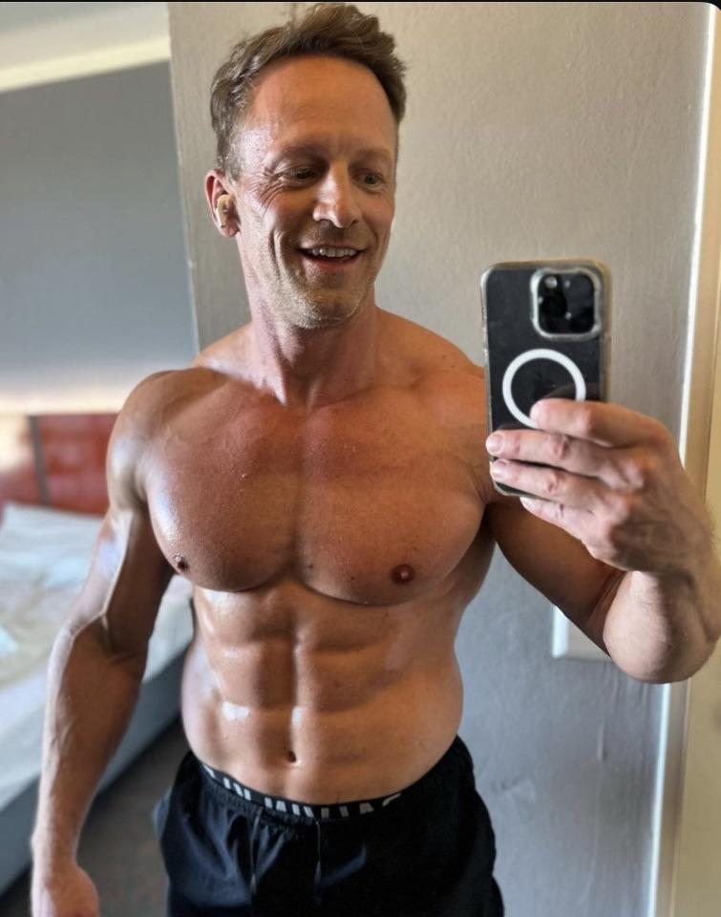
As Brian exited the conversation and headed back to Grindr, the man smirked as he took in the endless amount of messages he had received during his chat with Deb. Although there were an endless amount of options that piqued his interest due to their profile pictures displaying glorious muscles, Brian couldn’t help but gravitate towards the accounts that begged to be “punished and fucked by Daddy”. Never in his life had he elicited such respect and desire, so the concept of finding someone utterly submissive to him sounded absolutely glorious.

After a few minutes, he finally chose the most appealing man to him and ordered a car to come pick them up and bring them to the hotel. As he waited, the muscle daddy smirked as he realized just how perfect his life will be. Whether it was in the boardroom or bedroom, Brian Richards would always come out on top…

