BIG MISNAKE
FEBRUARY 2022 REQUEST STORY
BY CHALDEACHANGE
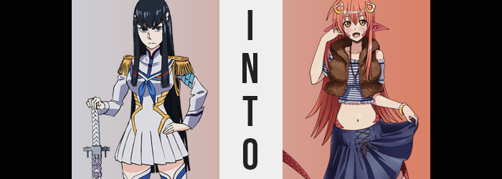

Satsuki Kiryuin had a number of questions about an outfit she had mysteriously found within her wardrobe one day.

Well, to say she even had a wardrobe by this point might have been something of an exaggeration. For the sake of her goals, for the sake of toppling her mother’s ambitions and freeing the world from the influence of COVERS, she had decided to only wear Junketsu until those goals had been accomplished. She had no reason to wear anything else, and doing so? Well, it certainly might have been seen as a sign of weakness.

There were many that were out to kill her, being the family’s heir. Ryuko Matoi was among them, and while she had been becoming more of a thorn in her side as of late, she didn’t exactly care too much about that feisty little rebel’s actions. There was a much higher chance that she might be killed by someone linked to her own family. If her mother caught wind of her plans, who knew what assassins she would send.

Nui Harime would be the least of her worries in that case.

And so, to those ends, Satsuki had effectively emptied out her closet in its entirety. No clothing other than Junketsu would be allowed to be worn both as a show of her conviction and a tactic for scaring away any would-be deterrents. The only reason the teenager even checked her mechanical closet was out of habit, and she was constantly berating herself for forgetting.

She had been on the verge of doing so again when something very bizarre caught her eye. What should have been an empty void without a single piece of cloth or fabric within? It wasn’t quite as empty as it should have been. In fact, on a pair of hangers there had been an entire outfit. “When… did these get in here?”

Satsuki knew for a fact that she hadn’t purchased nor moved an outfit of that design, and she likely wouldn’t have bought it based on its design. A striped, blue and white top with bare shoulders, exposed midriff, and loosely attached sleeves sat beneath a fuzzy, brown, armless jacket. And hanging just a slight ways below? A long, pleated, navy blue skirt that looked long enough to cover her thighs, tied up in the front with black lace. Again, it didn’t quite speak to Satsuki’s own fashion sensibilities.

So, were they planted? Stepping closer into the closet, this was the only logical conclusion, wasn’t it? In all likelihood they were laced with Life Fibers, making them potentially dangerous if worn. “Like hell I’m going to put those on.” She murmured under her breath, despite wearing an outfit completely made of Life Fibers. Junketsu… it was different, though.

Just as she got close enough to tear the hanger away, however? The young woman’s eyes went wide not by choice, but because they were forced to by a bright light that radiated from the outfit itself. One that filled the entirety of the room, and blurred her surroundings. “WHAT!?” Until, when the light finally faded, she realized she wasn’t in her closet any longer.

She wasn’t even in her room any longer.

“This isn’t…? How on Earth was I transported!?” The room she now found herself in was reminiscent of the sort of room you might find a middle class Japanese girl living in, with a view in the window overlooking a quaint, little street. Satsuki was naturally reasoning that she had somehow been transported elsewhere in Japan, but that wasn’t quite the case. She was, technically, still in Japan. She just wasn’t in her Japan. This was a different world altogether.

Everything in the room was wholly unfamiliar to her. Well, everything except for an outfit laid out on the bed. The very same one that had been hanging in her closet, all folded up neatly. “Of course you would be the only thing I recognize.” Because it had clearly brought her here, after all. The thought brought her to clench a fist to her chest, and in doing so? The feeling of her hand stroking her nipple in the process revealed something that she had yet to notice on her own.

She was naked. “What did you do with Junketsu!?” Too proud to remain silent, she barked this question at the outfit that had seemingly brought her here. Her signature outfit and her blade were both missing, and the young woman was blatantly naked in the bedroom. Was this just part of a scheme to make her wear that outfit? She would sooner walk out onto the street butt naked!

Unfortunately for her, she would soon find her opinion of that garment shifting rapidly.

Unbeknownst to the teen, her eyes had already taken on a peculiar color. An amber yellow that contradicted their usual, darker hues. But more than seen with a change of color, there was also a change in shape. Corners that gave those eyes an almond shape appeared to soften, and as a direct result? Her optics came to seem rounder. This distorted her pureblooded, Japanese appearance, and that only came to skew further in the moments that followed. Before we depart from her eyes, mind you, it was still important to note that her lashes had lengthened, and her brows had thinned.

But overall, Satsuki’s facial features didn’t possess the overwhelming strength that they typically displayed. She always came off as intimidating and series of course, but part of that ‘charm’ came from narrow cheeks and a sharp jaw. Features that still existed but didn’t exactly match up with those exact descriptors. In their place her chin had become rounder, and her cheeks both wider and gentler. They gave her an almost girlish appeal, despite the fact that she remained at her age of eighteen – and would throughout the rest of this endeavor.

“Why do I…? I feel groggy.” Her head and body alike felt heavy, and to those ends the woman brought a hand to her face to hold it a moment. That said, one needn’t look much farther than the hairline just above where this hand was located to understand that a Western facial restructuring alone was not all she was doomed to endure. For a rosy tone of red soon penetrated the usual raven of her locks, seeing its full length dyed and its style altered so that it was different naturally.

Satsuki’s hair, typically, had an even length and a very straight cut. It was orderly, which made sense for a young woman of her reputation. And yet locks began to curve ever so slightly out to the sides, lengths slightly shorter on the sides than it was in the dead center of her back. On top of her head, it actually had a rather right-sided lop side, and her bangers were inconsistent in their party. Paired with her foreign face, the more this wore on, the less like herself she appeared.

“Where is my darling…?” And the less like herself she acted too, it seemed. She hadn’t meant to blurt that out, and after considering what she had said, she couldn’t even put a name to the sentiment. “Who was I referring to? I don’t have someone I would refer to with such a title!” And yet, deep down? Did she? Why was there this nagging feeling that she was being submissive of someone very important in her life?

Regardless of what she was thinking or how she felt, her transformation raged on. The muscular form of her bare body seemed to faint with time, strong arms and legs swelling as that muscle melted, and her tummy ultimately inherited a gentle sheen. What was much more astounding about her body though could be seen in her bust. Satsuki certainly wasn’t lacking in the breast department, but the force changing her saw it fit to capitalize on their girth and push them so that they were even fuller. Those tits inflated several sizes, nipples thick and firm, until they were perky E-cups that wouldn’t fall to the gravity of age anytime soon.

That said, there was no real change to the size of her hips and ass. Rather, they almost seemed to have thinned? Just a tad, but it wasn’t so unremarkable that it wasn’t worth mentioning at all. Rather, it was actually a preparatory step, but for something we would come back to shortly. For now? Going back to Satsuki’s face, there was something bizarre beginning to show in the corner of her cheeks.

Red spots. Not the type of spots that were indicative of blush or even a rash. No, the affected areas looked drier than regular should have been. Harder, too. With segment lines formed between these spots, it became clear what they really were. Scales. Like those of a reptile. They didn’t encroach too terribly upon her facial features, but the sides of her head, specifically Satsuki’s ears, were another story altogether. The crimson was quick to coat their cartilage, and in doing so? It pulled their lengths long and wide, forming points that stretched out far behind her hairline.

“I bet if darling was here I’d feel… NO, I don’t know anyone like that!” Despite her resistance, it was evident that subconsciously the way had been paved for this to all transpire without a hitch. She had paid no notice to her transformation thus far, and that included the lengthened, forked tongue that had flickered out from between her lips while bantering with herself. Progressively she beginning to accept the hand that had been unknowingly dealt to her, and that included the continued growth of red scales.

Having forgone any influence on her torso, the had instead begun to engulf her ass and hips. Cheeks didn’t take long to be covered in the textured red, and yet strangely? The two cheeks were ultimately connected, the crack between them discarded and altered into just a subtle indentation that implied where her ass should have gone. These scales continued down the outer sides and backs of her legs, and yet in the front? It wasn’t the same.

“WoOoAH!?” With hands outstretched to the side to maintain her balance, Satsuki let out a rather uncharacteristically comical cry thanks to a shift in her balance. Since when had she found it so difficult to retain her upwards posture? The thought hardly crossed her mind, actually. But the cause? It was quite blatantly apparent. Her inner thighs, her knees, her shins?

They were steadily connecting together, fusing into a singular appendage while the fronts that had not been traditionally scaled were instead textured with horizontal folds that seemed to possess a terrifying grip. Not even her pussy escaped their influence, but her slit did remain in place. A vague flap of this pinker skin covered a gaping pussy, leaving a long vertical line pointed downwards. This fold likewise concealed where she would, uh… Do #2.

This trend of scales and folds continued down to her toes, which ultimate folded in a singular point once her ankles bent to point them behind her. Satsuki likely should have fallen in this instance, but instead of doing so she was held upright by what was clearly a snake’s underbelly – for there was no way to describe what was happening to her lower half as anything other than becoming that of a crimson snake. So for what purpose did so much of her body still resemble a human’s?

It might have seemed strange, but it most certainly wasn’t strange for the world that the teen now found herself in. Rather, she might have been changing to fit in better than she would have in her human form. But even then? What she was experiencing wasn’t completely finished yet, for her tail slithered and extended out behind her. Before long it was twelve or so feet long in total, and she seemed more than familiar with it. She had to have been, else she probably would have knocked over some of the furniture in a bedroom that looked much more familiar.

“Umm… What was I doing? Oh! I must’ve been getting dressed, right? Or maybe I was getting ready to take a bath?” The woman formerly known as Satsuki Kiryuin, now in all of her new, serpentine glory, slithered from one corner of her bedroom to the next as her mind finally pieced together a plausible excuse for why the past five minutes or so felt so vague. Well, it was early in the morning! She must have just been tired, right? That made more sense than anything! She always felt disoriented in the early morn!

And so everything was able to click together now. Her name? She’d forgotten her old one, and now something different stood out in its place. Miia. She couldn’t remember ever going by anything else, and why would she? Miia was her name! Where was she? Her darling Kimihito’s home! He had been so kind as to take her in, and she was just one of the many monster girls living here that yearned to be his lover.

And she was going to win!

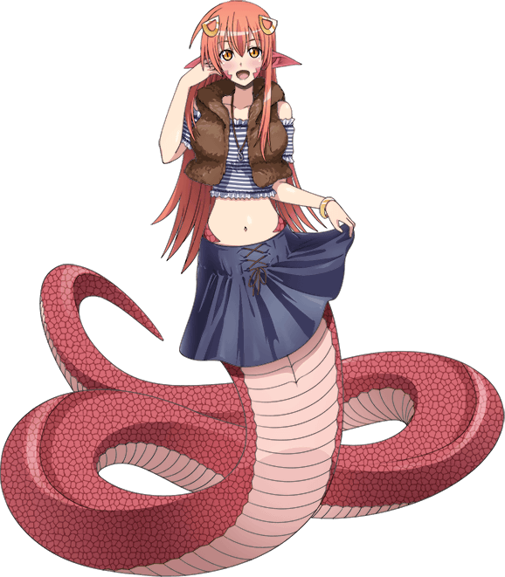
…At least this explained the strange feelings of longing she had possessed over the course of her transformation. In fact, even as she began to put on the outfit she must have laid out herself on the bed, her mind wandered to what she would say to the young man when she encountered him that morning. “Should I give my standard greeting? Or maybe I should spice things up a little to leave an impression?” Miia’s forked tongue darted in and out from between her lips as she spoke, cute but dangerous fangs ever present as she displayed an adorable smile.

Forgoing putting on a bra, the open nature of her top made it simple to slide over her long, triangular ears. That was part of why she enjoyed the outfit so much. Short of it being adorable, of course! And the brown jacket? It went over her shoulders with ease. A shiny belly and scaled hips exposed in between this short and her nether region, her skirt was wrapped around the back and tied up at the front. Because how was a lamia going to slide a skirt all the way up the length of her tail!?

Finally, the young woman slithered over to her dresser and grabbed a pair of golden hair decorations that went in her red hair. “Perfect! I look cute and sexy, as always!” She had to pride herself in these things if she was going to win her man’s heart! She had to outshine all of the others that were after him too! Sometimes life could be so unfair…

Yet, being a monster girl whose biggest issue was trying to win the heart of a human? It was a rather simple goal, and one that was far less dangerous than what she would have been dealing with had she remained Satsuki Kiryuin. This world was peaceful, without any threat of COVERS taking over. She could live a happy, somewhat mundane monster girl life when Satsuki had never been given that chance before.

So in a way? Perhaps this was a happy ending.

