***Remote Girlfriend***

***Siggy Commission for AxelMagnus***

In a campsite high up near a mountain lodge. Two families far flung from the modern comforts of civilization have just finished settling into the cozy building; their new shared home for the next two weeks together as in a family vacation for the summer holidays.

Born in a tightly knit suburban neighbourhood where the different households treated each other like one giant family, Jason and Todd were close friends since the day they met each other as toddlers, spending every moment of their lives like brothers would; doing everything together, getting into fights with each other and getting over their differences together. They were inseparable buddies.

After cruising through school together, the pair had seen the first split in their lives when the time came to go to college, going their separate ways with their split interests in game development for Todd and engineering for Jason. Although it wasn’t much of a long distance relationship considering they had video calls and messenger apps to fill that void in each other's sides.

And now with the arrival of their first break, the two brothers from different mothers were reunited once more, all in on their parents' plans to bunk at a mountain lodge owned by Todd’s family. A vacation in the embrace of mother nature, free from the troubles of modern civilization complete with a lake for fishing and swimming in, a forest filled with fresh game to hunt and even a working blacksmith’s forge at the back of the lodge far away from anything flammable of course.

Jason however, had other issues plaguing his heart, coming along on the trip with a heavy look in his eyes and his mind playing back the moment when his girlfriend, who he had only met for 3 weeks but loved dearly, had broken up with him. Wondering how things had turned out this way. Would she be by his side right now if he had done better as a boyfriend? Maybe, but he would never know for sure

Todd on the other hand, had already noticed something was wrong the moment he reunited with his buddy in the flesh; noting his deflated greeting, the lack of enthusiasm in his voice and how he seemed so *‘serious’* now. Assuming it to be stress from college life, Todd had decided not to pry any further into the matter…unless he had to.

Unbeknownst to the Jason and Todd however, this seemingly innocuous family vacation in the mountains would prove to be a major turning point in their lives, setting in motion a series of events that would drastically alter their simple relationship as blood brothers, elevating it into something more than either of them would ever know was possible between them…

**Chapter I - The Stone**

Trudging through the woods with a fishing rod slung over his shoulder, Todd slowly steps over toward the base of a gnarly log rotted green and covered over in vibrant vegetation, beneath which loomed fungal colonies thriving in the damp shade. These spots were perfect nesting and feeding grounds for a certain creepy crawly he had fond memories of slipping inside a certain someone's clothes, smiling in mischief at the memory of their panicked screams as they struggled to get the thing off.

Over the past few days he’d noticed his friend enter these solemn periods of silence where he’d stare off into the distance as if contemplating something profound, his brow furrowed into a look that blended anger, sadness and peace. Maybe this would be the thing to shake his mood up abit. But the matter of catching it still remained up for debate, with Todd shiftily grabbing his gloves from the back pocket of his pants in preparation for this big game hunt.

These things were fierce creatures though, if an inexperienced fool were to handle one without care, they’d earn themselves a fiery bite and a welt the size of a meatball for days. Which was why Todd had chosen to wrap his hands in gloves for this one, making sure his partner was still staring off in the distance as he slowly stalked off for the sandy shores of the lake. Slipping his protected arm into that familiar mound of damp wood he had learned to spot for, finding its mark as he feels the familiar vice-like grip of the insect’s mandibles pinch at his skin. Only this time; he was prepared for its nasty bite, gingerly removing his arm from the hole, pulling free a nauseatingly large centipede with its intimidating mandibles holding on for dear life, armoured brown body wriggling in the air. A huge score!

Not wasting a beat, Todd spins on his heels, peering out at Jason who was still absentmindedly staring into the shimmering surface of the lake. Unaware of his buddy aiming the centipede his way, taking on a pitchers stance as he flings the nasty thing high into the air. Getting a tad bit worried with his friend seemingly oblivious to the giant payload of wriggly toxin flying right at him. While he personally knew centipede bites were not all that painful, he’d read about bites to the head being far worse than anything most people had ever experienced next to water beetles and bullet ants.

“H-Hey Jason! Think fast!”

Spouting that one last warning, his friend stops mid step, barely noticing the giant centipede land on the grass with a subtle thud as it begins to skitter around madly, finally grabbing the man’s attention as it finds his shoe, and then his bare exposed legs, proceeding to scurry up the hairy length of it in it’s maddened dash to get away.

“What the fuck?! T-Todd! Theres a fucking big worm thing crawling up my leg! Get it off me!”

“J-Just hold still! I’m coming!”

By the time Todd had managed to get the repulsive arthropod off of Jason, the creature had left the big man traumatised after it had managed to find a gap in his trousers, giving his jimmies a good tizzy as it rounded the length of his waist before being ejected by Todd who had to forcefully strip him down before sticking his gloved hand down his underwear in an effort to get it to bite on to them.

While the plan worked, the two friends were left feeling way more out of breath than they would’ve if they had just gone fishing like originally planned. With Todd breaking into laughter at the happy little accident.

“H-Haven’t heard you raise your voice like that since we last saw each other! How’s that for an ice breaker eh buddy?”

Scoffing as he puts his trousers back on after another cursory inspection for any more adventurous critters, Jason shoots a sceptical look over towards his friend, about to let loose a witty remark before his gaze remains locked at something just over Todd’s shoulder.

“What is that thing?”

“I see what you’re doing…the moment I turn around you’ll clock me over the head or something right? Can’t fool me buddy, I’m the master when it comes to tr-”

“-Todd just…just turn? Please?”

Sighing as he plays along, the prankster soon realises his friend wasn’t playing him for a fool as his eyes land on a subtle pink glow emanating from the log where he’d plucked the centipede from earlier. Maybe he dislodged something by pulling out the centipede earlier? Whatever the case was, they weren't going to figure it out lying all the way back there. Eager to see what was producing the glow, Todd rushes to his feet, turning around excitedly as he calls for Jason to join him.

By the time Jason had gotten his trousers back on, Todd was already halfway through lifting the massive log off the forest floor, unveiling a nasty bunch of ants and alot more centipedes where that first one came from.

As well as the source of the glow, like a scene straight out of Indiana Jones where all the insects seemed to avoid the strange pink gemstone sitting half buried in the muddy floor.

"Damn…how much do you think we could make if we sold that…"

"I dunno man…looks dangerous don't you think? A glow like that must mean it's radioactive or something…Hey, what're you doing?"

Predictably, the less than thoughtful Todd was already well on his way to reaching out for the pretty pink stone, his fingers already digging into the soil to retrieve his prize by the time Jason's warning had reached him.

"Relax~ It's just a stone…it's just…really glowy for some reason…wait…hold on second, holy shit!"

Holding out his shivering hand toward Jason with an ecstatic look on his face, his friend could see the stone begin to sink beneath his palms, leaving behind dirt with its smooth exterior already extending well past bone, freaking out the level headed James who didn't seem to share his friend enthusiasm at having a stone melt its way into his hand.

"Dude what the fuck?! Why're you letting it do that?!"

"And? Why are you being such a bitch about it? God, I swear you're more strung up about safety than a ditzy streetside skank preaching safe sex! Loosen up a little will you?"

"Bitch? I'll show you what a…bitch…is? Urgh…"

But before Jason can make good on his comeback, the large man collapses to his knees, scattering mud and dirt as his hands dig into the soil, groaning in pain as Todd rushes to his side in concern, the desire to help his friend overpowering the brief spat of animosity between them.

"Hey! You alright Jason? Ja..son? What the hell? Your skin! It's ripplin like water!"

"The hell are you…on about? My freaking head hurts…"

Holding his friend close, Todd could see strange waves spreading out across the hairy length of his arms, startled and enamoured by the sight of his muscles and flesh rippling, darkening into a natural cocoa skin tone as hair begins to recede back under rapidly smoothening, delicate skin. Not a single trace of the buky, well trained arms that were there a second ago with slender hands tipped in smooth nails trembling in fear.

“T-Todd? What’s happenin’ to me…I’m totally scared!”

Inspecting his face with an incredulous look at the effeminate voice he just heard, Todd could already see the changes affecting it as well; softening Jason’s rugged face as his fearful scowl melts into a heated look of lust with each passing second morphing the chiselled visage of his friend into the strangely familiar face of a smoking hot babe. Creeping Todd out as he backs away from his transforming friend while rising to his feet in one swift movement, the stone in his hand temporarily forgotten as Jason’s alluring visage shifts to face him with a wanton look uncharacteristic of the rugged bodybuilder with his deep blue pupils shifting into a hazy green coloration…barely recognizable anymore as his crew cut raven black hair begins to slither like snakes, tumbling down around lean shoulders stripped of their muscle with his singlet morphing into a loose fitting coat that exposes an overtly feminine torso similarly devoid of muscle with the exception of an erotically tight navel with muscle buging in all the right places Todd would’ve loved to see on a woman, not his best friend.

“Like, where’re you goin’? Is something’ wrong with ma face~”

“Oh god, Jason, your voice…you sound like-”

“-A total ditz? I know right~ Now come on and screw me already~ I’m totes in the mood! Oh, but no creampies tho! I don’t wanna get like, preggers or somethin…”

“No way…this can’t be real! Professor Sada?! Are you still in there Jason?”

“Who’s Sada? My names Jason? Or was it Jasmine? Hah! I totes forgot!”

With the growth of a pair of pendulous breasts filling in the makeshift top while Jason’s pecker gives up the fight before slithering back up between her now fattened thighs, Jason had completely been replaced with a new individual altogether; a ditzy young woman wearing a constant vapid smile on her face as she eyed Todd with a suggestive look, playing along with the beaded necklace around her lanky neck dotted with bone shards and fangs, something that makes the avid gamer finally realise why she seemed so familiar to him.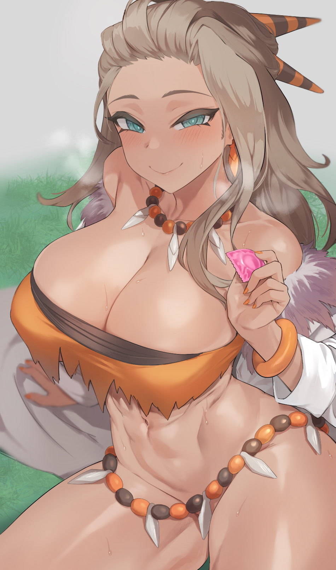

Jason had somehow been transformed into a sexed up version of the new professor from that latest Pokemon game they announced a while ago before the trip, unable to keep his mind off the hot cavewoman tribal design they had going for her. Except the Sada prostrating herself before him on the forest floor with a condom wrapped between her dainty fingers with her wide set hips thrusting in need looked and sounded nothing like what the trailers made her out to be. It was like looking at a porn parody of a video game character people would joke about. But that only served to help answer the question still burning in Todd’s mind:

“The stone…the stone did this to you…”

“What stone, dummy? The one in your pants? It’s totes makin’ me feel all funny!”

Trying not to give in to the urge to lay his hands on a Sadafied Jason, Todd takes a step back as she begins to take action, crawling toward him while giggling madly in that soprano of a voice as he spreads his palm toward her, feeling bad for unwittingly turning his friend into a slutty minx with no control over herself, hoping this thing had a reset button and that he hadn’t inadvertently doomed Jason into becoming a streetside skank for the rest of his life.

“Become Jason Henderson again! Just the way he was a few seconds ago! No ditzy talk or whatever!”

“Tee hee! You talk all funny…oh…now I’m totes feelin’ funny…what…the hell?”

Sure enough, Todd’s suspicions are confirmed as he watches the perverse form of Professor Sada freeze in place before the same ripples that had turned Jason into her begins to swarm her once more, watching as the hot babe slowly morphs back into the familiar form of Jason with all the proper body parts in the right place, coming to as he looks around in confusion, apparently having no memory of his time as Sada; soliciting sexual favours from him and whatever else was running wild in her empty head.

“Todd? What happened to me? Was I crawling on the floor? W-What happened to the stone?!”

“Uh…yeah…about that…promise me you won’t get mad?”

By the time Todd had finished explaining the events that had occurred while Jason was ‘gone’, the sun was beginning to set in the horizon. Before the tranquil rustle of treetops above are interrupted by a bone crunching crack as Jason lands a hard punch over Todd’s left cheek right as he ends off his explanation.

“Arrrgh! Y-Yew pwomised yew wouldn’t hit me!”

“That was before I knew you turned me into some…some street whore! I thought it was just my imagination but I was…I was still feeling things when I…y’know what? Never mind…just forget this all happened…you sure you’ve got that thing under control?”

“Y-Yeah! It’s not acting up for now…and I definitely won’t fool around! Promise!”

Sitting in awkward silence around a clearing free of insects, the two friends remain that way for a good minute or so, with Todd looking like he wanted to say something, only to hesitate and meekly shuffle away. Finally having enough of his back and forth jittering, Jason rises off the grass with a disgruntled sigh, patting himself down before picking up the fishing gear and walking back towards the lodge, leaving Todd alone as he glances down warily at his outstretched palm where the stone had vanished earlier. With all this new power at his command, he’d have to be extra careful with it if he didn’t want anything like what happened earlier to afflict his loved ones.

But a little trickery wouldn’t do anyone harm, right? It wasn’t as if he was going to use it on anyone but himself, and in a way, it could help with mastering the power of the stone. Then there was also the matter of figuring out why his friend seemed so down ever since getting back from college.

Making sure Jason was well out of sight, Todd plants his right hand firmly against his chest. Before taking a deep breath…

**Chapter II - Jason**

Jason had gone to bed uneasy that night, flustered by the strange lingering sensations of the ditz his friend had turned him into; lying restlessly in bed with the thoughts plaguing him ever since the incident in college that resulted in him falling out with his girlfriend no longer bothering him one bit. Unable to feel a thing for the girl he used to fret over non stop.

But that was precisely why James had found it so incredibly unnerving to the point where he could barely get a good night's rest. Fussing over the way he could no longer feel a lick of remorse and self loathing over the girlfriend that had dumped him with the accursed compulsion towards men leftover from the alter ego that had taken him over a few hours ago clouding his judgement. Made worse whenever his thoughts drifted back to Todd, trying his damndest to feel a lick of anger for what he had done to him, only to end up with a raging hard on that lasted until the early hours of dawn, fading away like the retreating darkness of night as day breaks over the mountains.

Left grumpy and tired, Jason slogs through the toilet before remembering to wash up, brushing his teeth and getting a good look at his deep dark eyebags before remembering he had to chop up the firewood for late, grumbling in annoyance while cursing Todd under his breath.

“Wait a second…where did he even go?”

Realising he hadn't seen Todd since he parted ways with him at the forest, worry begins to build in Jason's heart as he hurries out of the toilet, grabbing a fresh change of clothes before hurriedly making a quick exit, catching sight of Todd’s mother by the storage shed.

"Morning ma'am! You haven't seen Todd around now have you? He wasn't at dinner last night either so I'm getting worried."

Frowning in confusion, the middle aged lady shoots Jason a sceptical look before giving him an answer that chills him to the bone. "I suppose you mean Tina? She's down in the forest hunting game for tonight's dinner, peppy girl ought to be thankful she's got a charming man like you looking out for her! You might want to watch your…Jason? Sheesh…kids these days!"

Hurrying down the mountain trail without even waiting to hear the rest of her words, Jason heads off for the forest, praying to God his friend hadn't done anything stupid with that magical rock of his. Whoever this Tina Simmons was, he had no memory of ever meeting her as far as he could remember.

"Goddamnit Todd…i swear if you messed up…stupid kid!"

Trudging hurriedly through the lush green forest, Jason could already see the silhouette of a girl he had never seen before kneeling by a small clearing by the edge of the forest, cursing at the sight of the young lady's ass crack peering through her unbelievably tight shorts, peachy white skin shining radiantly in the sunlight, wearing a strange outfit colored a daring red with dark brown undertones that instantly struck a chord in Jason's head.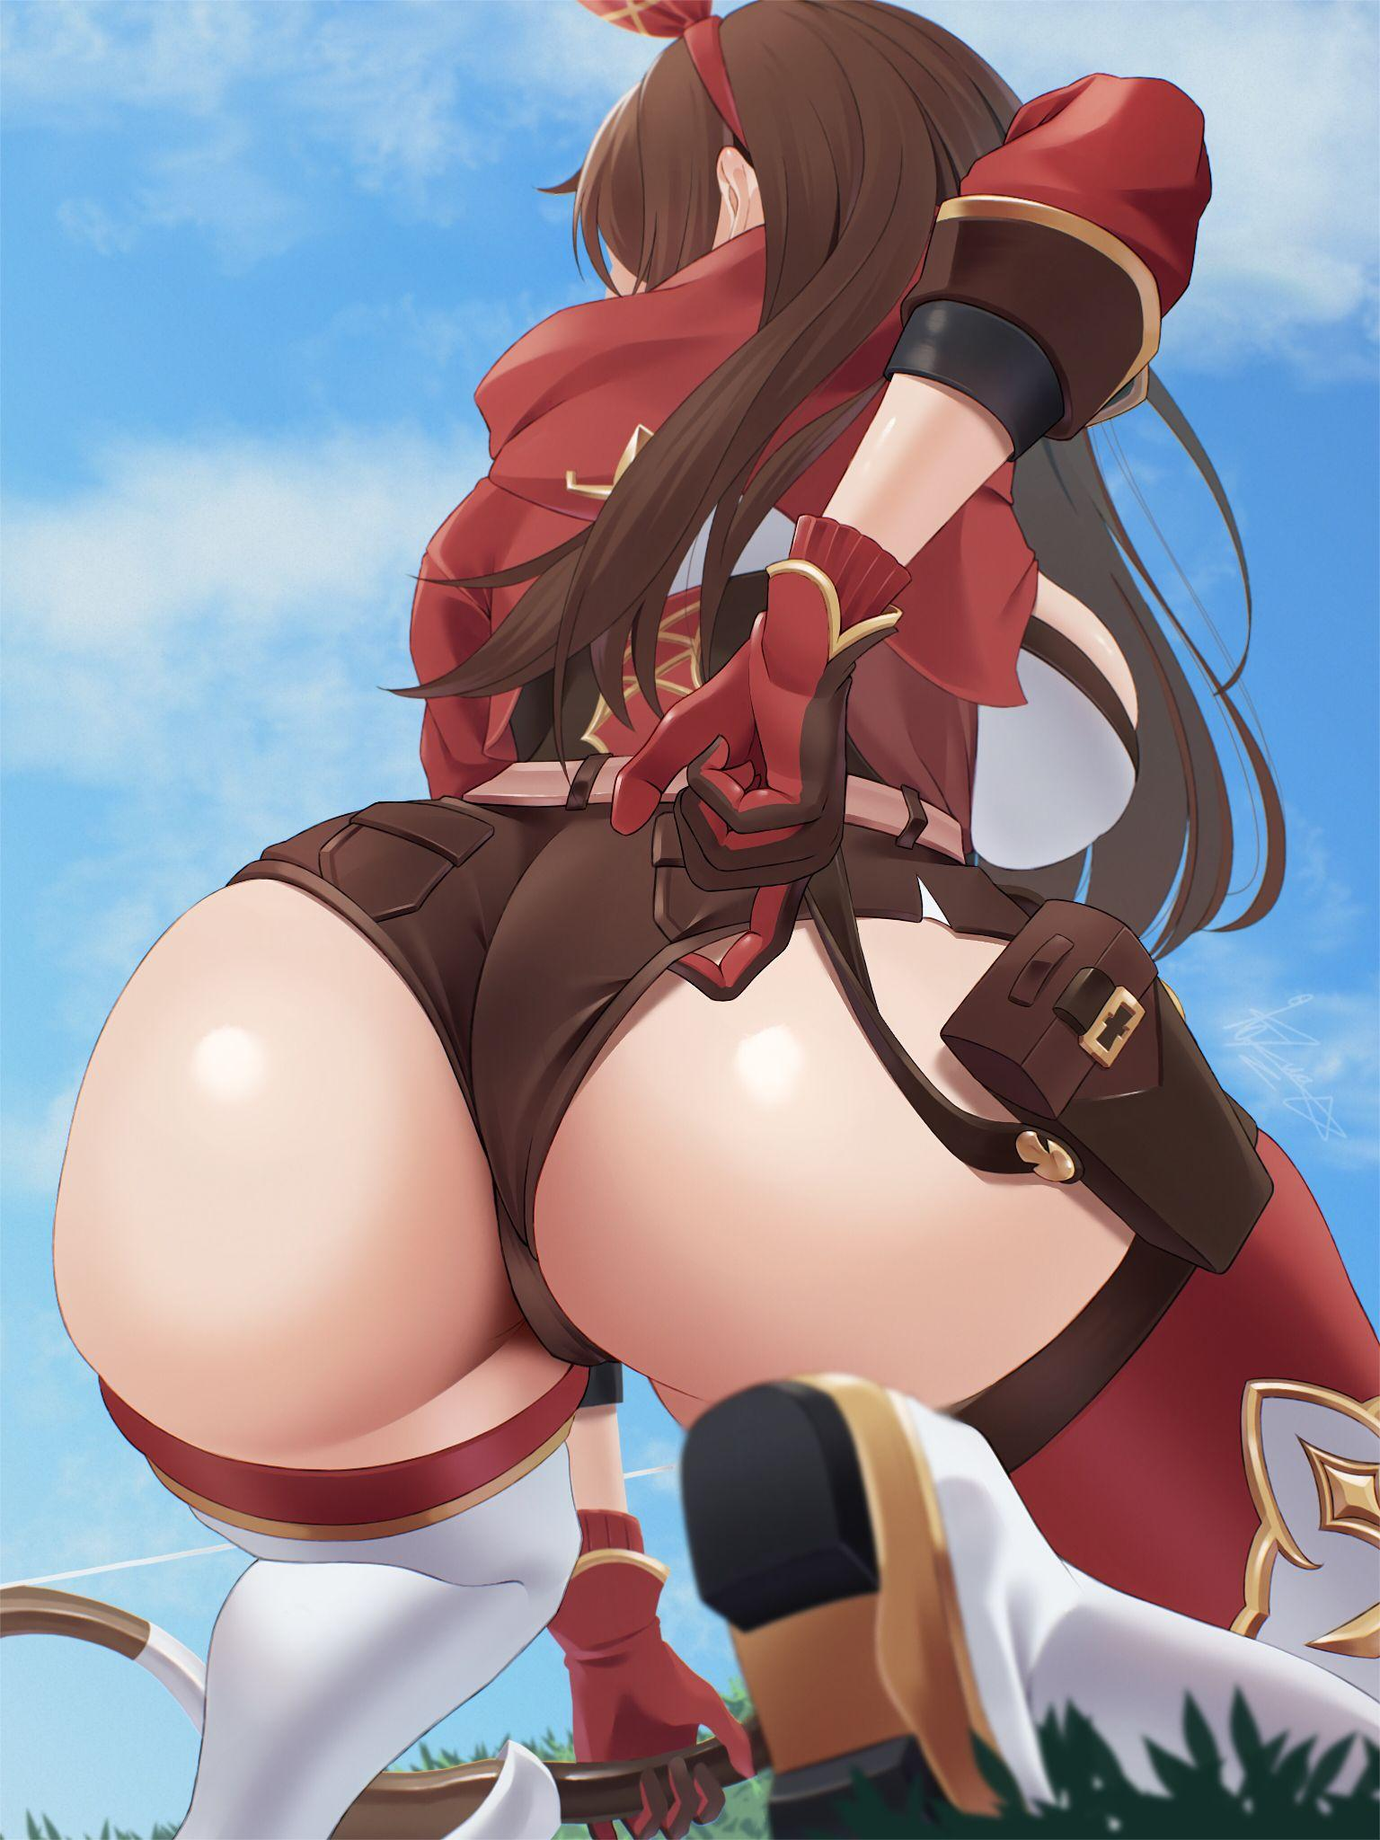

While he wasn't fanatically into gaming like Todd was, only a hermit living underground would fail to recognize the signature getup of the Outrider: Amber from hit video game Genshin Impact…as corny as it was, Jason couldn't deny the lifelike projection of the character kneeling down in the grass in front of him with her rear end waving in the air.

Although he didn't quite remember Amber being this stacked in the short time he played the game during the height of its popularity.

"Good morning *'Tina*'...had fun fooling arou-*mpf!*"

*"Shhh! You'll scare it away!"*

Whatever Todd had done to himself, evidently it was more than just a simple name change, the way he moved barely gave Jason time to react before he found himself laid out flat in the grass with a gloved hand wrapped around his mouth, staring up into his friend, or rather Amber’s, wide orange eyes before she whips back around to face the unwitting boar she seemed to have been tracking in a flurry of brown hair…

“Oh lord…”

*“Shut it!”*

…while giving Jason a show that had his morning wood raging full force as Amber’s globular ass dwarfs the blue sky above, drawing dangerously close as gloved hands reach around for non-existent arrows in a non-existent quiver, fumbling around while mumbling quietly to herself ,almost raising the struggling fabric that was the only thing keeping her snatch concealed. He had to stop her.

“N . O . A . R . R . O . W . S”

Picking up on Jason’s whispers, Amber raises her right arm up to her breast before muttering something under her breath, watching in wonder as a quiver stocked full of steel headed bolts materialises out of thin air, slinging one into her bow before letting loose a shot that flies straight and true, catching the unwitting animal straight in the eyes for a killing blow as it squeals loudly before hitting the ground dead.

“Nice~ I could get used to this! Since you're here and all, wanna follow me back to the lodge? Can't leave this prime catch out to waste after all!"

Disgruntled as he accepts her outstretched hand, Jason sighs before lifting the board on his shoulders despite the fact that Todd, or at least Todd in Amber's body, could easily drag the heavy catch back to the lodge without difficulty.

"Since you're some mighty video game babe…mind…helping out a little?'

"Aww~ That's a no-no James! Asking a frail girl like me to handle the heavy duty stuff…besides, I already did most of the work hunting the thing. Time for you to pull your weight, don’t you think?"

Chortling to herself as she skips off on the path ahead, Jason grumbles to himself as he lugs the massive boar back on his lonesome. Trying to get Todd to fess up all while she dodged his questions with incessant giggling or outright ignoring him entirely.

“Why’re you even doing this anyway? Why all the secrecy?”

“I could ask the same of you! Just zip it and carry the damn thing alright?”

*'The hell is wrong with him today…'*

By the time Jason had made it back, he was a sweaty mess and Todd had taken the chance to slip away once more, vanishing from sight the moment he went inside to notify them of Todd's catch while leaving a little note behind with the simple message of *‘Hide-&-Seek’* scrawled in girly handwriting, careful to use her new moniker of *'Tina'* since everyone besides him had forgotten their lovely little prankster hadn't always been a girl in the first place. Treating Todd as if he'd been born a girl. Which made their implications of a deeper relationship between them all the more uncomfortable with the break up still fresh in Jason's mind. But for now, he had a power hungry friend to catch, hoping to god he wouldn’t do anything drastic until he found him.

"I swear once I find him…he's gonna pay big time!"

**Chapter III - ~~Todd~~ Tina**

Musing silently to herself on the empty couch in the vacant lounge she had ‘convinced’ everyone besides Jason to leave, the naked lady with nothing more than a skimpy bikini top to cover up her nipples with raises her right hand high in the air, adoring the way her manicured nails glimmered in the gentle orange warmth of the nightlight behind her, sighing as she turns her attention to the palm of her hand, where a certain magical stone had fused with her two days ago.

Sighing despondently at the memory of her best friend popping into mind, the woman presses her right hand over her stomach, producing a ripple that alters her alluring figure into a younger, more modestly dressed configuration with a halo floating atop her head with bob cut blue hair tickling her shoulders; the new look she now sported over her old drab male body. While she didn’t have any dislike for her old appearance, being a girl just felt natural now.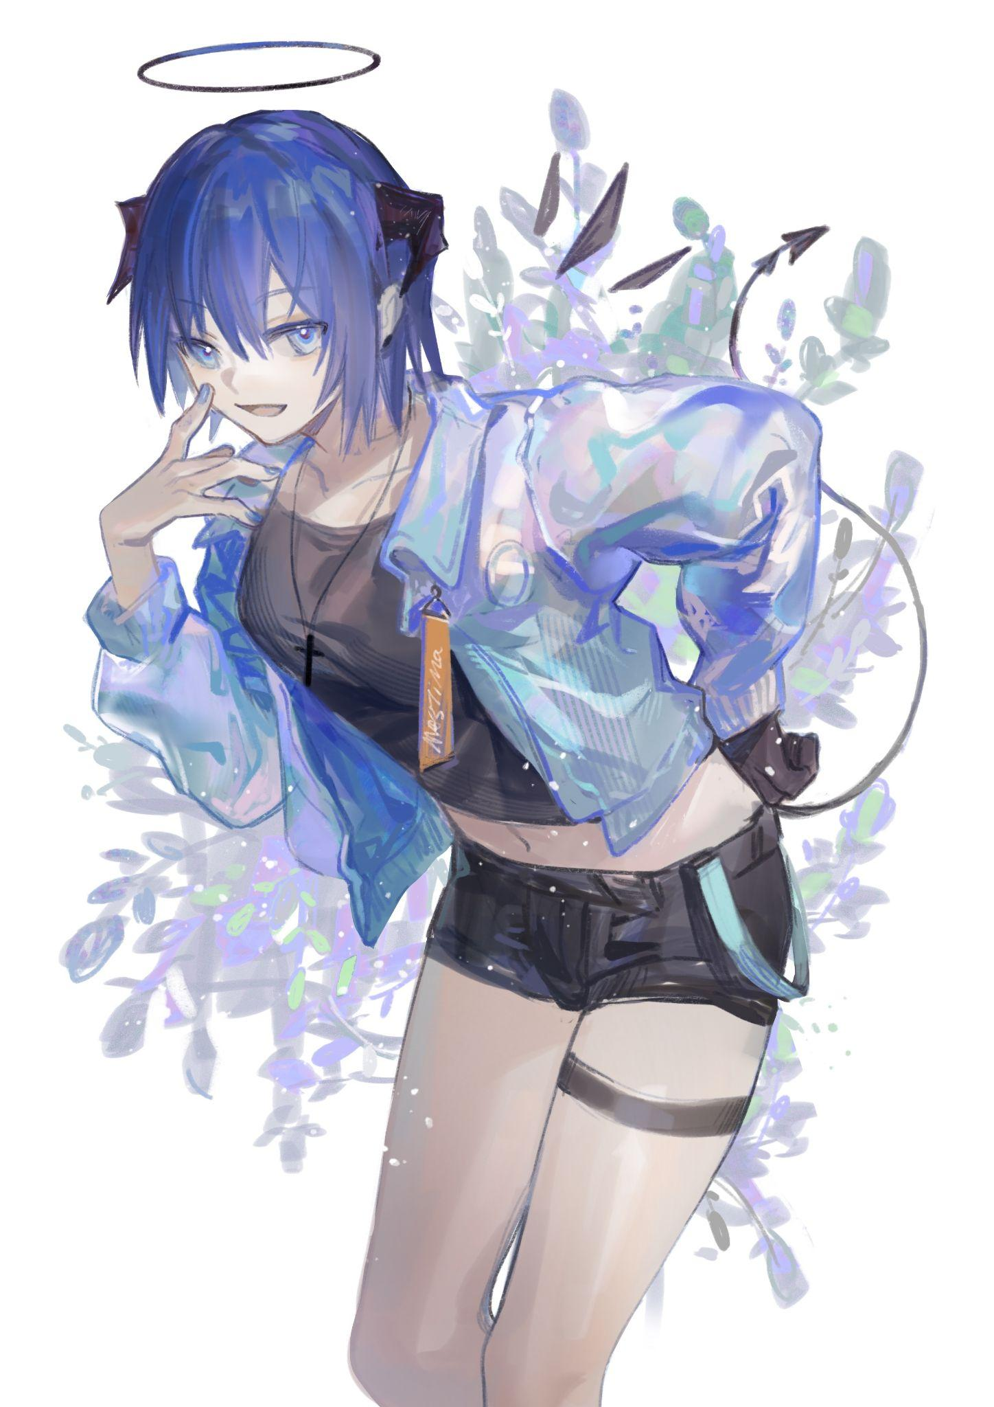

*‘Life’s so simple when you just don't know a damn thing…’*

Two days ago, she had been a simple college student with an interest in game development and a never ending thirst for fresh experiences, but after making what should’ve been the discovery of a lifetime, she had grown bored and aloof. Unbeknownst to her best friend who only perceived the passing of two days, Todd had gone through what felt like weeks all on his own; one could get many things done when all they had to do was press their hands up against themselves and say ‘I can control time.’

With all the time in the world literally to himself, the curious student had begun experimenting with the stone to test it’s full capabilities; turning himself into a girl, turning into fictional characters with access to their full roster of extraordinary powers, bending reality so others perceived him differently and vice versa with other subjects he simply had to point his right hand at before reciting the desired outcome.

But that also meant very dangerous implications for anyone on the receiving end, realising the gravity of his mistake after the first, accidental use of his newfound power on Jason; transforming him into a ditzy bimbofied version of a video game character he simply had in mind since he never specified a specific outcome when it came to appearances. Thankfully, it seemed the changes could be reversed but that wasn’t enough to convince him to go all out without care, not willing to risk permanent alterations on the people he saw as family.

In a nutshell though, it was like a remote…except the container was his arm, the rock; the battery, and the buttons; his very mind. A biological remote with total control over anything and anyone he so desired…not like the idea appealed much to him. If anything, it sounded like the perfect tool to prank people with.

And so he kept practising, testing out transformation after transformation, enjoying the pleasures of the female form until he grew tired of it. But unbeknownst to Todd, small incremental changes were beginning to pile on and on with each transformation. Notably, whenever he took on the full mental and physical changes of more *‘powerful’* characters in fiction; maintaining the stoic persona of Artoria Pendragon, taking on the timid nature of Sylphiette, every single character, fictional or real, was beginning to leave their mark on Todd's psyche.

It didn't help that almost all of his transformations so far had been girls, leaving a very noticeable change when he began to sway his hips with every step, taking on a preference for long hair and the overall feel of the female body; being a boring old boy was nothing compared to it. Before coming to realise he had kept time frozen all this while, resetting everything back to the way it was before heading off to join his friend for dinner. Taking on the form of a blue haired girl that would soon become her go-to body. But besides Jason who knew of her little secret, everyone else would perceive her simply as **Tina Simmons**; eldest daughter in the Simmons household. Never noticing her blue hair or the fact a mystical black halo was floating atop her head alongside a twisted pair of horns, complete with a spade tipped tail swaying behind her.

That was when the idea to pry into Jason's secrets to figure out what was ailing him all this time drifted into mind, assuming the abilities of a character from a well known manga series she knew had the ability to read into a person's life like a book after the idea to ask him was briefly considered before being rejected.

“Not like he’s gonna tell me about it even if I asked~

That was when she came upon the news that Jason had broken up a few weeks before college break started. Only, instead of cracking up like she would have if she knew this was the reason why her friend looked so gloomy all the time, something strange had begun to build within Tina’s chest, stinging unlike anything she had ever felt before as she freezes in place, glancing at the fading figure of Jason as he trudged back toward the lodge off into the trees.

“I can’t be feeling…jealous now can I? But Jason’s my friend…yet he went and got himself a girlfriend without telling me…”

Tina wouldn’t show up for dinner that night, nor would she return to the lodge to rest, unable to focus on anything but the fact that Jason had a girlfriend, the emotions of Todd; the childhood friend and best buddy mixing with the seeds of jealousy and love from Tina; the newborn female alter ego beginning to fuse together, taking her frustrations out in the forest with no one there to witness her uprooting trees and slamming them into ground like giant stakes. Begrudgingly cleaning up her mess by the time the sun rises over the sharp mountain peaks before heading back up to the lodge for some breakfast. Hatching a plan to lead her best friend around on a leash while tormenting him with veiled threats, animosity and a game of Hide-&-Seek she had no plans to act on after treating him to a good show early in the morning to set the stage.

With how worrisome he could be, she knew he'd never be able to rest until he got answers from her. Leaving breadcrumbs ranging from jumpscaring her siblings by masquerading as a masked serial killer to leaving a perfectly forged axe at the blacksmiths forge. Watching from the comfort of the lounge as Jason scurries from place to place looking for her. Coming up short each time. Whether he liked it or not, that was the punishment she had for him. A little nonsensical and vindictive…but that was the best Tina could think of to make Jason face the music with his actions.

Watching through her clairvoyance, a worried look furrows Tina’s brow as a bird’s eye view shows Jason trying to swim out to the middle of the lake where she could see deadly currents just below the waves waiting to sweep the unsuspecting man out into the deep where he’d surely drown. Wasting no time in teleworking to the lake just in time to see his silhouette suddenly vanish under the clear blue water with a splash, gasping in panic before zipping down in the blink of an eye…

**Chapter IV - Reunion**

Jason was at wits end, having scoured the entirety of the lodge, the forge behind it and the forests below, the only places left where he hadn’t yet checked for his friend weas the lake and the mountaintops, which were inaccessible to him unless he had a death wish in mind. Which until a few weeks ago, was true for him. Standing at the edge of the serene lake with a frown on his face.

Two days ago, everything had been normal. But now he regretted ever telling Todd about that pink light considering how he now seemed fully absorbed by the power the stone offered him. Noting slight hints of anger in his, or rather her voice when she’d last spoken to him. Did he do something to offend her?

“Goddamnit Todd…why won’t you just tell me what’s wrong…”

Muttering under his breath, Jason was beginning to come to a realisation that maybe he himself should’ve come clean sooner rather than hold out on those close to him. Thinking back to his relationship with Sarah; the girl he’d fallen in love with at college, he never did reach out to her, keeping his worries bottled up while only ever treating her out on dates and chatting over the phone. To him it felt like a dream come true, to be going out with the girl that had mesmerised him on day one. But to Sarah, it must’ve felt like a superficial relationship, only ever receiving what she saw as blind ‘I Love U’s’ and free meals.

Not too surprising she had broken off the relationship then and there, never knowing how Jason truly felt since neither side had dared or bothered to approach the other about their concerns regarding the strained relationship. But that was something Jason already knew, he’d simply been avoiding that conclusion, thinking it was something else entirely. But with how Todd was treating him now, his reluctance to share his problems must’ve been the issue.

Which begged the question how he found out in the first place…

“Ah hell…asshole has the power to bend reality…who am I kidding…”

Moving towards the lapping shoreline of the lake, Jason strips down to his underwear, shivering at how cold the water was as it soon goes up to his calves until eventually encapsulating him entirely as he pushes off the mud, swimming out to the middle in the hopes that maybe Todd was there hiding out just underneath the surface as unlikely as it sounded.

If he wasn’t there either, then he’d just go back to the lodge and wait it out until he eventually decided to crawl out of hiding. Hide-&-Seek or not, he wasn’t going to play this game of his forever.

But unbeknownst to Jason, dangerous riptides were storming away just beneath the surface of the water bordering the shoreline, waiting to take him on a one way ride down to the inky depths near the middle of the vast lake with his flailing feet only narrowly missing the hidden deathtraps deadly influence. But sooner or later, he’d fall for it.

And with his feet dipping down the water surface just a fraction deeper than it usually would have, the flowing current ensnares him, surprising the young man and pulling him under mid stroke, panicking as he finds himself pulled along by the invisible hand of mother nature to the murky depths of his watery tomb as his panic-induced screams sends water flooding into his lungs, wasting precious time and energy fighting against the riptide until eventually, his resistance fades entirely.

In the last moments of his fading vision as he rapidly descends to the lakebed scattering fish in his wake, the blurred silhouette of a woman breaks the water surface, swimming down toward him with her arms outstretched, cyan blue eyes filled with worry and relief as she cradles him in her arms with the warmth of her body breaking through the ice cold snare of Jason’s watery blanket. Combined with the halo floating atop her head and the tiny stones forming the shape of a wing on her back, Jason leans into the hallucinations arms; an angel there to accompany him in his final moments.

But just before he blacks out entirely, Jason wasn’t sure if he heard the beautiful maiden from heaven call him an idiot…

“Ughh…my head…shit, that's right, i was drowning wasn’ I?”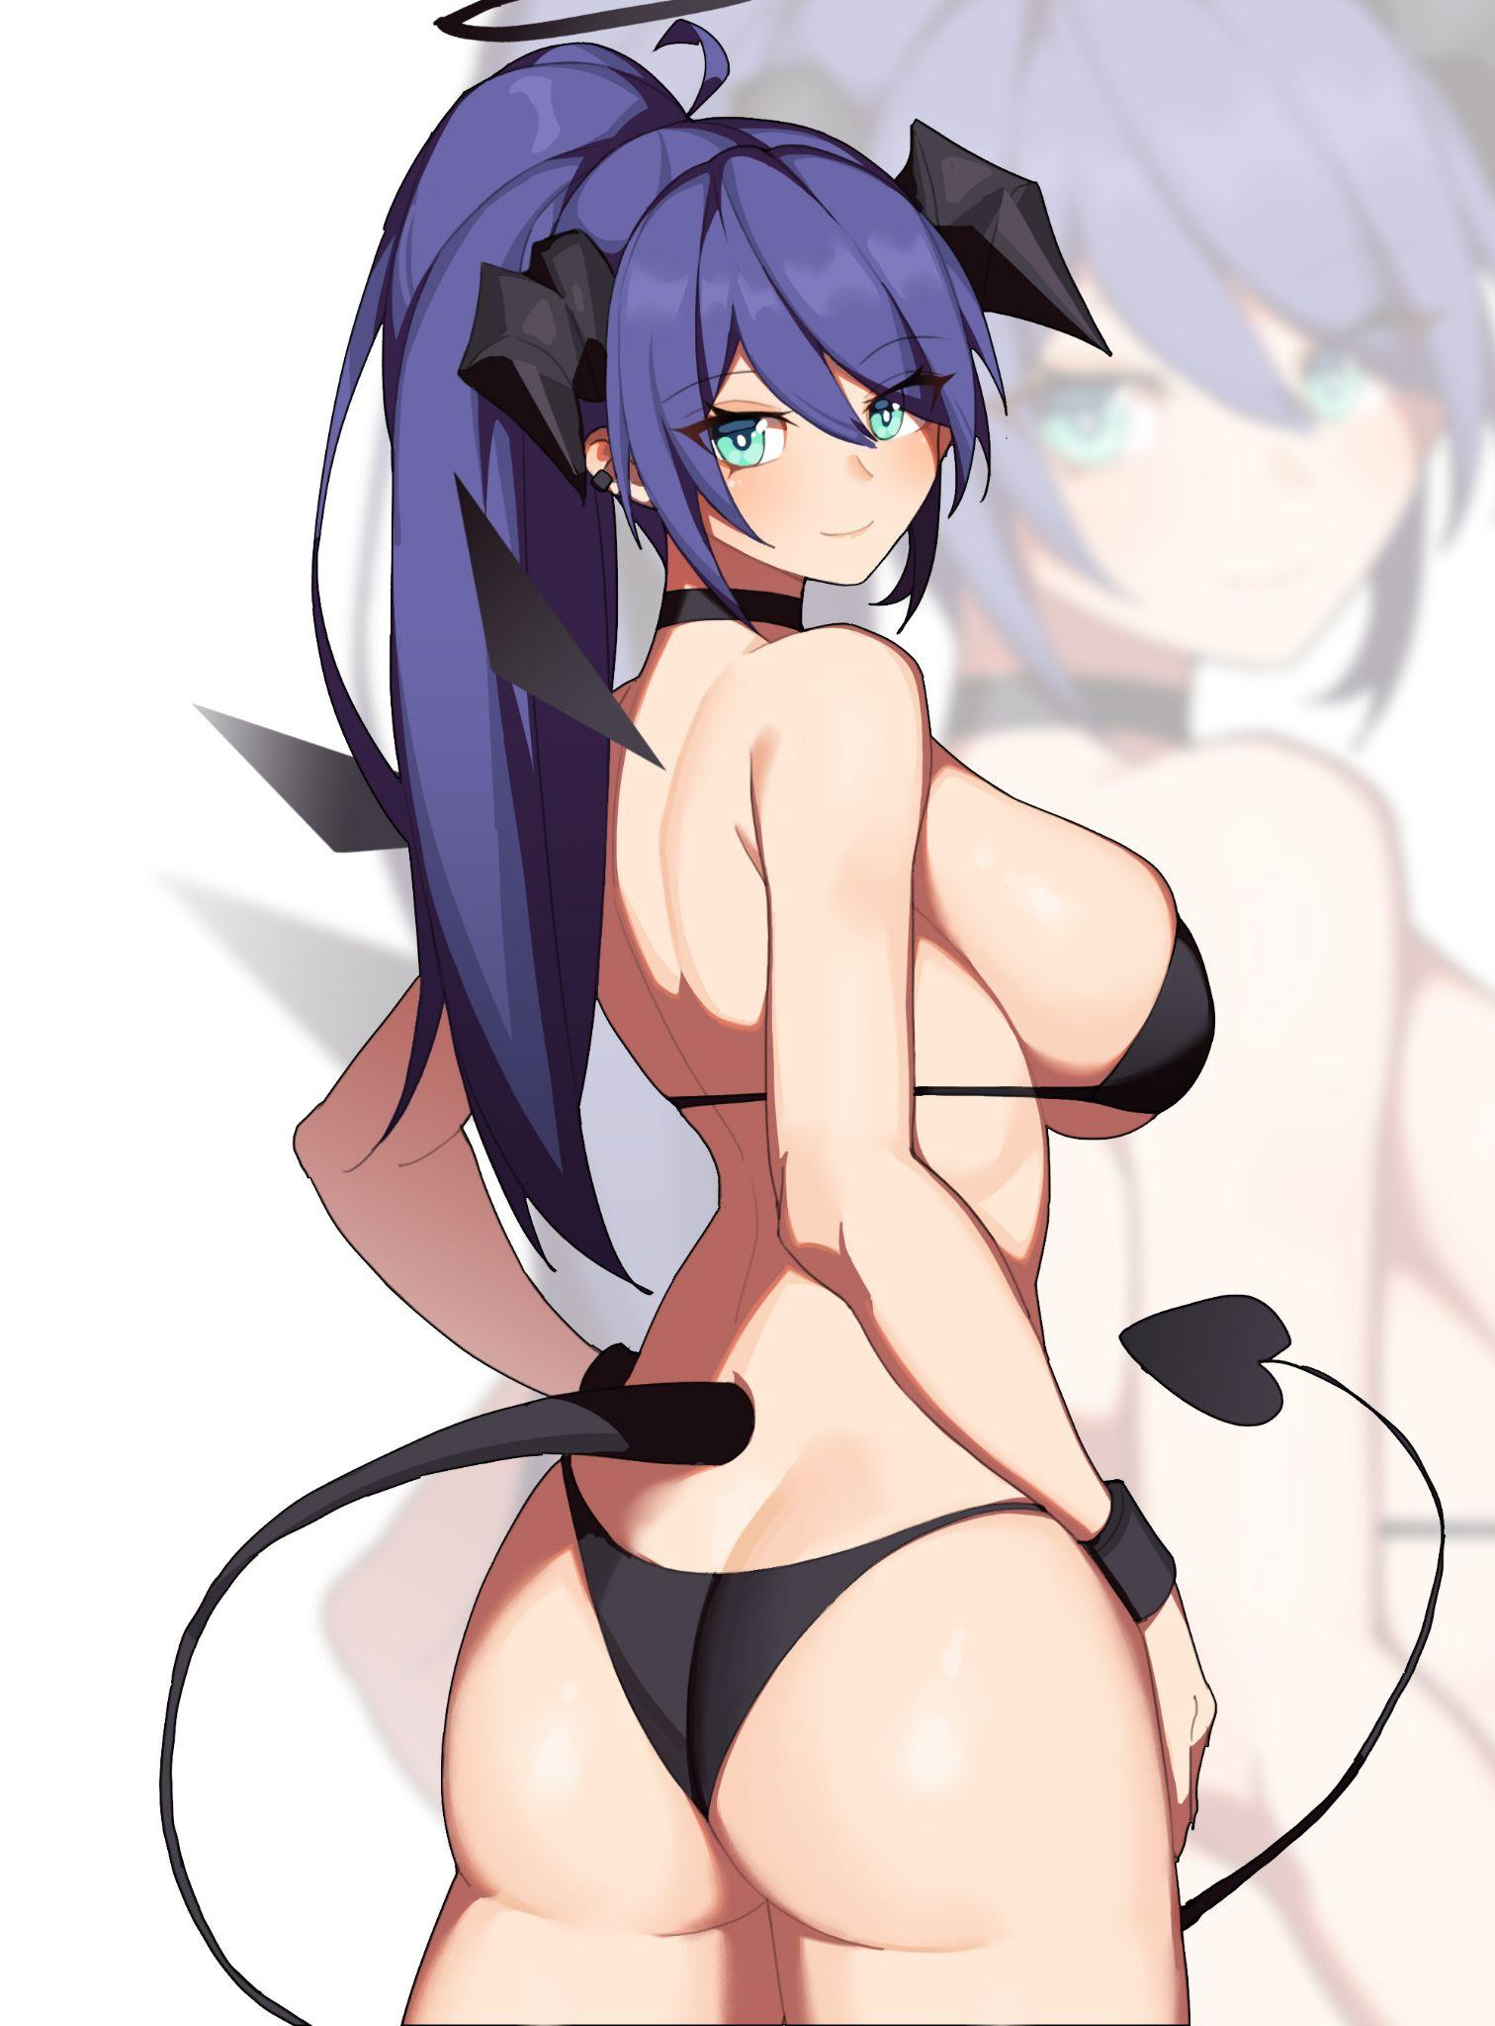

Stretching his limbs before realising he was back on the sandy shores of the lake, Jason rights himself as he gets to his feet, feeling like he’d taken a nap instead of experiencing a near death situation. Walking around in his soaking wet underwear to figure out what had happened, deciphering the last few moments he could remember before he fainted as he gazed out once more at the crystalline surface of the lake that had almost claimed him, spotting someone else swimming near the shoreline.

It was a beautiful young woman, probably the same age as he was, with a lustrous head of blue hair tied up into a ponytail with a voluptuous figure clad in a string bikini that would leave most girls burning with envy. A cool, mesmerising visage framed by devilish horns with an angelic halo atop her head.

*‘Beautiful…’*

As soon as the words drifted into Jason’s mind though, the blue haired woman instantly turns for the shoreline, swimming rapidly back towards him "before rising out of the waters with her killer body on full display, sashaying towards him with her slender arms running through her soaked hair, a smile on her face as she draws closer until eventually, standing right before Jason in an awkward stance with neither of them unsure of what to say to the other. Jason unwilling to look at his friend's buxom new body and Tina…with a look of remorse on her pretty face.

“Nice body huh?”

“O-oh! Y-Yeah…I like being a girl so…this is…*me*…now…”

With the bravado in her villainess act from earlier all but annihilated, the pair remain in awkward silence for another minute or so before eventually, Jason sighs, taking a seat by Tina’s legs until she takes the hint, hesitantly seating herself a comfortable distance away from him. Fidgeting with her hands with her lips curled inward, gnawing on them in frustration.

“Thanks…for saving me back there…”

“D-Don’t say that! I should be apologising…I didn’t mean to…*\*hic\**...I didnt wanna…”

“Todd…It’s not your fault…I’ve been hiding stuff from you too…and that stone. It’s messing with your head, you need to stop using it!”

'W-What does the stone have to do with all this?!"

"Do you even hear yourself? Whatever it is you think you’re feeling it’s all fa-"

Hearing that, Tina growls in a mix of anger and frustration before pinning Jason to the sandy ground, mounting him in one swift movement while keeping his arms pinned with her unnaturally strong arms. Her face; a teary mess mixed with the fury of a lady scorned.

"So what if I'm a girl now, huh?! You couldn't even come clean with Sarah! And you think you can lecture me about a stone? You massive idiot!"

"It's my own damn problem not yours! And since when did you get to peek up my secrets without my permission?!”

“Because you weren’t ever going to tell me! How am I supposed to do anything if you never say anything?!”

Before Jason could think up of another retort, Tina breaks down into silent sobbing with her arms freeing Jason to wipe away the flow of tears dripping onto Jason’s chest, slowly rising off the sand with a sigh before gingerly shifting Tina around to cradle her in a comforting hug, cursing himself mentally and wondering how things had gone this far down south with an assuring hand over the head of the girl he whose heart he had broken.

After a few tense minutes of bawling followed up by silent snivelling, Tina had fallen silent, shivering every so often in Jason’s arms, looking down at reddened eyes looking even more regretful than they had been earlier.

“Look…Tina, I'm sorry…I just didn't know you were being serious…that thing you pulled with our parents? Are you-"

“Dont…just…dont talk about it anymore…alright? Let’s just forget about all that and…move on.”

Growing slightly saddened at his friend starting to shy away, Jason instead presses onward, leaning over to face Tina down as she averts her gaze, a slight look of disbelief on her face. He wasn't going to let another Sasha happen again.

"W-What're you staring so hard for?"

"Does that mean you don't have feelings for me? Making ma and pa think we were dating wasn’t intentional?"

He knew he'd struck a nerve when he felt her jolt a little at that remark, curling into an even smaller ball in his arms while landing a gentle kick to his shin; he was right on the money.

"Well…not really…"

*"Really?"*

As awkward as it was to essentially be flirting with his best friend, he had to remember that while he didn't see Todd, or rather Tina, as a true blue girl yet, whatever she had done with the stone had essentially left her female enough to go this far in punishing him for meeting up with and then losing Sarah.

Which made him wonder what she would've done if Sarah was still his girlfriend and the pity from Todd wasn't around to temper the wrath of a jealous girl. Drawing his attention back to reality though, James holds his breath as Tina sighs in defeat, rolling around so she ends up facing her friend with a bashful smile on her face, grazing his forearm with her spiny horns and pressing her pillowy breasts up against his chest.

“Took you this long to notice, huh?”

“Since when did you become so…”

Giggling as she slides her body up over Jason's burly chest, Tina wraps her soft slender arms around his neck while lying down comfortably across his lap. Wiping down her blurry eyes before raising her right hand in the air, flexing dainty digits that catch the glow of the setting sun.

“...Gorgeous? Let’s just say i've had all the time in the world~”

Over the next two hours, the pair would remain cuddled together as the warm sun eventually crests back under the horizon, paving the way for a cold evening sky, breaking the tranquil silence every now and then with small bouts of conversation with the two best friends unsure of how to proceed with things as they were.

But a hormonal young man with a scantily clad girl in his arms was bound to slip up and give in to his urges eventually, finding himself going from tracing her hair in a gentle pat to running his hands over her shoulders, down her smooth neckline and eventually caressing a breast. With Tina arching her spine before letting loose an airy gasp at the sudden sensation of Jason’s hand roaming over her sensitive bosom.

“Hey…Tina?”

“Mmmf! W-What is it?”

“Do you really…love me? Like, this isn’t the stone talking? It really is…you?”

Leaning forward, the dexterous figure of the blue haired maiden stretches her neck in an erotic arch, locking lips with Jason as she pushes him with her fully weight, collapsing sideways into the sand with her hands planted firmly atop his chest, pulling away with a lengthy bridge of saliva hanging between their lips.

“I’ve been your friend, your brother…we’ve known each other since we were kids! What did you think was gonna happen once I became a girl?”

And as she said the last words in a cheeky tone with her groin nudging suggestively against the tent in James boxers, Tina grabs his arms before planting them firmly atop her supple hips, smiling as she feels his hesitant grip tighten, staring into his Jason with burning passion in her crystal blue eyes.

“I won't force you if you don’t wanna do-*mpff!*”

Another kiss, this time from Jason, and that was all Tina needed for an answer, gently undoing the tight boxers holding back her lovers giant member before pulling down the string bikini around her waist, grinding her uncovered sopping wet snatch against Jason’s erect pecker, gripping his chiselled face in her hands as she wraps her tongue around his in full acceptance, exchanging saliva while moaning her love for him until finally, the heated couple parts, panting heavily with Jason having secretly undone the straps to Tina’s top, leaving her perky breasts on full display, his hands now firmly wrapped around her supple hips in determination.

“I…I know it’s not my place to say this…but I-”

“You’re not Sarah, and you don’t have to be…Todd…Tina…whatever you call yourself…just be you. If you’ll have me…then I’ll gladly be with you…should’a said so earlier…”

“You….Hah ha! You dummy…I-woahh! Wait, Jason wai-kyaahn!”

Raising Tina up in the air, her newly crowned boyfriend sends her crashing down on his waiting member, impaling her over his heated rod with her abdominal muscles instantly clenching down around the pulsing dick now stuffed deep inside the wanting vagina. Arching her back with a cockeyed face twisted in lust, tongue lolling in the air as her pleasured cries end off in startled moans with a healthy release of slick fluid coating Jason’s chest. But the night was young and they were just getting started…

By the time Tina was able to free herself from Jason’s lust, the poor girl had collapsed onto her side with a copious amount of semen flowing freely out from between her legs, twitching and gasping in a sweaty mess on the beach with her flexible tail curled up into a ball like a millipede, afraid of unfurling in fear of Jason’s itchy hands. Rolling over with his non-existent lower half flopping over, Jason lays a hand under Tina’s head to give her something to lie on, both of them unable to move an inch further as they begin to drift off to sleep next to each other’s arms.

**Epilogue**

The remaining few days at the camp would be a jovial one for Jason and Tina as the pair spent their rest of the vacation hanging out together, with Tina eventually coming to use the magical stone embedded in her right hand one last time to ensure the world saw her as a simple girl without the more fantastical elements that only Jason; her boyfriend could see and make use of whenever the time came for sexy time together; one of many new additions to their daily routine together.

Having gotten over his breakup with Sarah to some extent and with Tina there to comfort him, Jason's mind was put more or less at ease,but with how fast Todd had become Tina and in turn; from best friend to girlfriend, Jason still felt weird calling her by her new name and how touchy feely she was around him. But even that would soon fade with the more time he spent around her, coming to think of Tina as a female Todd which she very much was…*a very beautiful and sprightly female version of Todd.*

It didn't help that she looked drop dead gorgeous as well. Not like either of them were complaining.

When the time finally came for them to go their separate ways with the end of the holiday break with Tina accompanying Jason to the taxi stand however, Tina didn’t seem too sad to see Jason go, reminding him why with a simple wave of her right hand.

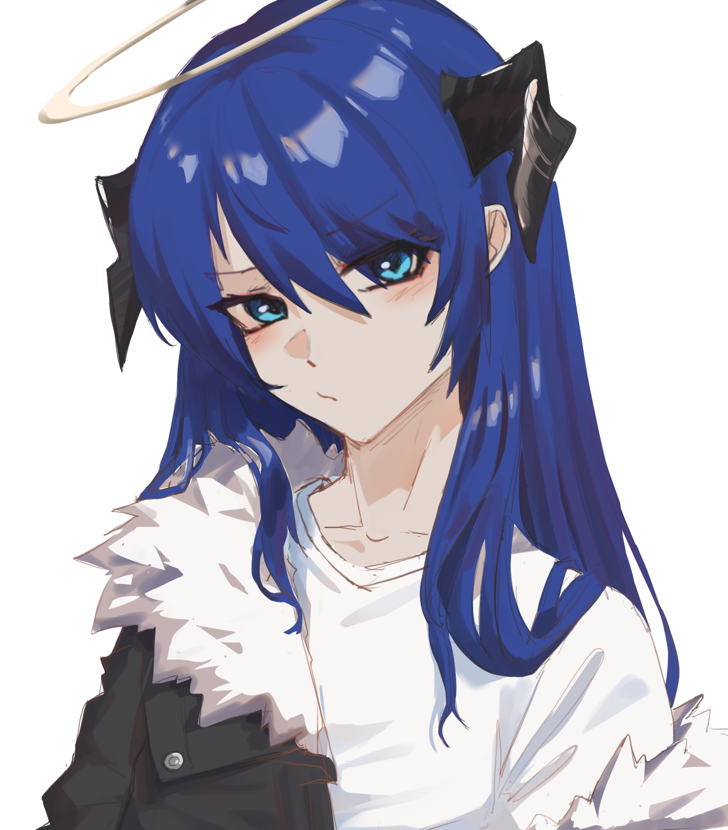

"I still feel like we should get that checked out Tina…what if it starts acting up in the future?"

"You worry too much! Isn't it good news anyway? Instant girlfriend whenever you start feeling a lil lonely~ Besides, who’ll actually believe us?"

“Speaking of instant…wanna take a picture?”

“Hmm, why not? Whenever you're ready then!"

"Alright then…love you babe."

"Mm! You cheat!"

***THE END***