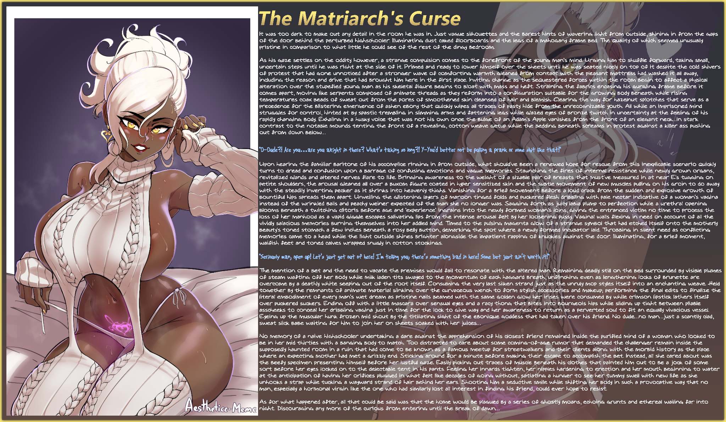

It was too dark to make out any detail in the room he was in. Just vague silhouettes and the barest hints of wavering light from outside, shining in from the gaps of the door behind the perturbed highschooler. Illuminating dust caked floorboards and the legs of a mahogany frame bed. The quality of which seemed unusually pristine in comparison to what little he could see of the rest of the dingy bedroom.

As his gaze settles on the oddity however, a strange compulsion comes to the forefront of the young man's mind. Urging him to shuffle forward, taking small, uncertain steps until he was right at the side of it. Primed and ready to lower himself over the sheets until he was seated nicely on top of it despite the cold shivers of protest that had gone unnoticed after a stronger wave of comforting warmth gleaned from contact with the pleasant mattress had washed it all away, including the reason and drive that had brought him here in the first place. Inviting change as the sequestered forces within the room begin to affect a physical alteration over the stupefied young man as his skeletal figure begins to bloat with mass and heft. Straining the fabrics encasing his gurgling frame before it comes apart, moving like serpents composed of animate threads as they reform into a configuration suitable for the growing body beneath while rising temperatures coax beads of sweat out from the pores of smoothened skin cleansed of hair and blemish. Clearing the way for hazelnut splotches that serve as a precedence for the blistering emergence of ashen ebony that quickly wipes all traces of pasty hide from the unrecognizable youth. All while an imprisoned mind struggles for control, hinted at by spastic trembling in slimming arms and fattening legs while glazed eyes of bronze twitch in uncertainty at the feeling of his rapidly changing body. Exhaling in a husky voice that was not his own once the bulge of an Adam's Apple vanishes from the front of an elegant neck…in stark contrast to the notable mounds tenting the front of a revealing, cotton weave getup while the bedding beneath screams in protest against a killer ass pushing out from down below…

**"D-Dude?! Are you…are you alright in there? What's taking so long?! Y-You'd better not be pulling a prank or some shit like that!"**

Upon hearing the familiar baritone of his accomplice ringing in from outside, what should've been a renewed hope for rescue from this inexplicable scenario quickly turns to dread and confusion upon a barrage of confusing emotions and vague memories. Staunching the fires of internal resistance while newly grown organs, revitalized glands and altered nerves flare to life. Bringing awareness to the weight of a sizable pair of breasts that must've measured in at near E's tugging on petite shoulders, the arousal gleaned all over a buxom figure coated in hyper sensitized skin and the subtle movement of new muscles pulling on his groin to do away with the steadily inverting pecker as it shrinks into heavenly thighs. Vanishing for a brief movement before a loud crack from the sudden and explosive growth of bountiful hips spreads them apart. Unveiling the glistening layers of maroon tinged folds and puckered flesh dribbling with pale nectar indicative of a woman's vagina instead of the wrinkled balls and peachy weiner expected of the man *she* no longer was. Sagging forth as juicy labia plump to perfection while a urethral opening blooms beneath a twitching clitoris before age and 'experience' ingrains into the newly formed woman's loins, giving the entranced victim no time to process the loss of her manhood as a vapid giggle escapes salivating lips from the intense arousal felt by her loosening pussy. Vaginal walls flexing in need on account of all the vividly *salacious* memories burning themselves into her addled mind. Timed to the pulsing magenta glow of a strange symbol that had etched itself onto the motherly beauty's toned stomach a few inches beneath a rosy belly button, demarking the spot where a newly formed incubator laid. Throbbing in silent need as conflicting memories came to a head while the light outside shines brighter alongside the impatient rapping of knuckles against the door. Illuminating, for a brief moment, waifish feet and toned calves wrapped snugly in cotton stockings.

**"Seriously man, open up! Let's just get out of here! I'm telling you; there’s something *bad* in here! Some bet just ain't worth it!"**

The mention of a bet and the need to vacate the premises would fail to resonate with the altered man. Remaining deadly still on the bed surrounded by visible plumes of steam wafting off her body while milk laden tits swayed to the momentum of each haggard breath, unflinching even as lengthening locks of brunette are overcome by a deathly white seeping out of the root itself. Consuming the very last silken strand just as the unruly mop styles itself into an enchanting weave. Held together by the remnants of animate material slinking over the curvaceous wench to form stylish accessories and makeup; performing the final edits to finalize the literal embodiment of every man's wet dream as pristine nails beamed with the same golden glow her irises were consumed by while crimson lipstick lathers itself over puckered suckers. Ending off with a little mascara over sensual eyes and a racy thong that bites into bourgeois hips while sliding up tight between pliable asscheeks to conceal her dribbling vagina just in time for the lock to give way and her awareness to return as a perverted soul to fit an equally vivacious vessel. Eyeing up the muscular hunk frozen mid shout by the titillating sight of the ebonique goddess that had taken over his friend. No dude…no man…just a scantily clad, sweat slick babe waiting for him to join her on sheets soaked with her juices…

No memory of a naive highschooler undertaking a dare against the apprehension of his closest friend remained inside the purified mind of a woman who looked to be in her mid thirties with a banging body to match. Too distracted to care about some coming-of-age rumor that demanded the challenger remain inside the supposedly haunted room in a ruin that had come to be known as a famous meetup for streetwalkers and their clients along with the morbid history as the place where an expecting mother had met a grizzly end. Sticking around for a minute before making their escape to accomplish the bet. Instead, all she cared about was the beefy specimen presenting himself before her lustful gaze. Easily picking out traces of muscle beneath his clothes that painted him out to be a jock of some sort before her eyes locked on to the delectable tent in his pants. Feeling her innards tighten, her nipples hardening to erection and her mouth beginning to water at the anticipation of having her orifices plugged in what felt like decades of going without, satiating a hunger to see her tummy swell with new life as she unhooks a strap while tucking a wayward strand of hair behind her ears. Shooting him a seductive smile while shifting her body in such a provocative way that no man, especially a hormonal virgin like the one who had similarly lost all interest in finding his friend, could ever hope to resist.

As for what happened after, all that could be said was that the home would be plagued by a series of ghostly moans, echoing grunts and ethereal wailing far into night. Discouraging any more of the curious from entering until the break of dawn…

Images by AesthethiccMeme : <https://www.pixiv.net/en/users/34090973>