The Gashapon

*Finch* had always thought himself the odd one out, a loner never meant to fit in with any crowd. Born to a family where both parents hailed from different countries, it didn't help much to change the boys outlook when the schools Finch were sent to all had terrible moderators when it came to discipline and maintaining a 'healthy learning environment'. And in a Japanese school, keeping one's name hidden from the class was a hard thing to do when greetings were an expected courtesy.

While his last name was that of a local, his father, out of respect and admiration for his wife, had left the task of naming their boy. Deciding on the name he now used on its own without any surname because she found his crying oddly song-like when he was but a babe in her arms.

Things however, did not go well for Finch during most of his early years. Bullying aside, things at home were beginning to go bad. With the onset of a recent pandemic and then some global dispute that further worsened things in a matter Finch was still too young to understand, his father's business was beginning to go topsy turvy, and as a result, squabbles between Finch's parents would begin to become a common occurrence around the house, all while the poor boy was left alone, wondering why mommy and daddy kept screaming and shouting, wondering…if he was somehow at fault.

Finch would never get the chance to experience the life of a normal boy. A divorce that would shatter the once lively home after allegations that his father had been dealing with shady loan sharks from the unsavory yakuza, bringing hell upon the family when debt collectors began showing up to harass them all. Combined with the shame of it all, and the refusal of her family to see their daughter wedded to a lowlife (whom they saw as inferior due to racial stigma), Finch had been left in the care of his despondent father. Much to his dismay.

The proceeding years after that were tumultuous and dark. Without a parental figure to lean on or guide him, Finch's once innocent mind would begin to turn dark and brooding, and without anywhere or anyone to turn to. A then teenaged Finch would go to the one place his mother always warned him about when he was a boy. Abandoning his father in their now rundown apartment with months of unpaid rent weighing it down.

Fast forward to the current day, and Finch had already become a seasoned member operating under one of the many street gangs that worked in secrecy today thanks to the country's shifted perception on the Yakuza, the same group of people his father had dealt with for loans, although he couldn't blame them, he spited his old man for even making the deal in the first place. And the way he treated his mother still burned fresh in mind everyday.

But even amongst a new, more accepting crowd of thugs and ruffians with an emphasis on familial ties, Finch still saw no success when it came to integrating himself into a group. Socially stunted, emotionally broken and razor focused on whatever his bosses needed him to do, Finch had instead become a well known name in his circle for being so proficient and successful despite his junior status.

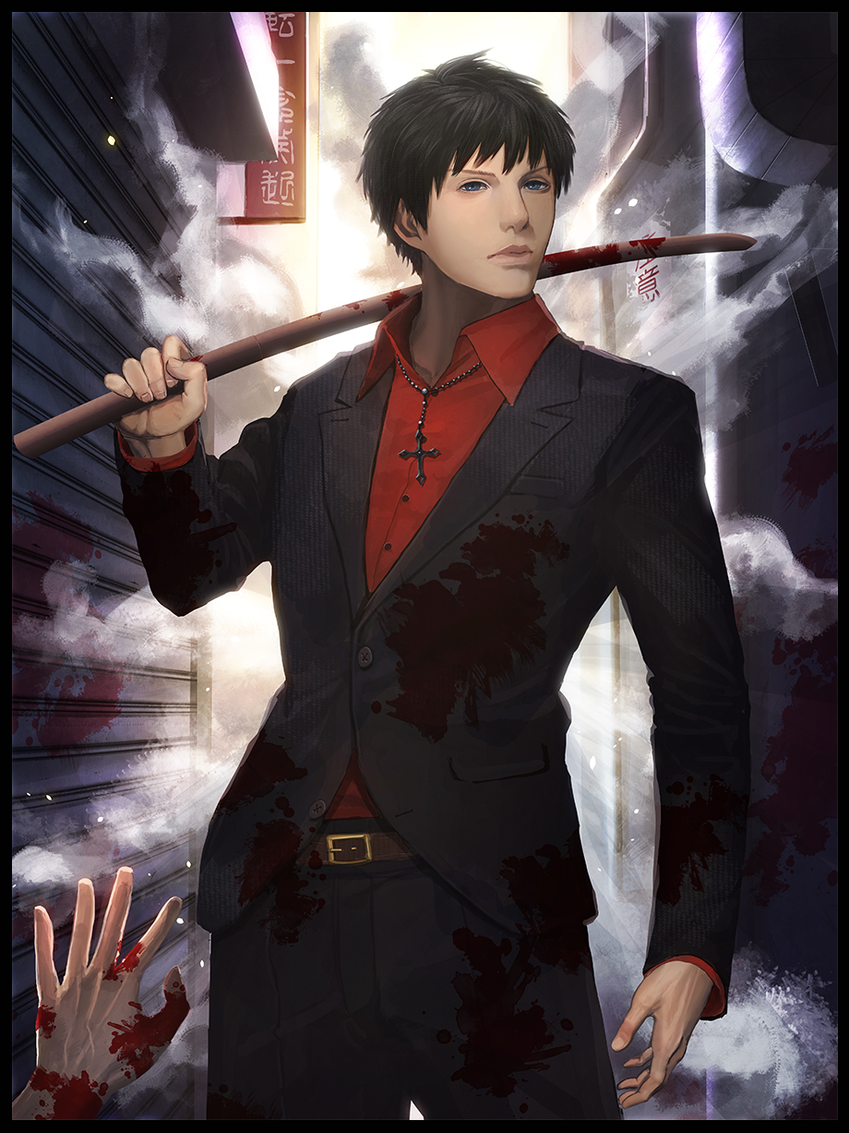

Most suspected him to be just another overambitious newbie who would most likely either lose steam or get caught up in the authorities. But all the man wanted was to find a place he could really feel…'at home' in. He'd been a goody two shoes, he tangled with the wrong side of the law, and neither path seemed a fit for him. If it weren't for the pay, Finch would have already left long ago.

When he wasn't 'working', Finch was either lounging around in a small poxy flat he'd rented or taking a walk through the less explored streets of Tokyo's alleyways or the much more serene countryside where the hustle of daily life couldn't reach him. And it was on one of these walls where Finch would soon come across something with the power to change his life forever…but not without a little game of chance before said change could ultimately be decided.

Moving silently down an empty street lined with closed shophouses and derelict lots in an unspecified locale, Finch was simply minding his own business as usual until his eyes come across an oddity on the quiet path ahead, something that shouldn't be there…or rather, had been installed at the wrong place altogether.

It was a gashapon machine, the sort children would spend about a hundred yen on per attempt in an effort to obtain their favorite figurines. Except this machine didn't seem to have any distinct images detailing its contents. Only the words 'Roll For Life' in Japanese were plastered in bold over the plastic casing.

A firm shake was all Finch needed to know that the thing did indeed contain capsules ready for dispensation. And despite not having any visible extensions for wires, the machine was functional, probably running on batteries or something, not like it mattered to Finch as he rifles through his pockets before extracting his wallet.

He would take a gander, not like it would cost him much at all. From what he could see, each try would cost him the standard fee of a hundred yen, chump change for him. He could probably buy up all the contents within if he wanted to…but that remained to be seen until he saw what he was in for.

Something about the machine seemed strange, enthralling even. Maybe it was the images of the many colored balls beckoning his hand forward as he takes a knee, lowering himself to the ground before slipping a coin into the single slot on its face. But something within him resonated with the plain white construct, anticipation building within as metallic whirrs and clicks resounded from somewhere inside the machines innards before finally, the familiar sound of a capsule bouncing around down a tube could be heard;

*Da-dum…Pong…*

And there it was, a blue sphere with its contents concealed behind a smoky plastic case, rolling around from the impact with the metal plating beneath. Picking it up before twisting the pleasantly matte smooth shell in his hands, Finch frowns at the contents, or rather, a lack thereof inside the split sphere. But maybe there was a catch to it? Like a prize that would be worth all that money spent. Considering how each roll cost a little less than a dollar, that theory was beginning to take root in Finch's usually idle mind.

Trying once again, another coin is fed into the machines bowels, inciting another rhythmic tune of clanking metal and churning mechanisms until that same beat rings out once more;

*Da-dum…Pong…*

This time, the sphere was green and equally as smooth as the first, popping it open revealed nothing once again. Except instead of more wisdom, a brief wave of nausea runs through Finch's mind before passing just as quickly as it had arrived, leaving the man clueless for a second before he returns to fishing out another coin to insert into the machine, oblivious to how his muscular form had been cleansed of tattoos and scars earned over his years serving as a loyal Yakuza stooge. In fact, that sordid history had vanished entirely from Finch's mind.

Instead of breaking storefronts and sitting in on business meetings as an intimidating lapdog, the man remembered a much more serene and respectable lifestyle working as a chef for a well known ramen store in downtown Tokyo, uncaring of the way the creases and calluses earned from years of swinging around sticks and bats were replaced by burn marks and scarring from accidents in the kitchen. And while his quiet, solo nature remained, there was now a traceable timeline of events that saw him through a normal education all the way into a culinary school that earned him his place at a well paying job that allowed him to spend money on past times such as the money sink before him, inserting yet another coin before tapping his knees to the sound of the third capsule falling down;

*Da-dom…Pon…*

His eyes dulled at the sight of pink, holding it up into the sunlight refracting off the eave of the metal plate roof above him before popping it open just like she had done the others. Again, nothing to be had from within yet another capsule, eliciting a soft sigh from tender lips as she changes her position, making sure to keep her knees huddled close together so as to not give any passersby an accidental 'show'. Even though the street was empty, she still took her mother's teachings about a lady's modesty to heart, something she used to despise when she was still in highschool. But now that she was a fully grown woman living on her own, it had her smiling warmly upon the remembrance that also sparked another longing within her.

*'I know you're entering highschool now Finch, but that's all the more reason to be careful about who you talk to or how you demonstrate yourself…and if you ever find that special one…I hope you introduce him to me before you think about doing anything else~'*

**"Hahh…sorry about that Mom…still haven't found you a stepson yet…"**

With a beep from her phone and the sun steadily approaching it's peak overhead, Finch withdraws one last coin from her purse before pocketing the thing back inside her blouse, popping it inside the gashapon machine for one last go, this time humming a catchy tune to go along with the last orb rolling down towards the opening;

**“Hmm, humm..hm~ Oh? これが？” (This is?)**

For a moment, the world comes to a standstill midway through Finch's hurried grappling, prying open the rainbow capsule tinted just a little before it's otherworldly contents wash over her and the surroundings, bleeding out in an effervescent wave that manifests as ripples in the air, distorting the young woman's appearance as her dress morphs into a neatly ironed, form fitting blouse while her leather skirt loses its prestige and designer touch for a more traditional and ordinary pleated design that was standard for the girls uniform set by the local highschool near her home.

While her mature, slightly plump motherly form begins to regress and shrink down into the more slender and petite physique of a young, teenaged girl. High heels compact into polished sneakers while leggings turn into long black socks reaching up to cover toned calves. And while it was a minor setback, her breasts would soon give in to the adjustments, losing their perky D cup status for juvenile B cups nestled comfortably in the cups of a cute pink bra. Fidgeting uncomfortably for a moment as the instinctual memories of having a pecker conflict momentarily with the virgin vagina now hugged tight by cotton panties slung around broad hips, passing easily once the major changes, both physical and mental, finally lock themselves in, returning *Kairi* back into the normal world just outside the front of a convenience store. Stripped completely of the memories stemming from the troubled man she no longer was.

Kairi remained motionless for a good few seconds, staring dumbfounded at the ordinary red gashapon capsule she was holding with a strangely strong grip as evident in the way her knuckles were beginning to grow white. Snapping out of that strange but brief hypnotic spell once a young man's shrill voice bounces into her ears, triggering a switch that sends the young highschooler reeling in mild shock, staring up at a young man dressed in the boys uniform approaching her with a concerned look on his face.

**“カイリちゃん大丈夫？出てくれないから、あれ...ガシャポンかな...？はああなんだお前、子供か？” (You okay there Kairi? You weren't answering so I thought...is that...gashapon? Hah! What are you a kid?)**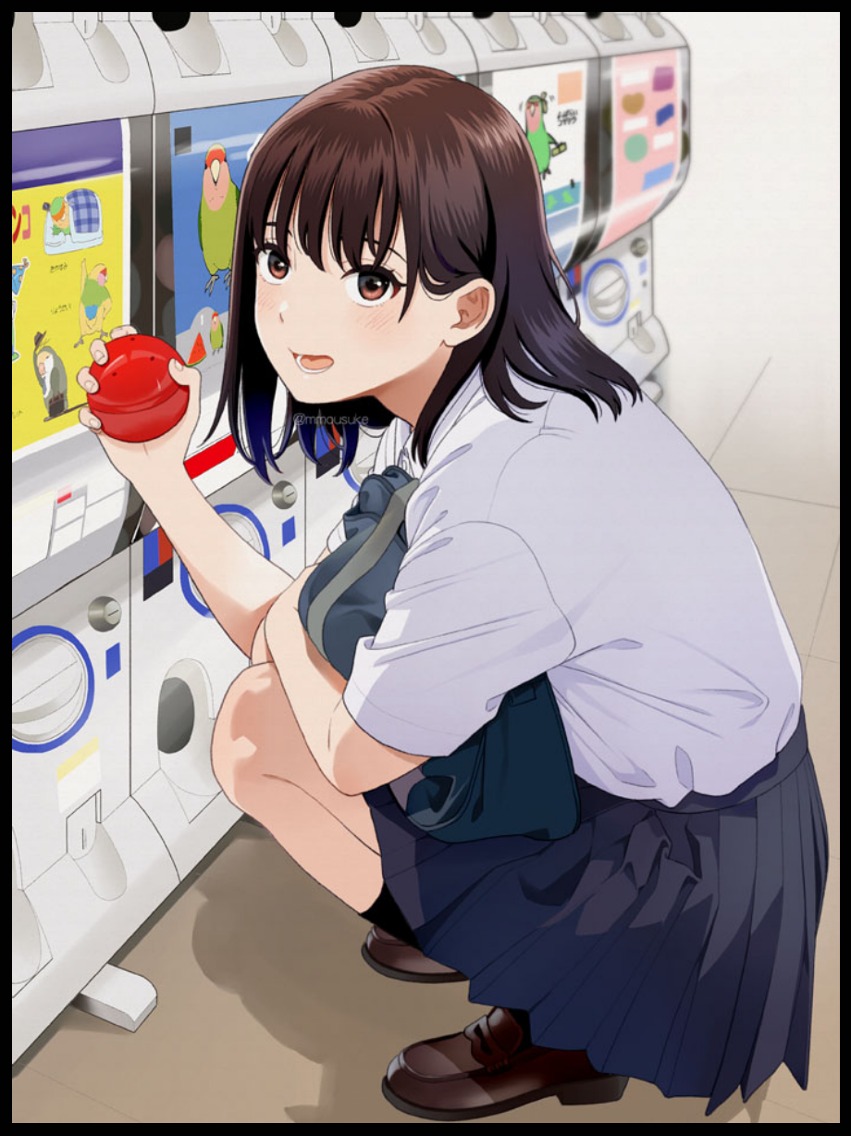

**“ただ、かわいいと思っただけなんですけどね。買って損はないでしょう？ 誠人も欲しい？お揃いだもんね~” (I just found it cute alright? No harm in getting one right? Do you want one too? We'd match~)**

**“そう言われると...確かに...ありがとうカイリちゃん...” (Well...when you put it like that...sure I guess...thanks Kairi…)**

**“何か気になることでもあるのか、アイダ？なんか...変な感じ？” (Something bothering you Ida? You sound...strange?)**

Rising up to her feet with a bob to her medium length head of silken oak, Kairi closes the distance between herself and Ida, brushing his short fringe aside to check for a fever, uncaring of the small outburst of chatter coming from somewhere to their left, no doubt from the neighborhood aunties on their way back from grocery shopping.

Instead, she was more focused on the sight of her boyfriend melting in front of her face, clearly not used to having someone of the fairer sex this close to him. She knew he could smell and feel her warmth, she knew how much of a newbie he was when it came to skinship between lovers, and she loved teasing him about it. Despite her mother's warnings, Kairi had already grown quite intimate with the boy she had gotten to know ever since they were juvenile kids in junior high.

Now that they were on their final year as senior highschooler, Kairi had surprisingly been the first to succumb to the instincts her body started being assaulted by when she first grew conscious of her standing as a woman and what that strange little pull on her heart meant whenever she looked at Ida in recent years.

While he remained the plucky, ever go lucky boy she always knew, Kairi had matured into a young lady madly in love with her sweetheart, longing for the day he'd feel the same and confess…but Kairi was not a patient girl, and after a few months of her throwing subtle signs his way through her attire and body language, she had enough, finally pulling Ida aside one Friday afternoon during a study session to make her feelings known.

That had been two weeks ago, and now they had returned to their normal routine after Ida had recovered from the initial shock of it all. Kairi knew she was at fault for him feeling that way, but even now as she shot him her usual nonchalant stare, a part of her felt the urge to just lean in once more and feel her lover's lips embracing her own.

With a gasp, Kairi would soon find herself snapped out of her daydream when she felt that familiar warmth press against her mouth, going further than before as a relentless pushes into her mouth, trading saliva in an erotic act that had her body growing weak at the knees, feeling a strange tingle in her loins and a fire in her breasts while she felt Ida's strong hands wrap around her waist and neck, turning the tables and pulling *her* into a kiss much more ferocious yet tender than what she had done to him two weeks before.

By the time they parted with pants and heavy breathing, Ida was glowing with an air of maturity Kairi had never seen before while she could barely hold on to her bag stuffed full of the capsules she had won earlier, backing off with an obvious tent to her chest and a severe blush on her face.

**“いつから、あなたは” (S-Since when did you-)**

**“この勇姿を見るか？あなたから学んだと言えるかもしれない...準備はいいか？” (Get this brave? Could say I learned it from you…ready to go?)**

**“ははは...いつもこんなに滑らかに話せたら...ほら、これ、オウムだ！” (Haha...if you could only talk this smoothly all the time...here, this is for you...a parrot!)**

**“おかしいな...あれは何だろう？” (Funny…what’s that one?)**

**“ああ、これか？これは...ソングバード...小さい頃、母がよくそう呼んでいた...” (Oh, this? It's...a songbird...mother used to call me that alot when I was younger…)**

**“ああそうか...何て言えばいいんだろう...あのね？日本人だからって断られたりしないよね？” (Ahh right...what am I supposed to say when I...y’know? I meet her? she's not going to say no to us being together just because i'm Japanese right?)**

**“リラックスして～、自分らしく～、彼女のことをそんな風に言わないで～、彼女は差別主義者じゃないんだから! “ (Relax~ Just be yourself...and don't talk about her like that...she isn't racist!)**

Wiping the tiny little trail of saliva running down her lips before brushing aside a dislodged lock of hair, Kairi turns to clip her newly earned keychain around the zipper of her bag, smiling as she watches Ida do the same for his, urging her to stand up on her heels before launching a sincere peck on his forehead, bounding off toward the exit of the car park, waving excitedly for Ida to catch up with her with happy laughter echoing around the quiet Japanese suburb bathed in the pale orange of a solemn afternoon, excited to introduce her mother to her soon to be stepson. And after a few years of having no one besides her to talk to while working hard as a single parent after her husband had up and left them, Kairi was hopeful the news would brighten her right up!

Walking off down the street hand in hand with her boyfriend, the newborn highschooler would remain blissfully ignorant to the short lived life of the wanderer who had been reformed to give her shape, carrying on the life he never could have experienced in his stead. Leaving that little known gashapon machine standing on its lonesome once again in that empty street far outside the city, waiting for another wayward soul to happen upon it for a chance at life…

THE END