Welcome Introduction

Thankyou for coming along with us to shoot in Cyprus. We hope that you’re going to enjoy every moment of your stay. We have sought out a beautiful villa , to accommodate you and other guests in private. In this introduction, please allow us to share with you some important information. Any questions or suggestions you may have, please contact Ashley or Zeus to discuss.

**Contact information:**

Ashley: [nicnov@outlook.com](mailto:nicnov@outlook.com)

Zeus: [admin@zeusphotoshoot.com](mailto:admin@zeusphotoshoot.com)

Your Models:

**GROUP 1**

Anna Chumakova PP: [[4 / 0] Anna Chumakova, 27yr old Female freelance model based in Ramsgate, Kent, United Kingdom (purpleport.com)](https://purpleport.com/portfolio/annachum/)

Ashley Ashton PP: [[4 / 0] AshleyAshton222, 28yr old Female freelance model based in Yeovil, Somerset, United Kingdom (purpleport.com)](https://purpleport.com/portfolio/aston/)

Your Villa:

We have booked a 5 bedroom villa at Aphrodite hills, Kouklia. This villa is private and is close to local amenities, restaurants, shops and a pharmacy. The villa will be shared with 2 models and 3 other photographers. You will have your own room with double bed and ensuite.

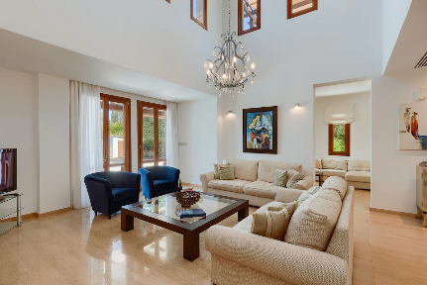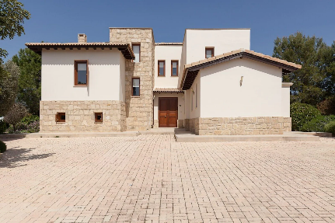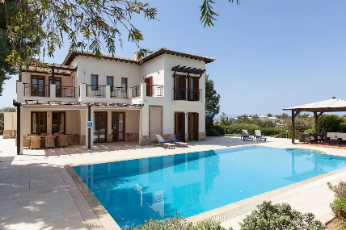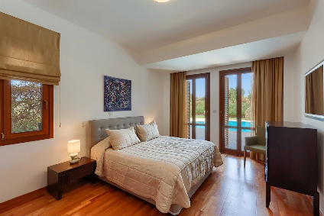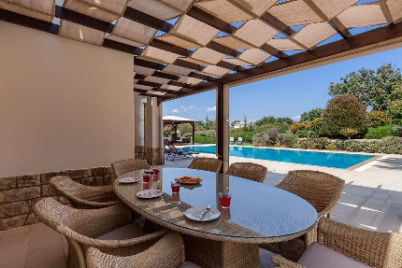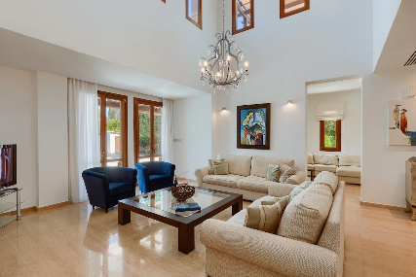

Your Package:

The price of your trip includes:

- 4 full days of shooting

- superior accommodation at Aphrodite hills

- Your transfers to and from Paphos airport, and to all locations specified on the trips. This will be by a 7-seater vehicle, hired and driven by Zeus.

(Aphrodite beach and pebble beach, Ancient Kourion, White Stones and old town– Limassol)

- 23 hours of shooting time up to nude (equivalent to over £1000 worth of shooting time in the UK

- All food and drink at the villa (you pay for your own meal at the restaurant-please see schedule)

- assistance, catering, cleaning and organisation by Ashley and Zeus

Your inclusive price is £2400.

Important dates:

Check in date: 27th September 16.00 local time

Check out date: 2nd September.

No shoots will commence on check in or check out day. These are for you to relax and to prepare or unpack, to or from your journey.

Deposit – Your non-refundable deposit of £500 needs to be paid to secure your slot. There are only 3 places available.

Your second balance of £1000 needs to be paid by 29th July 2023

Your final balance of £900 needs to be paid by 1st September 2023

Cancellation policy:

If for unfortunate circumstances, you need to cancel your place:

Your £500 deposit will not be refundable. If you cancel before August 20th 2023, your second payment of £1000 will be returned. If you cancel after the 1st September 50% of the total costs will be returned if we cannot fill your slot. If we fill your slot, your fee of £1900 with be returned.

If we cancel, 100% of the payment will be returned. If a model cancels, a replacement model of the same standard will be provided.

This policy is to protect our investment in the trip and to protect the model’s investment on the trip.

PLEASE SIGN AND DATE BELOW TO CONFIRM YOU AGREE TO THE CANCELLATION POLICY.

Name:

Date:

Signature:

Information we need from you.

As a party, we would like to ensure all our guests are protected and that all considerations are made to ensure the trip is reliable, secure and safe.

Please could you provide us with the following information:

* Your flight information
* Your contact details and emergency contact information
* Any illnesses or sickness, disabilities you may have
* Your travel insurance proof
* If you require model release
* Any dietary requirements

As considerations

As we would like to respect our photographers and models on the trip, please take the following time to consider:

- the models wellbeing and safety, at all times during the trip . In direct sunlight the model may tire, allow her time to drink water and keep yourself well hydrated. We will provide all the bottled water at the villa, make sure you pick some up before you go out on location.

- At breaks , please allow the model her own privacy , during changes and whilst she is getting ready. There will be plenty of time to socialise at mealtimes.

- be respectful to your fellow photographers. At times you will be shooting a ratio of 2:1, be fair and equal with your time. That way we all get lovely images and it saves dispute on the trip. If you find yourself unhappy about something, or another guest, please speak to Ashley or Zeus to resolve.

- be open to listen and respectful of other peoples opinions regarding photography and their skill level at meal times. This is usually when a lot of discussion around photography takes place. We are still all learning, regardless of skillset. As a holiday, we hope you enjoy every moment you spend with us.

- on location, please ensure you pack sun cream and wear suitable shoes. The pebble beach is difficult to walk on, so please bare this in mind. Pack a light jacket if needed for sunrise and sunset, in case it may be windy. The white rocks are on a slope, please take extra precautions when shooting here. Wear trainers or boots with reasonable grip. In may also be worth packing a set of “shooting clothes” for when shooting on the beach or at the white rocks. This is because your clothes may get wet or chalky. If at anytime you feel unwell , please alert us immediately . Your safety is our priority.

- bring a suitable bag to carry your equipment on location. This will protect your equipment and also prevent you from tiring whilst walking.

- If there is anything you would enjoy which is not on the menu, please ask us. If you’re cold and need more blankets in the villa, if you need to rest or if you would just like some quiet time to relax , please just let us know .

-any further questions or uncertainties you have, please contact Ashley or Zeus

Warmest regards

Ashley and Zeus