INTO A NEW CENTURY
COMMISSION STORY
BY CHALDEACHANGE
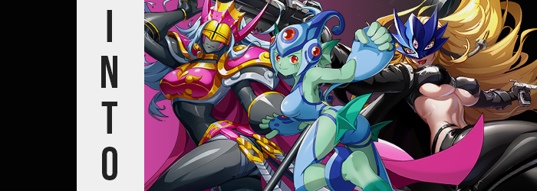

Digimon.

If you grew up in the 90s or early 2000s, it was very unlikely that you hadn’t at least heard the name. If you weren’t a fan of it yourself, you were still likely liable to see it being broadcasted along with other popular children’s shows at the time – usually in anime-specific programming blocks. Many saw this show, which dealt with children adventuring with their Digital Monster partners, as competition for the more popular Pokémon. But in the eyes of a child? You could really just enjoy both.

But as you got older, and the years ticked by? One of those two series would fade a little more in the public eye than the other. Pokémon was a worldwide phenomenon that pumped out game after game on top of having a very successful anime, while Digimon? Unfortunately, it wasn’t able to keep up in the same way. It didn’t have a successful and consistent game release schedule, even though a lot of the games they did release were fun.

It also didn’t help that some of them didn’t even get localized.

“Digimon New Century? I really hope this isn’t going to install a virus with the backwards method Axel suggested. What even is ‘Digigate’?” Kay glanced down at the progress bar showing on his smartphone. He had been speaking about Digimon with his friends Axel and Joseph a few days prior when Axel had mentioned ‘New Century’. It was a Digimon gacha game that was played in China, but it had never made the jump out of the region.

And then several days later? He had come back with a link to a program he’d found. ‘Digigate’ was the name, and apparently it could install the game with a translation patch. Both Kay and Joseph had assumed that Axel had properly vetted the program before recommending it, but…

Were sparks of blue lightning supposed to be shooting out of their phones?

“I— Huh?” When a burst of lightning and light alike had shot out from the phone he was holding, Kay had naturally thrown the phone on his bed and recoiled, closing his eyes tightly. But when he opened them once more? He couldn’t see his phone. He couldn’t see anything from his room. All he could see was what he could best describe as a ‘digital void’.

It was as if he was standing in an endless space where everything from the ground he stood on, to the clouds in the sky were constructed with blue wire grids and polygons. “Wh-What just happened to me!? Maybe I passed out or something? This is just too weird.” It almost felt on theme, though. He’d been downloading a Digimon game and now it was like he was in a Digital World of some kind.

But it hadn’t been his intention to become a resident.

Despite how disorienting and confusing this all was, Kay felt compelled to stretch all of a sudden. He reached up towards the artificial sky with a groan. “Assuming this isn’t a dream, does somehow being warped into a vast, wirey void always make you feel so stiff?” Was it just a matter of feeling stiff? He felt a little heavy too, and not in the sense of fatigue. Just like there was more weight on his body. There was a reason for this.

Although it wasn’t a comforting one. There had yet to be any visual signs of it thus far, but the man’s body had begun to change. It was just that those changes were limited to his body’s depths. Internally, a very dramatic shift had begun that had hardened and blackened his bones until they were crafted with a fine, hefty ivory. Had that been the full extent of things then it would have still been alarming but he might never have realized the cause of the weight, and yet…

The ivory had begun to move outward towards the surface of his skin. “Heavy… and cold?” While Kay didn’t shiver or anything like that, it was plain enough that his body’s temperature was chilling. This was because the ivory was spreading to harden flesh and blood, even overtaking the beating of his heart until there was none at all. Did this mean he was dead? No. He was simply becoming something that didn’t require a physical, beating heart to be considered ‘alive’. Nor his liver, or his kidney… yet oddly, the existence of his stomach was preserved.

His body felt stiffer and stiffer as a result, and ultimately? The man ended up looking down at his own forearms and hands. “HUH!?” And he had done so just in the nick of time, because what he ended up seeing? Well, his skin darkened and hardened, with any body hair (tragically including his pubes) wiped away until not just his arms and legs, but his entire body including his face looked more like a black ivory statue than a flesh and blood human.

“Wh-Wh-What!?” Kay’s mouth chattered as he spoke, even his lips heavy and hard – yet not incapable of helping him form words. That was the strangest thing about it. His hardened body was definitely very stiff, but it still functioned like a human one would. It just looked smoother and was a little but harder to move than regular flesh and bone. But the flexibility of his limbs, fingers, and toes specifically was easily explained.

He could still feel through this body, and so the sensation of what felt like ‘skin’ being whittled away could be felt enough in key parts of his form – namely anywhere that would possess joints – surprised him and pushed him to force a stiffer neck down to look. Whether it was his fingers, toes, elbows, knees, and so on… Black ivory lessened, seemingly carved away until his joints were exposed.

Whether it was his hands or his feet though? All seemed to be smaller, smoother, and daintier.

Now all with ball joints between each segment. Although the ones on his knees now shone with gold plating overtop of them. “Wh-What the hell is happening to me!?” Understandably concerned as he was, even the haunting differences to his voice contributed to the panic that Kay felt. It seemed like it would jump up to a deep, womanly octave for a moment before settling back down to normal. Back and forth, back and forth.

All upon a face that appeared less and less wishy-washy upon his face. Hard, black ‘skin’ had gradually been smoothed away, painlessly altering the architecture of his maw so that it looked more like a mannequin or doll’s. But one that had been gendered as female, it seemed. Solid lips had somehow been remolded to be several times larger than they had been between slimmed, lengthened cheeks so that his face was longer overall. A more petite nose was in the center of his face now, between eyes that were shaped far more femininely… with glass eyes that featured a silvery blue color.

“Am I some manner of doll?” At least Kay’s voice wasn’t jumping around in pitch any longer, but he absolutely appeared more similar to a mature woman facially – which in turn matched his new voice. “Some manner? For what reason am I speaking…? I cannot stop?” He sounded very regal and self-important, let you might expect a monarch in a medieval political drama to speak. It bothered him.

While the man(?) had long since lost all of his body hair, the short, brown hair atop his head had remained. But it was just as destined as the rest of him to change even if it wasn’t wiped away, with strands lightening to a silvery blue like his eyes and inevitably spilling out past his shoulders and town to the center of his back. More and more he appeared like a woman.

But was only then that it became literal.

But she didn’t really react all that strongly to her ivory cock and balls retreating into a new, hairless slit. It felt like the inevitable outcome at this point. Well, that and what was happening to her was becoming clearer as not memories but instead context was bestowed upon her. “So I’m… Hm. Intriguing.” And once she knew what was happening? She found it hard to have any complaints about it.

Instead she simply embraced it as her hardened body grew more plentiful. Her chest was prompt in lifting her shirt, the firmest possible pair of black, F-cup tits molded atop her doll-like torso while her waistline was smoothed away until it was significantly narrower. This helped when her hips flourished in kind, stretching her shorts – but surely not as much as ampler ass cheeks and thighs did. All rock hard but clearly shaped with the intention of evoking a womanly beauty.

Kay could already visualize what she was becoming, and so she hardly bat an eyelash once her nearly six foot body began to grow even taller. She felt no pressure nor pain from her human clothing becoming tighter around her, nor did she let a cry escape as she eventually tore through it and tatters fell around her naked doll physique. But by the time she peaked at eight feet in size she was no longer cursed to be nude, either.

Equipment had formed. Hot pink and gold armor around her tits, with matching pauldrons that sported a pink cape, as well as a complimentary belt with silver blades hanging off of it. Black and gold boots and gloves that conceal her ball jointed fingers, and a pink and gold helmet that resembled a pointy crown, with a golden half-mask composing the upper half that completely hid her gaze above vertical, pink markings running down her cheeks from her eyes. And finally? An ornate mallet appeared in her left hand.

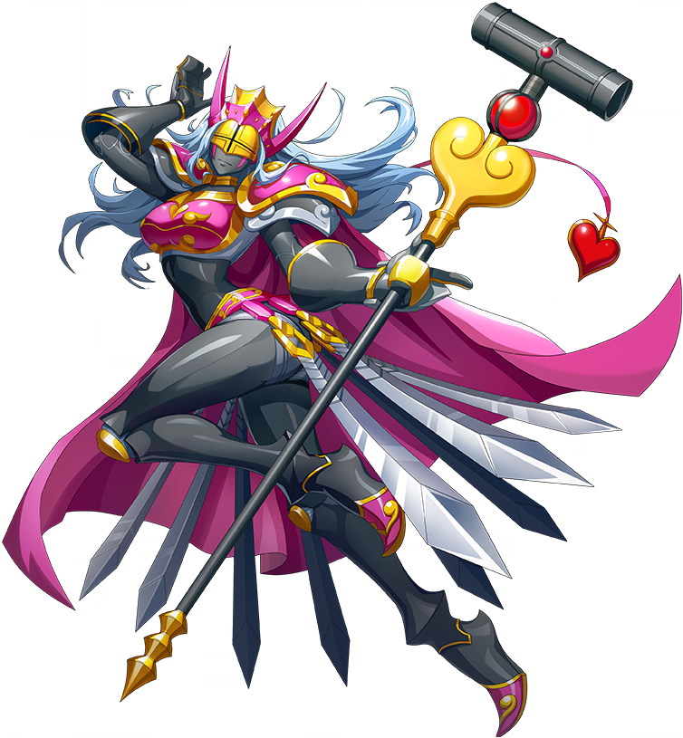
The newly transformed QueenChessmon surveyed the digital land around her through the golden half-mask that she wore over her face. “Hmm… I see. So, I’m a Digimon now, am I?” She both thought and spoke in the Chinese language, indicative of the fact this place she was trapped within was actually a Chinese game. But she also recalled where she had come from, as well as the fact that she had once been Kay. “QueenChessmon… Quite the regal name. I must say: I’m a fan!”

There was an air of elegance to the tall woman’s speech and movements, as expected of a Digital Monster with ‘Queen’ in her name. Of course, the giant hammer she held in one hand made her seem all the more intimidating regardless, especially when her body so clearly wasn’t flesh and blood. “If I was to have one complaint… It’s a tad lonely here in this void, is it not? I suppose I’m just waiting to be summoned.”

But she wouldn’t be lonely for long.

“This is an unexpected development…” And Joseph knew that he was definitely understating that. He had ended up in what appeared to be the same digital space that Kay had after having a similar phone ‘malfunction’, but there was no one else to be found. He couldn’t even really draw the same conclusion that Kay had, that this place in its digital structure invoked similarities with settings from the Digimon franchise.

And that was because that, unlike the other two, he didn’t really have very much experience with the franchise. He knew of it and more or less understood the gist of, say, the original anime, but he didn’t even really know most of the monsters. “I want to assume this is a dream, but somehow it doesn’t really feel that way.” He couldn’t quite place a finger on why that was.

Joseph was actually reminded of how just how certain he was that this wasn’t a dream as his body began to feel cooler? As far as he could tell, the temperature in the space hadn’t changed at all. It was more like the blood that his body was pumping wasn’t as warm as it had been before. Little did he know that the blood his heart was pumping was now actually blue in color.

But it was a reality that began to show across his flesh, even if he didn’t immediately realize himself. But it was showing in the pigmentation of his skin. While it had been a darker olive tone his entire life, now? It looked like it was lightening, that olive shifting to a color that, well… Wasn’t normal. It would’ve been weird if he’d just been paling, but in Joseph’s case? His body was turning light green instead. Not a skin color that any human definitely possessed.

“I guess I need to find a way out of here.” Or so he mused, arching a brow at that odd crack in his voice but ultimately dismissing it as just a fluke. Aside from feeling a little cold, he hadn’t really felt the need to examine his own body and so he hadn’t looked down to notice the change in his skin’s color. At least at first. But the inherent feeling of falling sure made it abundantly clear to Joseph that something was wrong. “Whoa!?”

In a panic he threw out his arms as if to catch himself, but moments later realized how silly that made him look. Because he had completely misunderstood what had happened. It wasn’t like he was falling, but his brain had been delivered that expectation once eyes noticed his eye level was lowering. It wasn’t like he was about to land on his ass or anything like that – his body had been shrinking. Something that was clearly felt with pants and boxers slipping off, although it was fortunate his shirt ended up acting more like a dress now that he was about five feet tall!

“Uh…” Joseph stared down at himself as he stepped out of his pile of lower wear. In the process? Shrunken feet slipped out of his socks while doing so, finally forcing him to address the change in his skin’s color. “WH-WHAT!? My skin!?” And of course, the much shriller pitch of his voice demanded attention, but he could only focus on a couple of things at a time.

He allowed his now bare feet to rest on the ground and instead turned his attention to the skin of his hands and arms since it was easier to touch. “Why am I such a pretty green!? Or adorably small for that matter!?” The man was alarmed, but why was it that he couldn’t stop lapping on the praise to such concerning changes? Did he feel a strange amount of pride towards these features? Mind you, Joseph didn’t really have the full picture of what had happened so far, either.

Without a mirror it was difficult to see your own face, and he absolutely would have been additionally alarmed if he’d had access to one. He would have been able to see how much more youthful he seemed, instead resembling someone in their late teens rather than a full fledged adult. And there was a growing cuteness to green facial features that seemed smaller overall, but were enhanced in areas like his lips or eyes. Eyes that were rounder and shimmering now with a bright crimson. The left eye also had several vertical markings beneath it that almost resembled gills.

“…Eh?” While examining his green hands, the younger man eventually came to the realization that his fingers looked a little thicker? No, not just his fingers. His whole hands appeared to be puffy and swollen, and they grew more and more so before his very eyes until they were approximately three times their original size. But the rest of his arms hadn’t swollen, given them an almost cartoonish appeal.

But then again? The same thing could be said about his feet. They had shrunk along with him at first, and had even became smoother and softer to the touch. But they grew again in a similar fashion to his hands, albeit they only doubled in size comparatively while the arches of his heels flattened a bit and toes claimed a bulbous roundness that was ‘cute’ by comparison. What was perhaps strangest about these slightly bigger yet adorable feet was how the green skin darkened on the front halves.

“EEP!?” She squeaked very girlishly as a direct response to her genitalia undergoing their shift, blessing her with a green pussy that meshed with the rest of her body’s changing aesthetic. But as had been the case with Kay? Joseph’s changed sex appeared to be tied to some semblance of clarity. “I’m a cute girl… Ah! I understand what’s going on here! I guess it isn’t so bad then, is it?” And she gave a cute little shrug.

One that jiggled a weight building beneath her shirt. “I guess that must be my breasts, huh!?” She sounded so excited now, even drawing up her huge hands to press against her bosom while her ears stretched into a pair of fins on the sides of her head. She wasn’t wrong, mind you, green skin and blue nipples beneath her top had been swelling into perky D-cup tits beneath. But it also wasn’t the only place where she was becoming womanlier.

Beneath a trimmed waistline her butt and upper legs followed a similar trend, becoming much more plentiful compared to her shorter body. Her ass was firm and perky and helped lift up the base of her shirt. But a pair of green fins that were colored like the fronts of her feet extended from the back of puffier thighs to help with that lifting. Not that it realistically mattered for long.

Her old outfit disappeared piece after piece, leaving her naked for a brief second before a baby blue outfit decorated her like armor. It clung to her chest and pelvis almost like a bikini, while fingerless armored gloves and thighs wrapped around her hands and thighs. Her big, cute feet were left bare aside from thick, blue ankle bracelets. And on her head? A blue helmet was set, erasing the little hair she had left beneath so that she was effectively bald. But it wouldn’t matter in the end because she would never take that helmet off from that moment on.

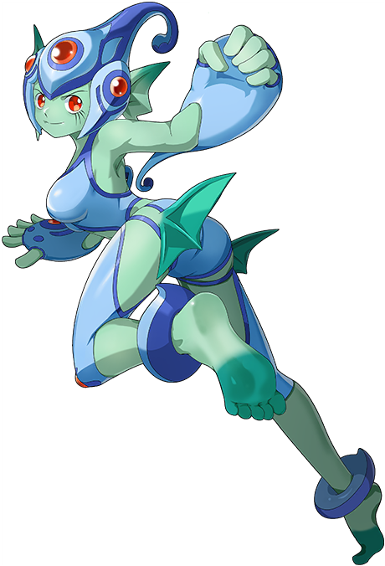
“That’s right, everyone! It’s Ranamon! Eh— Why do I keep blurting this weird stuff out!?” The short, fish-like woman had preserved her sense of self from her past life, but in the end, she was still prone to odd outbursts that were courtesy of her the new personality that came with her new body. Ranamon was her name now, and she couldn’t really remember what her old name was even if she could recall her past life vividly.

Ranamon could be a very temperamental Digimon, but she also liked to be the center of attention almost like an idol. Her bare, blue feet pattered against the grid-based ground beneath her while groaning about her little ‘outbursts’, but with time she would adjust to them. For now? She just couldn’t stop dancing— “Ouch!? Hey, watch it!” She had just been alone, but suddenly she’d run into another Digimon. One who was tall… and hard.

“Oh? And where did you come from, little one?”

“I’m not little!”

“Uh…” I had a lot of questions about all of this, and in search of answers I recounted the few minutes leading up to that moment. I had downloaded ‘Digigate’ after sending it to Kay and Joseph, and then my phone had like exploded or something? I had only closed my eyes for a single moment during that, and when I opened them again? I was standing in a vast, digital landscape. That was otherwise empty aside from myself. “H-Hello?”

It wasn’t like such a meek cry would catch anything’s attention, but I was so off put by all that had happened that I didn’t project my voice the way I probably should have. Like the other two, part of me wished to dismiss these unusual circumstances as a mere dream. But deep down I felt like that wasn’t the case. Even the most lucid of dreams didn’t feel this real.

And what I could feel early on had been quite alarming. I felt oddly— “Light?” I ended up finishing my internal sentence aloud, looking down at my body – or at least the clothing that covered it. I was around thirty and fairly overweight, so I was used to movements feeling very cumbersome. I was also used to my stomach pushing out a couple of inches. But by the time I had looked down. “Urp!?” Well, for some reason I had burped with surprise.

That was probably because something had happened to my stomach though. My gut was gone and that burp was likely just a side effect of it. “What the hell!?” What else could I even say to that? It wasn’t just my stomach either, but my face, chest, arms, legs – all of them were thin now. In a panic I lifted up my shirt to make sure I wasn’t seeing things, and I wasn’t. There’s weren’t even any stretchmarks from my old weight, but… My waistline looked a little too thin? It made my hips stand out, almost like the body shape of a woman. And my pants? They slipped right off, boxers and all.

“Okay… Should I go back to assumin’ that this is a dream?” Because I had just lost a ton of weight all at once and I knew that was impossible. Had I not dropped my shirt back down immediately, I would have noticed seconds later how my hips appeared to part so that they were farther away from each other than ever. Not to mention how much narrower my shoulders had become. “What’s a girl supposed to… Eh? A girl?” Why had I said that?

Fortunately, or unfortunately depending on your perspective, I didn’t have to wait very long for an answer. “Ngh!? What the…?” I groaned, my voice feminizing by simultaneously taking on a smokier sound as both hands shot down to my crotch – still thankfully hidden by my now oversized shirt. “It’s gone!” But ultimately? I was too late. There was nothing hanging off of my pelvis any longer, but fingers that were both longer and slenderer than they had been moments ago rubbed up against something sensitive a little farther down. I blushed.

“W-Wait, does that mean I’m a woman?” I don’t even know why I asked since that was obviously the answer even without context, but on a subconscious level a piece of me felt like it knew why I was a woman now. It brought me a little bit of ease, even though if the answer wasn’t clear from my point of view just yet. What was clear was that my changed sex had invited the feminization of my body to escalate.

I licked my lips without thinking, paying little mind to how they felt a touch plumper than I remembered. But I couldn’t really note how they were black without pushing them forward to see, and I hadn’t felt compelled to do so even though my nose had slimmed a little bit. My eyes now shone with a dark red too, lengthened lashes fluttering along a narrowed gaze. It was clear in my facial features that I was a woman now, and I was a very beautiful one, too.

That beauty was furthered enhanced by my hair. Once short and dark, each strand slithered out like a snake emerging from its nest while being smothered with a bright blonde color as opposed to its usual tone. “Woah there!” I reached up the moment it tickled my shoulders, black-painted fingernails sliding through this beautiful, thick, gold mane that cascaded down to my ass.

Well, it was almost like my ass was trying to push into it courtesy of the curves I was developing. My hips had widened earlier for a good reason, my tightened cheeks taking advantage of the additional space and burgeoning out into a curvy heart of abundance that the base of my top now rested on like a shelf. This ass was firm yet plush, a trait it shared with upper thighs that, now hairless, swelled until either upper leg was a little thicker than my waistline. The arch of my hips gave me a figure that was borderline hourglass-shaped when it came to my silhouette.

“Tits too!? Well… I mean I guess that makes sense.” The body I could visualize in the back of my mind had a huge rack, and that was the bust size I was bestowed with in the end. The way my tits inflated was almost reminiscent of what it looked like to see a pair of water balloons fill up, with the fat that swelled their sizes sloshing around inside skin that jiggled and bounced while lifting my top until my (now toned) belly was exposed to the air. “Well damn.” That was all I could really say at the J-cup tits that I couldn’t help but fondle at least once, twerking nipples that rivaled my eyes in size.

How sexy was I? Actually, I knew how sexy I was. The very idea of it filled me with confidence even as more of my body was rendered naked… because I was now growing taller. A whole foot, in fact, my flesh tearing through a shirt that was much to small for a buxom, seven foot tall beauty. I had even helped tear it away myself! Because I knew I wouldn’t be naked for long.

And I had been right. Bestowed upon me by the forces that were assimilating me into this world, a pair of tight, black leather pants and matching heeled boots dressed my lower body. While above? My stomach and underboob was left bare as a matching, leather, cropped jacket wrapped around my arms and shoulders. It was tight, gloves and all, but a black cape hung loosely behind me. It all felt right. And if anything? The most jarring addition was the dark blue half-mask that settled around my red eyes. It took me a moment to adjust, but a big part of that moment was because a third eye had opened vertically between the two I already had.

The mask was part of my body. As was that third eye.

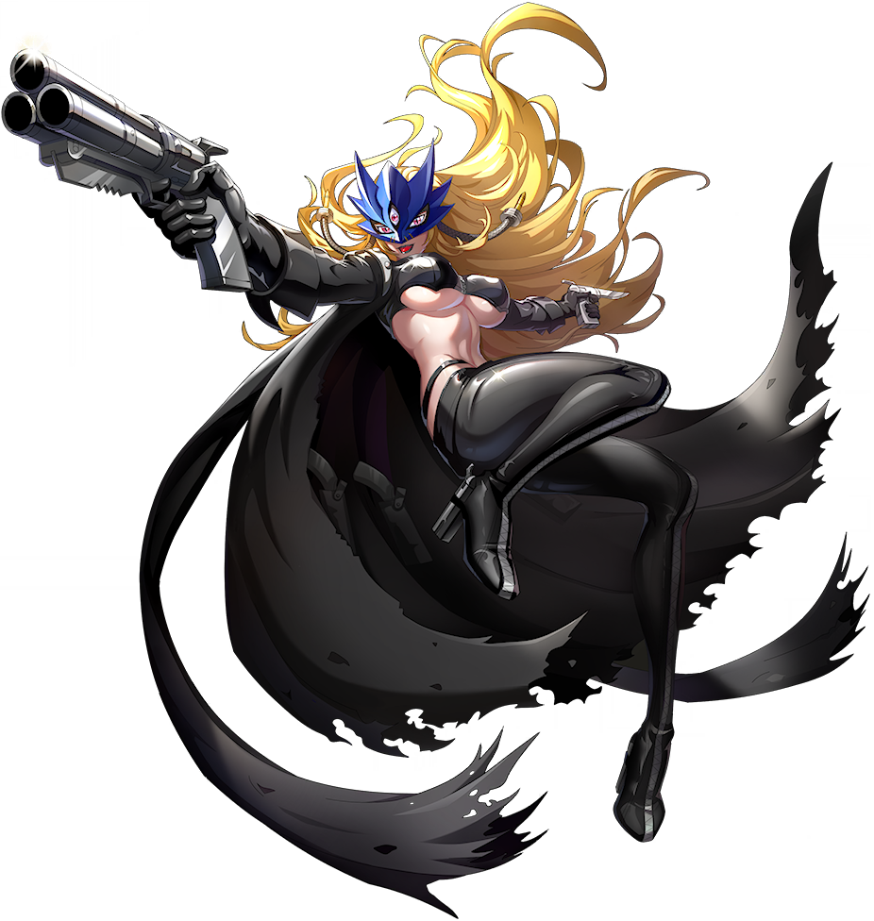
“Oi! Oi! Oi! What gives!? Turning me into a Digimon all of a sudden!?” My words and the way I spoke were both much rougher around the edges than I had ever spoken before, and I certainly didn’t seem to have any problems raising my voice now. But that was just my nature as BeelStarmon. I was more casual and cruder, but not in a way that was especially offensive. “Well, at least I’m hot!” As if to drive that point home, I laughed and grabbed one of my own big tits boldly. It wasn’t like there was anyone around to see! …Or at least, so I thought.

“Hmm… A rather lewd thing to be doing in the company of others, isn’t it?”

“Hehehe… Is that how you were planning the time until you got summoned? So scandalous…”

At the sound of two voices, two women who were also speaking in Chinese, I froze up. My gaze shot over in the direction of their voices. “QueenChessmon… Ranamon… It ain’t what it looks like!” It totally was, however. But it took me a second. “Eh? Why do I know your names? And they’re like… familiar.” Like I was talking to a couple of old friends. And summoned? I suppose Ranamon was right. I knew deep down that we were in Digimon New Century.

QueenChessmon was the one to offer an explanation. “Well, you see, dear, you were brought from another world and transformed here too, right?” I gave a rather brainless nod to the question. “Well, we were too. And I assume you’re the one who sent us the program? We can’t remember our old names, but our lives…” Wait, did that make them… those two? I couldn’t remember their names either, but I could picture them.

“Y-Yeah, I’m the one who sent ‘em to you…” I didn’t really like where this was going. QueenChessmon was being polite, but I could sense a little irritation behind her words. “But I didn’t know this was gonna happen! How could I have known!? Besides, we’re all pretty good lookin’ now, so…!? EEP!?” From behind, Ranamon had grabbed my ass – probably because she couldn’t reach any higher. But then QueenChessmon approached from the front and leaned into my personal space. “Oi! What are you two…!?”

“Oh, just a little punishment. We have a lot of pent up tension from our transformations, you see.”

“…Eh? I mean it’s not like I’m not in the mood but isn’t this a little sudden!?”

“Nu uh! You kept talking about how attractive we are, so now you need to take responsibility for those comments!”
GULP!

