BEACH-I THE ROCK
CH2: HEALING SEAS
BY CHALDEACHANGE
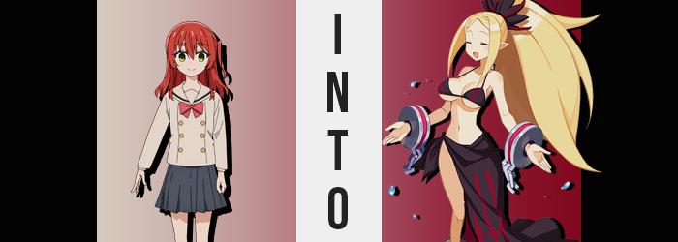

Ikuyo Kita was growing increasingly concerned.

It had been her idea for the Kessoku Band to all go down to the beach for the summer’s final legs. After all, the year before they’d all only remembered to take Bocchi out on the very last day of vacation! The beach had been closed for swimming by that point, and so there was still a week left of vacation. More than enough time to hit the beach! They had all thought it was a great idea, and Kita had even gone to the lengths of going to pick out a swimsuit for Bocchi, but…

“She’s been in there a long time…” Already at the beach, they had found a singular changing stall way down at the farthest end of the beach where no one else was around. They would probably have to swim there with Bocchi’s anxiety which was fine. But they were so isolated that she only really had to show her swimsuit to the band! She didn’t need to be that nervous!

She’d already tried knocking on the wooden door several times to no response; she must have been disassociating hard. Of course she couldn’t have known that her friend was in the middle of a transformation. She was just worried about her! Well, that and because it was the only stall nearby she had wanted to get changed into her swimsuit too. It was hot standing there in her uniform!

Kita sighed. “So this is why the other two snuck away, huh…?” Ryo and Nijika had fled the second that Hitori had gone into the changing room while talking about grabbing snacks from the nearby convenience store. They were probably actually doing that, but now she was suspicious they had just wanted to offload Bocchi on her because they knew she would have an episode like this.

“WAH!?”
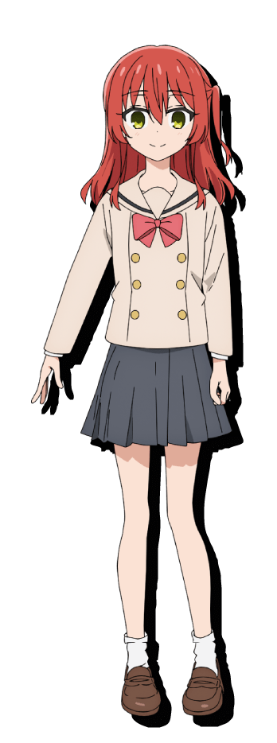
The red-head’s concern was replaced by shock as the stall door finally flew open, mind you. For a split second she had believed that Bocchi had ultimately decided to brave the beach, but she was once again left concerned because the one who stepped out was not Bocchi. She was a tall, beautiful woman with big boobs and a tan! How was that possible!? “Oh, sorry Healer-chan! We’ll talk later, I want some udon!”

“…Huh?” Kita’s mouth was open so far it looked like it was about to hit the sandy beach. The stranger had just sped off as a rainbow light trailed along with her from a stone sticking out of her bag. Wait, that had been Bocchi’s bag! “B-B-Bocchi-chan!? Are you in there!? Were you mugged!?” Piecing together what she could, she ran into the stall to find it empty. Was this some sort of magic trick? Where had her friend gone!?

Well, something about this was magic. She’d basked in the rainbow stone’s light just long enough for it to begin to affect her too.

Having been enlightened to Bocchi’s absence in the changing stall, the genkiest member of Kessoku Band stepped back out and onto the sandy beach. “She isn’t here… Should I chase after that lady? Maybe she knows where Bocchi went?” It wasn’t possible that she had somehow gotten confused and had wandered over to the wrong stall, was it? But the closest one otherwise was way down the beach.

As she pondered this riddle signs of change began to emerge plainly in her shoulder length, red hair. Or, well, it was supposed to be red, but it seemed that the color was becoming lighter. Almost like it was being dyed in real time without any chemicals it gradually shone with a blonde that wasn’t all that different from Nijika’s. But it wasn’t dye so much as it was now a biological pillar of her body. All of her hair had become blonde, and any hair that grew from her body from this point on would be blonde as well.

Which was a fact that immediately became relevant. “Huh?” Kita found her head tilting backwards without meaning to accompanied by an odd tugging sensation. Slender fingers naturally reached up to try and pinpoint the cause. “Don’t be a bird pulling my hair, don’t be a bird pulling my hair…!” But the truth was a realization far more shocking than even that. “M-My hair!?” It was lucky that there was no one else that far down on the beach else they definitely would have heard this screech and assumed that something was amiss.

From Kita’s point of view it very much was amiss! Her hands traced the length of her hair far beyond the length it was supposed to. It almost felt like hairs were squirming about in her grasp as they grew even longer. “This is impossible, my hair isn’t supposed to be…!?” That long or that thick. It fell down past her ass and was immensely voluminous. It was heavy, with bangs parted in the center and the hair on the sides of her head reaching down to her chest. This was all weird and wrong, and yet…!?

Hm? But I prefer keeping my golden hair nice and long~!

In a tone of internal voice that came across as far more flippant than Kita ever was, something dismissed her concern about her hair and was quick to dry up her panic. At the same time her eyes began to glow with a menacing crimson that was almost the same red that her hair had once been. Something that was very obvious for a moment, and yet the girl felt an overwhelming desire to shut her eyes. Despite closing them though? She could somehow still see perfectly. She hadn’t even realized she had shut them!

“I… Uh… What was I so worked upth abouth?” The vocalist couldn’t really parse together her own thoughts and feelings and was left more or less stunned, incapable of thinking too deeply about what was happening to her. The seemingly unprompted lisp had come about because her lips had swollen and she briefly struggled to articulate properly with thicker lips. Though this was part of a broader, sweeping change that completely altered the identity portrayed by what existed beneath her hairline. A narrower jawline, thinner brows, smaller nostrils, but above all else…

Maturity. Kita didn’t look like a teenaged girl facially, instead looking more like a young adult woman. The thicker lips certainly helped with this, but the structure of everything lent itself to an older impression. Were her eyes open, though? It would have been easy to note that her eyes were no longer shaped like a Japanese woman’s either. Was she Caucasian or something else entirely?

The woman tucked a strand of golden hair behind her ear just as said ear lengthened into a point. “Hm… and what was I doing again?” Why was she so calm? Why was her voice so sultry? Both very good questions that she didn’t ask. In fact she couldn’t draw much from her memory whatsoever and so the personality she expressed was one born from instincts. Instincts of the new persona that were being imbued within her.

From that point on she didn’t bat much of an eyelash at her changes, and not only because she didn’t exactly open her eyes to blink in the first place. The woman’s height abruptly shooting up to 5’7” with no comment or even fidget was a pretty dramatic showing of just how desensitized she had become to what was happening to her. Instead she was searching for clarity in her recollections. Why was she at this beach? Who was she?

Evidently she was a woman with a pretty bomb ass figure. With her height increase her uniform top had been lifted so high that you could see her belly. You could readily observe how her waistline pinched in to what felt like an impossibly narrow width while her hips flared out to the sides to lift up a skirt that had already risen to show off more of her thighs.

From here you could see those thighs thicken graciously. It was fortunate that wider hips meant more space between one’s legs, because each thigh bloated to surpass that impossibly narrow waist of hers. This flesh was perky and firm, but there was an enticing softness to it. Oh, how I enjoy pretty women using my lap as a pillow as I lull them to sleep! A very, very normal thought for a beautiful woman to have, surely.

What couldn’t fit in those plush thighs in turn flowed into her butt. Kita’s rear wasn’t all that pronounced, and seeing as she was taller it had appeared even more lacking. But the back of her panties filled up with bouncy flesh that forced the cloth of her undies in between the valley of her cheeks, ultimately cursing her with an unpickable wedgie midst her slappable rear. “Mm, wouldn’t it be nice for a beautiful lady to give it a slap?”

Clearly the fact that Kita was a raging lesbian was not being removed. It seemed like it was becoming more perverse. Why else would she say that aloud unprompted?

Rounding out her luscious, bodacious figure were her breasts, which wasted little time in filling her top and the blouse hidden beneath it. “Oh!” The strap of her bra snapped thanks to the mass that accumulated within a bosom that just barely surpassed a handful even at her previous age, for it pushed forward suddenly and almost violently into a pair of F-cups that bounced along with the cloth that contained them once that strap had been overwhelmed. The undersides of her huge tits were on full display beneath her yanked up tops.

Before Kita could even think to adjust the ill-fitted garment that her buxom body was practically spilling out of, a flash of lingering rainbow light stripped her so that her tits and ass bounced free before immediately refitting them in something more appropriate. A black and red bikini that struggled to hold her insanely round breasts, while a skirt was tied to one side around her waist. Strangely she had cartoonishly large, broken shackles around her wrists and ankles. When it came to her thick, golden hair? It was tied up into an immense ponytail in the back.

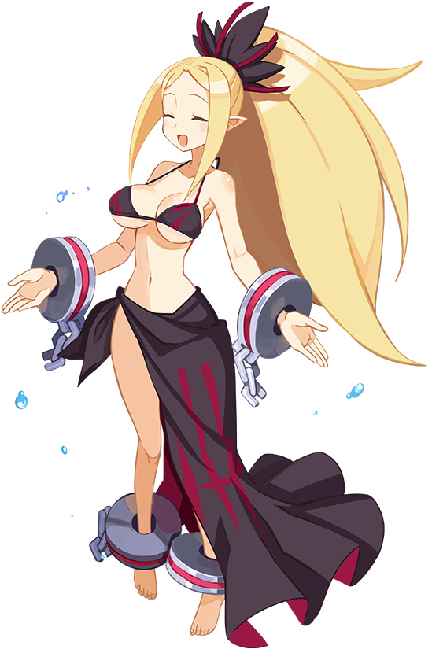
“My, I wonder why Miss Musashi had sped off like that? Was she really that hungry?” Something had spurned her to think back to recent events, and while the blonde, pointy-eared woman couldn’t remember being a Japanese girl nor her transformation, she could recall Musashi speeding out of the changing stall. That woman was always on the move when she wasn’t stuffing her face… It was kind of cute, honestly!

This demon, a Healer named Kii did not belong in the mortal realm. But using magic she was able to disguise herself from the gaze of mortals so that they could not tell her true nature. It was useful not only for herself but the other non-humans in her party as well. Wasn’t a Japanese beach great? The view was beautiful, the sun was warm and the breeze was cool! Plus so many women stared at her beautiful body in a swimsuit!

Looking around, it was no good to be standing there by herself, was it? Now that she was changed she could go for a swim, but that was something better done with friends! A rumble of her tummy provided Kii with another option though.

“I am a bit peckish though. Perhaps I’ll join her? Now what stalls serve Udon around here?”

