The Venus Idol

Walking through the cold, sterile corridors of a subterranean facility painted a bland white from floor to ceiling. A surly man dressed in scientist's garb goes through doorway after doorway, greeting nameless colleagues and simple cleaners with an unnoticeable nod of the head, his attention clearly elsewhere altogether as he moves into a discreet section of the pale labyrinth.

Lesser faces passed him by, until eventually, the moody scientist was alone. Having entered through doors normally inaccessible to most of the eggheads working there. But he clearly wasn't normal, not when most of the people he had passed early on seemed to regard the man's presence with a modicum of respect and mild concern thanks to his ghastly visage. He looked like he was about to burst with anger.

But the moment the last door standing between him and his destination slides open, all animosity in his eyes fade for a more serene look once his gaze comes to rest on a dark figure standing in the middle of the low lit room, too engrossed in their work to notice his arrival. Taking one glance at the placard bolted into the side of the wall with the name of one 'Dr Richard Bernard' emblazoned across its polished surface, the man shrugs his shoulders with a sigh before entering the room, walking by inactive stasis tubes before momentarily stopping to stare at a strange wooden sculpture covered in still living moss and saplings despite the lack of light and water in the active stasis pod it was suspended in.

The thing looked like an ancient Venus figurine carved and shaped from a single hunk of wood, except the design seemed…modern…in the way that it depicted a woman with over exaggerated proportions dressed in what could only be assumed was a playboy bunny girl outfit complete with two erect rabbit ears poking up at the top of the sculpture's nondescript spherical head.

Whatever it was, the man knew enough about it to steer clear, seemingly avoiding it altogether as he continued toward the lone figure moving between workstations, filling the silent air with the rapid clacking of depressing keyboards alongside the clip clopping of high heels striking against the cold floor, and the closer he got, the wider the smile on his face grew as mischievous eyes found themselves magnetically drawn towards the heart shaped bubble butt bobbing up and down before his eyes. Contained within a leathery latex leotard that outlines every inch and curve of the voluptuous woman's figure, complete with an overly revealing cutout starting at the midpoint of the spinal region that leaves her alluring back exposed alongside a generous helping of cleavage and skin, with triangular flaps barely concealing their wearer's painfully swollen nipples and areola considering the immense heft and perkiness of the breasts they had to reach around just to support.

And her legs…those gorgeous legs of hers, wrapped up tight in fishnet stockings that end off in dainty feet clad in sleek, raven heels were simply a sight to behold; plump thighs lined up perfectly with her rotund ass alongside the undulating waves of her toned belly and hairless loins, firm calves and sturdy musculature that provides a strong balance between rigidness and supple pomf. Truly a body befitting a goddess.

Not to be outdone, the head that adorned the scantily clad beauty was no exception. Sporting plump lips painted a glossy cocoa beneath a cute arching nose line smack dab in the middle of unamused eyes burning amber gold that finally take notice of the new arrival's presence in the room, hiding the blush that paints itself over her rosy cheeks while giving the man the tiniest of niceties before continuing with her work. Turning her back on him with a swish of her long flowing ponytail emerging from a head of the most lustrous hair he had ever seen reaching down in long inviting curls that taper off into effervescent trails of ghostly purple.

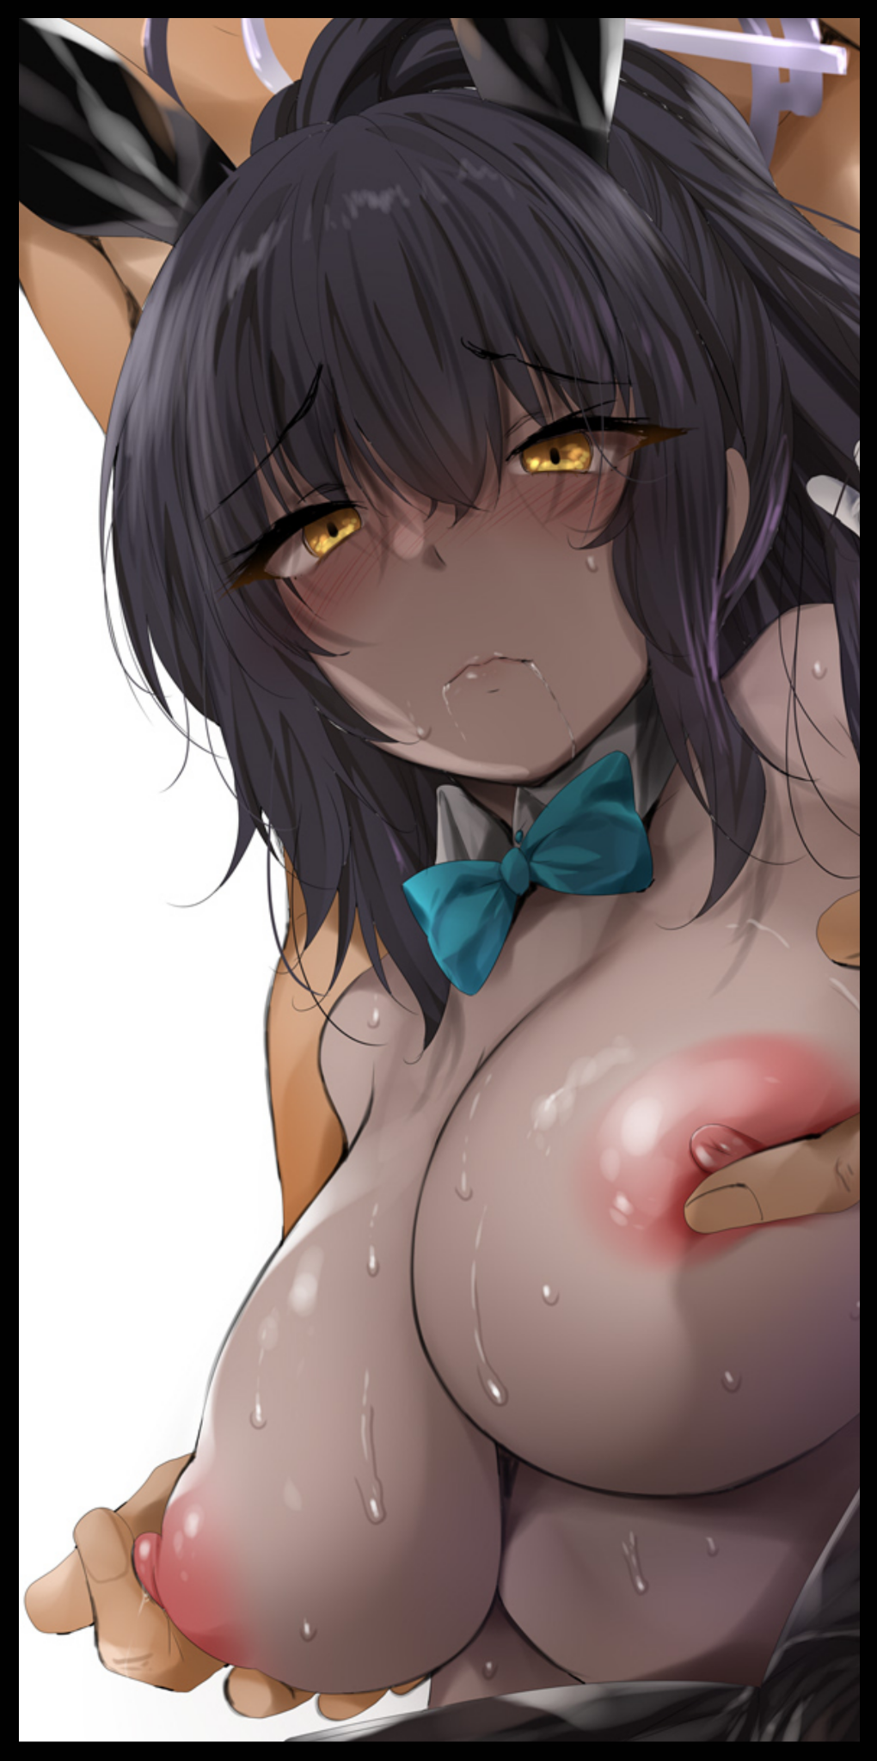
Combined with her porcelain smooth skin of khaki shimmering with a natural oily sheen, and she looked sorely out of place with the drab, boring scientific institute she was currently inside of. Operating complex machines and entering notes with dexterous fingers wrapped up in gloves more suited to dealing a hand in poker than they were handling test tubes and rapping keyboards. Something the man seemed more than aware of as he saunters up behind the bunny girl before bringing his bands down between her armpits to grasp at her pillowy bosom, feeling her shoulders jump at the sudden stimulation, easily detecting the spike of arousal from the way the nipples between his thumb and index fingers instantly harden and swell, clicking her tongue in frustration…but doing nothing to stop the man from fondling her bosom, simply glaring at him with eyes that were putting up a terrible imitation of anger.

"Hmm, you didn't moan today…good improvement from last week don't you think?"

"Y-You…goddamn pervert!"

"Hey, don't blame me~ After all I'm not the one who got cursed by some fertility idol out in the middle of the Amazon~ Isn't it about time anyway?"

"Thats-kgh!"

Despite her best efforts to resist, the woman's rapid typing on the keyboard comes to a slow crawl before stopping entirely in an effort to brace herself against the table, biting her lower lip in an effort to contain the sultry moans leaking from her once the man's kneading begins to intensify, freeing ashen brown melons from their stimulating prison with long, loving rubs that pushes her to her limits.

"G-Goddamn br-bre-ahn!"

"There we go…your singing voice is as fine as ever Rina~"

Finally managing to muster a weak kick that pushes the pervy man off of her back, the exhausted bunny girl rises shakily back up to her former prim posture while wiping a line of drool down her lips with the back of her gloved hand, glaring at the unremorseful man with a look that only served to rile him up further. Cursing the day she had made the supposed 'discovery of a lifetime' that left her body ruined and her mind in a constantly deteriorating state she so desperately wished to reverse before things reached the point of no return.

And from how wet she could feel her loins were after that brief tussle as trickles of vaginal juices run down her thighs, she knew that point was fast approaching.

A few weeks ago, Rina hadn't existed yet. In her place was a portly man of science with a renown for sniffing out relics and artifacts from across all facets of human civilizations across the globe. From the ancient Egyptians to the Aztecs, Richard was the foremost expert called upon by the secretive organization he served dedicated to locating, excavating and preserving 'items of interest' that could pose a potential risk if left unchecked. Mythological artifacts of all kinds were found under his leadership, and that in turn, had given him a lofty position of power in the organization. Something the man, a cranky fellow known by Kramer, found irritating, considering how he treated Richard like a rival despite their close knit friendship stemming all the way back to highschool. Watching him ascend the ranks while he remained tagging along as his assistant made him feel inferior, looking for any scrap to try and one up Richard to no avail.

That is of course, until an expedition into the Amazon rainforest would lead to the discovery of the strange bunnygirl Venus figurine currently floating around the lab in stasis. What was once thought to be an unassuming sculpture in a strange part of the world devoid of such carvings would soon turn into a stroke of luck for Kramer and the beginning of a nightmare for Richard once the man had laid his hands on the moss covered wooden woman, still remembering the supernatural chill he felt the moment the coarse skin of his fingers made contact, followed immediately afterward by a rapid darkening of his hide alongside an undulating wave of warping flesh and tortured bone.

Even dropping the sculpture wouldn't stop what was already set in motion, falling back onto the muddy floor of the Amazon rainforest with his flabby arms left as the long, graceful manipulators they now were before the rest of his pudgy form followed suit, groaning in a gradually lightening alto while flabby pecs inflated into functional breasts, feeling his penis slip away too late before the leathery leotard replaced her baggy lab coat and undershirt, squeezing her broad figure into a compact hourglass shape while the new chocolate skin tone envelops her completely, doing away with the scientist's Caucasian visage in exchange for a soothing mask bearing a heavy resemblance to the local native population albeit with slight 'modern' adjustments in the form of sleek, narrow eyes and less protrusive lips.

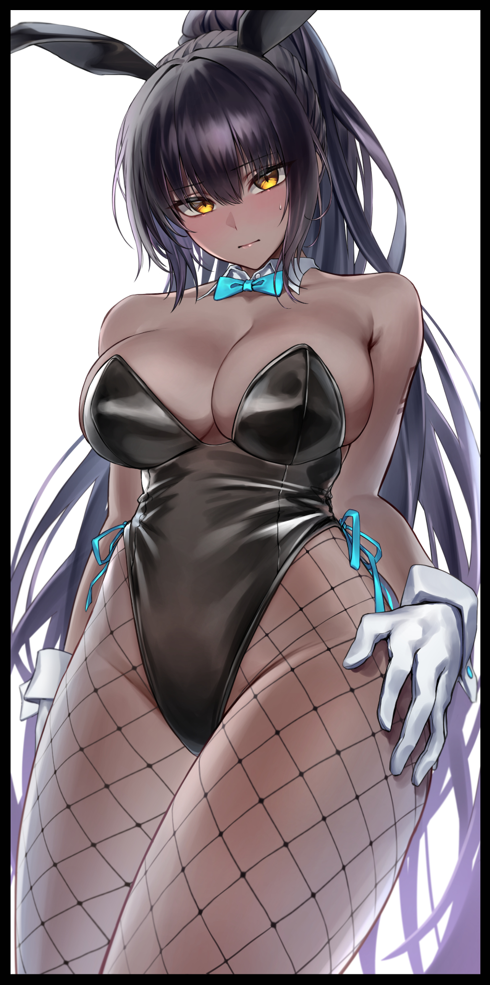
By the time her crew cut mop of blonde had been replaced by a mesmerizing curtain of obscuring black and radiant purple, the Richard of old was gone, replaced by a buxom Amazoness dressed up like a sexy casino bunny girl complete with two floppy ears dangling down the front of her head. Drawing further attention with the presence of gaudy cyan attachments like the ribbon around her neck and the frills hanging off her handlebars. Shifting awkwardly where she stood with her back pressed up against a towering tree trunk upon the realization that whatever had changed her had done so in other ways besides the more immediately known physical alterations. Biting back the impulsive urges that almost had her leaping on her assistant when he had taken her by the wrist gently, leading her slowly back to their encampment…all while she couldn’t seem to stop casting lustful glances over minute details in her assistant she had never noticed until now.

Details like how the front of Kramer’s pants formed a painful tent containing a beast she so desperately wanted to set free or how devilishly handsome he was…

Looking back upon the memory only brought shame, especially when she was still new to the old ‘being a woman' ordeal wrought by what they now knew was a cursed fertility idol that had arrived in the Amazon rainforest from foreign lands after taking one of the locals over to see if they knew anything about what had befallen Richard and if it could be undone. All while she laid in solitary confinement like a test subject, standard procedure for those who came into contact with potentially infectious or dangerous magics and diseases the likes of which humanity was not prepared for.

Unfortunately for them, the local's knowledge came too late, because by the time Kramer and the rest had rushed back to the base, Richard had already been consumed by the beginnings of what could only be described as an elevated state of estrus. Begging for someone to fuck her while she rolled around on the floor of the circular sir tight chamber, in a shameless display that, according to her assistant; 'had the boys all riled up' every time he brought it up just to spite her.

The single most disastrous point in her career for sure…

The following days were fraught with experimentations and attempts to break the curse that now held a firm grip over the feminized scientist after she had recovered from unwittingly putting herself through dozens of orgasms within five minutes. And through these experiences, discoveries were made, all of which did little to help Richard get closer to regaining her manhood.

Firstly, she couldn't wear anything else besides the bunny suit the magic had bestowed her with. And that whatever this curse was, its potency was on a whole other level. Nothing the organization had on hand was capable of reversing its effects, which meant that the only way Richard could hope to last against the accompanying bouts of maddening lust that gripped her at inopportune times of the day was through sheer willpower: focusing on whatever task she had to do that day lest her mind drift to thoughts of satisfying the bow permanent itch in the foreign gash between her legs she forbade herself from looking at or touching…until recently that is, after her assistant had started to become emboldened by the fact that his rival had become a buxom wench prone to breaking down into fits of orgasmic seizure at any moment.

The first time he had tried his luck, Richard was not ready, instantly finding herself bucking her hips in instinctual pleasure while letting loose the most guttural moan known to man once she felt Kramer's sneaky hands twist around under her leotard, fondling her breasts much like he had done a few seconds earlier. She felt ashamed, disgusted, furious that her friend would take advantage of her predicament instead of helping her with trying to find a cure back at the laboratory where she now spent most of her time considering the face that no matter what she ate or how slovenly her lifestyle was, her new body maintained its gorgeous physique throughout. A fact that frustrated her even more…at first…

She wanted nothing more than to return to her old body, working day and night while eating suppressors supposedly tailor made to stave off one's libido. And to her pleasant surprise, they were actually working. She could go to sleep without spending hours fighting off the unbearable fires of arousal. Talk with her colleagues without looking at them with inappropriate eyes. It felt like a tiny bit of normalcy had crept back into Richard's life ever since they left the Amazon with the cursed package in tow, safely retrieved by machine of course.

But after the stunt Kramer had pulled on her, the desires she once thought forgotten to her had reared their ugly heads once more. Finding herself working on her formulas and research less and less when that itch down below would return once more, biting back the ghostly imprint of her assistant's snobby hands kneading her breasts without remorse while cursing his name under breath.

Until he struck again, grabbing at her tits just like before, pushing her to near insanity before leaving just as quickly as he had arrived. And even more shocking to the new woman, she soon found herself eagerly awaiting the pervert's arrival every day from the second assault onward. Focusing less and less on work while her mind began to drift to what she wanted Kramer to do to her instead of just playing with her breasts.

It soon became nigh impossible to get more than two pages of notes and test results jotted down and processed when she spent hours on end leaning against her workstation, standing idly by, ready and waiting. While at other times, she realized she wasn't even working when she excitedly went to compile dozens of pages worth of notes and schematics, only to realize only a quarter of what she thought she had been writing was full on gibberish nonsense…like the formula she had been inputting today just before another of Kramer's impromptu visits. Sighing with a hint of venomous anger in her voice as she finally tears her gaze away from the man.

Until she felt firm hands wrap around her chin, twisting her neck back to stare him straight in the eyes, an act that had Richard's heart pounding like mad, softening her frown into an incredulous look that might make a bystander assume she was about to faint from being so brazenly handled by a man they wouldn't be faulted for assuming was her boyfriend.

"Come now Rina, why the tears? It doesn't suit a girl like you~"

"I...I-I…I told you not to call me that you perv!"

Unlike the many previous encounters, Kramer took glee in noting the fact that Richard didn't slap his hand away, relishing the way she gently cradled his palm before dislodging it from her soft chin. And her voice, while still sharp and shrill, had lost the vitriolic edge that lent credence to her fury and disgust just a week ago…something both sides were well aware of as the smile on Kramer's face widened while the grimace on Richard's darkens.

'If this keeps up…I might just really become his Rina…'

'Just a little more, and she won't even think of going back anymore…'

And as much as she feared what going over the edge meant, a part of Richard couldn't deny the fact that the impure, unbridled lust she once felt was beginning to give way to a warm pulsating ebb and flow that made her heart swoon…the reason behind why she had begun to stop acting so shamelessly whenever Kramer did his thing wasn't because she was growing desensitized to it but because that unadulterated lust was gradually transforming into what could only be called some form of fledgling adoration for her assistant. And from the looks of it, the simple minded man hadn’t yet realized what was really going on in his rival’s confused mind.

Whether it was because her brain was starting to acclimate to its new female form or yet another influence wrought upon her mind by the curse, Richard wasn't sure…just like how she wasn't really sure if continuing this futile struggle was worth it over choosing the alternative, envisioning herself in a bridal gown instead of this bunny girl get up, walking hand in hand with a smartly dressed Kramer who had turned to leave her lab without another word. Giving her the privacy to squeal in shame and embarrassment at the vision she had just dreamt up so clearly, huddling up into a glowing red ball on the floor…

“Oh god…what am I supposed to do~?”

THE END

Closer Than Ever

"You were right to come here Ava…the sunrise is just…absolutely gorgeous!”

Lounging around the lonely beachfront with the slow lapping waves rolling into foamy walls that wash further and further out to sea with the arrival of the morning sun, two women could be seen huddled close together in the privacy of an exclusive corner of the beach. One, a boyish rogue with a bob cut blonde head of hair and a toned, athletic physique dressed in boxer shorts and a bikini top laid flat on the sand, hands behind her head gazing skyward. While the other, a voluptuous babe sporting a pale khaki hide of chocolate skin wrapped up tight in a contrasting snow white bikini with an alluring mop of curly brown hair that tapers off into an artificial blonde seemed far more energetic, desperately trying to get her friend to watch the sunrise with her to no avail.

“C’mon Ava…you promised you’d watch with me…”

“Yeah~ Yeah~ I will…just..five more minutes okay?”

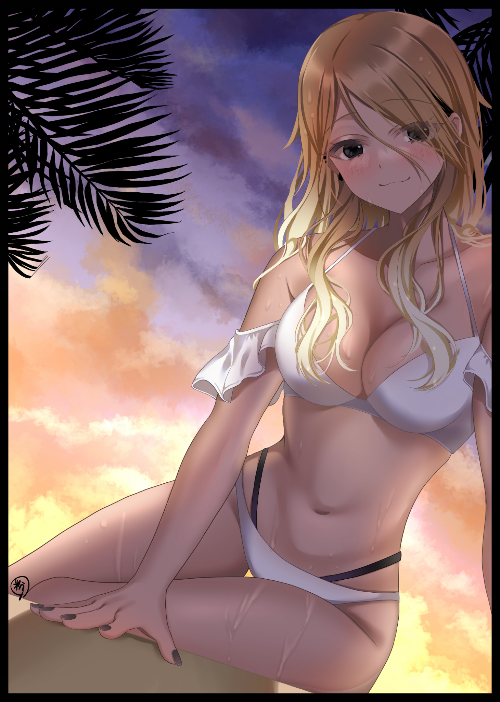
Watching her friend throw a mild tantrum behind closed eyes with a wry smile on her face had her thinking back a few weeks ago when going to a beach for a summer vacation like this couldn't have been possible in the slightest.

Ava was what you might call a wunderkind; successful in her studies and especially so in sports. Wherever she went, she had been the target of envy for those who met her. Whether it was her classmates who wondered how she could be so suave and level headed at all times to her fellows in the track and field team vying to best her record times, there was always a sizable crowd of adoring fans trailing not too far behind the prodigious young woman.

But all that chatter and endless flattery was bound to irritate someone, especially when that someone was Ava herself. She had always been a quiet girl, loving the solitary peace of life before highschool. Even when she entered the phase that was supposed to be the peak of every youth's life, Ava remained isolated from her classmates, sitting all by herself through lessons, attending after curriculum activities without chatter before heading home without so much as a goodbye.

In truth, it wasn't just her isolationist preferences that kept her away from others but rather a fear that someone like her couldn't really make friends. Thinking that people would only ever be interested as long as she remained a 'Supergirl' in their minds, and once she didn't have anything unique to gawp about, she would simply be tossed aside like used rags. That, and there was also the matter relating to her other, more unique abilities that terrified even herself…but one she had relied on many times in the past decade.

It was an ability that involved the use of her voice. By speaking from the bottom of her heart and a strong enough emotional response to back up her words with, she could transform any given person in accordance to her words. A one time only decree that could see her rewrite reality, a taxing effort that left her strained and exhausted. Even more so than if she were to run right consecutive laps around the field.

The first time she discovered this trick was back during her earlier years in middle school. Being a well read kid, she had just the right words in mind for a perverted train molester that had been active around that time. Keyword being 'had', because after what Ava had unwittingly done to the man, it was safe to say he wouldn't be doing anything remotely human anymore.

"Get your hands off of me you scumbag!"

Shoving him away with a flash of light, the molester was gone, leaving Ava initially confused and afraid when everyone on the train stared at her with wide eyed surprise and shock as the people closest to her spun their necks around, looking for the supposed pervert who would lay his hands on a young girl. All oblivious to the tiny, boat shaped cockroach squatting right where the man Ava swore had grabbed her once stood. Feeling a dizzy spell wash over her alongside a heavy weight in her limbs that made focusing on lessons for the rest of the day an agonizing affair.

From then on, Ava would strike out on her own everyday after school. Taking it upon herself to investigate what she just couldn't accept as a false alarm. And after two more repeated attempts against the most deplorable folk she could think of loitering around public spaces and alleyways, Ava would have learned enough to figure out how this curious ability worked…and how dangerous it could potentially be. Hence her self imposed isolation from the world bolstered by the feelings of false friendship she harbored over the years as the town's local prodigy.

So when a boy from Ava's class had approached her out of nowhere when afternoon training was over claiming he had a crush on her, she had taken it the wrong way. Being a complete stranger to highschool romance and social cues, Ava had assumed the boy, a well built fellow going by the name of Kent, had been trying to pull a prank on her. Just because she refrained from contact didn't mean she was completely lost to who she was talking to, and she had seen Kent mixing around just fine with the other girls in class and beyond. In fact, Ava knew him to be one of the more popular boys the girls incessantly kept gossiping about.

'Kent? Having a crush on the silent nerd of all people? Fat chance…' were the words that ran through her mind while she pretended to hear the mumbling jock out. She wasn't the sort to engage in games like these, and on that Friday afternoon, she was feeling particularly grumpy. Wanting nothing more than to return home and get some rest, but because of this supposed dunderhead wasting her time with a prank, extending the time she spent boiling under the humid sun until finally, she snapped, laying a hand on Kent's shoulder while mouthing the words that would change both of their lives from then on.

"I've got a better idea. Instead of wasting my time, why don't you feel what it's like to get yours wasted? Besides, I kinda wanna see what you look like as a girl…"

With the final words leaving Ava's mouth and trickling down Kent's ears, the familiar white glow of obfuscating light she'd witnessed many times now burns from somewhere within the boy before escalating into a sphere that burns brightly for less than a second before fading away akin to the flash of an obnoxious camera shutter.

Once the light had faded where the tall jock once stood, a far shorter tanned gal sporting heavy Japanese gyaru aesthetics had replaced Kent entirely, blinking with a dumbstruck look on her spritely young face while Ava leaves the freshly changed gal in the dust, assuming she had become just another stranger like all the others unlucky enough to be graced by her 'special' voice. Although she felt a little bad for acting so impulsively, the fatigue from training combined with the following haze of exhaustion was beginning to take its toll on her body in the form of a throbbing migraine, spurring her forward in an effort to get home as fast as she could.

"A-Ava? W-Why am I…a girl? Did you do this?"

Until a nasally voice pipes up from behind her, freezing Ava in place, shoulders jolting in a mix of surprise and fear. Slowly turning on her heels to come face to face with Kent's feminized self pushing her face straight into hers, not with anger or revulsion but excitement and pomp.

As it turned out, Kent, now known to Ava as Kendra, had retained the memories of her old self fused with the bubbly persona of the vapid highschooler she had become. A fault that weighed heavily on the brooding tomboy's head, blaming herself for what had happened to Kendra despite how hard the girl tried to assure her that she was fine. Mildly disorientated, but fine.

"I don't really know what it is you do but really Ava…I'm fine…besides~ if you really feel bad…why not come along with me on a date?"

"A-A date? Seriously Kent, you're a girl now! I might've done something wrong here! You could be thinking-"

"Kendra…don't make me repeat myself…"

It was like talking to someone else altogether. The meek, carelessness that had Kent fumbling over every word during his earlier attempts at a confession were all but eliminated in Kendra's suave mannerism. She spoke quickly, with a peppy lisp that made her voice a treat for the ears, and although she was now a girl, Ava could still see the same smug look the former man wore on his face whenever he was with his friends.

But if what she said was true…and she really did retain Kent's memories and bits of his personality…

"So…that whole thing about you actually liking me back there…that was real?"

"Of course it is…never thought someone else could love you the way you are?"

The silence and mild frown that crosses her brow was all Kendra needed to know what was going on inside Ava's mind, sighing before pushing off the stone bench right outside the school gates, brushing off her pleated skirt with a practiced finesse that made it hard to believe she had been a man only a few minutes ago. Looking Ava up and down, the excitable young lady had asked for her phone then, piping in a series of buttons before handing it back to her screen-first, displaying a new contact list with the name of Kenny signed off with a heart shape.

"Drop me a message alright? Tomorrow morning, 8am sharp at the mall. And don't forget to rest now, you look awfully tuckered out…thanks again Ava!"

She didn't wait for Ava to reply, simply skipping off down the street once she had said her piece, probably knowing better than to push things when they just weren't ready yet. But before the gal vanishes down the corner, Kendra turns around before shooting Ava a farewell kiss, leaving the shell shocked girl even more stunned and confused over what to do.

Ava would not text Kendra that night, she couldn't, not when a pounding migraine had developed by the time she got home. And even though she had absentmindedly made a promise with a simple nod of her head, the promised meeting at the mall would go unfulfilled when Ava would awaken in the afternoon far over their agreed upon meeting time.

"Ma! I'm goin' out for a bit!"

She didn't know what to expect but something told her to go anyway despite the severe lateness of her arrival. She had half expected Kent to be there. And even though it had been a busy weekend, spotting Kendra was an easy task when the first thing Ava saw when walking in from the main path was a blonde beauty sitting by her lonesome on the beaches under the trees. Slim lashes shut tight while the fluffy hem of a sundress flaps in the wind. Confirming to her that the events of the previous day had not been a dream.

And as soon as she gets close, Kendra awakens from her sleep, matching Ava's look of surprise with mild annoyance as she rises to her feet before nonchalantly closing the distance between them in a matter of seconds.

"You're late…"

"Y-Yeah…sorry…I just…this all hasn't set in yet…"

"Really now? Well then, we still have plenty of time to fix that…come on! Let's go!"

Grabbing her by the wrist, Kendra's surprisingly strong grip led Ava all throughout the mall with ease. And even though the pair were dressed like night and day, with Ava still wearing her pajamas and Kendra decked out in fashionable clothes, the loner soon found herself being taken along to shop for clothes, buying treats and hanging out in the arcade, spending the afternoon just like normal friends did…except it only made Ava doubt herself even further for every ounce of fun she felt hanging out with Kendra, using every moment she held her hand to try and turn her back into Kent to no avail.

But when they sat down at a cafe for some R&R after running all over the place, the keen eyed gyaru had already figured out what Ava had been trying to do, and she didn't look too pleased about it.

"C'mon Ava…I told you yesterday; I'm fine! But that's besides the point! You were supposed to be enjoying yourself!"

"Enjoying myself? That's precisely what got you into this situation in the first place!"

"Being impulsive and letting your hair down are entirely different things…just let it go, what's done is done. Besides, you've sort of improved my life anyway~"

"How so?"

"For one…momma and poppa really dote on me alot…and I don't know what exactly, but we're rich now too, way better than being in the red all the time for rent…whatever this thing is Ava…it's got a lot of potential to do good!"

"Yeah but…I just wanna live normally…not be some super secret superhero or something…"

"Hah! You don't have to…I'm just saying I'm thankful is all…you haven't answered me by the way…"

"About?"

"Going out with me, y'know? My confession?"

"Ahh…sorry…you were just so straightforward when compared to before I just…forgot about it actually…"

Gripping a handful of sand beneath her in the current time, Ava could still remember the way her heart began to pound rhythmically upon considering the idea of taking Kendra on as her lover. Remembering the moment when her face had soured somewhat upon Ava's answer to her prodding;

"I think…we could be friends…"

Until she finished the rest of the sentence with the intent on getting to know her before they took the next step as all relationships should, each word filling Kendra's ebony eyes with happiness that ended with a bear hug and an ordering of drinks in celebration.

In the many weeks that followed since then, Ava had gotten to know Kendra, slowly crawling forth from her lonely corner of the world with her newfound friend to share it with. And even then, Kendra was something of a communal individual; valuing friends as much as she did money. Doing her damnedest to ensure her future girlfriend wasn't some brooding loner.

So much so that by the time the girls were done with midterms and had the freedom to enjoy the last summer break in their highschool lives sponsored by Kendra, Ava had become more or less familiar with talking in front of a group of people with a spark of emotion in her once flat, stone cold gaze. Brows creased into familial curves, lips curled at the edges into a smile, sullen coals burned with an eagerness to participate in conversation.

But Ava wouldn't be the only one to go through changes of their own. Kendra for instance, had learned to embrace that new daring side of her that enabled her to act and do things her old self as Kent would never have been able to do. His smile had been a facade to mask the timid persona of a man who couldn't find much confidence to simply be his nerdy, fun loving self just because he looked big and fit for the football team. A renewed self confidence that Kendra now used to full effect as she flicks aside her girlfriend's glasses once her aforementioned five minutes were up, kneeling on all fours directly above her, long slender arms planted firmly around both of Ava's shoulders to prevent her escape.

They had shared enough time with each other, long enough for Kendra to believe that now was the time to act on the impulses fed to her by Kent as she hovers over her soulmate, bringing her pert ass to rest atop Ava’s groin, straddling her like a horse with a furious blush painting her cheeks from the sensation of her inner thighs rubbing against coarse leather.
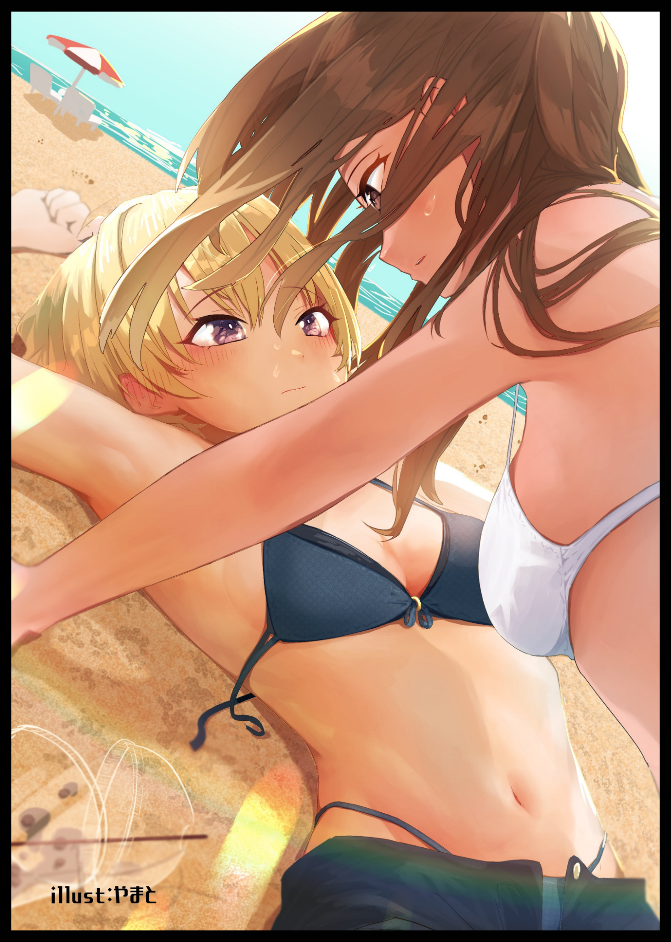
It was a sight that had Ava stunned to silence as her eyes traced the toned bulge of Kendra's tummy, the youthful sag of her breasts as they hang down over her before her gaze comes to a stop over her serene visage framed by swaying locks of curly caramel, half lidded eyes returning equal affection as they burned into her mind.

"Times up dear…"

"For what?"

"Hmhmm~ Care to find out?”

While Ava was still unsure as to whether or not the power she had festering inside her would one day prove to be a detriment as she once believed it to be, all those worries were set aside once her cheeks were tickled by the flow of silken hair smashing against her from above while her cold lips met Kendra's plump, warm cushions.

She had no idea how things could have turned out this way. But after experiencing life with Kendra for only a few weeks now? She only found herself looking forward to spending more time with her new girlfriend…

THE END

