YOU ARE (NOW) A NIKKE
BIG STORY #32
BY CHALDEACHANGE
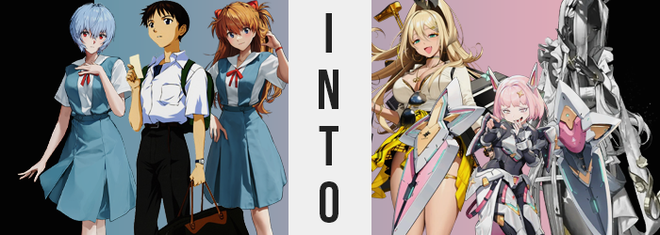

Shinji Ikari was confused, but that wasn’t exactly anything new.

Ever since he had been brought on as an EVA pilot for NERV, his life had been a confusing whirlwind. A mess of emotions that left him disoriented and sometimes forcing him to go with the flow, putting himself into dangerous situations by combating the Angels – whether he wanted to or not. It also took up a lot of his time. When the city was endangered, he was still a student, forced to attend classes even though his work for NERV tended to take up most of his afterschool time.

“I don’t want to do training drills again today.” Before setting out on his own from the school, he had been complaining to both Asuka and Rei about it. Neither of the girls showed him any sympathy, and Asuka’s words in particular were definitely a little too harsh. It hadn’t taken him long to find one of the hidden elevators that would lead him to NERV HQ and boarded it. It took him straight down, just as it usually did.

His confusion ended up stemming from the fact that about halfway down, the elevator stopped. “H-Huh?” For a brief moment it felt like it was moving horizontally, like it was being pushed onto a different track, and then it began to move up again. “W-Wait a second! Where is this thing going? Misato-san? Can you hear me!?” Shinji’s first instinct was to press the speaker button on the elevator in hopes of getting answers. But no reply came to him.

Making matters worse? A loud hissing noise filled the small elevator, prompting the boy to look up. Up at a pink mist that seemed to be pouring through the air vent. “I-Is that gas!?” What else could it have been? But the boy didn’t understand why there was gas in the first place. Wasn’t NERV supposed to be extremely secure? So, it couldn’t be the work of a bad actor, could it? Did that mean that NERV itself was subjecting him to this assumed toxin? “Crap! I should hold my breath!”
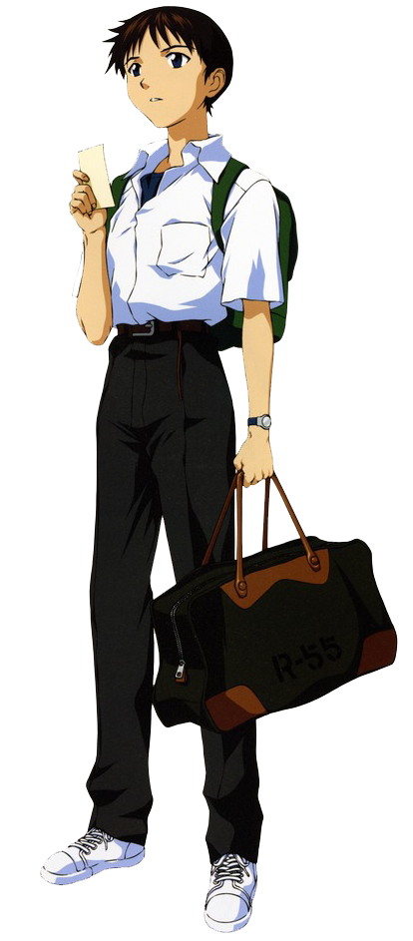
He did one better and covered his mouth and nose with his sleeve. He hadn’t gone that far down, so if he was going up now? It wouldn’t take all that long to reach the surface again where the door should have opened. He just had to hold out for a little while longer! …But the pink gas had basically filled the elevator now, even if it wasn’t thick enough that he couldn’t see.

The problem with his plan… was that the elevator didn’t stop. He should have reached the surface by now, right? But he hadn’t, and he couldn’t hold his breath any longer! Not given any other choice? He allowed a little breath to slip in through his nose. But a little was enough for his body to immediately begin reacting to its effects.

They just weren’t things that Shinji seemed to notice. All things considered? He could hardly be blamed for this. He was much too fixated on attempting to avoid inhaling as little of the gas as he possibly could. Even if that meant remaining ignorant to its effects in the long term. “Ack!?” His attempts were made all the more futile as the slightest bit tickled the back of his throat and pushed him to cough, his breaths sputtering to attempt to reclaim some of the oxygen that was lost.

Not that it mattered anyways. It was already too late for that. You could definitely see signs of the reaction in the boy’s appearance even before he’d coughed, for his hair? The color had been going awry. His hair was supposed to be dark. A very standard color for a Japanese boy, and basically the consistent color for most Japanese people in general. But his roots had lightened. They didn’t shift towards white or silver, but instead towards a hair color that was very not normal for a Japanese anyone.

Cotton candy pink. This soft and girly color traveled up from his roots and towards the tips of Shinji’s hair. It was only once this color had spread all the way through his hair that the full extent of the changes to his hair became even more apparent. Once it was all pink? It grew a little longer and a little thicker, transitioning in a layered bob that was long on the sides and possessed puffy bangs. No hair fell longer than his chin, but it was a very feminine hairstyle.

Which actually didn’t seem to appear all that out of place. “What’s… COUGH!?” Shinji could feel it. Something was wrong. But it didn’t really feel like he was dying? His voice sounded higher – was there helium mixed in? But without a proper view of his own face, it was difficult for him to put a finger on what was actually happening. It looked rounder and somehow even younger than it had before. More than that? There was no denying that it sported an increased level of femininity with poutier lips and smoother arches. His eyes narrowed in shape, but his lashes also lengthened, and his irises ended up shining with the same pink as his hair.

It made him look like a young girl. Especially with the small Adam’s apple he had smoothing away.

“I’m dizzy, too? This is so annoying!” Shinji was panicked, but it almost felt wildly out of character for him to bemoan what was occurring in such an aggressive manner. In the first place, his conclusion that he was ‘dizzy’ was actually entirely off the mark. It had arisen because he had felt unsteady on his feet, and because his head felt a little weird. The latter sensation was actually a product of internals making a dramatic shift from biological to synthetic, and a brain transitioning into a more computer-based form would only lead to such things.

But the unsteadiness on his feet? It was because his eye level was plummeting. He was shrinking, but not a substantial amount. He’d already only been 4’10”, after all. He merely dropped down to 4’7”, but this loss of height felt most like he had just been squished downward by an invisible force. It felt like this because, despite his shrinking otherwise, his shoulders appeared to broaden a little bit, and his thighs were parted several inches away from a narrow waist.

Shinji clicked his tongue and looked down at his clothing with disgust. “What even with this ugly outfit, anyways?” It clearly didn’t fit him, but was it really the issue here? He didn’t even really seem to care about the gas any longer – though it had practically thinned into nothing by this juncture anyways. Pants were bunched up around his knees while hugging him too tightly around his widened hips. This malfunction only grew as… what the pants contained also grew. Like his butt perking up into a small, bubbled shape, or his thighs thickening within strained pant legs.

If not for the height loss, it really would have put a lot of pressure on his junk. But… that wasn’t really all that big of an issue for very long. “Eep!?” While she was rendered incapable of properly processing her transformation, even the girl couldn’t avoid reacting to the sensation of her male genitals being pulled inside of her. The sucking of her dick to form a pussy seemed to be accompanied by the emergence of a pair of small breasts upon her chest, too. They just bounced out; a pair of perky B-cups.

“Ugh, what a long elevator ride! Were they trying to bore me to death?” Noah could feel the rising elevator finally beginning to slow. The girl probably should have had more relevant questions like that. Like why she was a girl, and such a bratty one at that. Or why she was a NIKKE, essentially an android modeled in the form of a girl to operate as a soldier. But as the pink haired youth seemed to see it? Nothing had changed at all! She was confident the elevator door was about to open so that she could step onto the Ark. And she was absolutely right!

She practically skipped out of the elevator door once it opened, a sprawling artificial city opening before her. It was the base within which she was stationed as a member of Pilgrim’s Inherit squad. “I guess I need to go report to Dorothy after getting changed, huh? But I should pay that stupid Commander a visit, too. I’m going to go show that dumbass just how much I grew on that mission!”

But she was an android? She didn’t grow at all?

“I SAID LET ME OUT OF HERE, DAMN IT!” Thrust into very similar circumstances in a different NERV-bound elevator, Asuka Langley Shikinami was not as nervous about things as Shinji was. Rather, her immediate reaction had been to express her anger. That seemed to be par for the course considering how she tended to act in general, however. “THERE’S SOME WEIRD CRAP COMING OUT OF THE VENT, TOO!”

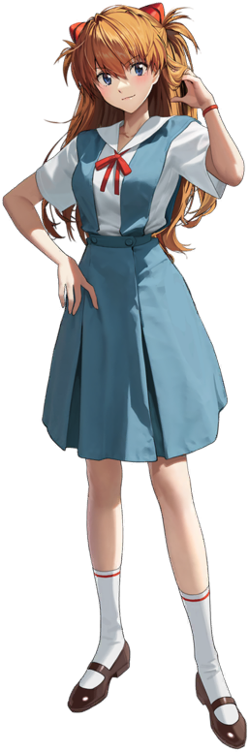
It didn’t really take the girl long at all to realize that the small space was filling with gas. But it wasn’t the same gas that was filling Shinji’s elevator at roughly the same time. Rather than pink? This gas was a silvery grey was a little more difficult to spot. Still, since she had both of her eyes (and nothing would ever change that, surely!), she was able to see it. She just didn’t have Shinji’s good sense to cover her mouth early on.

Which meant she began to succumb to it much more suddenly.

“That’s weird. I mean, there’s gas, right? But there’s no pain and I don’t feel sleepy? Maybe it isn’t even dangerous?” Or so she was boasting with her hands on her hips. If Shinji had found himself in this situation, she thought, he would definitely be freaking out! But Asuka, unsurprisingly, was just being blinded by her own smugness. Had she even taken a moment to look down at herself then she would have definitely noticed something very alarming.

Her complexion wasn’t right. Rather, her usual pinkish pale complexion had an odd tint to it? Like it was a little greyish in tone. But it was becoming more and more noticeable as the seconds ticked by and more of the gas was inhaled. What was originally more of a hue became a fully fledged color, the contrast of this grey darkening until she was practically a metallic silver color from head to toe.

Higher up? It was clear that it wasn’t merely her skin that was afflicted by an unusual color change. Her ginger hair wasn’t met with an unusual darkening, however, but instead lightening to a snow white from her roots. Much like with Shinji’s hair change, the moment the original color had been completely replaced, the locks grew longer. Asuka’s hair already reached the base of her back, but silkier locks reached past her butt whereas her bangs vaguely concealed her eyes. This length would remain consistent even if she grew otherwise.

Which she did. “H-Huh?” Asuka was made acutely aware of how her uniform’s fit no longer felt… accurate. She was also becoming a little wobbly on her feet, both products of a change in the girl’s size. Unlike what had happened to Shinji though? Asuka was becoming even smaller. Her own 4’10” height was rising. Her legs grew longer so that they extended out of her skirt, her torso lengthened so that her top was untucked, and a grey belly was exposed, and her arms pushed out of her sleeves.

“…These clothes?” They made up her school uniform, right? But wasn’t she a little too old for school? Her height had stretched up to 4’8” – a very dramatic amount of growth that had led to her hips and shoulders stretching, and not to mention her feet and hands growing in kind. Long, slender fingers rubbed at one of her now exposed thighs, the adult woman now conflicted about her garments.

It was plain enough in her facial features that she was older now. Asuka resembled a woman in her late 20s now, one with a long face and narrowed eyes that didn’t exactly look like an evolution of Asuka Langley Shikinami. No, with her dark skin and silvered eyes? Those full lips and big nose all helped contribute to the idea that she was not Asuka at all.

Of course, her body having become artificial in every capacity was part of this, as she was meeting the same fundamental fate as her fellow EVA pilot. She was becoming a NIKKE, but it just so happened that she was becoming a much more mature NIKKE than Noah had ended up being. Appearance aside, this was obvious in the calmer and collected way she spoke with her deepened voice. Even as she reached down to peel off shoes that hardly fit her any longer.

Even so, she could sense that something was amiss to an extent. “Something is off about this elevator ride.” The gas had thinned, but it was more or less out of her mind as if it had been invisible to her ever since she’d inhaled it. The issue here, at least from Asuka’s perspective, was her clothing. It clearly didn’t fit, and that issue was growing because, well, her body was still growing.

It wasn’t growing taller anymore. There was just ‘more’ to her body in key areas. Such as? Her chest. Her small cups ended up testing the already lackluster fit of a uniform top meant for a fourteen year old, lifting it even higher with the contents growing bigger. Breasts that were hardly even B-cups swelled until you could make out her underboob under the raised top, her grey tits clearly around F-cups instead when all was said and done.

Rounding her growth out, and finalizing her transformation, weight pooled into her thighs and ass. Grey skin became taut around her body in these places, thighs thickening into the kind of plush lap you’d love to rest your head on, while her ass? It had a perky heart shape to it that both lifted the back of her skirt and chewed up her panties within its crack.

“Hm.” Compared to the noisy, irate brat of a girl that she had been when she had first stepped on the elevator, Aria hardly uttered a word that wasn’t necessary in some capacity. This NIKKE had a much more reserved personality, one that matched her qualifications as a classical music and opera performer. She was refined and elegant, so much so that it might have been easy to forget that she too was an android soldier. But they were allowed to have hobbies and careers outside of that.

The grey-skinned woman was a member of the Prima Donna squad that had been created by Tetra Line. All of the members were musicians who represented different genres, and Aria was the most ‘proper’ of them all. Even now, she waited patiently for her elevator ride to come to an end so that she could step out onto the Ark and reunite with Volume and Noise, not a single thought in her head about her previous life.

“I wonder which venue I will be performing at tonight? Will Maestro be watching? …Will they have a change of clothing for me to wear?”

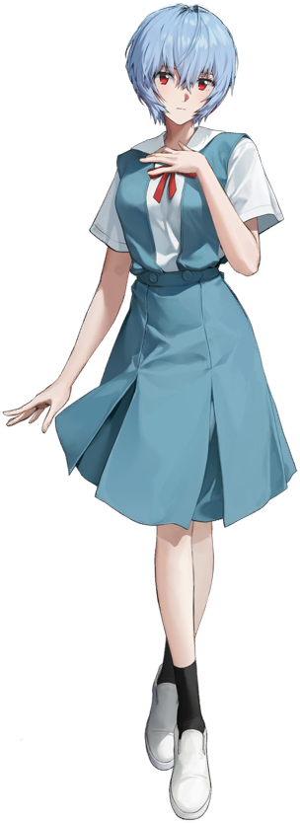
“…Ah.” Compared to both Shinji and Asuka, Rei Ayanami had perhaps the most indifferent reaction to what was transpiring within her own elevator. None of the three knew that NERV’s facility had been hacked by those on the ARK, and they were using their systems to steal away NERV’s staff, creating new NIKKE for them in the process. Rei was just destined to be another victim of this.

And she didn’t really appear to be that distraught about it. Her face wore the same expression even as the elevator stopped and changed tracks. It didn’t change when it began to move up again either. She barely even reaction to the sound of hissing above her. She just slowly raised her eyes to check what the problem was. “…Gas.” A yellow gas. But her body wasn’t normal, if it was toxic then it wouldn’t have affected her anyways. She didn’t believe she had anything to worry about.

But that was where she was wrong.

“…?” Rather than vocalize her confusion, Rei merely tilted her head slightly to the side when it struck her that the elevator felt smaller? And her clothing didn’t fit properly? She looked down at herself wordlessly, able to witness her own shirt becoming untucked from her skirt thanks to her shoulders pulling up higher away from her hips. Rei had been shorter than both Shinji and Asuka at 4’8”, but she must have already passed the five foot mark and was only continuing to grow.

The girl’s hands and feet grew too, her feet pushing the toes of her loafers to capacity while her fingers slimmed and took on a bonier shape. What was strangest about her fingers were her nails. They extended several inches past her fingertips and were painted with a gaudy, golden polish with glitter baked in. “What is, like…?” Why was she speaking unnecessarily. Why was she speaking like that? These weren’t even the questions she would have rightfully been asking herself.

Nonetheless, Rei’s height peaked at 5’4” with a similar side effect to what had happened to Asuka when she had grown. Rei appeared pointedly older, having a face closer to that of a woman in her early twenties. Those aged facial features likewise weren’t reflective of her previous identity, for her lips were big and round, her eyes softer in shape, her nose having more of a hook to it, and her face’s shape just being rounder on the whole. But there was also an addition of makeup, like pink lip gloss, blush, and dark mascara. Her ears ended up pierced, too!

“These clothes as so not it! But I’m sure I can… W-Why do I care about my clothes!?” The woman began to prattle on about her uniform like she was a fashion expert, and for a brief moment? She did catch herself. She wasn’t the type to care about things like fashion, but she couldn’t deny that she really liked fashion all of a sudden. And it just felt right to like fashion, so why would she stop? This acceptance was accompanied by a change in her eye color from crimson to blue – her ‘biology’ just as synthetic as any other NIKKE.

And that extended to her hair, too. Her hair still looked like hair, even though the color was clearly lightening to a sandy blonde and growing incredibly long, rather than remaining in its usual bob. When the hairs changed color, they also changed in design to be false copies of human hair. The style was long and luscious, cascading well past the center of her back while her bangs were long and messy. “IDK if I like this outfit? My hair’s a mess too. I wanna style it!”

She sooner had bigger things to worry about though. Physically. Rei’s small chest absolutely ballooned, inflating into a pair of G-cups that that easily filled her top and lifted it so that you could see the entire bottom halves of her tits, dark nipples and all. But there was something about this exposed skin… No, it was all of her skin. It took on a very light tan to give it a more copper-like hue. It was clearly a fake tan, but a tan, nonetheless.

The tan was only highlighted more by her ass, which wasted no time in lifting her skirt completely up. It forced her hips wide as the weight pushed her cheeks to jiggle about, a beauty mark appearing underneath her left cheek. Of course, her small panties had a hard time with such a big ass to contain – a hard enough time that their waistband snapped, in fact. The weight that her ass couldn’t contain bled into now exposed thighs, stretching tanned skin around upper legs that were practically three times thicker than they had been before.

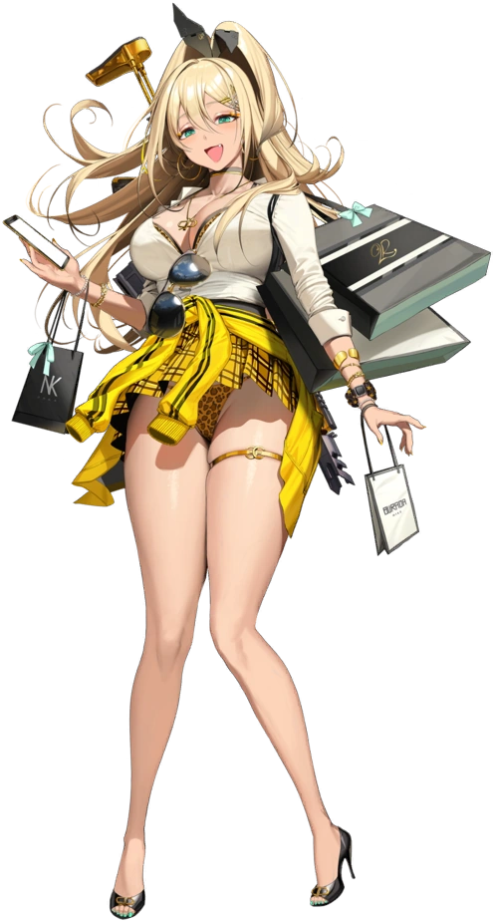
“NNNNNGH! Ahhhh! I guess I really need to find something else to wear, huh?” The NIKKE gyaru gave her arms a good upwards stretch and dropped those arms down again when she was done. Her tits had lifted while stretching, but when she allowed them to drop again? Her ample bosom heaved and bounce. Her tanned tits were quite excessive, but Rupee wouldn’t have had it any other way. She was the ARK’s local gyaru girl, and a good gyaru had things to look at, right? “O-M-G! What a long elevator ride! I totally thought I was gonna be bored to death~!”

Thankfully it seemed the ride was coming to an end, so the Talentum squad NIKKE could return to her shop. She was an entrepreneur, after all! Not only did she own a shopping mall on the Ark, but she was the CEO of her own company, Rushae! Being the fashionista that she was, it only made sense, right? But she’d been sent on a mission for a while now and was excited to be heading back.

“I am totally not looking forward to all of the paperwork I’ve missed, but oh well~! Them’s the breaks for a working business gal!”

