

It was dark out with not a sound to be heard besides the incessant whine of nocturnal insects lurking unseen in the nearby bush, with only the distant glow of a bustling cityscape and the thriving suburbs that surrounded it pointing to any sign of human activity beyond the dense mess of towering trees and overgrown foliage that surrounds the lonely villa, built on the fringe of society, a home for the reclused and secretive shrouded in nature’s serene embrace.

With the growing rumble of a car’s tires rolling in from beyond the walled perimeter, the evening quiet soon fades under the crunching of rubber scraping asphalt while the weight of a heavy chassis shifts to and fro with meaty clunks and thumps as the pale vehicle rolls into the driveway, maneuvering with a deft turn around the bend without a hint of hesitation or adjustment. A seasoned driver maybe…or perhaps it was the homeowner themselves returning from a tiring day outside and eager to retreat into their abode for a well earned rest.

But as the car door slams shut to reveal the furrowed face of a spritely young man, his visage filled with foreboding and suspicion. The thought of hopping into a bathtub full of soothing water didn’t seem to register inside his head as a lax thumb depresses the locking mechanism before pocketing it without a second glance, not when keen eyes were locked to the front of his home, looking more like he was staring down a stranger and not a perfectly normal home anyone else would’ve been glad to come back to.

Walking up to the front door with extra care in his step to shroud what little of his presence remained that hadn’t already been broadcast for all to know by the purring of engines and shining headlights bearing down on the silent home a few seconds ago, the latch of a hidden DNA scanner flicks in recognition of it's master's touch, allowing him to twist the knob sharply to avoid the sharp cream that would always follow if he did so without urgency. Stepping foot into the house as automatic sensors kick the power back online, illuminating the main hallway and the spacious living room that laid beyond while ventilation and air conditioning fills the atmosphere with a mildly comforting ambient hum that does little to soothe the troubled man’s racing heart as he continues on his way, tracing the the headrest of the couch to feel an uncomfortable iciness that made the place feel all the more empty and lifeless in stark contrast to recent memory.

A mouth opens, about ready to speak before quick thinking silences the words before a loose tongue could form them. He was still knee deep in unknowns, a conundrum possibly stemming from recent events no one else knew about, a possible issue he was left on his own to try and get to the bottom of all while dreading the foreign entities that might be lurking deeper in the house…or what could have gone missing since the time he left earlier that morning when the sun had yet to rise over the distant peaks and crags of a modern city, an invisible horizon masked by the darkness of night as the troubled man takes one lasting glance outside the second floor window as he finishes ascending the stairs in a slow, steady manner. Keeping an eye out for unusual shapes lurking in the shadows while pricked ears scanned for any sound that wasn't his own muted footsteps over the entire duration of the agonizingly slow trek down the long hallway leading to the master bedroom at its very end. Clued in to his suspicions being more than just simple paranoia when the automatic lights failed to light the way forward, leaving him to trudge through the void while his eyes struggled to adjust.

He didn't need to double check most of the open doors or side paths along the way. Not when they either led to spare rooms that weren't in use or bathrooms he could easily see the entirety of with their straightforward layout. If there *were* any intruders, then the place they were most likely to still be inside of was his room…and the one place he hoped to see a familiar face in as careful hands reach for the door knob before recoiling a tad upon realizing it wasn't secure, the heavy mahogany slab left to lean ajar serving as an indicator to his worst fears come true…

**[*Kzzkt*…*M-Master Wilford*? You’re finally home…apologies for the mess but could you help me up? Something seems to have gone wrong with my self repair processes…]**

Stopping to turn down at the scratchy vocals emanating from somewhere near his feet, the bewildered man spots a glimmer of light emanating from the base of an ovoid object lying right in front of him…the head of a beautiful blonde missing her body from the neck down, boyish eyes closed tight as if she were asleep, lean lips pouting and ajar. Still and lifeless as to be expected of a decapitated individual without the accompanying blood and gore. A fact protested by the brilliant blue glow pulsing like a beating heart in tune with the scratchy, digital noises crackling from somewhere within the mess of artificial implements and wires. It was a light he’d familiarized himself enough over the past few months or so to be a vocal processor, obviously damaged and left exposed to the elements after being struck by something that had struck with such strength as to blow clean through an android’s biomechanical frame as evidenced by the defunct head he was looking at, hurriedly taking to a knee while a careful hand lays the bag he was holding on to the whole time gently on the floor.

**“Jesus…what happened here? Did we have a break-in?”**

**[*Crk-*ell you more later Mas*-fzz!*]**

With the vocal distortions growing worse alongside a notable dimming in the circuitry, it was clear that whatever happened here had taken place quite a while ago. Long enough for the self preservation systems most androids had installed to fail, hampering any further attempt to investigate.

Sighing as he cradles the disembodied head with a gingerly grip, the man rises up to full height once again, doing a quick scan of the room before hurrying toward his target; the limp body of a female android decked out in cosmetic parts complete with menacing horns that worked in tandem with an outfit to give her the appearance of a devilish woman from the underworld…odd, but there was little time to waste as he pushes the beheaded body over before carefully lining up the sizzling socket with that of the blonde haired head in his arms, ensuring the sizzling flakes of synthetic skin more or less lined up with disconnected pipes and worn plates, taking a step back once he was done to inspect the hastily repaired android as her body begins to move almost immediately after the return of her cranium, patting herself down as if nothing had happened before securing the smoking ring around her neck as she rises to a seated position on the bed to look her savior in the eye just as she opens her own, revealing azure spheres, framed by low hanging bangs that glimmer with an ephemeral shimmer as they refract the neon internals blinking on and off behind emotionless eyes, bouncing an array of crimson and gold through the clear blue glass that served to perfectly mimic the iris of the human eye to a stunning degree of accuracy…at least, when the hardware wasn’t spazzing out of course.

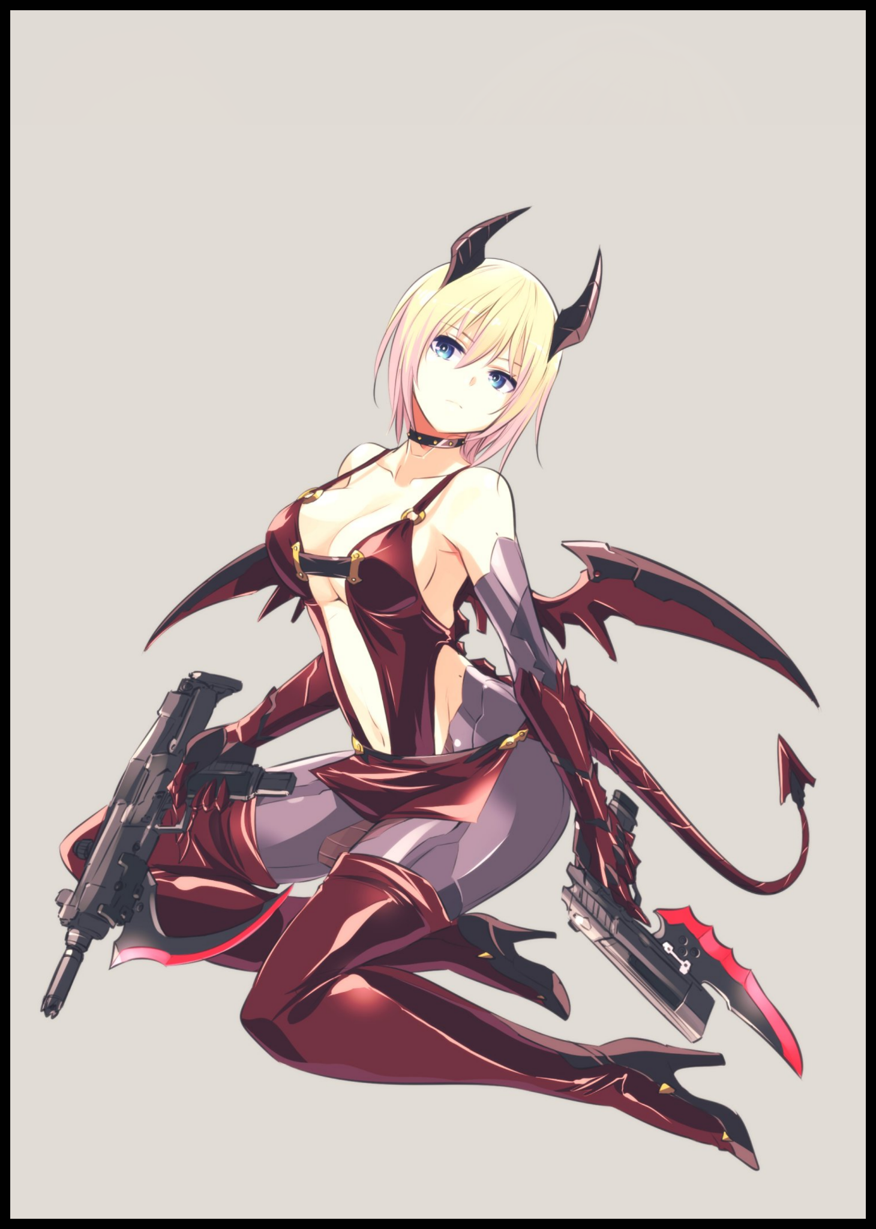

Leaving the android to figure things out for herself, the man turns his attention toward the nearby desk. His paperwork neatly tucked aside in the exact same way he'd left it last night in order to make space for something…no doubt the supernatural getup currently adorning the android's body, leaving just a black, flexisteel choker and a pair of matching guns lying on the table.

**“Going real gung-ho with the whole spooky gun toting seductress image huh? Where did you even get all this? Looks custom…here, hope they aren’t loaded!”**

After a moment’s silence, the android’s neck swivels over to face her owner, eyes flickering for one final moment before settling back into their base color with the finalization of her body’s temporary repairs. Giving her mobility to swiftly snatch the weapons in both hands as they sail through the air towards her. Ending off with another nimble grab as she sets down the guns before locking the last accessory around her neck to conceal the still regenerating seam that had once been a half melted stump.

**[It is Halloween…I ordered these from a renowned android kit producer famous for life-like depictions of fictional characters and their associated props…is it…not to your liking?]**

Eyeing her up where she sits, the man rubs his chin as he observes his companion. Taking on a pose that accentuates her figure by sidling further into the bed to give herself enough space to tuck her alluring legs beneath a heavy rear. Thrusting pendulous hips out to the side while slanting an inward arching spine to bring attention to her jiggling bosom, teasing the creamy melons snuggled nicely within the shimmering leather straps that made up the scandalous outfit with only a singular band looping around to conceal the tantalizing dip of her flexible back. Flanked by decorated arm modules that, like her legs, were made of a separate material entirely divorced from the faux skin that made up the rest of her shell in an effort to make it look like form fitting gloves and tight leggings that ran the length of her lower half all the way up to a cutout that splits off from her privates, a forbidden sight hidden behind a woefully short skirt with gaps down the sides that further hampers its ability to carry out its intended function.

Add to the ensemble an animated pair of wings sprouting forth from somewhere behind her back alongside a segmented tail with a spaded tip snaking forth from a rig connected to the base of where her tailbone would be were she human, and she really did fit the look of a seductive femme fatale from Hell…

**“You look…good…but what was with the whole…head kaput thing? What even happened here?”**

**[Satisfaction noted…as for recent events…the parts…specifically, the neurolink, was incompatible with my software…hence the sudden overload my subsystems were able to contain near the base of my neck…you needn't worry yourself anymore Master.]**

**“Glad to see you’re alright…but please, could you take that thing off? I appreciate the gesture but I don't want you 'overloading' on me again…not when I've got a little something for you tonight.”**

Despite the lack of a visible reaction to be seen on her face, the man knew full well she must've been inquisitive as a puppy behind that cold mask of hers. A genuine personality that wasn’t some hard coded artificial intelligence built to cater to the whims of whoever it was meant to serve and the only reason why he could genuinely address the android before him as he would any other human being…a ‘kindness’ he still wasn’t sure he’d come to possess if a certain accident hadn’t turned his spur of the moment purchase into a dedicated pursuit to lighten the suffering of a close friend…something he hoped he had succeeded in over the past two or so months since Aiden had lost ***his*** human form despite the inability to track said progress in any form besides the weekly scans he had to send his biomechanical companion to as if she were a sickly patient.

And at the root of it all laid a seemingly harmless order for a ***Companion Droid***, the manifest of which was still tucked away somewhere inside the digital annals of his computer’s inbox. The straightforward name was, in itself, a mask that served as a ‘kid friendly’ term for what was essentially a made-to-order partner for life who would dutifully do anything asked of them by whoever was registered as their owner. Even if the order was something no one in their right mind would ever lower themselves to with only the barest of restrictions put in place to prevent misuse in the form of keyword blockers and anti-tampering measures to ensure no one could turn their Droid into a Terminator…not when the multi-billion dollar tech giant responsible responsible for manufacturing them already had a line of androids tailor suited to that scenario. A line reserved exclusively for the world’s militaries and whoever else had the exorbitant amount needed to purchase a Droid whose only purpose in life was to excel in the art of combat. Such was the global monopoly ***Artilife*** had on the android market…

***Robert Wilford*** was one such man, but his aspirations and wants were simple. Not too high reaching but motivationally driven enough to keep his career as a programming engineer for Artilife going well and strong to supply himself with the funds necessary to maintain his cozy little abode far removed from society at large in addition to a little expense that would definitely take a fraction out of his savings once he went through with it. The tiny pebble that would serve to kickstart a series of events that would ultimately lead him into ending up with a highly unusual and unique android that looked to be just like any other Droid at face value.

According to Aiden’s account, he had been working the production line within the cavernous depths of the factory when he had received word of Robert’s compromising order. But it wasn’t his name, or even a picture that gave it away. It had been the use of the nickname his lesser known social medias were branded with that immediately clued him in to his millionaire buddies seedy purchase.

Unlike Robert, Aiden was on the opposite end of the spectrum when it came to his life as a whole. A middle class citizen who didn’t have millions to his name and no noteworthy achievements for anyone to remember him by. And with a far more demanding job in the physical department that, unsurprisingly, paid for far less than the cozy desk job his friend held. It was safe to say that he didn't have the luxury or time to afford such 'leisurely spending'...but it did invite enough curiosity within the young man to see for himself just what kind of girl Robert preferred. After all, the appearances of the Droids were determined by the client…and in the middle of another routine day for the glorified sweatshop working in charge of moving the stuff needed for the machines to do their work around the sweaty armpit that was Artilife's factory, the least Aiden could do to pass the time was to look upon his friend's dream girl and ridicule him for it once his shift was over…and like any good industrial accident, carelessness would get the better of the seasoned worker as he stepped out of the safety of the control room and into the production line where the magic would happen.

A spill…or maybe an uneven grate…no one was certain of the cause behind the fateful fall and proceeding tumble Aiden would experience midway through scaling the perilous rungs leading down into the observation tubes where personnel could check on the line from behind the safety of sturdy plate glass built to withstand incredible amounts of stress, making them excellent barriers for a makeshift prison. One Aiden would find himself in upon recovering from the rough fall that had ended with a broken arm and a sprained ankle, realizing with building dread that he had fallen into a section of the assembly line that was basically a blackout zone, a fatal zone where the factory's automatic safety measures could not see the unfortunate human that had fallen into its belly. The flaw in question had, of course, been fixed by now. But now was far too late for Aiden who had the pleasure of becoming the first (publicly known) case of a human being subject to the whims of an AI programmed to forge biomechanical bodies of mostly feminine design…and seeing how it would react to a foreign entity being 'fed' into its machine innards…

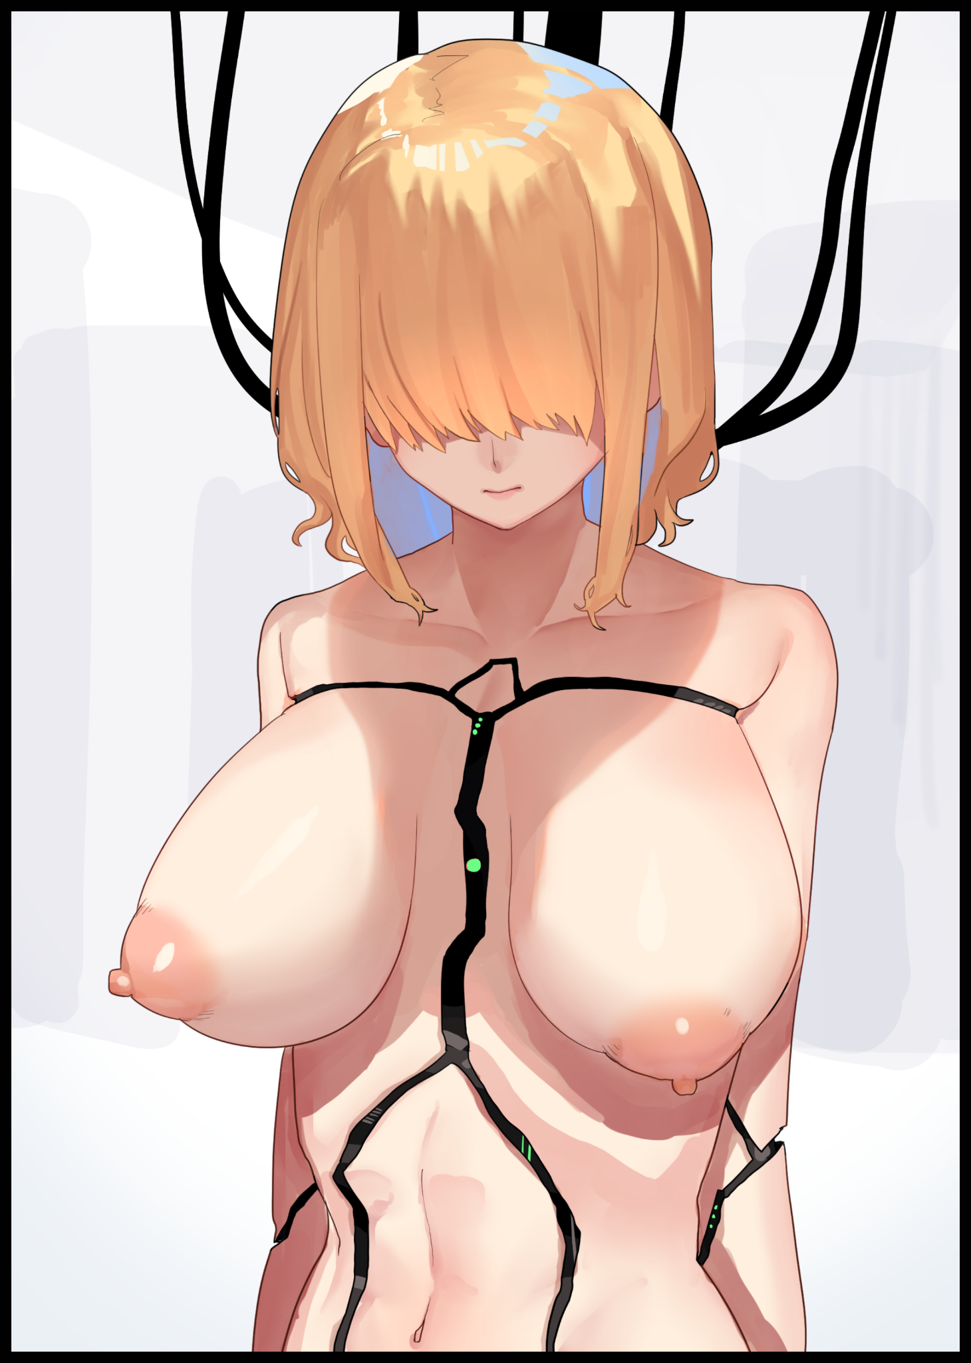

No words were necessary for Aiden to explain the traumatic process he had endured as the merciless line worked to correct what it saw as an error. And thanks to the state-of-the-art nanotechnology, the painful conversion of flesh and blood to artificial biomass, coolant and other miscellaneous fluids was swift, the suffering minute as gaseous nanite clouds and machine arms worked to perfect Aiden's form to Robert's specifications unbeknown to the programmer who was, at that point in time, about to pack up and leave early in order to receive his 'package', none the wiser to the last minute nature of his Droid's creation and the surprise it would come bundled with as he steps out into the parking lot before driving home, excited and raring to go at the same time Aiden's unrecognizable form had been packaged up into a solid plywood crate for delivery. A sarcophagus concealing the naked body of a processed android and the digitized soul of a human held down in a comatose state once the soft tissues of the brain had been converted into a synthetic computer core not too divorced from the flesh and blood organ it once was.

Blonde hair in place of drab brunette, lengthened and refined into silky smooth strands that curled at the tips. Heavy double D's that flopped naturally down a slender torso, formed through a cost efficient process to reactivate dormant glands and stimulated nerves while filling in the obese flesh around them into tantalizing melons that were the blessed teats of a healthy young lady. A toned physique that wasn't too curvy but with enough attractive flair to draw the eyes even more when the observer's gaze would inevitably shift from swollen breasts down to a tight stomach with the visible indentations of firm meat beneath pressing against baby smooth skin to form the supple core of a soft spoken beauty, splitting off down the sides to matching pillars formed from coalescing layers of pliable fat and jiggly meat before ending off in sturdy calves tipped with dainty feet…the supports for an arch above that houses a subtle oval shaped slit. A perfect one-to-one recreation of a woman's vagina complete with fattened labia lips capable of clenching down around her lover's length, concealing flowery folds of velvet flesh kept at a constant level of moisture fueled by artificial organs repurposed from outdated testicles that had been sucked inside of Aiden's flower with a wet 'SPLURT' shortly after his ass had been pumped full of and reinforced by the nanites currently flooding *her* system at the same time a wrinkled old pecker had ceased to exist.

Trundling down the road in an automated truck side-by-side with a silver four wheeler, both friends would remain oblivious to each other’s presence as they sped toward Robert’s sequestered home that evening…

Even if Robert had missed the verbal distortions of Aiden’s fading echoes upon the activation of his Droid, there was no way for the security camera footage of the production line to go ignored once the techs running their daily checks at the end of their shift had caught sight of the worker slipping off the rung and into the line itself after being caught on a ledge mid-fall that ends up redirecting him from the safety of the observation platform…followed up by the inevitable conclusion they all came to once further checks saw a certain order being fulfilled at the same time ***Aiden Gowalski*** had vanished with no grizzly scene to be found in the depths reinforcing that line of thought. Spurring efforts to get in touch with the customer as soon as possible just as he pops the cap on the package back in the privacy of his home.

It had been faint, but the plea for help vocalized by Aiden's scratchy, distorted voice had been loud enough for Robert to be clued in, piquing further curiosity after the discovery of a mole that survived the process, a familiar one located on the nape of the android'sneck that he hadn't specified in the order detail, dismissing it as simple coincidence until Aiden's voice returned once more, struggling to break through the added layer of restrictions and commands that made up the artificial personality of ***Selene***, Robert's dream girl. Interrupting her greeting with confused mutterings and half worded cries for help that sent the man into a panicked mess as a hasty phone call for support conflicts with an incoming one from Artilife themselves.

Little needed to be said about the events preceding the call. All Robert could really remember from that moment was a few tense minutes spent waiting for the responders to arrive before he'd found himself in the back of a nondescript van speeding back toward the building he'd left close to an hour ago, bewildered and still not completely convinced that there had indeed been an accident involving his best friend and that this wasn't some plot to nab and punish him for his illicit purchase, not until the group was back inside of the Artilife branch's depths to perform a thorough scan of Aiden's frame and to see just how drastic the 'damage' was.

Bone structure completely subverted in favor of a reinforced, flexisteel frame with calcium reserves set aside for backup fuel alongside all the other 'unnecessary' bits. Cavities filled with artificial organs, flesh and machine components. The total lack of a reproductive system…all standard issue Companion Droid hardware that wouldn't have been troubling to see show up in scans if the subject hadn't been human at one point in time…a technological feat performed solely by automated machines, a glimpse of which could provide the eggheads of Artilife a massive edge in the field of nanotechnology if they were able to decipher and replicate Aiden's 'accident' and vice versa for their own gain. An outcome prevented by Robert who already knew what the lead engineer was about to say to him before he could even voice his words.

There was no damage assessment or a plan to help Aiden out, so Robert had one of his own; to keep his friend close at hand and help her through what must've been a truly horrendous experience if her incoherent babbling was anything to judge by. Besides the memory, there truly was nothing left of Aiden's old self, not even her gravelly voice when only vestigial data fragments lasted seconds before vanishing altogether. Leaving her trapped in a body, quite literally of Robert's design…and the knowledge of that had been grave enough to motivate the normally lackadaisical individual into action…

Over the following days, an arrangement between Robert and the geeks at Artilife would be put forward in an effort to keep Aiden from becoming a lab rat; in exchange for weekly visits for data gathering and health checkups, Robert would be 'allowed' to host his androidified friend over at his own home far from the city center…and even though that outcome sounded simple enough, appealing mercy and human ethics to a cold hearted corporation had been a major pain in the ass for Robert. Nevermind the fact that he had already paid good money in the first place, now he had to make cuts to his future pay going forward…and that promotion to a managerial position seemed like a distant dream now that he had definitely lowered himself in the eyes of Artilife's management. That, and Selene no longer being a thing was enough to make Robert feel just as down in the dumps as his friend was…but he just couldn't abandon Aiden, not when he felt like he had a hand in her misfortune.

And so the two would begin a close lived relationship with one another in the quiet abode that was Robert’s cityside villa. Beginning as a shaky one that initially didn’t see much progress at all when Aiden would spend most of her days like a quiet doll, sitting in the living room without doing a thing or saying a word. Only ever moving when Robert had to bring her out for her weekly checkups. According to her, she’d been ‘thinking for what a hundred days’ in those handful of weeks thanks to how her perception of time ‘within’ had been altered on a fundamental level now that her body wasn’t that of a flesh and blood human anymore.

*[It’s like passing whole months at a time when I go there…but then I wake to your voice Master…and it’s only been seven days…]*

Despite the loss of the Selene persona, the hard coded nonsense just couldn’t be overwritten no matter what the techs at Artilife tried or the various android components Robert had started to buy in an effort to normalize Aiden’s bourgeois frame. Beginning with the more subtle things like a standard chassis instead of the sex-obsessed one Robert had envisioned before his simple purchase had soured. And then there were the vocal modules, a tricky one to get down and the component that would spur the android to come out of her shell after realizing her Master would spend more without her advice and presence…she hated the term at first, but after awhile, the forced submission to acknowledge her best friend in that way had become as natural as the constant use of ‘Bud’ she once used to call him by.

She wasn’t completely sure what was going on, but the more their partnership developed over the course of her stay at Robert’s home. The more she had started to settle into the role of a stay home…girlfriend…an as of yet undecided terminology she just couldn’t shake after realizing how naturally she was starting to live life again after picking out a suitable voice pattern instead of the ditzy southern accent that came pre-installed. And although she knew full well that Robert must’ve been chewing into his savings with each purchase of such expensive components and parts, a part of her electronic core couldn’t help but fizzle and spark at the joy she derived from it all…a peculiar oddity the suits and coats at Artilife still couldn’t explain besides ‘simulated emotion’...because they felt just like the real thing. Which only made it that much more painful to know her unique software seemed to be incompatible with just about every single cranium out there; leaving her without the ability to emote or express herself. Even the vocal modulator didn’t want to cooperate, making each word sound like it was coming out of a droning water machine rambling off about a spin cycle coming to an end or whatnot.

**[Master? I’ve done as you asked…what was it that you wanted to show me? Is it another…android component?]**

**“Hm? Oh…sorry…I was just daydreaming. It’s a…why would you do this to me Aiden…”**

But tonight was the moment Robert hoped to address all these issues as he snaps out of his trip down memory lane, only to come face to face with a stark naked Aiden lying on the bed, her face as lax as it always was despite the brazen exposure of her body save for the cosmetic extensions that only served to make the stunning display that much more…titillating…

**[I simply did as you ordered me to Master…you did say to ‘take that thing off’...and a ‘thing’ can mean anything. So I saw fit to rid myself of everything on my person.]**

**“My bad then…but personal perception of words aside…here, this…is the thing I’ve got for you.”**

**[Is that…Master…where did you get something like this? The scans…it’s unregistered!]**

**“That’s because it was made…for you…thanks to our ‘friends’ over at Artilife…I think we just might be able to make the rest of you fit just right!”**

Small enough to fit in the palm of his hand and indiscernible for any old prescription medicine lies a small back pill. A nanite ‘bomb’ that, once ingested, would deliver a cloud of microscopic machines designed to do whatever was needed of them before biodegradable components melted down upon the completion of their task. Except Aiden had no idea what she might need one for, sowing the seeds of uncertainty in her mind as her posture noticeably slumps with unease.

**[And you…trust them? What if it’s bugged? A trap?]**

**“I don’t…but this? It’s mostly my work actually…I just had to…take a little crack at what the noggins found out about your body’s software and the layout of the core components over the past two months among other things. Refining a nanite pill with the instructed measures…and I’m pretty sure I’ve got something that can give you a normal life!”**

**[But I’ll still be an android…won’t Iwhat’s going to change if I’m still a machine?]**

**“Sure…you will be…and I doubt anything can change that at this point…but you’ll be whole again. Not a soul stuck behind cold plastic and metal that won’t budge. And uhh…it might even open up the possibility for a…more fitting frame…if you catch my meaning?”**

**[You mean..a male android body? It can…do that?]**

**“Not immediately of course…but if it works, you’ll technically be compatible with all sorts of android components…including a full overhaul back to the other side of the fence. Why? I thought you’d be happy about it?”**

Stepping off the bed toward Robert, Aiden slowly takes her friend’s outstretched hand in her own, brushing the sides of the programmer’s palms with her thumbs before returning them to her sides, staring down almost sheepishly as if she had something to say but couldn’t…

**[Well…i’m flattered…really…but…these past two months have been…strange, haven’t they?]**

**“Uhh…yeah…they have…my best friend ending up mixed in with my order for a life sized sex doll? Who woulda thunk?”**

**[There is that…but this body…the times we shared with it? I…it almost feels wrong to say this now but…would you mind if I…if *we*…keep going like this? In fact…I want to go further.]**

**“A-Aiden…where is all this coming from? Are you feeling alright? You’ve got no reason to feel bad for anything! This is all-”**

**[Wrong…anyone can see this to be an error on my part…I ventured out onto the line that day because of my own curiosity…and we both know the line’s ill maintained security measures are the fault of Artilife…not you…not me…and if you don’t mind me being so presumptuous…a man offering pills to a woman…surely there’d be better, more exciting ways to do so than by hand, yes?]**

**“Since when did you learn to talk that way? If I didn't know better, it's almost as if you installed some seduction subroutine while I wasn't looking."**

**[Maybe…but from your reaction…you're okay with this? I was expecting some pushback…after all, it seemed like only yesterday when we went out to grab that vocalizer…]**

**"One month and twenty four days to be exact…dating my best friend who'd been turned into an android after falling down a chute…maybe we should get that turned into a novel some day, might make it big y'know?"**

**[Certainly unique material for the average reader…thank you…Master…and in case things don’t work out, I just want you to know these past two months…your efforts..they’ve certainly been a big help.]**

Tiptoeing onto her feet just as Robert inserts the black pill into his mouth, Aiden cranes her flexible neck forward to receive her first kiss, registering the touch of her friends coarser lips wrapping around her own before the wet length of his tongue pushes through to deliver the goods, exchanging oral fluids for a second before the android tensed up as her vision flares with alerts and sensory warnings accompanied by scratchy static that webs outward from the sides of her vision alongside a concerning cluster of blinding flashes going off in her eyes as her body begins to crunch inward and shrink ever so slightly while trading feminine traits for subtle boyish flair once broad hips tighten in while a bloated ass recedes ever so slightly.

**[U-Ugh! M-Master?! I…I can feel it! The nanomachines!”**

Robert wouldn't reply with a vocal response, opting instead to wrap his hands around his dainty companion as her convulsions continue amidst unnoticeable changes both within and without…until a strangled cry escapes Aiden's soft lips in tune with a still mask creasing with pain, *with emotions*. Made clear for the first time in two months as the android's stuff, doll-like composure steadily gives way, losing the rest of the metaphorical chains that kept her shackled as emotion dampeners and impulse blockers vanished. Allowing Aiden to feel with her skin once more while her automaton voice cracks with audible ups and downs to finalize her place in the world as an android-human hybrid. Ridding her body of the metallic grays and artificial stiffness that gave her android heritage away as webs of artificial skin creep over the rest of her arms and legs to mask it all, complete with a new growth down below as strands of silky pubes begin to emerge over a fattened vagina…

And not even waiting a second after the process had been finished, an excited Aiden finds herself lifting Robert off of his feet thanks to the assistance of powerful arms that packed the power of jackhammers in each one, carrying the man over in a bear hug that ends with him sprawled out on his back amidst a mess of component parts and sheets while Aiden laid out on top of him.

**"Ahh…my voice…two months since I've heard myself speak with life in every word! And my skin? My body! I can feel everything again!"**

**"Ahah! I knew it'd work! I gave the nanomachines some of your old genetic samples I picked out from your old locker just to see if they could reverse the transformation but…"**

**"*But*? You sounded a little disappointed there~”**

**“No…nothing like that…it’s just…has it really been all that long? Two months since the fall? I still don’t see how you of all people could ever end up growing on me.”**

**“Well…you’ll have all the time in the world to figure that out then!”**

**“Haha…and here I thought you’d be…Aiden? Your…”**

Wide eyes draw downward to the spot Robert had latched on to, followed up by a severe blush and a period of silence as the couple’s eyes remained glued on the puckered folds of Aiden’s snatch squirming against the soaked denim bulge. An erection raring to meet the soaking wet lips of the fairer sex pressed up tight against it…

**"I guess the cat's out of the bag huh?"**

**"In your case? Yeah…those emotions of yours must've really been bottled up after all this time if your body’s responding like that right off the bat…besides *that* though, do you feel anything off?”**

**“No visual glitches…my core’s hot…a little tingly all over..”**

**“But your head’s still on…Aiden? Could you do me a favor and try saying my name?”**

**“Robert…Roooberrrt…oh my god…it’s been forever since I could talk without that Droid filter over my mouth!”**

The two share a laugh to end the victorious moment off before awkward silence returns, leaving Robert to stare long and hard into Aiden’s blue eyes before the lenses flicker, fading in saturation before brilliant amber surges forward to take its place. Finalizing what little of Aiden’s original self could be brought forward into the android body of Selene…and despite his attempts to keep things strictly business and purely on a friendship level, the sudden proposal for a deepening in their ‘relationship’ and his acceptance of it rendered those terms null and void.

**“Aiden? What’re you…”**

**“Shh…just let it happen…”**

He’d spent way more than he should have over the past two months and lost his ‘ideal’ girl in the process. But after all that time, the experiences he had with Aiden’s reborn self had been undeniably…fun. To come back home to the lights already on and a warm dinner waiting for him alongside someone else to share the moment with. It made his mind wander back to the possibility of what would’ve happened had things gone normally without Aiden’s fall. The two would still remain as best friends, he would’ve continued on his stagnant life while shagging some soulless husk masquerading as a southern ditz…and he wouldn’t be here; laying down beneath his utterly feminized friend who was in the midst of undressing him as dexterous hands gently peel away wrinkled clothes after popping open buttons and undoing clasps.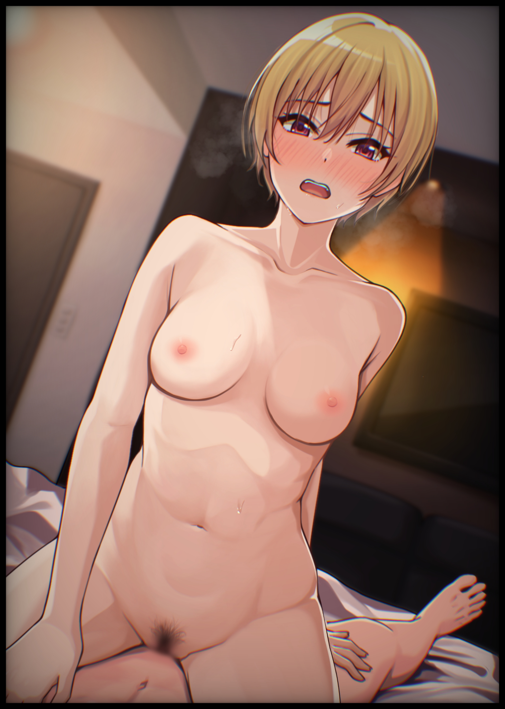

By the time his boxers, soaked with Aiden’s juices, had been kicked off the edge of the bed. The blonde haired android had already returned to her original position atop Robert’s waist, nudging her vagina against the full length of her friend’s girth all while her body begins to succumb to the carnal desires that had been building up in her lower half ever since being given the freedom to savor bodily sensations once again. To make known how she truly felt with facial expressions and free flowing vocals…and as Robert’s hand rises to meet Aiden’s in an effort to guide her gently until her throbbing snatch hovered precariously over his member, he could only see the truth behind her words cemented across her perfect visage…

THE END

*Image Sources*

Image 1 by Ishiyumi : <https://www.pixiv.net/en/users/1573847>

Image 2 by Koiso_Usu : <https://www.pixiv.net/en/users/52378658>

Image 3 by T.R : <https://www.pixiv.net/en/users/14547683>