FATE / CLASS WARFARE
CH1: THE SHIELDER
BY CHALDEACHANGE
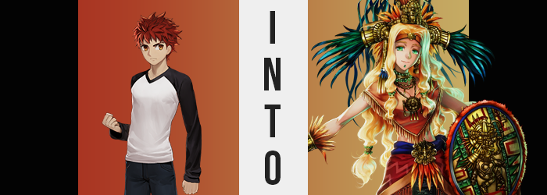

The Fifth Holy Grail War.

Contained within Fuyuki City in Japan, this war was a clash between Masters and Servants for the right to make a wish upon the Holy Grail. Those Masters were mere mages that had enlisted themselves into the war for the sake of the prize, while the Servants? They were the spirits of heroes and legends from times long past, summoned into the present to act as extremely powerful familiars for those Masters.

And at their core? Every version of the Holy Grail War across time and space followed a similar base format. The Fuyuki was had seven Masters and seven Servants, but in another war those numbers might not be the same. There were, after all, at least fifteen Servant classes in existence – although many were unknown to those participating in this war.

But what about another? A Holy Grail War taking place in another time and another place? What if the means used to summon Servants into it wasn’t as… traditional? What if the magecraft utilized in its conception had some very peculiar requirements? One that stole away mages from other times to act as bases for the Servants that had to be summoned? Mages like… Shirou Emiya.

“Huh!?” The red head practically jumped as a veil of darkness that had been cast over him all of a sudden was cleared. It had been so strange. They had been in the midst of the Fifth Holy Grail War, and Shirou had been at home preparing dinner for Rin, Saber, and himself when everything had suddenly gone black. He had sensed magecraft at work and had wondered if he was being attacked by another Master and Servant pair, but when the darkness cleared? “…Is this a summoning circle?”

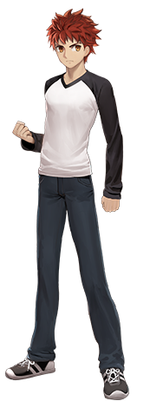
He was standing in the dead center of what only could be considered a circle for summoning Servants, and that alone was already plenty strange. But making matters stranger? The boy had clearly been teleported – yet the place he found himself to was familiar. “Isn’t this the Fuyuki Bridge, too? But… something’s strange.” It was the dead of night, and no cars were crossing it. Who had put a summoning circle there? Why had it summoned him? And why did the bridge appear more worn down than he recalled?

It was almost as if a lot of time had passed. Shirou gazed out at the city nearby and this sentiment was only enhanced. “There are buildings I don’t recognize… Is his really Fuyuki?” It was, but it still wasn’t the Fuyuki he knew. Nonetheless, he took a few steps to get off the road… but was stopped before he could step off the summoning circle. It was as if the glowing glyphs did not wish to free him from its grasp. At least not yet.

“Right, I suppose I have more important things to worry about.” As much as he wanted to pay more attention to this similar yet dissimilar locale, he still didn’t know how he had ended up there. Well, it was clear that he had been summoned, but how, why, and by whom? And adding on to his pile of questions: why was there such a strange warmth emanating from the core of his body? “Is this… mana?”

Shirou extended a hand to flex his fingers – an attempt at controlling what he now believed to be the mana flowing through his body. His efforts went unfilled in the end though, at least once something that seemed entirely irrelevant caught his eye. “My fingernails?” They were pointedly different. Longer, neatly manicured, and painted with a bright green paint? “What’s going on here?”

Of course, the boy was unaware that his eyes had inherited a very similar color, albeit in a shimmering emerald shade. But when it came to the shapes of those eyes? They ended up differentiating themselves as well, losing the sharp thinness that made him appear blatantly Japanese, and instead widening until they appeared better suited to someone of more Western descent. But not American nor European, but instead Mesoamerican.

This was something that was highlighted by, well, a highlighting of his skin. Pale flesh gradually shifted in color, although it was difficult to tell since the space around him was merely illuminated by the lights on the Fuyuki Bridge. Nonetheless, inch by inch it darkened until it was a touch richer in melanin – a healthy tan befitting someone that had Mesoamerican blood running through their veins.

“My body is changing in some way? But why? Then there’s the matter of this mana.” Mana that felt more plentiful as time went on. It wasn’t yet comparable to what he had sensed from Saber or any of the other Servants, but it was already more than anything he had sensed from the other Masters in his Holy Grail War. But it was reshaping his body in ways he hadn’t noticed yet, too. His form was hardening, muscles swelling and becoming more greatly defined. This was plain in the swell of his arms and legs already, but his abs and pecs became more rigid with time too.

Shirou clicked his tongue and then smiled. An odd reaction, all things considered. “Oh well! It doesn’t really matter if… ¿Eh? What am I saying!?” Was this truly something that he should have been shrugging off? But he found it a little hard to care, and that sentiment only built. After all, he felt kind of good and his mood only continued to improve as his transformation wore on. And it certainly did.

Enhanced muscles already made his clothing seem much too tight against his body, and that came to worsen once the young man’s body began to grow. Not outward, mind you, but upward; it was like years of height had been applied all at once, lengthening limbs and his torso so that he jumped from 5’6” to 5’11”. But this came with additional consequences to his attire as his shirt rose up to show off a waistline that somehow seemed to be much narrower than his hips now, and his pants rose up more like shorts with how much taller he was.

You could really see how much buffer he was now.

“I’m so much more mucho!” Shirou seemed a little too pleased with his growth, but it had been much more than a mere growth spurt ultimately. It was clear as day in his face that he was no longer in his late teens and was probably instead closer to the thirty years mark than anything. But his face had also taken an even sharper departure from his Japanese lineage… much less his biological sex in terms of implications.

He really did look more like a woman now. Lips had engorged until they were thick and luscious, while his nose had rounded in shape but lengthened in size. There was an effeminate appeal to his emerald eyes as they now shone beneath lengthened eyelashes with bushy, blonde eyebrows above them. But structurally? He appeared far more like a woman of Latina descent instead of a young man from Japan.

“¡Ay!” Out came a new exclamation in Spanish, this time in a much more energetic, womanlier voice, this time reacting to a sudden pain thanks to a piercing that emerged beneath his lip: a green gemstone now embedded in it. But it was hardly as eye-catching as the blonde strands that were emerging midst the short red of Shirou’s hair.

Nay, the blonde was quick to overcome it all just as it had his eyebrows, and in a similar vein this dyed hair grew ampler. Significantly so, it seemed, as it curled into waves and spilled well down past his hips in the back, whereas bangs that were brushed to the sides were both raised and fell as far as his chest. “I see, I see. So, I’m becoming a Servant? How veeeery interesting!”

He – no – she appeared to recognize the truth of her predicament now that the Saint Graph at her core had become fully formed; apparently in perfect harmony with the last shred of her masculinity shrinking into a pussy that formed in its place. Memories of another life were obscuring her old ones, but stopped just short of erasing them in their entirety as the woman’s transformation entered its final stages.

Shirou’s shirt and pants had already become so tight around her body that you could make out the indentations of her muscles underneath, and this made it all the easier to see how her body was becoming softer in places too. Her shirt was straining even more now that fat had begun to build beneath her nipples, nipples that were growing puffier and puffier themselves even though the shirt attempted to constrain them.

“Mm… This is muy incómoda!” She became frustrated with the discomfort this caused and, with a single tug of now very powerful hands, tore of her shirt so that D-cup tits spilled out and bounced atop the firm shelving of her beefy pectorals. “Aaaaand down here for good measure!” The woman didn’t even wait for her lower half’s discomfort to grow before ripping off her pants and boxers, revealing a bushy blonde set of pubes above her pussy.

It was an act that came just in time. Her knees buckled ever so slightly as hips pushed winder, making space for fat to tend to her muscular ass and thighs so that they were clearly thicker than they had been moments prior. This left her with a strong yet sexy pair of legs, and a perky rump that struck the perfect balance of mass and firmness. “That means all that I need to do is…”

SNAP!

The Servant herself seemed to recognize that her transformation had completed and snapped her fingers. This summoned mana from within that gathered around her body, firming into cloth and jewelry that ultimately covered her body so that it was cloaked in traditional clothing from her homeland. An orange poncho obscured the short top she wore beneath it, and a matching cloak hung off her shoulders. She was adorned with golden bracers, a headpiece, headband, and a shield appeared in her left hand. Her blonde hair was even tied off in numerous bunches, once again with more gold.

For some reason she felt the unyielding urge to declare herself!
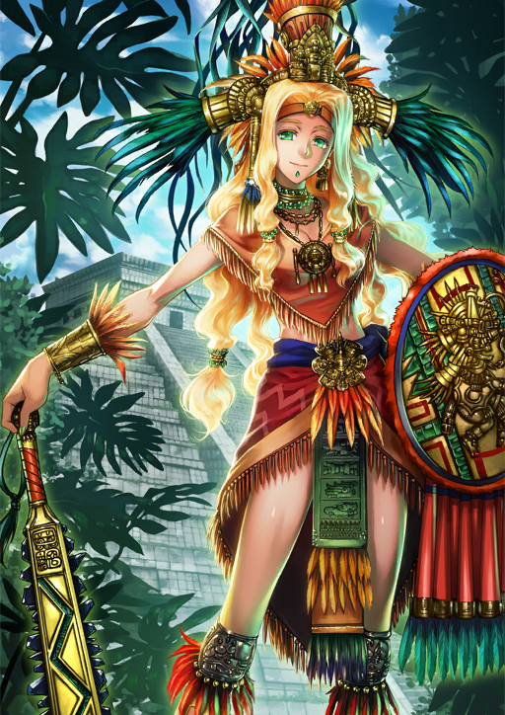
“The goddess Quetzalcoatl arrives in— Eh!?” The light of the summoning circle finally waned, allowing the Servant who had been trapped within its limits to finally step off of it. But as Quetzalcoatl stretched her tall, muscular body? She noticed something felt a little off. “Mm… What class was I summoned in!? Shielder!? Is this even a conventional class for me!? What kind of Holy Grail War is this!?”

At the very least the shield in her left hand was suggestive of her class, but as far as she knew? It wasn’t a class that she should have been summoned in, especially with her Rider appearance. But Shielder… “Well, I guess that isn’t a biiiig deal. I have problems that are much more mucho, don’t I?” And those problems were twofold. One: she had no idea who had summoned her into this Fuyuki City of the year 2055. Two: she could still vaguely recall her life as Shirou.

Even though her new existence as the Shielder class Servant, Quetzalcoatl, was a far stronger identity within her mind and soul. “Will other Servants be summoned to this war in the same way? Hmm… I feel like no one else has been summoned yet. I suppose this is a good chance to do some investigating~! Olé!” The woman gave an extraordinarily bright smile.

And then disappeared into Spirit Form for the time being.

