DATA CORRUPTION
COMMISSION STORY
BY CHALDEACHANGE


She had been surrounded.

YoRHa Type A No. 2, or A2 for short, had been in this type of situation numerous times in the past. She was an android on the run, after all, and not from an organization that someone would typically assume would be her enemy. The ones who had been pursuing her for years now were members of YoRHa, a group of androids that had been created in humanity’s image to supposedly defend against the threat of the Machine Lifeforms that had invaded Earth. That was the story the androids themselves had been told was true.

But A2 knew that it wasn’t. She may have been missing key context on the matter, but she also had learned enough about the organization that had created her to recognize that it was all a sham. Even if she hadn’t had an inkling regarding the reality that their mission was a lie, YoRHa’s true colors had been revealed to her in the wake of the Pearl Harbor descent mission years ago. When her whole squad had been treated as living shields to be disposed of.

And as the sole survivor, A2 had become hunted. The higher ups saw her as a threat. They wanted to silence her. Those actions on their part made it clear that her very existence was a threat to the illusion they were maintaining, but the android they were chasing had yet to prove it. Several times she’d attempted to have dialogues with the androids that pursued her to no avail. They weren’t open to the possibility that everything the believed in was a lie at all.

Who would be, realistically?

YoRHa androids were conditioned not to doubt their leaders and to suppress their emotions, strangely told they were ‘forbidden’. But if emotions weren’t permitted, then that opened another hole in their rhetoric. Androids were artificially created lifeforms. “If you aren’t permitted to feel anything, then why design you with the capacity to feel emotions in the first place?”

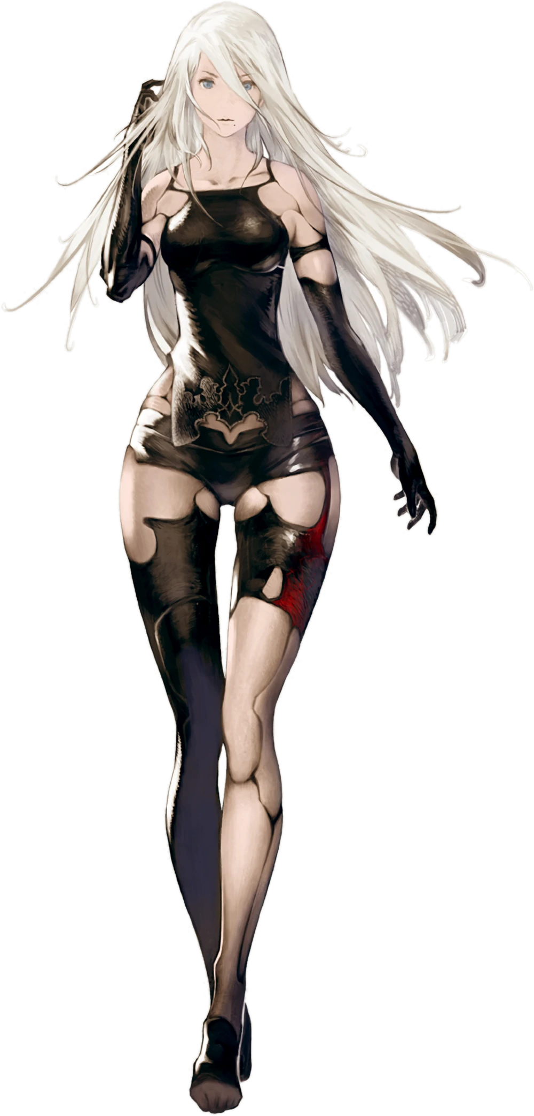
A2 wasn’t hoping for an answer to that question. After all, she had merely asked a YoRHa android that she had just impaled. The squad of units may have surrounded and outnumbered her, but they just weren’t making their soldiers like they used to. Maybe that was a disingenuous read of their abilities though. After years of evading and clashing with them, the older unit had more or less pinned down their strategies as well as their strengths and weaknesses.

That was why, despite five YoRHa androids surrounding her, five corpses were now scattered around the block of the Ruined City that she had been traversing peacefully. “Another attack. They’ve been becoming more common recently. Are they planning something?” Even if they were, A2 didn’t necessarily think that their plan was related to her. It felt more like they just wanted her out of the picture even if it meant keeping her distracted.

“Those two units…” The two she had encountered and even fought within the Forest Kingdom. She’d seen them around more and more lately. Did it have to do with them? 2B and 9S; she had at least caught their model names at the time. But the former of the two, the woman… Did she know the truth of her identity or was she ignorant to it herself? The fact that there was such a suspicious detail hanging in plan sight was what made her wonder if it was related.

FWIP!

But the rogue android had made an unfortunate error. She had assumed the squad that had attacked her had only consisted of five units; that was the number they usually jumped her with, and she didn’t sense another presence to make her doubt as much. And as she had begun to weigh why they had been attacking more frequently? She had lowered her guard a little bit. That had seemingly been the only opening that the YoRHa unit hiding in the shadows had needed to fire a dart from the shadows.

A dart with a needle sharp enough to pierce the side of A2’s neck. “Fuck!?” The victim of this attack didn’t respond very calmly to the sensation, reaching a hand up to grab the tiny object with pinpoint accuracy. She pulled it out and tossed it to the ground, not sparing a moment to examine it. If she had? She might have realized that the dart had contained some manner of liquid. But it wasn’t as if androids could succumb to things like poison or illness. And it also wasn’t a virus, something that could affect her. It was something else entirely, and something that was far more dangerous.

Instead of focusing on the weapon, she instead surveyed her surroundings to try and figure out where the attack had come from. Did only one enemy remain, or were there still multiple hiding in the shadows? “Get out here so I… can…!?” What had begun as an angry taunt trailed off, the woman’s body beginning to feel off someone. “Damnit… What did you…?” It wasn’t like the enemy that had actually long since fled was going to answer her.

But she had been injected with a hefty dose of nanomachines.

The most immediate effects she felt came with the intention of immobilizing their target. Not only would it have proven to be noisy if someone who was injected was able to move around freely, but it would have interrupted the work the nanomachines needed to do as they surged through and began to emerge from her body in the first place. But A2 lacked any context about what was happening to her short of the sudden fatigue she had felt. She had simply slowed to a halt, all of her energy necessary to prevent herself from falling over.

Her initial realization that something was seriously wrong with her body didn’t come until she felt the skin upon her torso, which was a more profound feeling than you might have expected. After all? While it appeared like the android was merely wearing clothing with how much of her body was covered in black, the only actual garment that she wore was the flap of cloth over her pelvis. The rest of that black was the frame of her YoRHa android body that was normally hidden by the artificial skin that covered them. It had long since been burned and peeled off.

“What the hell?” So, to watch that skin reconstruct itself in real time was shocking and baffling. It emerged from the black metal beneath to evenly coat it all, hiding the robotic joints of her body once more until her body was entirely covered in a way that made it difficult to immediately believe she was even an android in the first place. Even nipples had reformed, along with the faux fat that made her womanly body seem softer.

It had been a long time since A2’s body had last looked like that. But there was only one thing she knew of in YoRHa’s arsenal that could cause such a change. “Nanomachines!? But they were…?” When she had first been created, they had merely been in development, and they certainly hadn’t been intended to repair YoRHa units. The initial intention had been to break down machine lifeforms so that hand to hand combat was no longer necessary, but it was obvious that something had shifted in the Bunker’s usage philosophy for them.

“But why are they repairing my body?” It was a good question. They had been trying to destroy her for so long that this didn’t make much sense. But, unknown to the android, YoRHa’s nanomachine development had become so far along that it could actually alter more than physical matter. And some of them had already begun to embed themselves within what was functionally her brain.

A2 was right to be suspicious, and there were signs that much more was going on than a simple repair job. It was very obvious within her hair that something more was in the works, for the white roots that she possessed like almost all YoRHa units had been brightening to a slightly darker pastel pink. The color surged from there, flooding out to her tips as the hair it traveled across softened and lengthened. While it normally reached down to the base of her back? It instead stretched to the backs of her knees and curled a little bit so that it became wavy in an elegant sort of way that betrayed her normally gruff and exterior.

The android eventually noticed her bangs hanging where they usually didn’t. “What in the world?” She would usually respond with some kind of expletive to express her understandable shock, but because the nanomachines were working on her brain? Memory and personality data were both affected by them, and it had really begun to show. In what was seemingly a visual side effect of this? The colors of her eyes, usually a cloudy blue, had dulled to silver.

“Why is my hair—? Ugh!?” No, it was her voice too! It sounded so soft and sweet all of a sudden! If she’d eaten anything then it would have churned her stomach, but androids didn’t necessarily need food. She rubbed her neck with her right hand, and not even that hand was spared from the effects of the nanomachines. Her fingernails had lengthened, been painted pink, and were fixed on hands that were a little smaller than normal. “How far did that technology advance!?”

The mere act of speaking even felt off to her; a product of A2’s face undergoing changes itself. The difficult speaking was a byproduct of her lips bloating. They appeared substantially thicker than they ever had and stood out more upon a face that was becoming a little smaller in terms of features. Even the android’s resting expression became gentler as a result of everything softening, smaller eyes that were now blessed with lengthier lashes fluttering about as her attention was drawn back down to her body.

She didn’t look a single lick like herself from the neck up, though.

What had drawn her attention back downward, however? “Erm…?” Weight had; namely the weight that wrapped around her bosom. Even with her skin restored, A2’s cup size was the rough equivalent to a pair of Bs. Not that she normally cared. She was an android designed for combat, and so having a body that was too jiggly would only impede her movement. So, she could only find those concerns growing as her tits did the same.

At first, she had been so confused that she’d taken hold of her own tits with her hands. She could feel their weight increasing within her grasp, pushing her fingers apart as they pressed into the mounds. Nipples eventually poked through as well, larger in size just like the weight beneath them – and when A2 finally let go? Those F-cups bounced against her ribcage in a way that wasn’t painful, but it reminded her of those concerns she had always had. “I suppose… they aren’t as cumbersome as I thought they would be.” An observation made while speaking very politely.

It was her breasts that had stolen away the woman’s focus, but they weren’t all that had grown in that moment. Synthetic fat had chosen to accumulate within her ass in kind, and behind her? It had bubbled out into a fine cushion-y shape that would have made for a very comfortable seat. She was lucky she wasn’t really wearing anything still, since it would have readily been consumed by her cheeks.

Those cheeks actually swelled so large that her skin was stretched to capacity and the excess? It had no choice but to flow into her thighs. They swelled like sponges so that they were an additional two inches across, and the combined effort gave her hips absolutely no choice but to part a little farther apart than they had been.

“This is almost done, isn’t it?” She wasn’t sure how she could tell, but she could. The influence of the nanomachines was waning, and in one finally transformative push? They swallowed the flap of black cloth that hung from her waist and reconstructed an entire gown from it. An elegant white dress with a frilled skirt, one with detached, puffy sleeves that showed off bare shoulders and accentuated the size of her ampler bust. Matching lace thigh highs slid up her legs, underneath new shoes of white and gold, and a big ribbon extended from the back of her skirt. Not even her hair was spared from a style change, tied into a rose-like bun on the left as a braid was tied across the top like a tiara.


“I see… So this was what they had in mind, was it?” The very first act that Dorothy set upon herself was retrieving the dart that her previous self had tossed aside so haphazardly. It didn’t take her very long to do with her built-in sensors, because while her exterior appearance and personality data might have changed significantly? Her lack of biological nature within had not. She was still very much an android, just of a different production line and style. The woman knew the name ‘NIKKE’, but she didn’t really know much else about her new point of origin aside from that.

Once she had found the dart, she tapped at the transparent segment that had contained the nanomachines with a manicured fingernail. “And there’s still a small amount inside. Hmhm~ Now what could I do with this? I wonder…” As part of her new programming, the pink haired android could now understand what their plan was, at least. YoRHa had decided to give up on killing her and had wanted to indoctrinate her back into their ranks instead. The nanomachines were supposed to fully replace her old memories too.

But they hadn’t. Something had been wrong with their programming and while they had made some modifications to Dorothy’s memories to make her new life easier to accept, she could still vividly recall her life as A2 as well as the grudges she carried as a result of it. “But I suppose this is a good opportunity, isn’t it?” There were no longer any enemies in her direct vicinity. That meant that the higher ups within YoRHa believed that their plan had been a successful one.

“They’re expecting me to return as soon as I have my wits about my again…” Which meant she would be able to access the Bunker without issue. They must have created a spare body up there that matched the one she presently occupied to those ends. Dorothy rolled the dart around in her palm. There was still some translucent fluid within. No, that was wrong. They were just nanomachines that had been liquified for the sake of injection. There must have been more in the Bunker, so if she could access that supply… “I suppose I’ll need to return to ‘base’ after all!”

Commander White would undoubtedly wish to meet with her. She could start there and then consider what to do about that 2B unit. No, the 2E unit. “Let me see… The nearest terminal is to the east?” And so, with an elegant stride that led her enlarged bosom to jiggle a little with each step? The NIKKE began to head eastward so that she could put her new plan into action!

