FATE / REINCARNATED
CH5: ABUNDANTLY ELF
BY CHALDEACHANGE
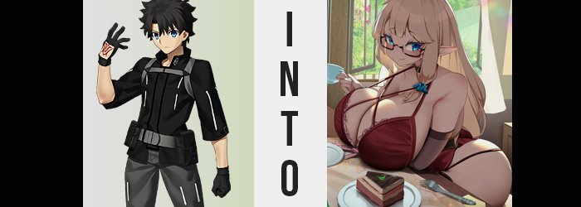

Summoning Servants was nothing new in Chaldea. It happened constantly as new information was made available to their summoning system, and in turn new Servants were ultimately made available to be brought on as assistants. It was simply part of the job, and so of course one of Chaldea’s two Masters, Gudao, did not think too much of it as he prepared to whirr up the device that aided in the summoning that day.

It was such a common practice that the facility had an entire room dedicated to the art. Which made sense, seeing as a great deal of energy was required to draw from in order to complete any summoning, and that energy had to be wired somewhere. The location of the summoning room drew directly from a leyline, making it the most efficient place to do just that.

“The next Lostbelt could be upon us at any time, so I guess we need to be prepared. But haven’t we been summoning a little too much lately?” The thought had crossed his mind once or twice as of late. Ever since the most recent summer event had begun, it was almost as if the summoning room was constantly being used between himself and his sister. Da Vinci was constantly reassuring them that ‘the more summonings, the better!’, but he couldn’t help but assume she only said that so she could sell off the extra Craft Essences.

Regardless of the reason, it was part of his responsibilities as a Master, and he knew that his sister was off helping with farming that day. So it fell on his shoulders to do the daily summoning. Not using Saint Quartz, but using the less valuable currency that they somehow collected from the day to day. This meant that they probably wouldn’t summon anything of real worth, but at least he could say he had accomplished his task before moving to the next!

And as it should have, everything proceeded as normal. At least until… he felt an unusual pulling sensation radiating from the glowing circle of lights that typically summoned Servants. And the next he knew? He had been completely pulled in!

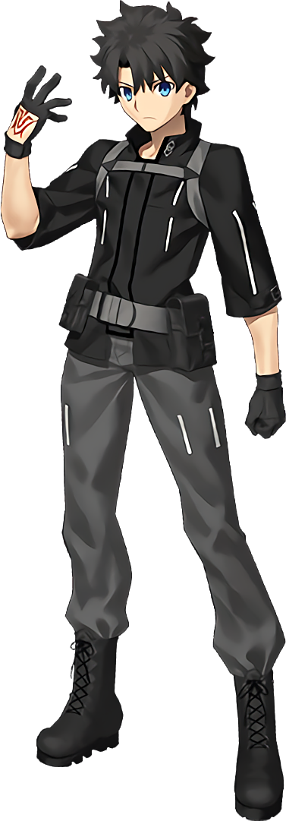
The next that Gudao knew, he was standing in an unfamiliar room. His best guess was that it was some sort of atelier, being a wooden building with only a handful of rooms. Numerous tables decorated it, and there were also a number of open windows throughout the space that revealed rolling fields before a lush forest. Book after book lined some nearby shelves, and it was clear that there had been a part of the space set aside for teaching based on several desks before a chalkboard.

What the space was wasn’t as important as where it was, though. “Where…? How did I end up here!?” Hadn’t Chaldea’s summoning system just gone and slurped him up? That was supposed to be impossible, but say someone went backwards through something that was meant to summon others from different times and worlds… Did that mean that this person might end up in a different world and time themselves?

He really didn’t want to believe it, but something about the world around him made him certain this was the case. There was just something a little too fantasy about it all. It reminded him of the sixth Lostbelt, and yet also not at the same time. “I need to get back somehow.” Perhaps he could get in touch with… with… with… “Wait, who am I supposed to contact?” It was a real headscratcher. He knew there was someone he was supposed to get into contact with at times like these, but for some reason he just couldn’t remember who.

Lost in thought on this matter, he hardly took notice as the shape of his own body began to change – almost as if it was being molded like clay or putty. A lot of these changes were discreet, and affected his overall body shape rather than anything too dramatic. For example? His waistline looked to crunch in slightly, appearing thinner, while on the other hand his hips had pulled just a little wider. Shoulders narrowed a tad as well, and Gudao’s overall height? It was only two inches, yet… it diminished.

“Was I supposed to contact someone from the village? Erm… Which village?” The boy was very clearly confused, and by plenty of things it seemed. Somehow that felt wrong, like why would he be contacting a village when he came from…? Where had he come from again? And the only civilization for miles around her was that village, wasn’t it? Wait, around her?

Evidently, either Gudao’s confusion served as a very potent distraction, or something was at work to prevent them from noticing the extent of what was happening. Because not only was she thinking of herself as a woman, but it had also actually happened. With only the slightest bit of discomfort in her loins, those loins in question had completely collapsed, her cock and balls regressed and repurposed into the lips, clitoris, and chasm of a pussy. Of course, the appropriate organs were established within her body as well.

The signs had already been there with how her frame had shrunk, but it really had come to fruition in the end. With her clothes hanging looser from her body, it was a wonder that they had yet to fall. Or, at the very least, that her pants had not fallen. Fortunately her wider hips had seen to it that this wouldn’t be the case, and those pants became even more solidified in their positioning as their contents began to swell.

And that applies to all of their contents. It had started simply with her ass, which gradually plumped up in size until it began to push out against the back of gray fabric, the cloth of her boxers given no choice but to tuck into the crack between those cheeks in the meantime. But what started as a notable swell soon barreled into an unbelievable accumulation of weight, and Gudao’s cheeks burgeoned with such heft that the fabric of pants and underwear alike began to tear down the center of the ass crack. Before long, gigantic, jiggling cheeks emerged – far more abundant than you would expect from pretty much anyone – with the sound of fabric tearing almost comically fart-like.

“Oh!?” It was surprising enough to get the girl herself to cry out, but ultimately she didn’t linger on it for very long. Which was a little odd, seeing as her girthier bottom made quick work of the rest of her pants. Her ass had swollen so huge that her hips had been given no choice but to part even wider as a result, and the bones of those hips uncomfortably tore through the once firm waistbands of her lower wear.

But even still, her pants did not peel. Even though the backs of them had been blown out by an ass so big a donkey might be jealous, and even though the waistline that was meant to hold them there had been completely obliterated, it was her pantlegs themselves that remained in place, keeping the rest of it up despite how her pussy was utterly on display now.

Because her thighs had swollen along with her ass, and they were excessive enough in their own right. Soft flesh would jiggle as she stepped, or at least if she had been wearing pants that actually fit. For now, though? They were content with her pantlegs gripping them for the most part – at least aside from the tears that had formed where flesh appealingly peeked through. From the waist down, Gudao was absolutely bombastic now. Which was only highlighted by how masculine her upper half remained.

“I feel strange… groggy?” She shook her head, her voice airier and far more feminine than it had any business being. But the change in voice had accompanied an overall structural change to her head. Not only had her more masculine facial features softened so that they were undeniably feminine, but she hardly even looked like herself any longer. While not necessarily a facial feature, her hair, for example? Dark spikes had flattered, the length of those locks creeping down her back as a light blonde saw their colors completely changed.

While the blues of her eyes persisted, that blue did take on some additional contrast so that they almost appeared otherworldly at the end of the day. They did appear a little heavy, as if she were tired, but that was helped by a change in their shapes. They appeared rounder, wider, brighter, and as she blinked her lashes fluttered larger like the wings of a butterfly. These eyes, so different than they had been before, were not the eyes of a Japanese youth. They were more mature, but racially there was nothing Japanese about them at all. They appeared more Western, and gratuitously swollen lips helped with that impression. “Huh!? My glasses? Where’d I put my glasses!?”

And her vision quality had deteriorated significantly.

Once confused about whom she was supposed to contact for some reason, she now had to prioritize restoring her vision. Arms were reached out and began to paw around the atelier with no shortage of familiarity, fingers growing longer and adopting lengthier nails as she did so. But those fingers weren’t the only things to lengthen, because so too did her ears. Into long, sharp points that by all assumptions would belong to a fairy… or an elf. An elf that physically looked much older than the boy had been.

Truthfully, the woman felt imbalanced. It wasn’t the fact that her ass was now that of a middle-aged elven woman. No, her mind had adjusted to that. It was because she wasn’t as top-heavy as her mind had been wired to accept. That is to say, because she hadn’t grown her huge honkers yet, she felt off. Well, it wasn’t really a concern for long.

Beginning with a puffing of her nipples, fresh meat began to pour into the containers that would ultimately form her bosom. It only took a few seconds for them to bloat into lackluster A-cups, but a sizing such as that was a far cry from what was actually intended for her in the end. Because with their base established? They then exploded with new mass. And the bindings of her jacket were unsatisfactory to contain them.

“Ohhhh!” Still blind without her spectacles, the woman almost fell forward thanks to the combination of weight and pleasure that complete snapped the belt wrapped around the top of her jacket, and utterly separated the teeth of the jacket’s zipper that had run down the front. D-cups spilled out, tearing even Gudao’s undershirt so that eye-sized areola could escape their restrictive container – and from that point on, they continued to surge even more.

She had to stop her search for her glasses, because the constant change to the heft of her bosom kept her from functionally moving around. What were D-cups quickly bloated into G-cups, and not even that size satiated her brain’s new recollections. They were already bigger than her head, but they continued to grow, jiggle, and bounce. Until each breast was twice the size of her head, yet appeared to remain perky somehow.

I keep them perky with magic, of course!

…Or so her memories said.

The fact that she had just sprouted a pair of impossibly huge tits didn’t even register now that it was completed. She was much too fixated on finding her spectacles once more, but her search came to an unexpected conclusion. “Oh! Was I wearing them all along?” Her vision was suddenly perfect again, because a pair of red-framed glasses had appeared upon her smaller nose. Not only that, but her entire outfit had changed into a red negligee and matching thong, both of which struggling to contain her excessively ample curves.

Well there was little doubt now that the woman sauntering around the atelier in Gudao’s absence was a woman that belonged in this world. From her elven ears to the way she so casually wielded magic to clean her home, she appeared to be more than familiar and comfortable with her current circumstances. This was, of course, because Eltina Shroud believed that she had lived and grown up here her entire life. A life that spanned hundreds of years, because elves had much longer lifespans than humans did.

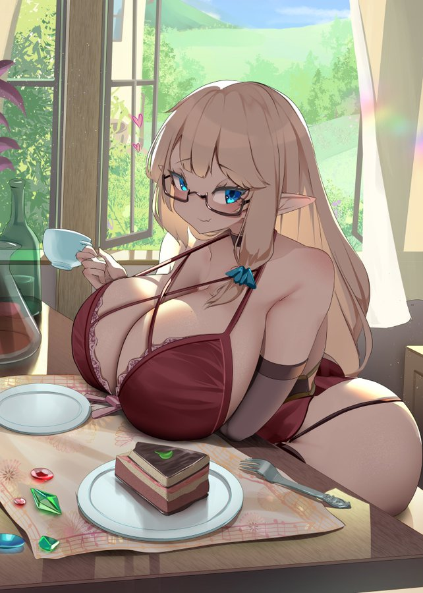
With a wave of her fingers, a pot of tea was brewed upon a nearby countertop. Eltina moved towards it, and each step saw her ginormous cans and abundant ass bounce. Even for an elf she was exceptionally attractive, her thick body the subject of many advances from men and women alike in the past. But this was also why she had decided to retire out in this clearing, far away from any civilization. She wished to be undisturbed, and she didn’t desire that life for herself any longer.

“If they’re on time, I suppose they should be here soon…” Using long, slender fingers, the elven woman adjusted the glasses on her face. She did have some visitors, fairies from the neighboring forest that wished to learn how to properly use magic. Eltina was often bored as she lived so far away from everyone, and so she had taken up this job as a way to pass time. But her students? They were mischievous, but they really were endearing!

“I suppose I should get changed…”

She couldn’t exactly teach with her ass and tits out, now could she?

