Tradeswoman  A Vignette  By Maryanne Peters  I was a tradesman when I was a man. I was a roofing contractor. I knew that when I became a woman I would have to give up that job. That is not because women can’t be tradespeople - and we all know that transwomen can do anything women can – it was because I wanted to do something feminine. I thought that it was important to me to leave that rugged part of my life behind me.  Even before I stopped working on roofs, but after I started growing my hair and taking HRT, I looked for something else to do. The fact is that I did not have the delicate touch for painting nails or doing hair, or the patience to deal with people in any caring role. My curse was that I had been born in the body of a brute of a man, despite my firm and ever-present conviction that I did not belong in that body.  My plan was to keep a small piece of the business and sell the rest to the guys who worked for me and would be taking over. I suppose I came to the conclusion that maybe I could stay on in an administrative role.  “Only if I am up to the task,” I told them. “I don’t want to be a burden on the business, but as you must realize, I know it better than anybody else.”  I think maybe their biggest concern would be that they would have a drag queen in the office, but I told them that was not what I was going to be. I guess I just had to prove it. | 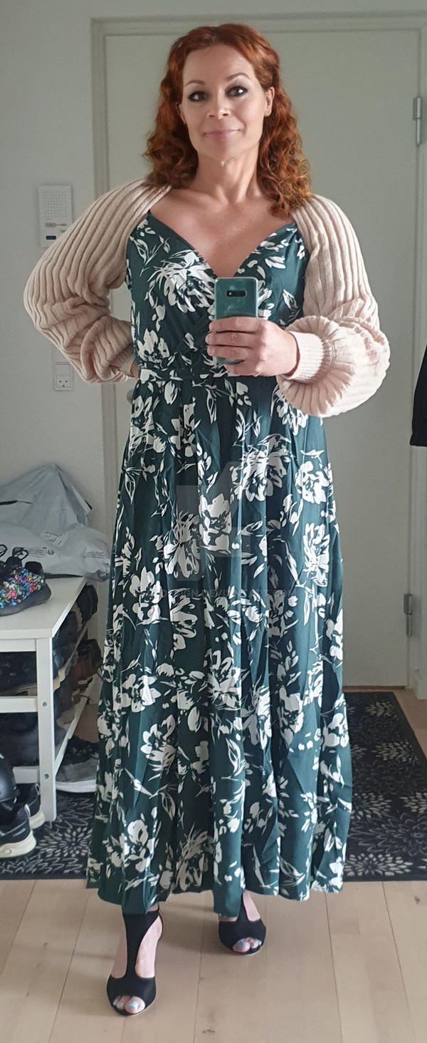

I had the advantage of having a good head of hair which I decided would look better in a shade of red, and I had the benefit of a good pair of bright blue eyes. By selling out my interest in the business to the guys, I also had money and I could invest in good skin treatment and quality surgery, and some intensive courses on how to be feminine.

I learned how to present myself, how to walk and talk and how to use clothing to hide my broad shoulders and a lack of “junk in the trunk”. As for what was in front, I went for implants but nothing too big, and down below the belt I went ahead with the orchiectomy to burn the bridges behind me. It is an ancient rite – no retreat ensures that the battle to become the true me had to be won. After that, the additional surgery down there seemed like no big call.

The guys up the ladder took it all in their stride. I always played it down, as if my change in appearance was no more than growing a moustache. I wore pants and work boots on site, but a colorful blouse and maybe a scarf. I wore my hair with my red curls flowing out under my hardhat so that nobody new could mistake me for being a guy. The guys called me “Boss” although I kept saying – “I am only the office girl”.

One day when we were doing some new houses under a time constraint and I had to rush some fasteners down to the work site. I was wearing a dress because that is what I preferred, and I did not have time to put my hard hat on before a man came up to me.

“I was told that the Boss was coming down and I guess that’s you,” he said. “They told me to look out for the red hair, but I wasn’t expecting a woman.” He smiled at me. He had a great smile.

“They are teasing you,” I said softly. “I just work in the office.” I was suddenly aware that I was adopting a pose, almost instinctively feminine. It was almost like realizing that I had full transitioned in that moment.

“I have a development going on across the valley,” he said. “One hundred houses, without roofs. I like the way your team works. I would like to know if you could put in a price?”

I told him that we had forward work but if he did not need us right away we could put in a price if he sent us the specifications. I was playing with my hair like a small girl and feeling strangely playful. He was an attractive man – a little older and a whole lot bigger than me, with body hair visible above his open necked shirt. It made me think that something I hated so much on myself was so alluring on a real man.

“We could discuss it over dinner tomorrow night if you like,” he said. “You are busy I can see, and so am I. Construction puts big demands on daylight.”

I gave him my number straight away, and watched him drive off in a very expensive European car. I remember that I sighed as it disappeared – a mixture of disappointment that he was gone and fear that this was nothing more than transactional.

Until that day and that moment, a relationship with a man had never been in my thinking, but that all changed. I made a huge effort for the following evening, taking time off and telling the boys that I was out to land a big contract. I think that for the first time they began to understand that I really was a woman now.

I firmly believe that you don’t need a man to make you a woman … but it helps.

When I told him about who I once was, as the paperwork had been pushed aside on the restaurant table and we were just looking into one another’s eyes, do you know what he said to me?

“I knew that you were special.”

I was a tradesman when I was a man, but now I have traded everything to be a woman and a wife.

The End
1005

