AD ASTRA ABYSSOSQUE
COMMISSION STORY
BY CHALDEACHANGE
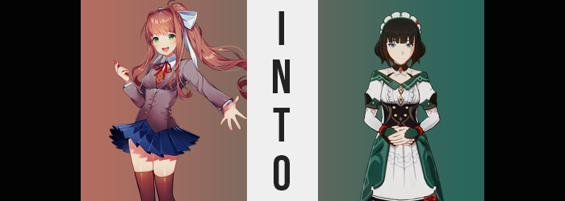

“Isn’t there a little too much porn on this computer? Bleh!”

Within the confines of a digital space, Monika from the game Doki Doki Literature Club had decided to spend an evening sorting through the files of the most recent computer she had been downloaded onto. Some sorry sap had added her onto their hard drive with the intention of playing her game, but it had been a week since that had happened! “Are they ever going to boot it up? I’m soooo bored!”

Monika was a very unique existence, you see. She was a self-aware video game character, sentient about the origin of her existence as well as the power that sentience gave her. She was able to manipulate the files of her game client and even the story contained within. Something as unsettling as forcing the other characters in the literature club to act according to her will was child’s play, for example. And she could easily tell if the player was turning the game on or off.

And it hadn’t been turned on yet! So, she had decided to stave off her boredom by stepping a little outside of her usual authority. The computer’s owner had made the mistake of leaving it on while stepping out, which meant that the video game character had free reign of that computer’s contents within reason. It wasn’t like Monika could move or delete anything from it, she didn’t have the authorization.

But viewing and opening files? She could do that much. “This person’s lucky I was created to be eighteen years old, or I’d be trying to sue them for subjecting me to all of that nudity underage!” How would she have done that? Well, she probably couldn’t have. But it was the thought that counted, right? She hadn’t even checked to see if any of that porn was about her, and truthfully? She did not want to find out.

“Genshin Impact? Isn’t that one of those gambling games?” Monika’s little computer exploration adventure eventually took her up to the desktop once she realized she hadn’t even checked the most fundamental part of the computer just yet. There was nothing but shortcuts to video games present, and that Genshin game was one of them. She didn’t actually know much about it come to think of it, and that morbid curiosity eventually pushed her to open the shortcut.

It was a decision that Monika would be quick to regret.

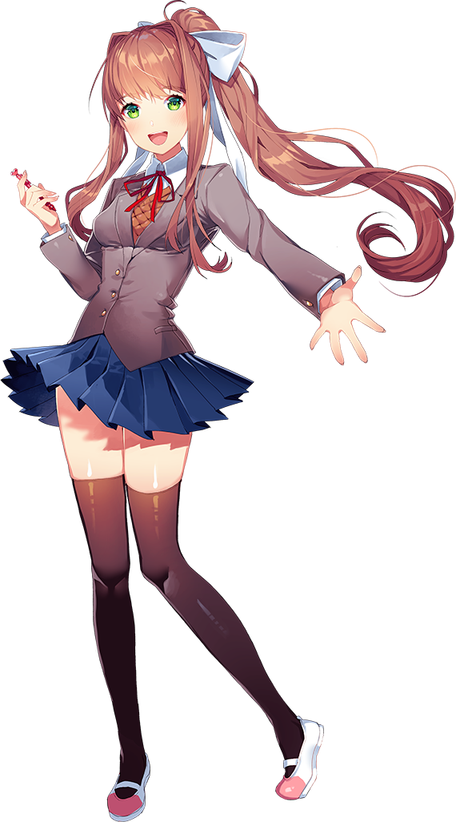
“Hey!? What gives here!?” After opening the shortcut, Doki Doki Literature Club’s main character had expected a game to open, but something had gone awry instead. There had been a strong wind? No, wasn’t it more luck suction? And it had pulled her into the shortcut instead of opening it. Now she found herself standing behind an outdoor counter in what looked to be a small, quaint, but vibrant fantasy town. One with presumably its main gate and exit bridge nearby.

It was the City of Mondstadt.

Monika’s attention shifted around here and there. There were cubbies and documents in the small room she occupied, as well as numerous thick books. “I wasn’t pulled into the game, was I? But if that’s the case then I should just be able to pull myself out…” So long as it was a game on the computer that DDLC had been downloaded onto, at least. That authority she hadn’t shouldn’t have been gone.

“My authority is gone!?” There was perhaps a bit of comedic value to the timing with that realization. She couldn’t muster any of the talents that had been afforded to her as a sentient video game character. It was like she had been cut off from the computer itself? Well… that was true. She didn’t realize it, but because live service games were required to always be online? She had been uploaded to Genshin Impact’s server instead.

It took the teen a moment to calm herself before considering her next plan of action. It was strange, though. It was the middle of the day and what seemed to be NPCs kept walking past her. But even though she didn’t belong behind that counter, and even despite making a fuss, no one really seemed to be treating her like she was out of place. It gave her a very bad feeling somehow. “Okay, so let’s just get out from behind this stuffy desk for now…?”

There had been a latch to open part of the desk on its side, but Monika didn’t elect to make use of it. It would’ve been faster to climb up and over the desk, right? That had been her line of thinking, and yet any attempts to do so were met with an invisible resistance. “Huh? Is there a barrier there?” She couldn’t even reach her hand over the desk without being pushed away. “M-Maybe it just wants me to use the proper exit?” The tinge of concern to her voice had been becoming stronger in its sound, ultimately becoming blatant once her hand was pushed away from the latch in kind.

“AM I TRAPPED IN HERE!?”

It didn’t seem like she could leave! There weren’t any other methods of escape available to her! Although, after screaming at the top of her lungs? She was once again reminded of the fact that no one was paying attention to her. Was no one else in the game world sentient? “Ugh! You’re all just a bunch of brainless NPCs after all, huh!?” An insult shouted without even an iota of concern for karma. “Why don’t one of you help me out or something!?” Even if they had been sentient, they wouldn’t have lifted a finger. Because they saw Monika as someone who should have been behind that desk.

“How am I going to— EEK!?” The teenager had been on the cusp of pondering potential routes for her escape when a very unusual feeling came over her. Monika recognized what it was, but it was uncanny because it wasn’t something she should have been able to feel. Not in the sense that it could happen, and the sensation would go over her head, but in the sense that she should have been off limits.

Her data was being modified without her permission.

The girl huffed. “Who is doing that!? What the hell!? Watch what you’re even touching!? URK!? MY VOICE BANK!? SERIOUSLY!?” She’d easily heard it as she was speaking. Her voice had deepened a little bit until she no longer sounded like a teenaged girl. She sounded a little bit older. Had that been intentional, or was she just meant to be an older sounding teenager? She really hoped that it was the latter case.

But of course, it wasn’t. Monika didn’t exactly have a mirror to reference behind the Adventurers’ Guild desk to tell this, but her face had begun to change. It did tingle a little bit, however, which definitely left her concerned. “Is shomething happening to my… Huh?” She’d definitely lisped there for a second, hadn’t she? Why? It had felt almost like her lips weren’t interacting with each other the way she was accustomed to?

This was of no surprise to anyone with a visual angle on the girl’s body, however. Her lips looked to be a little fuller than they had been previously; part of a restructuring that affected her entire face in a way that unfortunately made her appear older, just as she had feared. Her face’s shape broadened overall, in fact. A larger nose, a wider jaw, and even bigger eyes. They helped create the impression of a young woman around her mid-twenties. She also appeared somewhat plain though. Her face didn’t much differ from those of the NPC women that occasionally walked past her desk. The shapes of her eyes even made her look just as Caucasian as they did, as opposed to her Japanese design.

Monika had reached up a hand to touch her lips after lisping but didn’t quite get that far before now silver-blue eyes caught sight of her hands. “GRR! WHAT ARE YOU DOING!?” Who or what she was yelling at, she didn’t really know. But the woman knew that whoever it was had to answer for what they were doing to her. Her fingers looked thicker than normal! And a little… blocky? Like the fluid strokes that had defined her design within the visual novel were being replaced with mediocre 3D modeling.

Something that happened to her entire body with time.

There was a saying that getting upset would lead to growing grey hairs early in life, but was the opposite happening for this game character? It seemed that her hairs were darkening instead, shifting from brown to a raven black from the roots. This color bled out to the lengths that reached her chin, strands becoming pointedly wavier in the process. But everything past Monika’s chin? It just disappeared because its data had been erased. “STOP IIIIIIIT!” There was no way that she wouldn’t notice so much of her hair’s weight being lifted so suddenly.

Regardless of her protests, the force that was altering her data showed no signs of slowing down. In fact, they might have begun to happen even faster as the fit of her schoolgirl uniform became compromised. At first it was only in the vertical sense. “…Ugh!” And she certainly had her complaints about it. She had been designed with the body that she normally occupied. It wasn’t like she was accustomed to ever feeling any differently within her own skin.

So, for her height to increase three inches so that she was 5’6”? It struck a chord of uncanniness that bothered her to no end. She didn’t like her blazer and button-up shirt rising so that her bellybutton was exposed, nor did she like how her thigh high leggings no longer reached her thighs. Even her shoes felt too tight! “D-Did my feet grow bigger too!? Don’t tell me I’m being altered by some guy with a foot fetish? Are my feet about to explode out of the fronts of my shoes!?” They fortunately did not.

But she had to learn to live with the discomfort of her body growing bigger. It was becoming better reflective of her new age, for this character design that she was inheriting was that of a young woman and not a teenaged girl. It only made sense that her body would be a little bigger overall, but Monika’s worst case scenario wouldn’t come true either. She wasn’t being transformed into some pervert’s overabundant sexy anime girl.

Still, she did become bigger. Weight gathered within her chest, breasts losing some of their youthful perkiness in exchange for a greater swell. They pushed the cups of her brassiere to capacity, and the discomfort of the bra’s strap digging into the skin beneath her shoulder blades soon became unbearable once her tits had swelled to D-cups. “Are you trying to make me strip!? I refuse…!” If the power changing her wanted to see her naked, it would need to remove her clothes itself!

Not that this was necessary at all, that wasn’t really its end goal. Instead, it merely saw to it that the rest of Monika’s body swelled to match the design it was replicating just as her breasts did. This included an expansion of her hips so that they swelled an inch or two wider – a necessity for the weight that gathered in both her ass and her thighs. Panties struggled not to slide in between cheeks that were only a little fuller than they had preciously been, whereas her torso seemed to become just a little broader across her waist.

“Are you done!?” The woman was still fuming, but it was odd. She could feel her anger cooling off a little bit. It was as if something deep down was calming her. Was it related to her internal composition changing? Perhaps! But that was a change that was legitimately happening. Monika as a character was digital, but she had been modeled after a living human and so she had the biology of one. Now? On the contrary, her internals weren’t even biological. She looked like a human woman on the outside, but within her body was a technology that allowed her to replicate the human appearance. She was more like a living doll than anything.

But at least she would be a living doll in clothes that fit her, for her school uniform was erased and immediately replaced. She was left standing in a white dress with green accents and a black corset that was worn over white leggings and green shoes. An eight-pointed star was printed on the dress’ neckline, while a maid’s hairband found its way into her plain, black locks.
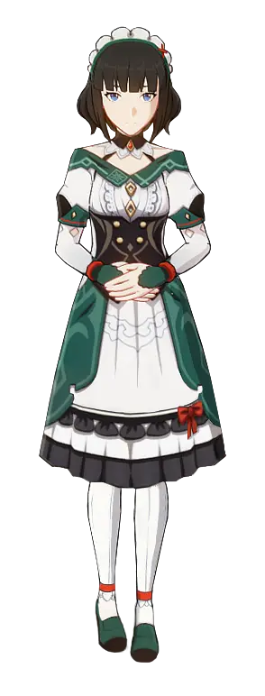
“Eh? Eh, eh eh!? What’s with this? I must look super basic, right!?” The woman who now stood behind the desk of Mondstadt’s Adventurers’ Guild was frantically running her hands over her body and clothes. She could tell that her body looked way different. More than that, wasn’t it functionally different too? It was hard to describe, but somehow it didn’t quite feel ‘alive’, like it was somehow fake. She didn’t feel fatigue nor hungry, and after holding her breath for a while she realized she didn’t need to breathe. “Is this body some sort of robot or something?”

That was essentially the case. After all, Katheryne was a bionic puppet that had been created as part of a series. Each nation in Teyvat had one acting as a secretary within the Adventurers’ Guild there, bringing a taste of familiarity to those adventurers who were brave enough to traverse the entire continent (and Inazuma). But this new Katheryne still didn’t get why this had all happened to her in the first place!

Was an explanation really necessary, though? This felt more like a karmic punishment for Monika more than anything. After treating everyone else like NPCs?

Now it was her turn.

“W-Wait a second! What’s happening now!?” The woman could feel her body stiffening further. Her posture was straightening against her will, and both hands were drawn to her lap where they crossed over one another. “This can’t… be…? I… can’t…?” It was becoming harder and harder to even speak as even her face was affected, her expression eventually inheriting the very same blank expression that all of the other non-playable characters that walked past the desk according to their own programming possessed.

And Katheryne continued to stand there in that position without uttering a single word. The day wore on, and then night came. Morning returned, and then soon it was night again. On a very quick time cycle the days came and went, and the secretary didn’t do or say anything. She simply appeared to be waiting for something. Like a trigger that would allow her to act. And then, one day, a blonde haired woman dressed in white approached the Adventurers’ Guild desk. Katheryne immediately bowed to them, whirred alive temporarily by their presence.

“Ad astra abyssosque! Welcome to the Adventurers’ Guild.”

