STIFF LOVING
FEBRUARY 2021 REQUEST STORY
BY CHALDEACHANGE
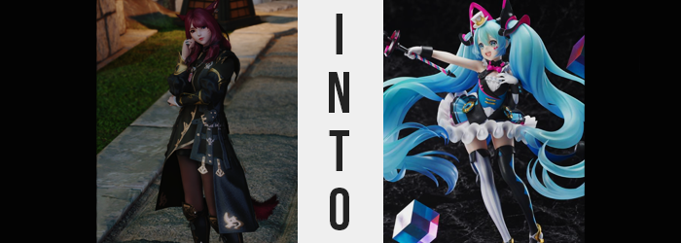

It wasn’t often that Silvia found herself alone these days. If she wasn’t on an expedition within some ruins, or researching an artifact discovered on one of these expeditions or throwing herself at some entirely new unknown for the sake of her research and / or curiosity.

These were all things she did with a partner or with a group, and honestly? She preferred it. Not one to wish spending time alone with her feelings upon herself, it was much healthier to keep herself distracted as much as humanly possible. “Well, strange disc thing? I guess it’s just you and me today.” All of her friends were busy that day, and midst the season of romance of all things. Well, it wasn’t like she was lonely.

That didn’t mean you couldn’t still yearn for love though. She was always so busy that she wasn’t even sure where a romantic partner could even fit into the equation. She didn’t need one though! She had this disc… thingy! It was a circular, white object she’d unearthed in some ruins recently, the only exceptional trait otherwise being a pair of what looked like studs sticking out of the surface. It didn’t look crazy or anything, but when she’d discovered it? It had glowed, and she was trying to figure out just why that was, even if it hadn’t happened since.

“Augh, who am I kidding!? I just wish I could be loved too; you know!?” Frustration finally boiled over though, and as she jumped up from the inn bed she’d been laying upon, she cast the disc away into the corner of the room. It landed upright on the floor as she stomped over to the desk where her parchments were, but in doing so did not realize that the disc had begun to glow again, not unlike the day she’d found it.

Before Silvia even realized what was going on, her point of view had changed. She wasn’t in a different place or anything, she was still in the room she’d been staying on. On the other hand, it was as if she’d suddenly teleported from in front of the desk over to the room’s corner. Had she blacked out suddenly? If this were a medical concern, it seemed likely that she’d become paralyzed from the waist down too, for she could not move her legs nor feet.

“What the-!?” It was answers the ruby-haired Miqo’te sought, and it certainly didn’t take her exceptionally long to discover them. Looking down, she could see the disc glowing beneath her. Had it summoned her to it? How? Why? Okay, so maybe now she had more questions than she did answers. Things were growing exceptionally strange though, for it wasn’t like she could only perceive the light of the disc with her eyes. She could almost feel it, like that glow was seeping into her flesh and bone. “Is… Is it doing something?”

The glow certainly was, in fact, having an effect on her. Silvia would spend a few moments flustered before she realized, but that didn’t change the reality of the situation. The reality that she was being affected. Changing, even. For throughout her body there was a change in pigmentation and color that varied from place to place.

Her skin? It became paler. An almost unhealthy alabaster, a ghostly white that was even fairer than her usual tone. Her eyes? They sparkled with a blue so bright that it could rival even the sky itself. And her hair? Her ruby red locks, beginning at her roots, took light with a baby blue that quickly swept through the entirety of their lengths – and not to mention the fur of her ears and tail.

But in the case of these two areas the discoloration was only a temporary burden, for they were not areas longed for this world. Regarding her ears initially, their pointed, feline tips ended up folding inward before they rolled down towards her scalp like a rug being rolled up for transport. Before long, the blue of their fur disappeared into the blue of her hair, signalling the absence of her ears altogether. But Silvia did not grow deaf. Rather, carving themselves out of the sides of her head were a pair of counterparts born of flesh and cartilage, a pair that were suspiciously similar to those of the Hyur (human) race.

As if to confirm this transition, a tail that had already been numbed by whatever had left her lower half immobile began to unwind. Long and fluffy as Silvia’s tail had always been, that fluffiness waned as it pulled back into her tailbone like a whip, its length little more than a furless stub by the time it was slurped up entirely.

The imbalance brought about by her tail’s absence was immediately noticeable. One did not live their entire life with one and not take notice when it went missing, and so, as she was still able to bend her waist and neck, Silv did her best to gaze over her shoulder. “Wh-Where’s my tail…?” A soft gulp could be heard from her throat, her mind attempting to best process the fact that she was clearly missing an appendage. What’s more, she’d caught an eyeful of bright blue hair too, in no small part because, well, it was lengthening.

“H-Hey!? Is this some kind of joke? Stop it!” Cry out as she might and scoop up as much of her hair as she could, it all had no bearing on the process. The length wriggle long even while intertwined with her fingertips, but more than that? She’d never seen hair that was so damn fluffy (perhaps making amends for robbing her of the fluffiness of her tail). It was extremely soft and comforting to the touch, and for a brief moment Silvia couldn’t help but think ‘surely someone would love me with hair as pretty as this’ before the thought was buried in her panic once more.

Even as her locks danced longer and longer still, dropping towards her ankles as if she were some kind of Eorzean Rapunzel, there was further changes to be observed elsewhere. The woman’s figure, for one. It was diminishing rapidly in terms of height and build, which would have typically left her costume in loose-fitting disrepair… were her clothes still on. “Ah!?”, she cried out in a voice she could barely even recognize any longer for it sounded higher and, oddly, a little artificial? The cry was because all of her clothes had simply up and disappeared, leaving her flesh completely bare.

And what she saw? It unnerved her. Or did it delight her? Those feelings of hers came across as strangely mixed, with a tiny smile pulling at her lips without intent. Her chest was small but perky, her pale skin soft by appearance. How much shorted had she become? Surely only a few inches, but she felt more energetic, more youthful. “Maybe… If I’m younger…?” Speaking in a voice that was simultaneously melodic and robotic, elation built at the thought of earning the endearment of others with how much cuter she assumed she looked.

Almost like her wish had been granted. Or, well, a bastardized version of that wish.

A smile fully formed regardless; attention drawn to her facial features found that she hardly looked like herself at all any longer. Her nose was smaller, lips fairer, blue eyes wider. Anime was not something that existed in Eorzea, but she looked absolutely anime. But that’s how Vocaloid were designed, right!? “Right, I’m a… Vocaloid?” Caught up in the higher energy that had built up from within, she’d all but forgotten that her lower half was paralyzed. Then again, she’d even forgotten her old identity.

A new name had come to fruition. Mike…? Mikan…? Miku! An idol beloved by all! Surely, she could bask in that love sooner or later! “That’s right, I… I’m shrinking!?” She’d been ready to celebrate, but after a moment she’d notice something tragic. Her height was plummeting, and rapidly at that. Before long, the bed nearby looked like a building, and the glowing disc beneath her? It was almost like a stage.

Now, little could Silvia – Miku? – see, but a set of grooved had dug their way into the heels of her feet. And those grooves? Once she’d shrunken down to roughly 1/8 of her regular size, they clicked into the two studs on the disc’s surface. The moment they did, all control over her limbs and head were completely lost, and the girl was completely paralyzed. She couldn’t talk or breathe, yet her body didn’t lurch for breath either. Her body was wrapped in an immediate stillness.

But she wasn’t dead. Her consciousness still functioned, so she could perceive the fact that her limbs had begun to slowly bend of their own volition. Her left hand was pulled to her breast, while her right one extended outwards as if it were grasping something. The overall lean of her body pushed forward too, and she could feel that smile from earlier opening ever wider while her eyes glistened in all of their roundness. As if guided by a mysterious force, her hair was pulled out into long, bushy twin tails on the sides of her head.

Completely petrified, Silvia was powerless as she watched her outstretched arm take on an unusual gleam. Her skin had grown so shiny that it almost looked falsified, but that was because that in truth, it had been. Skin, blood, and bone alike, all throughout her body; it was all changed into a plastic material that was both durable and light. Her body became PVC in its entirety, a substance not even present in Eorzea otherwise. The maiden couldn’t even blink, for her eyes? They’d become little more than stickers, just as her open mouth had. She was completely plastic, void of any organs – much less a brain. But that consciousness was not lost, it was strengthened.

‘I need a cute outfit, don’t I? No one will love me if I’m not wearing cute clothes! A figurine’s worth is in her aesthetic, right? So I need to look adorable!’ As if reacting to this thought line, an outfit born of the same PVC her flesh was shaped around her naked frame. An idol’s dress of black, white, blue, and magenta was fashioned around her torso, with the skirt layered and fluttering out in all 180 degrees. Funnily enough, these clothes weren’t covering her skin – her skin had merged with them. So her breasts nor her ass even really existed anymore, it was more like they had become one with the ensemble.

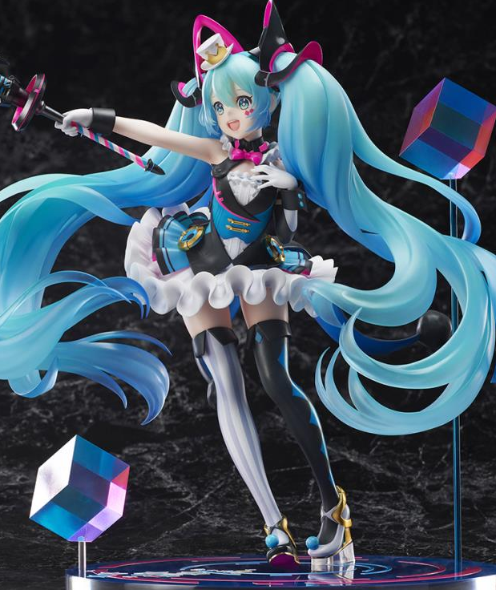
Otherwise, mismatched leggings of black and silver crept outwards from her legs, silver heels with blue balls on the tooties rounding out from their tips. An elaborate hairpiece likewise found its way around her twin tails, black and magenta weaving almost like futuristic cat ears around them while a tiny, white, and gold top hat settled to the right of her head.

Finally, a pair of magenta diamond stickers were pressed beneath her left eye, clearly meant to replicate tattoos against her falsified flesh. And the hand that had been grasping air? It now grasped a microphone accessory that brought her entire outfit together. And Miku? She was both elated and absolutely satisfied with her current condition.

How could you be distraught about being a figurine if you couldn’t remember any other life? Her consciousness was now geared towards one thing and one thing only: being adored through her unyielding cuteness!

Minutes passed, and then those minutes turned into hours which then likewise turned into days. All the while, the figurine had been left frozen in place, entirely alone. She was granted a moment of excitement when a caretaker finally entered the room, though she paid no mind to the woman’s wonderings about where the guest had gone to leave all of her things out and about. Everything had been gathered and tucked away.

Everything but the Miku Hatsune figurine, that is. Smiling, the caretaker had hoisted her up off the floor and placed her on the desk. In that moment, Miku had felt elated. Would someone appreciate her? Love her? But the caretaker merely left, and several more days came to pass.

And then, finally, it happened. “Look, mommy! Isn’t this toy so cute!? She’s so pretty! I love her! Can I keep her!?” If the figure were capable of crying, she undoubtedly would have shed tears in the moment the young Miqo’te girl had picked her up. She was absolutely elated, feelings blessed to finally have found someone that would treasure her.

That wish was granted. She’d be treasured and kept in tip-top shape for years to come!

…But every object had an expiration date.

