BOTW: WITHOUT BLESSINGS
CHAPTER 3: SUBSERVIANT AND SCALY
BY CHALDEACHANGE
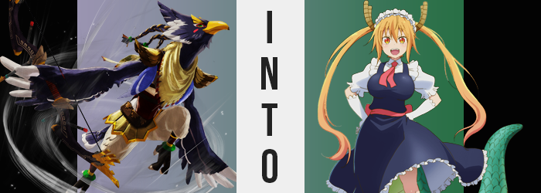

“Tch. Don’t like the looks of this, but it isn’t something I can’t handle.”

The arrogance of the Rito Champion, Revali, had not at all been shattered by the unpredictable chain of events that had teleported him away from the other champions and into what appeared to be a manor in eastern Hyrule. He could see the crimson sky burning outside through one of the nearest windows, although he did not understand the purpose of being where he was to begin with.

Like Link he had been stripped of all of his equipment. His bow, his clothes – you name it. But a naked Rito wasn’t all that exposed in the first place, clothes were simply meant to make their day to day lives more comfortable. Or to provide armor to protect them from the dangerous weapons of an enemy.

“Getting back to Rito Village as soon as possible is a priority, but I need to find something to defend myself with first…” Even Revali wasn’t so stupid as to jump out into an environment plagued presumably by Calamity Ganon’s forces without a bow to his name. Clothing he could live without. A means of self-defense? Well, he wasn’t suicidal.

The issue was whether or not this manor had any weapons to speak of. He’d appeared in what seemed to be a set of bedchambers. A large bed made up neatly, with a maid uniform dangling from the back of wide, oaken doors. When it came to clothes, he wouldn’t in a million years be putting that on. He firmly believed that.

But beliefs, of course, could be changed.

“Hmph.” Not so tasteless as to break through the window of someone else’s home, the naked Rito set out towards the door to the bedchambers. There was a good chance that whoever lived here – and there were signs that it had been lived in recently – were panicking because of the red sky. If that was true, then he would undoubtedly have an awkward encounter on his way out, but it was more or less unavoidable with all things considered.

As a wing reached out to grab the door handle, however? He stopped short of grabbing it. I can’t leave dressed like this! Goshujin-sama wouldn’t approve! “…What?” Where had that thought come from? What did it even mean? There was nothing in the room for him to even wear other than the maid uniform, and it certainly wouldn’t fit a Rito male. Not to mention he would never be caught dead wearing it.

How could he functionally adorn it in the first place? The feathered body of his people was not meant to wear such elaborate garments. Or so he rationalized, and yet… One look at the man’s body revealed that it might not be so compelling of an argument going forward. Because? His navy blue plumage appeared to be thinning. Whether it was his arms, torso, face, or even the feathers upon his lustrous wings – they shortened and obscured to reveal a pink skin concealed beneath them. Where it happened, however? It appeared to affect the overall shape of his body, too. Stealing from it its Rito lineage altogether.

If this didn’t make a lot of sense, then a look at Revali’s wings might have shed some light on it as a perfect example. He already used the plumage at the tips, which was white as opposed to the blue, as something akin to a set of fingers. It was through them that he could hold and draw his bow, and it was a Rito trait. But those feathers and bones in particular appeared to shrink as more and more of his pink skin was exposed. Before long? He possessed a pair of hands, complete with wrists that ultimately lead into arms where wings had once been.

“Hm…” Something was playing at the back of the warrior’s mind, and it wasn’t the fact that he now had a pair of regular arms. The same kind that any Hylian or Gerudo might have. But that wasn’t even all, for the what softness that clad his upper legs had faded away into pink, and the three-toed avian feet he possessed pinked and flattened, claws shaving away into regular toenails that split so that there were five fleshy toes in the front, while a heel had flattened in the back. Again, like those of races he would consider lesser. At least his legs had grown? Only slightly, mind you.

Revali, for all of his usual arrogance, just could not remember what he had intended on doing. Had he wanted to leave? Why? Never in his life had he wanted to leave this place. But since when had he possessed any familiarity with it? Had he even been here before? Something was telling him yes, but his mind? His mind was telling him no.

Not that it mattered much, not compared to his ever changing flesh and bone. Now possessing arms and legs that were pointedly not those of the proud Rito race, the phenomenon rippled through his torso next. Before long he had a set of rippling abs, a pair of mammalian nipples, and a bare bellybutton. Farther down? A cock with blonde hair nestled above it could be seen.

His neck soon shrunk in slight and thinner, and his face went next. Revali’s beak collapsed in on itself and pulled closer to his face, which in response seemed to fold outward so that his eyes were no longer pointed to the sides, but forward. While pink had spread where feathers had, with his yellow beak almost wholly consumed by his maw, it softened into skin of the same color while plump lips were forged and his nostrils found themselves mounted upon a much more mammalian nose.

What’s more, his green eyes widened and appeared to take on an almost reddish gold, with eyelashes sprouting and growing rather long. But therein lied something of concern. From how thick his lips were, to how curved his new almond-shaped eyes appeared to be, it almost seemed to be the case that the man appeared to resemble a woman more in some key areas.

This was further accented by what was ultimately hair sprouting from atop a head that now was entirely red. Like the hair around Revali’s pubes, it had turned blonde where his braids had once been and spilled far down until it reached just behind his knees. Wavy and soft, the silky-smooth design was not reminiscent of anything a man might rightfully wear. Well… Perhaps Link?

Who was that again?

“Kyaa!?” For a man that had once been arrogant and proud, a scream that was rather girlish in type and sound shot from his lips at the sensation of suddenly falling. Not that he actually was, but his point of view had been readjusting thanks to limbs shortening so that his height fell to around 5’4”. All of that toned muscle that had remained after becoming a ‘human’, rounded ears and all, evidently melted away as well – leaving him with a body that seemed to be much softer.

This was highlight just above a waistline that had narrowed, for in a panic daintier fingers brushed past a jiggling phenomenon focused on the man’s chest. “Why do I feel so weird?” The fact that his new nipples were standing at full attention was probably a good sign. Their swelling in size counted among the strange, but the jiggling beneath was the uncannier looking of the changes. Because where abs had once been, the undeniable growth of a woman’s breasts was taking place. They surged forth, jiggling soon turning into a distracting bounciness as they filled like a pair of water balloons. Ultimately, they culminated with a pair of bombastic D-cups.

Not that his lower half faired much differently. Hips parted like the Red Sea, their newfound width allotting plenty of space for fleshy thighs to expand with a tender, shapely thickness. Quite rounded, they were undoubtedly feminine. If you did for some reason have any other doubts, though? One need only look at how his seat expanded, with human butt cheeks then swelling with a fit bounce that would rise and fall as he stepped.

Or she stepped.

“Mmn!?” Gaze cast back to the maid uniform dangling on the door (and wondering why she hadn’t adorned it yet), she stifled an aroused moan that was directly linked to the subversion of her genitals, transitioning her from man to a woman. Strange as it was in the end though, the new woman hardly thought anything of it. Her memories had already been altered to accept it, after all.

Just as they had been altered to accept the additional growths that emerged from several points on her body. The first came from her skull – four horns that curved upwards. With horizontal grooves, they were colored brown and certainly didn’t seem akin to those on any race nor monster that might be commonly found in Hyrule.

But there was also the tail that erupted from behind her. Big and thick, it sported emerald scales on the top with paler ones beneath it. It was fortunate that Revali was naked, because it was just as wide as her ass at its base, and definitely would have obliterated any garments that might be worn.

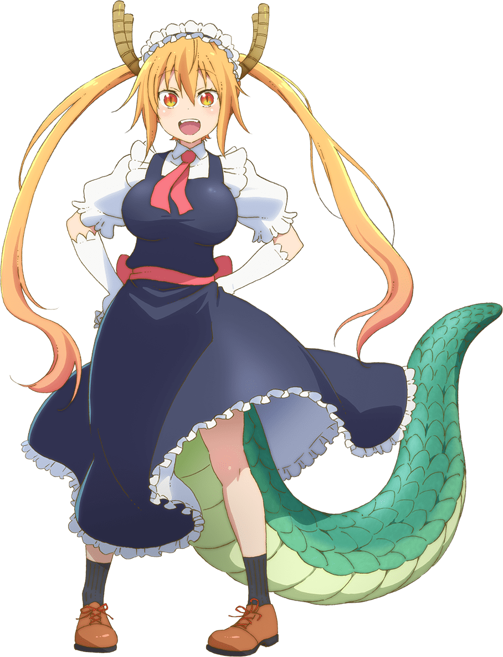
“Oh! That was strange. And why’s the sky all red? I wonder if goshujin-sama knows anything about it?” Still stark naked, the dragon maid known by the name of Tohru stared out of her nearby window. These bedchambers, as she now recalled, were hers. She had been serving the lady of this manor for some time now, and that lady was a monster just as she was.

Fortunately for her, that lady had imbued Tohru with a protection against Calamity Ganon’s influence. Despite the burning crimson sky’s intent to stir every monster into a frenzy, a dragon maid in such a state would be pretty much useless, wouldn’t it? “Wha!? Was I about to go meet goshujin-sama naked!?” That would have been wrong, but on the other hand? If her master had approved, then she absolutely would have walked around nude!

That tragically wasn’t the case though, and she instead quickly plucked the uniform from the back of her door. Lace panties went on first, then the leggings, the shoes… and then finally the gown! “There we go, ready for another day of work!” The maid outfit in question did little to disguise just how bountiful her chest’s assets were, though.

“After I prepare her tea, I should ask goshujin-sama what’s going on!”

