*Inescapable Fate*

**"Go! Squirm! Struggle however hard you wish to! But all who bear the Mark return to these hallowed grounds…savor this victory while it lasts…"**

Those were the parting words spoken by the Demon King when the warrior's blessed blade pierced the last of his four hearts, severing the hellspawn's connection to the mortal realm within a crumbling canvas of shattered cobble and rotting wood; the King's former abode and the single permanent fixture the demons have ever made in human territory throughout the millennia since the first incursion led by the original iteration of the Demon King, quelled by the first of many Herpes who had in turn, risen to halt his armies advance.

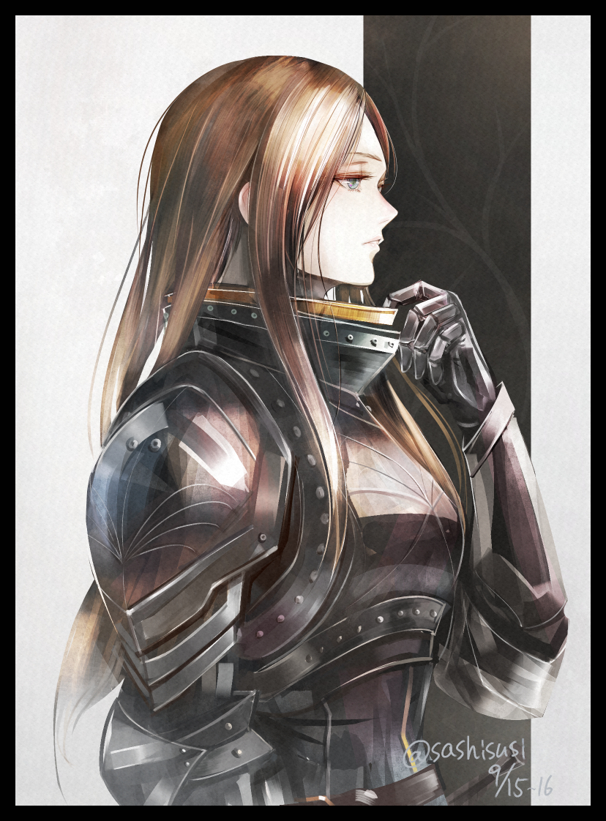

The latest battle was hard fought, but through perseverance and an iron will, ***Feran The Fair*** and his comrades had come out on top just barely. With lives lost and villages to rebuild, the festivities would have to wait as the victors licked their wounds and said their farewells to those who couldn't be there to see the next sunrise. But the Demon King was repulsed, and with it, a millennia of peace was guaranteed.

But not everyone seemed to be in the mood for celebrating. Even more surprising when folk realized it was Feran himself who didn't seem to share in their happiness…for no one but him had heard the ominous parting words of the Demon King as he beamed his last thoughts through telepathy before his body vanished to the aether. His mind constantly pondering the words…and not without justification of course.

For within his eyes, deep beneath pale indigo irises, the Mark the King had spoken of burned a brilliant magenta, criss crossing strokes forming a crest radiating sinister energies for purposes unknown. And just like the words, no one else seemed to notice the Mark whenever they spoke with Feran. It bothered the Hero to no end, wondering when he’d been hexed with this spell and dreading its intended purpose after waking up shortly after the climactic battle, stunned by the thing inside his eyes as he moved to wash up, doing all he could to figure out what the Mark meant and if it could be removed. Knowing a good bit of magic techniques himself, Feran was hopeful curative spells would do the trick. Wanting to get himself out of this mess without involving anyone to risk, par the course for Feran’s self sacrificial nature.

That was when the effects of the Mark made itself known as purifying magics ran through his body, triggering innate alarms that begin to alter his body as muscles honed from years of training and battle experience ebb and fade while fat begins to bubble and brew, gradually replacing the Hero's solid build with a tender gentleness that made Feran The Fair an all too literal title as his gaunt build is soon replaced by one too waifish to be considered a warrior. Sighing as he moved to check if anything had changed, oblivious to the physical alterations. Sighing in disappointment at the Mark still glowing within eyes that were taking on a crimson hue as if the thing was seeping into his very being…which it was.

The changes would only become known to Feran a few days later, assuming it to be a cause of the Mark, but with his secretive nature and how he distanced himself from his comrades after they made their triumphant return to the capital, only a few were vaguely aware of the Hero's plight as he sought advice from some of the most powerful magic practitioners with a crude drawing of the Mark, gaining nothing to follow up on as no one seemed to have heard of or seen this strange rune of his. Leaving him frustrated as each day passed by with no end in sight.

While his comrades enjoyed a well earned break, Feran would continue to flounder in the dark, utilizing a reliquary of relics and ancient spells in order to undo the Mark, each one furthering its hold over Feran, molding his physical form in the first few days before eventually moving on to his mind.

The first week would come to a close with the Hero's former brunette mane being replaced by extravagant locks of gold that couldn't be cut in addition to losing the last of his abs to a mellow core of supple fat and toned flesh. The third would pass with Feran's effeminate visage fully slipping over the edge, losing what little was left of his identity as a proud and elegant swordsman. No longer able to pull off masterful sword arts thanks to his center of gravity being altered by expanded hips, compact shoulders and an exaggerated arch to his spine that forces out a pert chest while a bubbly rear wobbles above long, slender legs scoured clean of body hair.

By the time a month had come to a close, Feran's once proud member had been reduced into a flaccid thing that could no longer grow erect without effort while the beginnings of a pair of healthy breasts would begin to grow forth. Nurturing ripe flesh and supple fat behind succulent pink nipples that tingled with the slightest brush of fabric, discouraging the use of attire he once preferred to wear. Turning in tunics and other baggy clothes for comfier silk and airy garments that unfortunately only came in the form of women's wear, further wearing out the Hero's assumedly unbreakable willpower as he soon came to dress in revealing kirtles and exposing dressed that ashamedly fit his new, bodacious form well. Showing off pronounced curves with plentiful gaps for vibrant skin to peer through. He didn't even need to go to the effort of hiding his identity considering how drastic and thorough the Mark was in making sure he looked completely unrecognizable. Ensuring if he ever tried to get help from his former connections, they would either laugh or chase away what they could only see as an insane blonde woman for daring to claim she was Feran The Fair, the Hero of humanity.

But that didn't stop the man from trying to cure himself of his ailment, fighting new urges and a withering intellect that only seemed to be spurred on by every single thing he tried, be it spells, potions or even soothsayer myths, masking it's insidious growth by blinding Feran to the changes for a few days, giving plenty of opportunity for him to get in trouble wherever he went, going out to buy alchemical supplies in clothes far too small to fit his ever expanding form, with dresses and brassieres struggling to hold back glutinous folds of fat and sensitive skin. Turning heads as lecherous eyes and jealous girls stripped the platinum blonde woman walking the streets naked with their combined gaze, taking in the sight of bodacious hips swaying from side to side with every step of perfectly sculpted legs sticking out below the short hem of a suffocating dress, teasing the plump cheeks of a heart shaped rear while the thin layer of silk clinging to her torso outlines every single rise and fall of enticing flesh, especially the two gracious mounds stop her chest, bouncing beneath Feran's notice as he went about his business, turned on by all the judgemental, leering stares everyone seemed to shoot his, blushing as he bathed in the attention, the jealousy it aroused and more importantly; the men it lured in.

Because the stronger the Mark's influence grew, so too did sinful urges and sensual visions, bubbling ever higher like the frothing contents of an active volcano as they swarmed over Feran’s intoxicated mind, dulling inhibition and doing away with morality while boosting his body's sensitivity and amping up his libido in a bid to turn the upstanding Hero into a decadent being empty of moral and completely self serving to fulfill the growing fires of carnal desire now burning inside him.

Blissfully unaware, Feran would continue to both uphold his duties as a Hero and seek out new ways to rid himself of his malady. Remaining unaware of just how inappropriate he was behaving in front of others as his mannerisms soon changed to fit the bill with the vanishing of his manhood as the last of its defeated nub slips away unnoticed beneath flaps of sopping pink and aching muscles lining a void leading into a steaming incubator flanked by freshly formed ovaries molded from useless testicles, pumping Feran full of hormones and chemicals that further dull her senses to her seditious she was becoming as her former insecurities about showing off too much skin in her increasingly flamboyant choice of attire vanish altogether, walking around town in skirts short enough to show off lace panties even while standing, slaying beasts with buoyant cleavage bouncing to her wilder sword swings, doing her hair up into cute twintails and even soliciting sexual favours from any man who would wander into view. Feran of course, would be blinded to these disgraceful acts, taking a backseat in her consciousness as her body moves on autopilot, giggling happily as she willingly gives herself to man after man, only to come to her senses again in a dizzying shock, blinking that brief spell of darkness away as she continued whatever she was doing at the time with her clothes looking slightly disheveled, vanilla tinted spunk dripping from pert lips and a warm, bubbly sensation in her belly that further sinks her deeper and deeper into the depths of depravity.

Until one day the veil was no longer a necessity on part of the Mark, freely allowing the newborn woman to indulge her wanton urges as the demonic seeds of corruption fully take root in her soul, blackening her heart forever to all morality, blindsiding her goals to rid herself of the Demon King's curse with an even stronger goal driving her forward even though she didn't know what it was exactly. An alien instinct within her thoroughly whacked brain strong enough for her to view her old, chivalrous life with emotionless eyes and her new, sinfully gratifying one with glee, dropping the blade that had slain countless demons and beasts where she stood while she was on her way back from a hunt one day without ever looking back…

At this point, Feran The Fair had been considered missing to the public eye. As far as anyone knew, the man had been seen around town for only a few weeks after slaying the Demon King with a flurry of speculation suggesting he had gone into hiding to live a quiet life while others claimed he had left to continue his quest for peace elsewhere. With no one batting an eye to the thought that maybe…just maybe the new harlot in town living in the former home of their savior might just be the Hero cursed to a fate worse than death. Joyfully bouncing off of men, riding phalluses and bathing in pungent baths of semen, soaking up strength through the absorption of a man's essence as if to replace what she had lost, knowing it would never be enough as she went through stud after stud, gaining an infamous reputation alongside a bevy of disgraceful titles;

Housebreaker, Slut, The Golden Bitch and the one that vibes with her the strongest; ***Fiolla The Fair***. Musing about the similarities to her past title when she had asked a particularly endearing client what he would call her as she continued to rack up infamy with the community. Until enough was enough as the sensible folk of the capital voted to oust the strange whore from their premises. And if she was hurt by their decision? She didn't seem to show it that day as people gathered by the town gates with judgemental looks, slinging hateful slurs and harsh words her way, showing little care to their words as she blew them all a kiss with a wave of petite hands that most men in the capital had already felt ravish their bodies at some point or another during Fiolla's brief stay at the capitol.

But as all things were fated to be, the feats of Feran The Fair and his company would soon fade to the annals of time, inscribed upon scrolls, tones and the minds of scholars as simple legend, tales of be retold across time with many including some of the Hero's closest trying to track his exact whereabouts down to this day.

Meanwhile, Fiolla, long having since succumbed to the Mark, would wander the vast lands beyond the Empire's heart seemingly without a goal. Making occasional stops at small settlements, some of which she still remembered saving not too long ago as she happily sucks off a farmer whose life was inches away from being cut short by a Gargoyle's wicked talons in one while playing wife to a widower in the village a few miles away, stroking his head as he laid in her lap, recounting the still familiar memory of a harrowing attack by a Wyrm that ended with the man's partner amongst the dead. While the concept of human emotion was as alien to her now, the faintest spark of pity within Fiolla's ashen soul had urged her to leave the man be as he drifts off to peaceful sleep for the first time in a long while, leaving to resume her travels on an empty stomach but the freedom to spread her literal wings in the peaceful solitude of night where creatures of the dark like herself were free to do as they saw fit, shedding her innocent, human disguise for her true self that had come to light not too long after her expulsion from the capital.

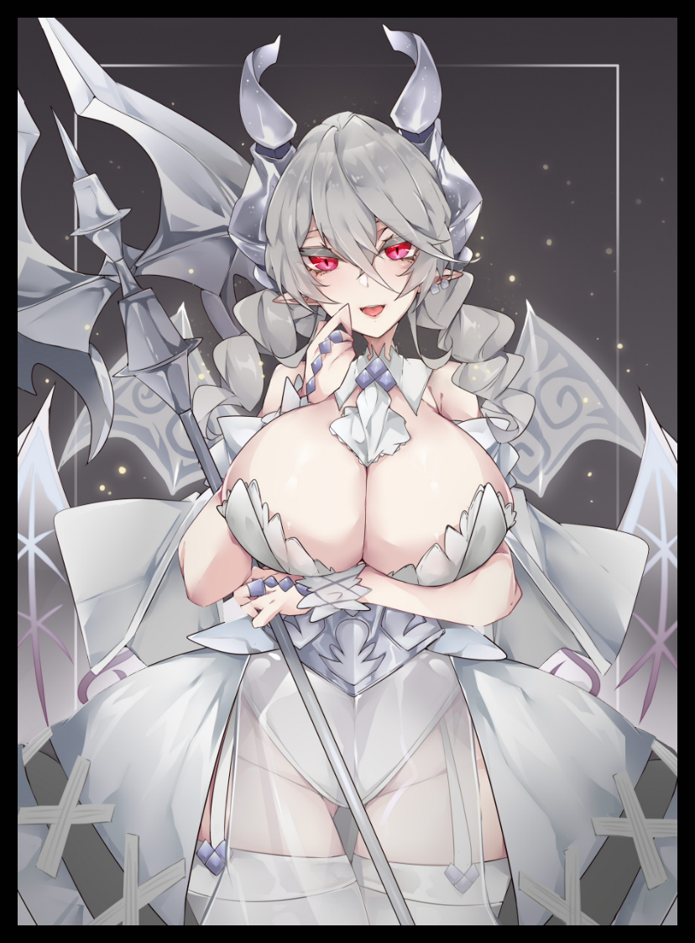

While she retained most of her physical traits, Fiolla's seductive form as a demon sported massive teats that stuck out with an amazing firmness coated in milky smooth skin that made playing with them a delight. Styling platinum silver twintails into long, braided ones that hung down long enough to tickle her rump. And true to her new heritage as hellspawn, polished effervescent horns jutted out from the sides of her cranium while two pairs of bladed wings patterned with gentle curving lines and symbols beat the air just above her shoulder blades and to her sides, mimicking the fluttering folds of a semi transparent dress when not in use, offering a tempting peek at the snow white leotard that hugs her tight body, highlighting a puffy cameltoe down below while loose, frilled flaps above tease swollen nips, pressing her breasts up close to form a deep cleavage that seemed endless in depth, an enticing fourth hole to use in case all others were taken.

But not all of her was as soft as she appeared to be, for her skills as a former paragon had been repurposed and put to good use when the need arose for her to draw arms in self defense. Gaining a sudden, but welcome interest in Halberds, whisking a rotted one away from one of the villages she had passed before reforming it to her desires, making it a part of herself as it's broken wooden shaft and worn out handle reforms into resilient Ebonsteel while it's singular stabbing edge morphs into twin ax heads surrounding a javelin tip. Ensuring severe damage in whatever ended up on the receiving end of the weapon swung by the superhuman strength possessed in Fiolla's deceptively innocuous form. A silver bridal warrior of the dark would be an apt description when it came to Fiolla's true form as a Higher Succubus as she danced across the plains and flitted through the sky, enjoying the cool air against her skin as she soared high above, thinking herself stupid for even trying to rid herself of what she now saw as a gift, crimson eyes locked on the distant ruins of a castle far off beyond the borders of the Empire; No Man's Land, a blasted landscape that would always remain uninhabited in preparation for the demons return every few hundred years.

A few more days worth of travel, and eventually Fiolla would make it to the shattered hill upon which sits the very same ruin where she had faced down mankind's greatest foe, feeling the gut punch of betrayal rousing within her heart thanks to her tainted mindset altering allegiances and priorities. By now, the compassion she had shown to the lonely villager only a few days ago has long been emptied out of her, squeezed dry like a cloth left out to dry. Leaving Fiolla a fully fledged demoness completely loyal to her new heritage and woefully submissive to whoever would soon prove themselves the new ruler fit to rule and someday expand Hell's dominion past these ravaged walls as her heeled feet clack against the ruined walkways leading up and into the bowels of the castle.

In an effort to cut down the Heroes and any hope of their bloodline expanding, the most powerful and depraved minds of Hell's armies had come together, formulating the Mark, the very same one that now burned deep within Fiolla's brilliant crimson eyes as she soon comes to a stop before the antechamber leading to the main chamber where she had slain her former King. Its goal was to subvert and corrupt the human aspect of the one unfortunate enough to bear it, with any attempts made to remove it working against the victim by speeding up and further numbing them to its effects as it had done so with Feran. Leading them to gradually deteriorate, fighting a futile battle that would always end the same way; with the resulting Succubi proving undyingly loyal to their demonic brethren, just like Fiolla now was as she spreads her wings while burning away any extremities of her dress to leave her bare and borderline naked, pushing open the doors leading to a strange space where the moon hangs eternal over starlit skies painted an obscuring black with distant mountain peaks spewing ashen clouds and an intense sea of fire to the south, an alien dream plain she knew to be the underworld, her home, where she belonged with all her other sisters as they sat around the ethereal garden, some basking in each others presence while others practiced their battle skills in preparation for the next assault against mankind.

But there, in the center of the circle, laid her target, the source of the call she could sense even back during her time in the human capital, awaiting her on his back, large leathery wings folded behind his immense muscular frame that instantly had her excited as her eyes widened in anticipation at what she saw, leaping over the short distance between them with a strong best of her wings before crouching over his waiting pecker with her drooling snatch spilling it's love juices all over solid abs.

With a stifled moan, Fiolla allows herself to be taken, smiling as she felt the demons coarse hand peel away the flap of her leotard, caressing her right breast while tweaking an erect nipples between them before releasing his grip and letting her buoyant tit flop back over her chest. Giving the Higher Succubus carte blanche as she presses down firmly over her navel with gentle hands, before her legs give way and her loose folds clench around their prize, not letting go as the couple lean in for a kiss, groaning with eager tongues entwined around each other as the Mark left by the defeated King removes itself from the mewling woman's eyes, it's purpose fulfilled.

From now till the next incursion, Fiolla would be left as a brood mother to birth powerful demons into the underworld, serving the dual purpose of spawning offspring as commepance to those she had cut down during her former life as the humans champion while also empowering the demon's armies if her children, imbued with the defiled Hero's blood, wished to join their ranks. But the Higher Succubus would not be treated as a criminal, nay. For the demons cherished strong warriors from all races, and in their own twisted way, the recent act of turning Heroes into fertile demon women was simply their way of recognizing their feats of resisting them where others had failed.

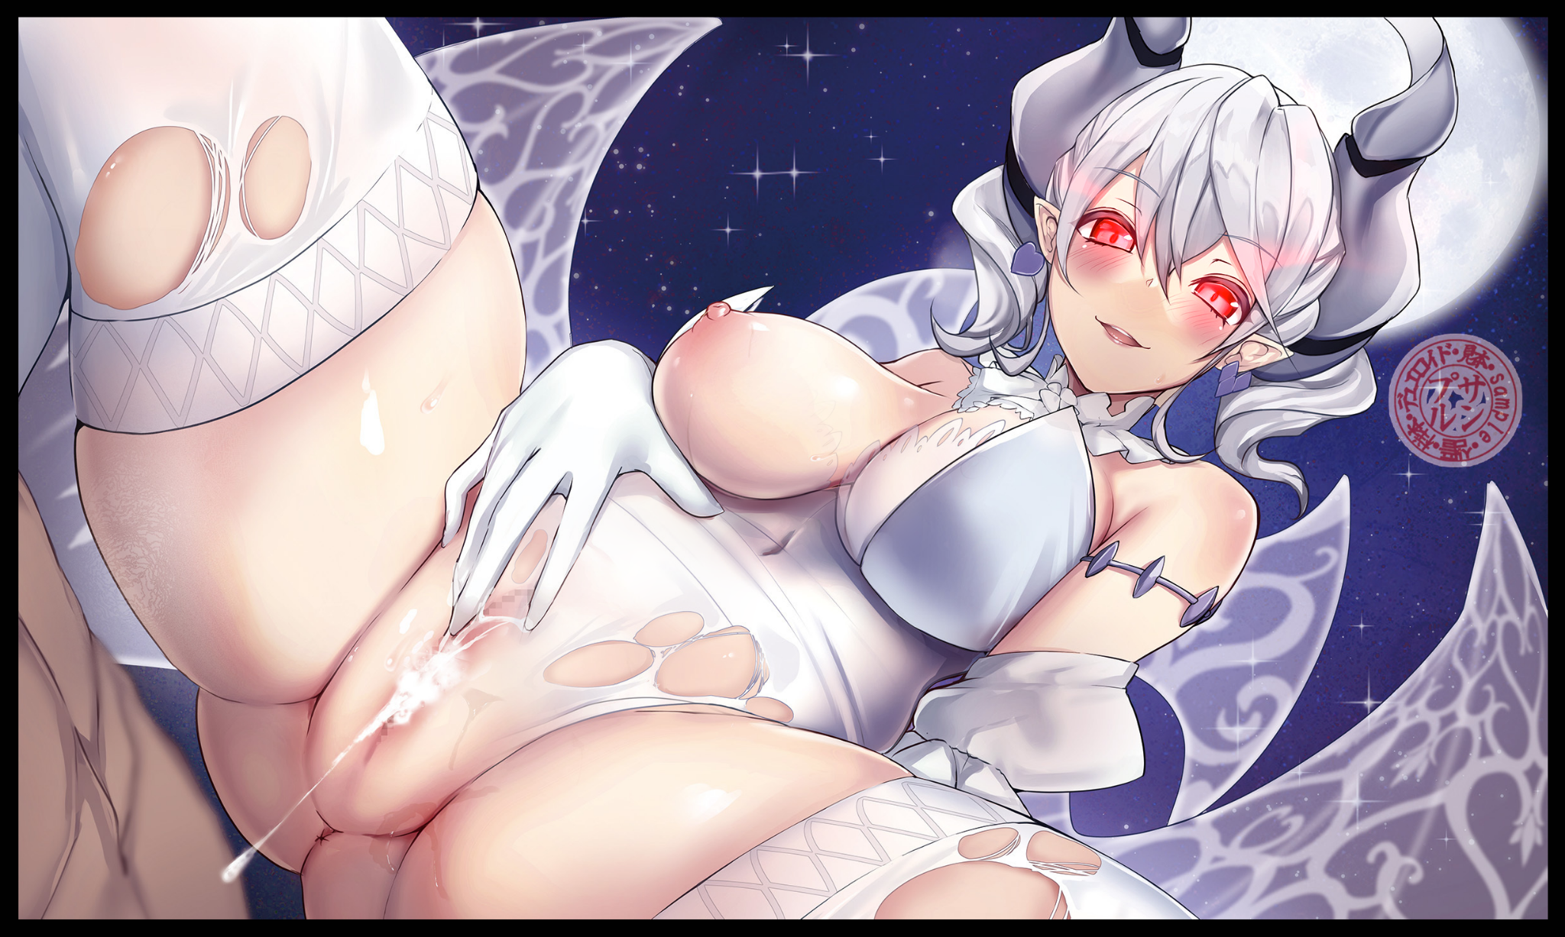

As fast as the incursions ended, none could deny that the demons had been growing stronger and stronger over recent skirmishes. And it was all thanks to the skills and techniques taken from mankind's best as they willingly spread their power amongst the demons. Thankful to their new brethren for granting them life everlasting and otherworldly beauty to boot. Who they once were, they could care less. With their very morals being flipped upside down, the only thing the ever expanding nest of Higher Succubus that guarded the portal to the human world in wait for their new King felt when thinking back to their human memories was abject disappointment.

So ends the true tale of Feran The Fair, starting life anew deep within the bowels of Hell itself as Fiolla, the latest to join the demonic legions with a hopeful future as her partner finishes up inside of her, falling over onto her back with a sonorous cry, tended to by her elders as they swarmed over her, giggling and fancying her hair while others poked and prodded at her body, laughing as they watched fresh splurts of demon essence flow from her aching snatch. Never would she have ever dreamt of being impregnated as such, but the idea of motherhood didn't scare her as much now that her mind was brimming with an eagerness to rear children into the world to be their own person. And if she was lucky, maybe one of them could very well take the crown and lead her people to victory. And if that were the case, she wouldn’t mind bloodying her fatigues a little if it meant fighting by their side against the humans, wicked halberd in hand…

*THE END*