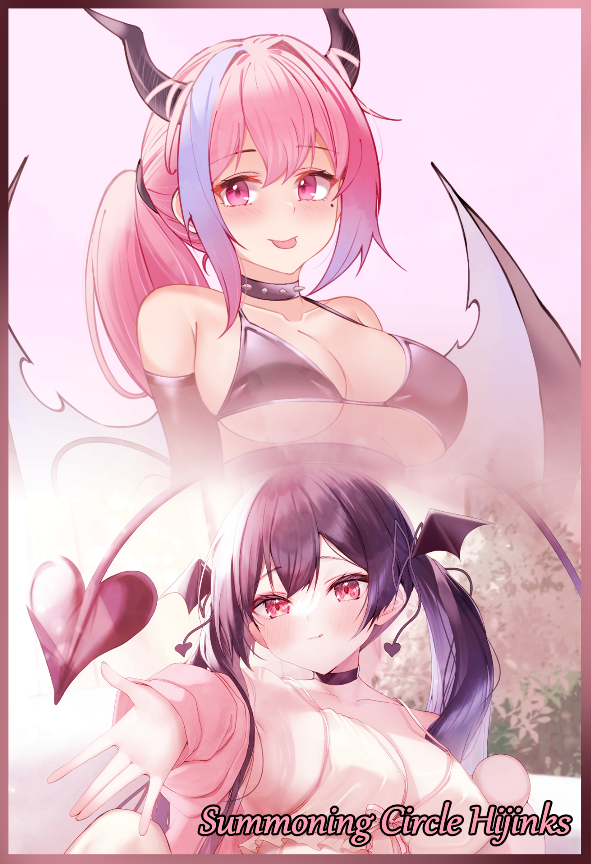

Dan and Maxon were probably the best example of close friends that couldn't have looked any more distant and separate from each other. On one hand you had Dan, your typical needy kid who didn't look much stronger than the average boy in highschool with a dead serious attitude to life and all its hardships. And on the other stood Maxon, a tall beefcake of whose stature belied his young age with an equally extroverted personality to go with his ever bright face.

One would think a coupling like theirs to be comparable to a victim and his bully until they saw for themselves the chummy friendship the two displayed, and especially since they were classmates, it was almost a rare occurrence to see the two apart. While they did have other friends they hung out with, the way they bounced off each other in group conversations made it seem as if they were always speaking directly to each other while ignoring the rest of their buddies.

Although the two tried to keep a good track record, they were still boys at heart. And so whenever either one felt the urge to do a little pranking, both Dan and Maxon would partake in their schemes, with each one having a distinct flavor to them, like a signature of sorts.

For Dan, his pranks were more akin to haphazardly strewn together scraps that all came together in a rube goldberg machine that had the victim's eyes busy watching some innocuous object like a marble or oblong eraser make its way across the contraption before ending it's journey with a thunk, triggering a plate or switch that would send a bucket of water right on the targets head or caking them in a thick cloud of chalk from a whiteboard scrubber. The end result of which would always leave a big grin on the boy's face as he speeds off with Maxon. Who, on the other end of the spectrum, preferred a more…direct…means of approach. Classic stuff like firecrackers in the toilets, tripwires in doorways or around corners. Straightforward and succinct, it was Maxon's bread and butter. And it served well in breaking up the monotony between Dan's more intricate pranks and vice versa.

But parlor tricks and pranks weren't all the two did in their spare time. Urban legends and mythological folklore about social taboos and cursed phrases were something the two delved headfirst into whenever they weren't busy cracking down on studies. And when the time came for long holidays away from school, such as the current summer holidays, they would pick out certain nearby places they could trawl through on exploratory trips to uncover the supernatural. Although they ultimately never found anything noteworthy, the experience was all that mattered to them. Trekking through an overgrown complex, ducking down between the floor and a half ruined overhang of gnarly rebar and concrete, the damp musk of long forgotten rooms, that was the main motivator behind their attempts to chase the supernatural, with Dan even amassing a neat collection of trinkets and baubles consisting of ruined objects of indeterminate purpose and more simpler stuff like glass fragments and glassy stone.

With the summer in full swing with record high heat waves beating down on the country, the boys had decided to stay inside at Dan's place, playing couch co op games while reading up on and pinpointing potential sites they could visit.

But there was something else on Dan's mind, something that would have dire consequences for the two of them unbeknownst to the naive adolescent boy, who, up until now, was convinced the supernatural just couldn't exist without tangible reason after a string of failed urban explorations and faux myths. Would this be any different from the norm he had come to expect?

"Hey…Max? I've got something I wanna show you…"

And so, as the hand held over the mouse guides the cursor over to the icon of a shady site he had bookmarked the night before clicks on the link, their fate would be forever sealed as his index finger presses down twice over the sinister heart shaped brand right as Maxon strolls on over from his side of the room.

"What's up? Found another spot for tomorrow?"

"Nah, nothing like that. This one's a bit more hands on though. Here, lemme show you!"

"Hands on huh? I'm likin’ this already."

Before the boy's eyes, the screen flickers for a moment before displaying a rather bland loading popup with blurred edges, eliciting an unimpressed scoff and a raise of the brow from Maxon. And as if in response to his friends increasing disinterest, Dan pipes up, filling his friend in on what this shoddy website was all about. And upon the mention of a certain subject every boy their age would more or less start to become interested in, Maxon was hooked.

By the time it was finished loading the necessary resources, Dan's exhaustive explanation of the website, one supposedly capable of 'summoning a wish granting spirit that could fulfill the desires of men's fickle hearts', had come to an end, a slow clap from Maxon was all the applause he would get for his detailed presentation.

"So you're telling me this thing can grant wishes related to your soul mate? Like what? It turns your computer into a lamp? Gotta run it hard for the big blue man to appear and land a hot girl by our sides?"

"Hah! Something like that…but that's where the hands on stuff comes in, see? Real DIY this thing…"

Gesturing to the monitor screen that had turned inky back save for a weird symbol scrawled in red, Dan waits for Maxon to get a full understanding of what he was seeing before saying anything else. And from the way the blonde jock's eyes widen as he examines the perfect circle filled in with a modified pentagram and some weird scripture, Dan knew his buddy had caught on.

"It's a…damn, isn't this some devil magic stuff?"

"Ehh, it's close, but not quite, for one it…well, it's unique! I've done some research and from what i've gathered, it doesn't match any known pentacles or demonic symbolism!"

"So…it's someone's oc? Circleman?"

"Funny…so, you in?"

"Do you even have to ask? Of course!"

Setting their mind to the task, the boys get ready the necessary materials for the circle (as well as ensuring they didn't make a mess before Dan for grounded), printing out a template screenshot on transparent paper before using simple red markers to sketch out the thing. And thanks to the immense size of the image, the tiny scribbles of ancient text were legible enough to trace the precise strokes in case they botched something.

And while they worked to replicate the circle which, according to Dan, needed a space large enough for two people to stand in. The boys filled the ambience with their chatter, with Maxon questioning Dan on how he even came across this thing.

"Ahh, it was just…there, on the forums I usually use for occult stuff. I thought it'd be a fun thing we could do since we're…y'know, stuck here when it's baking out there."

"Heh, no kidding, reminding me alot about…arts and crafts! Where's the information anyway? That link was just the circle wasn't it?"

"Ehh it came in a separate download."

"Jeez, talk about old school…"

With the last symbol scrawled and the template removed, the boys were left with a circle that looked like a mockery of the original, not helped by the fact that neither of them had the artistic skills to etch a full circle without some creases and bends. But as they stood over the thing, they knew this would have to suffice.

"So what's next? Are we doing this one by one or?"

"According to the manual…up to 5 participants can contribute to the ritual, each one stationed on each end of the pentacles star. To start the process; 'simply release your mind end envision the apple of your eye'."

"Pssh what is that haiku shit? I thought this was supposed to summon a genie?"

"Spirit! And I guess it conjures it only when we've made our wish for a suitable girlfriend known?"

"Well…only one way to find out I guess…Hey! Dan?"

"Whats up Max…you sounded a little…nervous there."

"If this thing actually does work…mind if you give me a go with your girl? If she's a looker of course!"

"Fat chance…and what're you even talking about? We're both…ah right, last year of highschool…"

"Keep your head in the game little brother! If this thing actually works we might just graduate twice in one year!"

Scoffing at Maxon's words, Dan takes position directly opposite to his friend, feeling giddy with sudden anticipation as they stand before their sloppy circle. Just a few minutes ago it felt like they were doing this for fun, to test a theory. But now as they stood ready with the knowledge of what they were about to do no matter how incredulous it all sounded, it was still enough to instill a measure of tense excitement in their hearts and a heavy air of suspense.

"So…how're we supposed to do this again?"

"Bring your hands together, then close your eyes, make no sound and just…let your mind do the talking I guess. We'll give it..let's say 2 minutes? Then we call it quits if nothing happens."

Nodding before clasping his hands with Dan following suit, the two boys begin to daydream about their dream girls. Dan with mild expectations and a solemn mind while he envisioned a bubbly girl, a companion to keep himself company with. And although he wasn't as big of a horndog as his friend, Dan made sure to include an ample libido and an undying loyalty to her man, to him, despite not knowing what it truly meant unlike Maxon who, with unadulterated lust and anticipation, allowed his perverted mind to work on building a caricature of the perfect woman for himself. Grinning like a kid in a toy store while envisioning a fashionable socialite with a banging body to go with the mind of a seditious slut whose only focus was on pleasing her man and nothing else. And if they weren't up to her standards, she would brush them off without a second thought. He did so love bad girls…

And as the mental image of their respective fiction begins to materialize and take shape, the hastily drawn circle between them begins to glow alongside a web of crawling darkness that creeps forth from the ominous scarlet light, consuming the paper beneath it with a barely audible crunch before moving on to the carpeting, and then the bed until eventually the entire room was painted in liquid darkness while the two boys continued to stand still, arms held tightly together as if in prayer.

While the purpose of the magic circle was indeed to summon a spirit who could grant the wishes of men looking for love, the absence of terms and rules meant that no one had any idea that the circle would infuse it's caster with daemonic energies drawn from the 2nd circle of Hell itself where those who drowned in lust wallowed forever, and with that energy, a wish granting spirit in the form of a demon would be summoned through the unwitting flesh that sought one themselves. They would remain themselves…depending on the severity of their imagination of course…alongside a healthy serving of demonic influence…

And as their thoughts simmer, the shadows began to lick and spit around the feet of the two oblivious boy like black fire, metaphorically warming their bodies in preparation for what was about to happen next as both Dan and Maxon begin to succumb to the influence of the shadows enchantment with Dan's childish form beginning to gain mass and elongate while Maxon seems to regress, losing muscle and a little bit of height in exchange for gradual curvature and gentle softness most unsightly on one such as himself.

With bones subtly cracking into new formations beneath sifting flesh and rustling skin, the two can only feel a slight itch and the occasional badump as their organs move to make way for new ones alongside an expanded set of hips thanks to a broader pelvis. And to balance it out, the invisible hand of the otherworldly masseuse working on them pinches lightly around their pecs, squeezing while kneading a gentle arch to their spines and a proud puff to blobbier chests resulting in an eye-catching hourglass figure that culminates in their behinds ballooning outwards as all the excess mass floods downward, filling in their gaunt asscheeks with pliable fat and firm meat while their bellies begin to change; hardening Dan's untrained abdomen with toned muscle and supple flesh while Maxon's hard earned abs begin to mellow out before sagging and collapsing into a petite core layered with baby fat and framed around a sexy belly button that had a slight pucker to it, reminiscent of a pregnant woman's stomach. All coated over in brand new skin stripped entirely of hair follicles except where it mattered around their crotch as the wirey beginnings of pubes begin to flake away in place for silken strands; the nascent badges of womanhood the two were beginning to adopt.

By now, the boys could tell something was off. From how suffocating Dan's clothes were beginning to get with his shrimp body having matured past lobsterhood while Maxon's daydreaming was beginning to become mildly pleasing thanks to the presence of B cup tits sagging down against his shirt, tenting the pale fabric with dark pink mounds that were only beginning to grow larger as inactive nerves and glands begin to fire up, pumping the mammaries with an abundance of creamy soft fat that jiggles with the slightest breath, all while rubbing his fattened thighs together as the hem of his pants begin to strain against the salaciously thick pillars, inevitably leading to a fault as a loud and sudden rip fills the air, finally spurring Maxon to open his eyes and check on the situation just in time for his blonde hair to begin lengthening down his womanly face in thick raven black locks.

"H-Hey Dan? Did you hear a what the hell?! Dude! Open your eyes! You're changing!"

“What? Changing? What’re you even…why’s everything so dark?”

Looking around in shock with their rigid prayer stance broken, their wild eyes would eventually return to settle back on themselves, examining their drastically altered forms before bolting upwards in shock to stare at each other, with tears in Dan's slanting eyes and surprise in Maxon's alluring pearls as his motherly face continues to lose its years.

But the time his buttons give way to perky D cup breasts with a healthy jiggle to them, horns had begun to push their way out of Maxon's skull while a leathery tail slips free of Dan's tightening boxers as they both open their mouths to voice their thoughts in a cacophony of voices steadily losing their grip on manliness as the bulge in Maxon’s now long slender neck fades away while Dan’s prepubescent voices gains a mature husk to it, all while the thick, brooding studs in his ears lesson in number for ones of a more feminine quality, bringing attention to the face of a minx beginning to show over the naive innocent boy Dan no longer was.
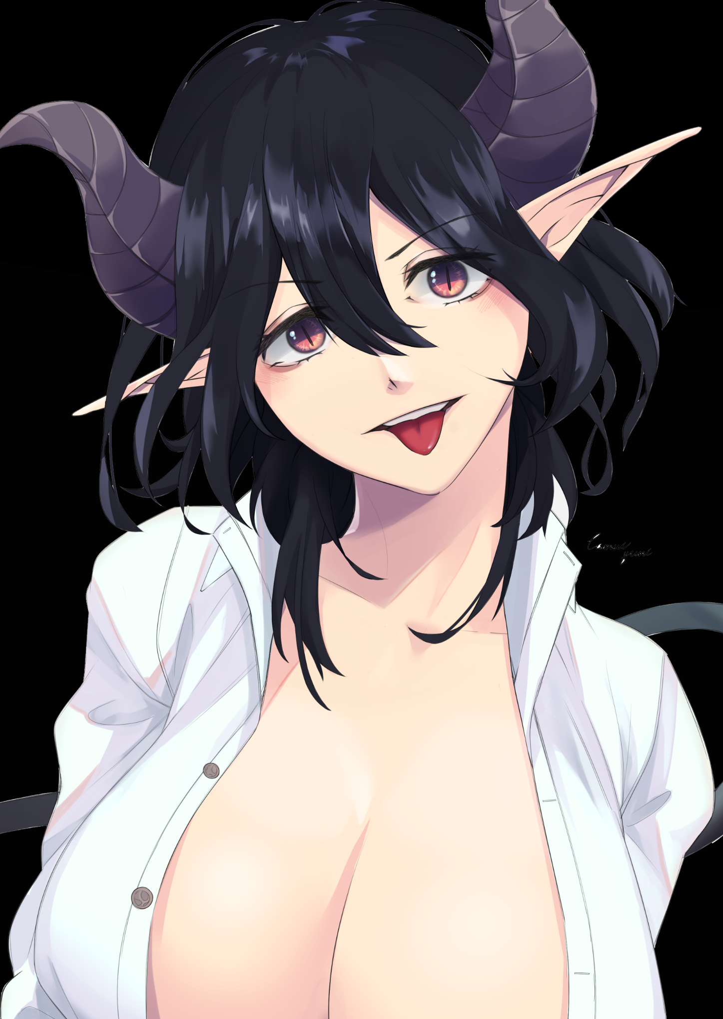
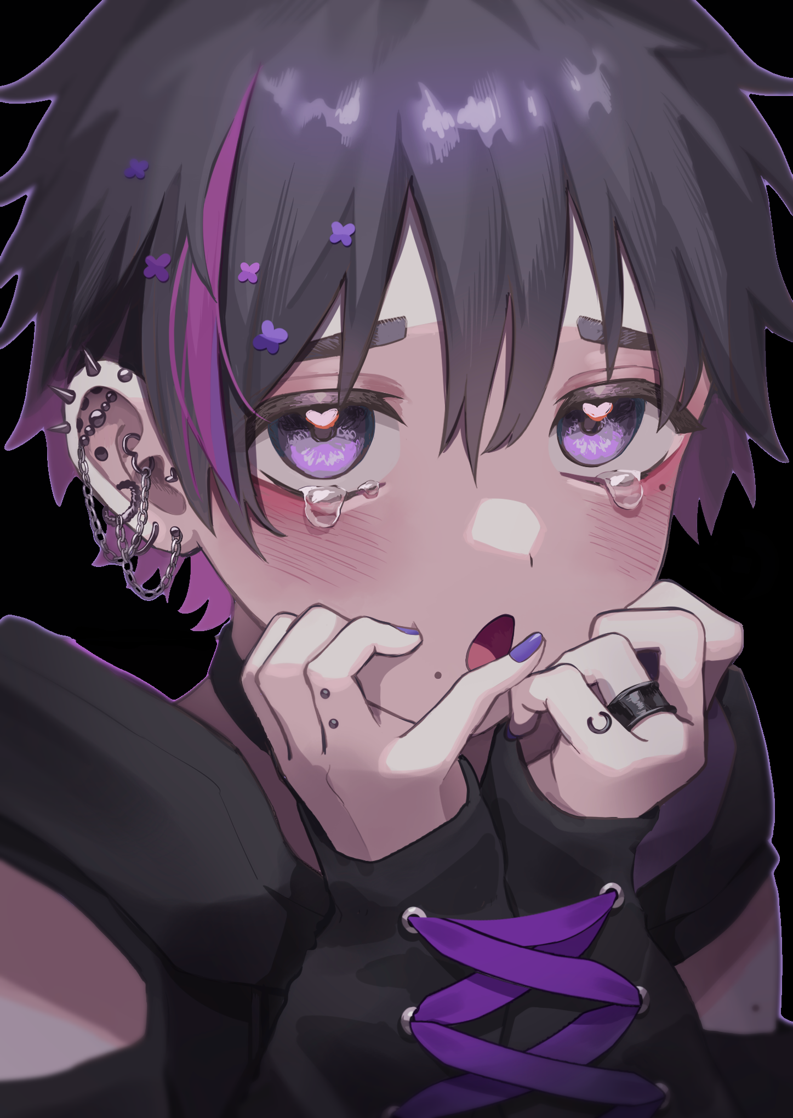

“WHAT THE HELL IS THIS?!”

But before either boy could distance themselves from the still glowing embers of the magic circle, the shadows around them sense their intent, sending in thick black tentacles to immobilize them, binding their legs to the floor.

"D-Did the circle go wrong?! Dan!"

"I-I-I dunno! Th-The m-manual never…it never said..anything about this!"

"A-Are you crying?! Come on, like, get a grip already!"

"Shut up you fuckin' bitch! Don't…talk to…w-why did I say that?!"

"Wow, way to be a total jerk! I was just con…c..worried about you!"

"M-Max?! Not you too."

In the height of their panic, only Dan seemed to be aware of their sudden change in lingo and mannerism as his gaze draws downward to gaze at his long, lengthy arms lined that were a far cry from his previous scrawny sticks inspected the pale skin as it darkens with a subtle sun kissed brown all while his trimmed nails begin to lengthen into sleek shells of calcified skin, painted over in pink gloss atop the dainty digits that were the replacements for his old stubby ones. Something that instills worry in his heart alongside a dull ache beginning to make itself known in his brain.

Ignoring the stirring in his chest to look at Maxon, what little remained of the burly teen he recognized was already well on its way past being replaced by the form of a bodacious girl with her tits swinging wildly in her attempts to free herself, each thug and trash loosening the pants around her legs before it finally tears away, exposing handlebar hips and a girl's flower in the middle of devouring Maxon's dick with Dan watching in abject horror, fixated on the sight of thick labia moving like the jaws of a hungry eel to slurp up what little remained of the former man's sausage located right below the gentle slope of her navel.

With her former strength stripped and the last vestiges of her manhood eliminated with a wet pop and an involuntary squirt of fluids that the shadows greedily lap up as more tendrils emerge around Maxon's shivering form, all composure was abandoned in favor of desperation and panic as the face of a cute young maiden turns to face Dan, eyes wide in panic and her cute mouth stammering to vocalize coherent cries for help, seemingly unaware of how vapid her speech pattern had been reduced to while her broad hips bucked against the cold touch of the darkness as it's tendrils begin to entwine around her calves with a particularly eager one pulling off the dangling men's underwear hanging between her knees, leaving her lower half fully exposed now with only her baggy shirt with its popped collar left to shield her. It was a highly arousing sight to witness…except there would be no unbearable strain between Dan's legs as his right eye slants, completing the perpetual sultry gaze of his new visage while his chest begins to bloat and press against his jacket. Unaware of a long silken mane of pink flowing down and around her tantalizing rear.

"Kyahn! Not my undies! Dan! Stop looking at me so hard! It's embarrassing! Wait…no like, I want…need your help!"

Even when her wails are interrupted by an impromptu moan as her virgin snatch spreads apart upon the sudden penetration of a stealthy tentacle, Dan was more concerned with processing the information she had learned or at least…was on the cusp of learning before she suddenly couldn't focus on the fact that Maxon had become her dream girl. No matter how hard she tried to, her mind seemed unwilling to as she stood there frozen, glancing down at her own changed form as tentacles of creeping darkness crept up her toned legs, gently undoing clasps and buttons, ripping apart ill fitting garments and caressing her sensitive body as it all falls apart like a molting chrysalis to reveal her nubile young form. Although she remained an 18 year old, the pronounced curves and tantalizing taut lines of bone and muscle against porcelain smooth skin rivaled that of nature gravure models in playboy magazines. And unlike Maxon who seemed unwilling to accept the changes even as her plump body bounces to the rhythm of her 'physical reconditioning' at the hands of her inhuman partner, Dan couldn't recall the overwhelming fear her childish mind once felt as adventurous hands moved to squeeze at her breasts, sighing at the touch of her pert tits alongside a wry smile as her dull nipples flare into swollen nubs.

The sounds of her friend being screwed right in front of her, the low whispers telling her things only she could interpret, the sudden realization of her new body's needs, from her tender teats to the stretching of her vaginal muscles aching for something to fill her insides. All of it spurred her acceptance of the fate she had sealed herself to the moment the naive young boy she once was had thought it was a good idea to play with the unknown. She didn't know why it felt good to look down on her old memories, but she found her vindictive persona highly pleasing…or was it because her naughty bits wee currently being played with by her demonic partner?

Gazing downward, Dan giggles as she bends over, spreading her legs wider before cupping her voluminous ass cheeks in both hands before spreading them apart, giving her adoring patrons who had been kind enough to wait their reward in the form of her dripping pussy as her spaded tail sways lazily in the air above her, jolting wildly as the first black phallus makes its move, prying past her twitching folds, filling her with momentary pain from her hymen being snapped up before the pleasure fully comes forward, forcing her hands to fly forward, landing on her knees to stabilize her posture as she remains hunched over, panting madly with each thrust that fills the entirety of her insides to the brim.

With Maxon and now Dan fully enthralled by their new forms, the corruption flowing all around them begins to bestow upon their ordinary flesh and blood forms the power of the nether; warping their perception of morality all while keeping their former selves intact to make the process that much more shocking and in turn faster as solid growths consisting of unnaturally hard bone begins to peek through Dan's scalp, forming a rigid pair of horns that ended in pointed tips much like her friend, who had earned herself a tail of her own as Maxon's first female orgasm brings with it the emergence of a long leathery extension just above her bubble butt, tapering off into a massive spade as her long messy head of hair begins to wind itself into long wavy twintails. Completing the image of a succubus who used faux innocence to her advantage when coupled with her gorgeous face and ornamental accessories that bloomed forth like alien flowers, all while her hands hung uselessly by her side, held up by new tentacles that had emerged to hold their prey steady as they continued to ram at her insides, filling it up with thick, pungent spunk that served to corrupt her flesh, tainting it to the light while imbuing her with a preference for carnal desire she had never felt so strongly about until now. But instead of women, Maxon now found herself craving what she had lost, all while her tongue lolled listlessly in the air while her eyes slink back up into her skull. It should've disgusted her when the image of a man's phallus entered her brain, but her newly ingrained Succubi heritage had her embrace it fully, rubbing it's mental girth all over her flushed face, too weak and busy to notice her once timid friend acting like a confident stripper in a club as she gyrates her hips to the tune of her tentacular lovemaking. All while licking her lips at the sight of her girlfriend hanging limp in the air before her just out of reach.

'If these bad boys, huff, weren't so good-hngh! Then…I'd most certainly be, hahh, enjoying that sweet piece of ass~'

In direct opposition to Maxon's descent from overconfident wannabe alpha male to a bubbly maiden who couldn't say no, Dan's timidness in the face of the unknown had been flipped on its head, no longer shedding tears from that effeminate visage she once bore, feeling contempt and rejection for the spineless wimp she almost couldn't believe she had been before becoming this immaculate display of peak femininity, grinning as her mind boiled with all the dark thoughts forming within, pushing aside the unnecessary information about the occult and engineering she once held close to mind. Compared to what she now knew about fashion, high society and sex, it was all nonsensical drivel to her now.

But before she could ponder her thoughts further, a sudden forceful pull on her hair fills her corrupt heart with the same sudden anger she felt when her then changeling mind had assumed Maxon had insulted her. Only this time, there was no child in her mind to hold back her anger as she turns to face the tentacle that had dared play her kindness dirty.

"Agahh! N-Not so rough you…oh…nice~ Good taste boy~"

Turning her head to feel up her hair but not before landing a peck on the meek shadow limb with her pillowy lips, the suave girl gives her newly tied ponytail a tug before looking over her bare body, realizing it was slowly being clad in new garments that were more than a fit for her sinful new existence.

A tight shimmering black latex bikini that hugged her assets while rubbing into her slit that her slippery friends had just finished ravishing. Thigh high see through stockings. Shoulder length gloves. A strip of dyed blue in her fringe. Spiked collar wrapped snugly around her slim neck and last but not least; an impressive set of wicked bat like wings sporting a sturdy membrane and sharpened edges that were more than capable of slicing apart titanium alloy if the need arose for self defense.

"Ack…D-Dan? Is that…you? He…hehe! You're looking…totes amazin~"

"Ugh, don't call me that, it's so unfitting…but damn…you don't look too bad yourself beautiful!"

Turning to face Maxon, who had likewise finished her transformation with a frilly set of obnoxiously girly clothes adorning her plump, juicy body. A reborn Dan struts toward Maxon, who remained lying on her back in midair until the scenery around them begins to reconstruct itself from under the flaking shadows, revealing a room far removed from the nerdy den it once was with pink wallpaper, picture frames of Dan's female self with different men and even a potted plant to replace the dreary plain paint, anime posters and collectibles.
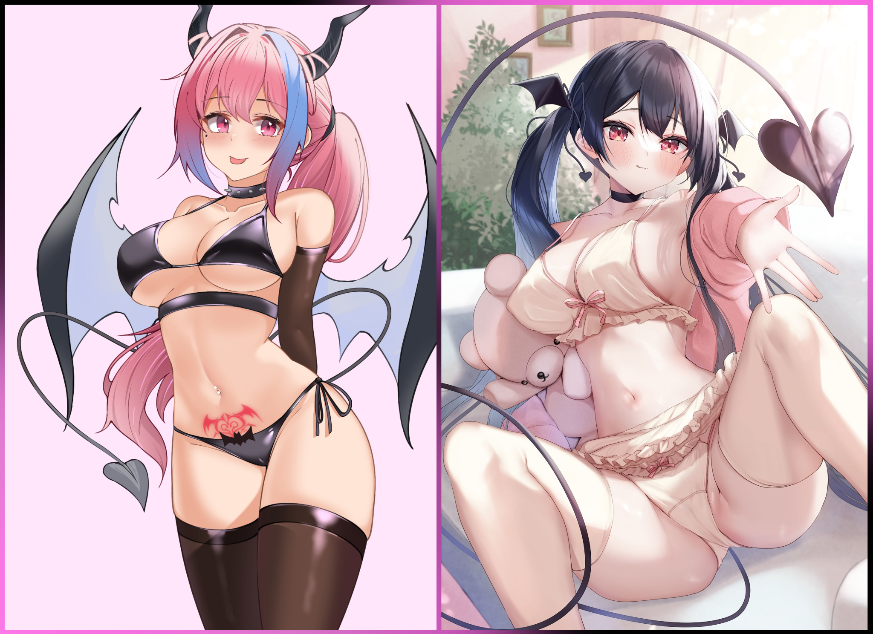
With a spacious couch large enough to take both of them, Dan moves to accept her girlfriends invitation of spread legs and an open hand, taking the petite limb in her own before lying over her, drowning them both under the shadows cast by her comparatively larger wingspan…in fact…Maxon had no wings to call her own, with the only hint of her demonic heritage being her twisted horns, flexible tail and elf like ears she had immediately hidden away with an enchantment unbeknownst to her less, magic savvy friend. She could be domineering all she wanted but while Maxon might now be a yes girl to her peers, that didn't mean she wasn't afraid to pull her own punches, a quality that harkens back to the young man who had been forcibly turned into her…not like he, or rather she, minded at all from how light and good her new body felt, a feeling she shared with her dream girl as her gaze softens at the sight of the goddess pressing her full weight down upon her belly, tracing the outlines of her stomach definition before stopping her fingers short of the frills that composed the hem of her beige panties before leaning in close, cradling the girls hips all while getting closer and closer until the pink haired succubus was close enough to smell the pleasant aroma radiating from her soon-to-be bedmate.

"From now on…you're Mia…understood?"

"Mmhm! Crystal…it sounds adorable…then, how would you like to be Dia? We can be like the bestest friends that way!"

"Heh…don't get your hopes up sweet cheeks…for now, we've still got plenty of time till evening so…wanna do it?"

"Do you even have to ask?! Lesbo sex totally rocks!"

With their respective names made known to each other tanks mostly in part to their shared responsibility in their creation, the two Succubi close the distance between themselves, latching their lips shut like opposing magnets, neither end willing to part from their embrace as twin spaded tails sway in the air while immense wings fold in on themselves, creating a steamy cocoon from which no sound, no matter how loud or erotic could escape.

'Mom would totally ground me if she caught me with Mia…'

'Don't worry babe! With my magic, I can make em forget it all~ Nothing can stop you from fucking me!'

'Mia? Is this…telepathy? Since when could you use magic?'

'Yep! As for when…I dunno actually, like…I think it was when the gooey dick tentacles did me, it made me think of stuff, like, alot of stuff! After that I could just do it, see? My ears are back!'

With a popping sound and a puff of smoke, her rounded human ears elongate, returning to their original wing like shape, unwary of the weak point she had opened for Dia to take advantage of as the mildly irritated succubus leans forward, removing her lips from Mia's to clamp down on them much to her partner's shock as her body convulses in a sudden fit of orgasmic pleasure much more intense than what she felt before.

"Oh hoh? You're weak in the ears hmm? Nice to know~"

"Mnyaahn! Dia! Stop it! No~ Not the ears~"

With her protests going ignored while the cocoon trembles with violent energy, the rest of the day would carry on as if nothing had changed. With reality warped so that Dia and Mia had always existed in place of Dan and Maxon, their parents saw no reason to fuss over the sudden change in their children's gender, personality and room decor…with the exception of Dia's emerging queen bee persona (and Mia's less than exceptional grades had she not used her mind controlling abilities to alter her scores in this new continuum…). Except the greater danger was that neither family knew they were raising demons into the world.

And when night fell, their preference for lesbian sex would be discarded with the emergence of their Succubi urges to feed on the essence of human men, granting their deepest desires in their dreams or, if they saw fit to; in reality where a battle of life and death would ensure, ending in either the death of the unlucky human that caught the eyes of the dominating Dia or precocious Mia or, on rare occasions, the birth of new life in the form of another Succubus in a process not too dissimilar to their metamorphosis as a result of the man surviving the emptying of his manhood.
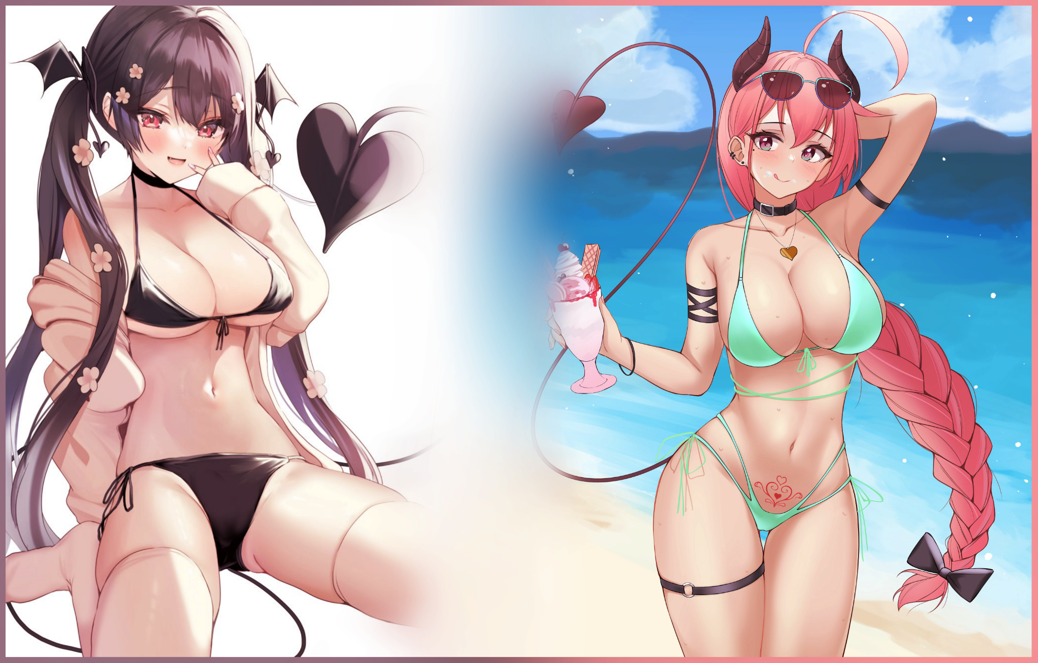
But even in this new existence the two found themselves in, their lives remained more or less the same with the exception of the deeper bond they both shared with each other considering both were each other's innermost desires made flesh. But urban exploration, the occult and pranks were far behind the two as they enjoyed the rest of their summer break with treks to the beach along with the occasional nightly stroll through town that would almost always end with someone being screwed too hard to walk straight for the next few hours.

Although it was a sudden twist to their rather mundane lives and they couldn't really say no whenever their instinct to feed or prey on whoever caught their fancy kicked in, both Mia and Dia still had their wishes granted at the end of the day. And it was only natural that they spend the rest of eternity fulfilling the wishes of others, as long as they were related to matters of the bed of course. They weren't genies after all…

THE END

