MEDB MAKER
COMMISSION STORY
BY CHALDEACHANGE
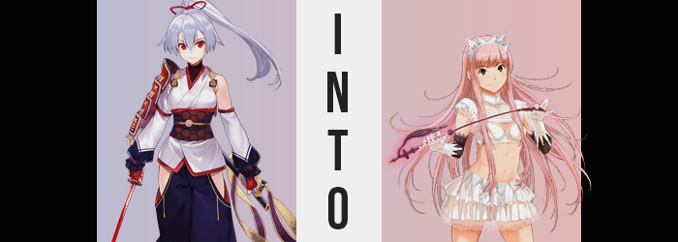

Medb was not having a good time.

The vibes lately? Terrible! Once upon a time she had earnestly believed that Chaldea was something akin to a paradise for her. Sure, her actions had been a little bit limited by the Chaldea Security Organization’s staff and her Master. They often told her that she shouldn’t do things. Thing that she actively ended up doing behind their backs. And if she got caught? Well then she would just apologize and do it again later.

This Celtic queen was very careful, you see. She had quickly figured out where the ‘line’ was. Said line being the point of no return, the line she absolutely shouldn’t cross when it came to her behavior. So long as her actions, while sometimes towing this line, remained within its limitations? There would not be any long lasting consequences for her actions. And teasing Cu? Teasing all of the Cus? For the most part she could play within that line so long as she was careful not to try seducing when told to stop.

Her Master, Ritsuka, had been very firm about that. Not all of the Servants had to get along but they were all banned from intentionally making each other uncomfortable. It made the trust between them difficult to maintain, which could make it risky on the battlefield. “But why does the line keep getting inched back!? This is soooo annoying!” And yet as she had recently learned? Not everything lasted forever.

With time the population of Chaldea had changed and grown. After Goetia was defeated? Management had changed for obvious reasons and the organization was thrown repeatedly into new and more dangerous situations. Dangerous situations that involved summoning even more Servants. Servants that occupy the same space as Medb and, while not always intentionally, observe her. Therein rested the issue at hand.

Because more people were watching her it was naturally harder to get away with even little things. Her Master was constantly coming to her to tell her what not to do. “Don’t bother Cu too much, don’t strip naked in the hall, don’t throw out all of the cheese! For crying out loud! A girl can’t do anything around here…” If only there was a way for her to do something about it. “Unless…”

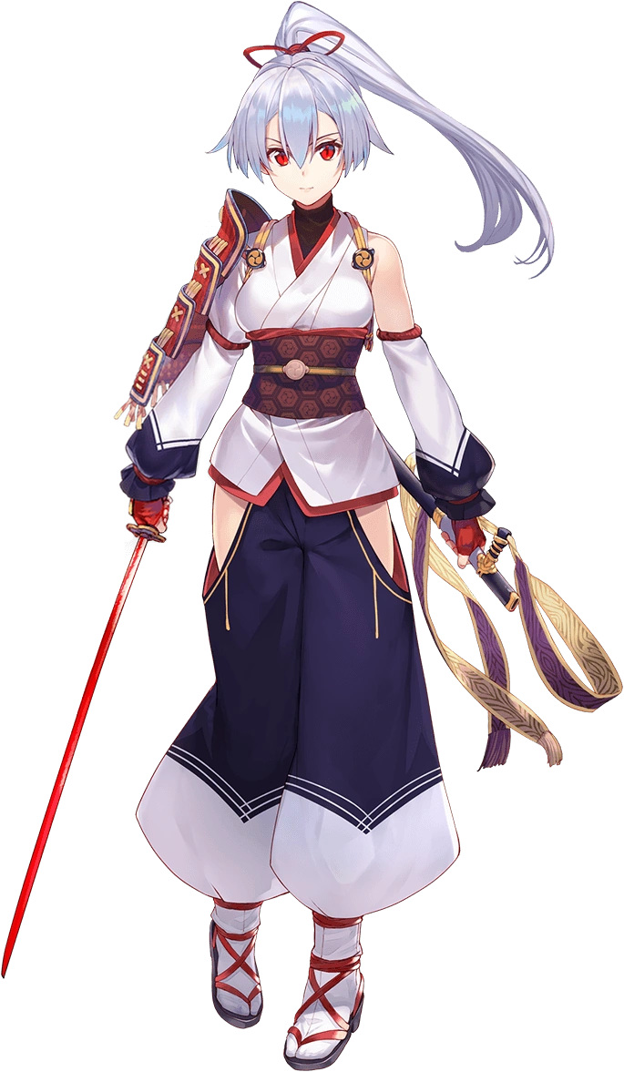
“Erm… Is this some kind of trap?” It was well past midnight when Tomoe Gozen answered a knock at her door. She hadn’t found a person but instead a basket of Japanese konpeito, all colored pink for some reason. Being a warrior and (while not gaming) a cautious individual she was naturally suspicious of the delivery. If the basket had been delivered at a normal hour of the day then it would have been less suspicious. If the sender had even stuck around then she wouldn’t have had as much reason to be concerned.

But looking at it logically? The only reason someone would deliver a gift like this so late was because they didn’t want to be seen. “I suppose that doesn’t mean that there’s any malevolence behind the gift though. Hm…” At the same time what if it was an earnestly delivered present? She couldn’t think of anyone that might have had any ill will towards her within Chaldea’s walls. Sure, she had reported Medb earlier that week for stripping in the hall again, but…

“I still don’t understand how she can have such little shame.” As a woman who had been married in life, she could hardly wrap her head around being such an open exhibitionist. Then again? One of Medb’s outfits was incredibly revealing. “Regardless, what harm could some candies bestow upon me?” Poison was the worst thing she could think of, but poison also wasn’t something that affected Servants all that strongly unless the poison itself was strong. Perhaps there were Servants in Chaldea capable of brewing such a concoction, but…

Again. No one had anything to gain from poisoning Tomoe Gozen in particular.

She did have her questions. Unfortunately? They were directed at the wrong part of the basket. Nothing was actually in the candies that could have been labeled as ‘dangerous’. But there was a substance that had been brushed onto the basket itself. A basket she had carried in with her bare hands – allowing the substance to both touch her skin and become absorbed by it. By the time she had closed her door and placed the basket on her desk? It was already far too late. She had triggered the trap from an unknown assailant, wholly unaware of the fact that she had become the target of a certain queen’s revenge.

“Whew… It has gotten quite warm in here all of a sudden.” The room hadn’t actually changed in temperature, however. It was the Archer’s own body heating up as the curse that she had absorbed began to take effect. As one that targeted the very structure of her being it had to expend a great deal of energy that was passed through her flesh. As such? She was getting warmer and warmer without understanding why.

Even though there were early signs of what was in store for her, as Tomoe moved back towards her bed she wasn’t exactly well equipped to perceive them. Because, after all, it was nearly impossible to see what was happening to one’s own face without a mirror or a similar reflective surface. At most? She rubbed at her face from fatigue, closing her eyes only to reveal to an audience of no one once she reopened them that the brilliant crimson of her gaze had been dulled and replaced with a much more mundane, chestnut brown.

The woman yawned despite the warmth’s vague discomfort. “I should go back to bed.” The knock on her door had woken her up after all, and while Servant’s didn’t typically need to sleep she had expended a lot of mana during a mission that day. Her browned gaze flickered around the room, but aside from the color there was something additionally wrong with it. The shapes of those eyes somehow felt fuller, lashes longer. It would have been easy to say that they no longer looked Japanese and might have been closer to what you would expect from a Caucasian woman.

She turned out her light, thinking that she could get back to bed as planned. But while making the trip from the light to her bed her face continued to change and, much like her eyes, her face as a whole was slowly shifting into the mold of a beautiful Caucasian woman’s. Her cheeks were smoothed out and pulled thinner and her lips pursed so that they protruded farther but were denser in design. Even her nose hooked up ever so slightly. Tomoe was still beautiful, but that beauty was foreign now. It was also almost identical to the beauty of the woman who had cursed her in the first place. An ill omen to be sure.

“Oh, right. I need to… COUGH! Test, test… Is something wrong with my voice?” She arched a brow. Had her voice always been so shrill? Perhaps she had a proverbial frog in her throat? If her throat was the cause then a drink of water would help, but she needed to turn around and turn her light back on to do that. It was only a few steps away from where she had been standing to do as much, but a lot changed in those few steps – at least when it came to her hair.

Silver strands extended, length slithering out an additional few inches in the back and an abundance of them at the sides. On the other hand? Her bangs actually shortened and thinned, giving her a neat bang line, and a straighter hairstyle overall. But before she could even flick that light back on a changed color flickered through it too. Beginning at her roots a bubblegum pink emerged. It was quick to catch ‘fire’, zipping down to the tips of every strand until her whole head, and even a straightened mess of pubes within her loins, were all dyed in a color that much better matched her new face.

CLICK!

The light came back on with a flick of her own finger and she took her water glass from the nearby table. It was already full, as she often kept a glass ready in case she became a little parched, and so she brought it to her lips and began to not sip as she normally would, but chug in a strangely aggressive way. A far more aggressive way than she ever would have… if she were still fully acting as herself. Glug! Glug! Glug!

So far Tomoe had managed to remain ignorant to her body’s changes thanks to a combination of their location and the intermittent darkness of her room. But the change that came as she drank? It was a little difficult to ignore. She couldn’t stop herself from polishing off the water glass and kept her eyes shut throughout, and yet? With each gulp it almost felt like her clothing was getting looser and looser and looser.

“Huh? Did things get bigger or am I going crazy?” After opening her eyes the woman waved her arms around energetically which, much like how she had begun to talk, was much more casual than how she had trained herself to act in life. It felt immature and vaguely self-important in her tone. But she did have a point. Her sleeves and pants were loose and she definitely felt closer to the table. She’d dropped from 5’4” to 5’1”, which didn’t sound like much but it definitely felt like a significant drop from her point of view. “Dainty can be sexy too, though!”

Why had she immediately been concerned about how sexy she was?

Tomoe also didn’t seem to be concerned about it. Pink locks had caught her attention in the corner of her eye and she noted the length, but again… Why would I complain about that? I’m clearly becoming someone much sexier and more powerful than I’ve ever been! Which was obviously a confidence wired into her by the one responsible for her transformation in the first place. In fact she almost looked 1:1 when compared with this individual. But she was still a little too big in some areas.

This was an issue that was easily corrected. Tomoe’s above average bust size had persisted even after she had become shorter, but now? That wealth of weight had become destined to dry up. With their skin tone pinkening like the rest of her body, that skin tightened and pulled against the heft of her best as if trying to push any excess mass away. They ultimately succeeded, and bit by bit the extra weight was banished to the void while her tits were lightened into a small B-cup showing comparatively. Small can still be sexy! Was the woman she was becoming delusional too? Maybe.

Her hips and thighs regressed in their mass too, but it was a saving grace for their owner that they weren’t as lessened as her bust. Her thighs retained a shapely density in the end, plush but muscular – to share in those muscles with a toned tummy. In a similar vein? Her ass actually seemed to bubble up so that it was round and easy to slap. In fact, she idly bit her lower lip as thought of having it slapped, or even penetrated, crossed her mind. Sexual thoughts were hard to ignore.

Because of the woman she had become, naturally.

“Oooooh! Oh. I see! So it was like that, hm?” The woman carried conflicting emotions within her heart once her transformation had finally concluded – through absolutely no fault of her own. At the very core of her person? The Servant’s previous identity remained. She was, at least in her very core essence, still Tomoe Gozen and could remember as much. And yet she wasn’t Tomoe Gozen simultaneously, which was where the conflicting emotions came in. She was Medb. A Medb, at least.

She couldn’t really remember her past life. What had she done? It was difficult to say because all of her memories had synced with the original Medb. All of them. That included setting the trap that Tomoe Gozen had fallen for so foolishly. “So I laced the basket, huh? I’m pretty smart, as expected!” Medb couldn’t help but boast and pat herself on the back for something she had… done to herself? Pretty hot of her, if she did say so herself!

“This means that there’s two of me, huh? Well duh, I wouldn’t have come up with this plan not knowing that! But how should we identify each other? I guess this means I’d be Medb II?” Would that work? Did it really matter all that much? Things would probably get confusing if they inducted even more of Chaldea’s Servant into their sexy ranks! “Hm… That doesn’t really sound like a bad idea! A Medb all her own for each Cu-chan!”

It sounded like a nightmare for the rest of Chaldea though. Dealing with one Medb was enough, but if the clone was thinking about it? Then the original must have been scheming something along those lines too. This duplicated queen simply shrugged off the thought for now though. Because she had other things to do. “Now… off with these ugly Japanese clothes!”

Or at least what had remained of them. They didn’t fit Medb II at all as she was now. Her figure was smaller but it was still one she was proud of. A smaller woman being able to woo men was a testament to her skill. Only a pro could manage that, right? “I suppose there’s the matter of what to wear now though.” She didn’t want to wear any of Tomoe’s old clothes. Not only did she no longer understand how to wear Japanese garments but there was no way that they’d be comfortable with their size difference.

Now butt naked, she wiggled her perky ass and gave a shrug. “This is kind of ironic, isn’t it? My only real option is to run naked through the halls back to the original’s room!” Seeing as how Tomoe had been the one to rat out Medb for her public indecency in the first place? It was ironic. But the woman she had become certainly had no interest in maintaining her decency. She wouldn’t hesitate to show off her tits and ass to someone if it fetched her a compliment. Man, she was really horny still. Maybe she should find someone to fuck, too!

And so the pink-haired clone skipped to the door. “Probably won’t show off to anyone at this hour though. Oh well!” There likely wouldn’t be anyone else roaming the halls after all. But she could always do it whenever she felt like it going forward. After all! Who was going to get her into trouble? If anyone so much as tried… The Medbs could just add them to their ranks.

