Swift Guitar Lessons

“Summertime” Doc Watson Version

**Intro/Verse Chords:** *(Solo over Doc’s rhythm)*

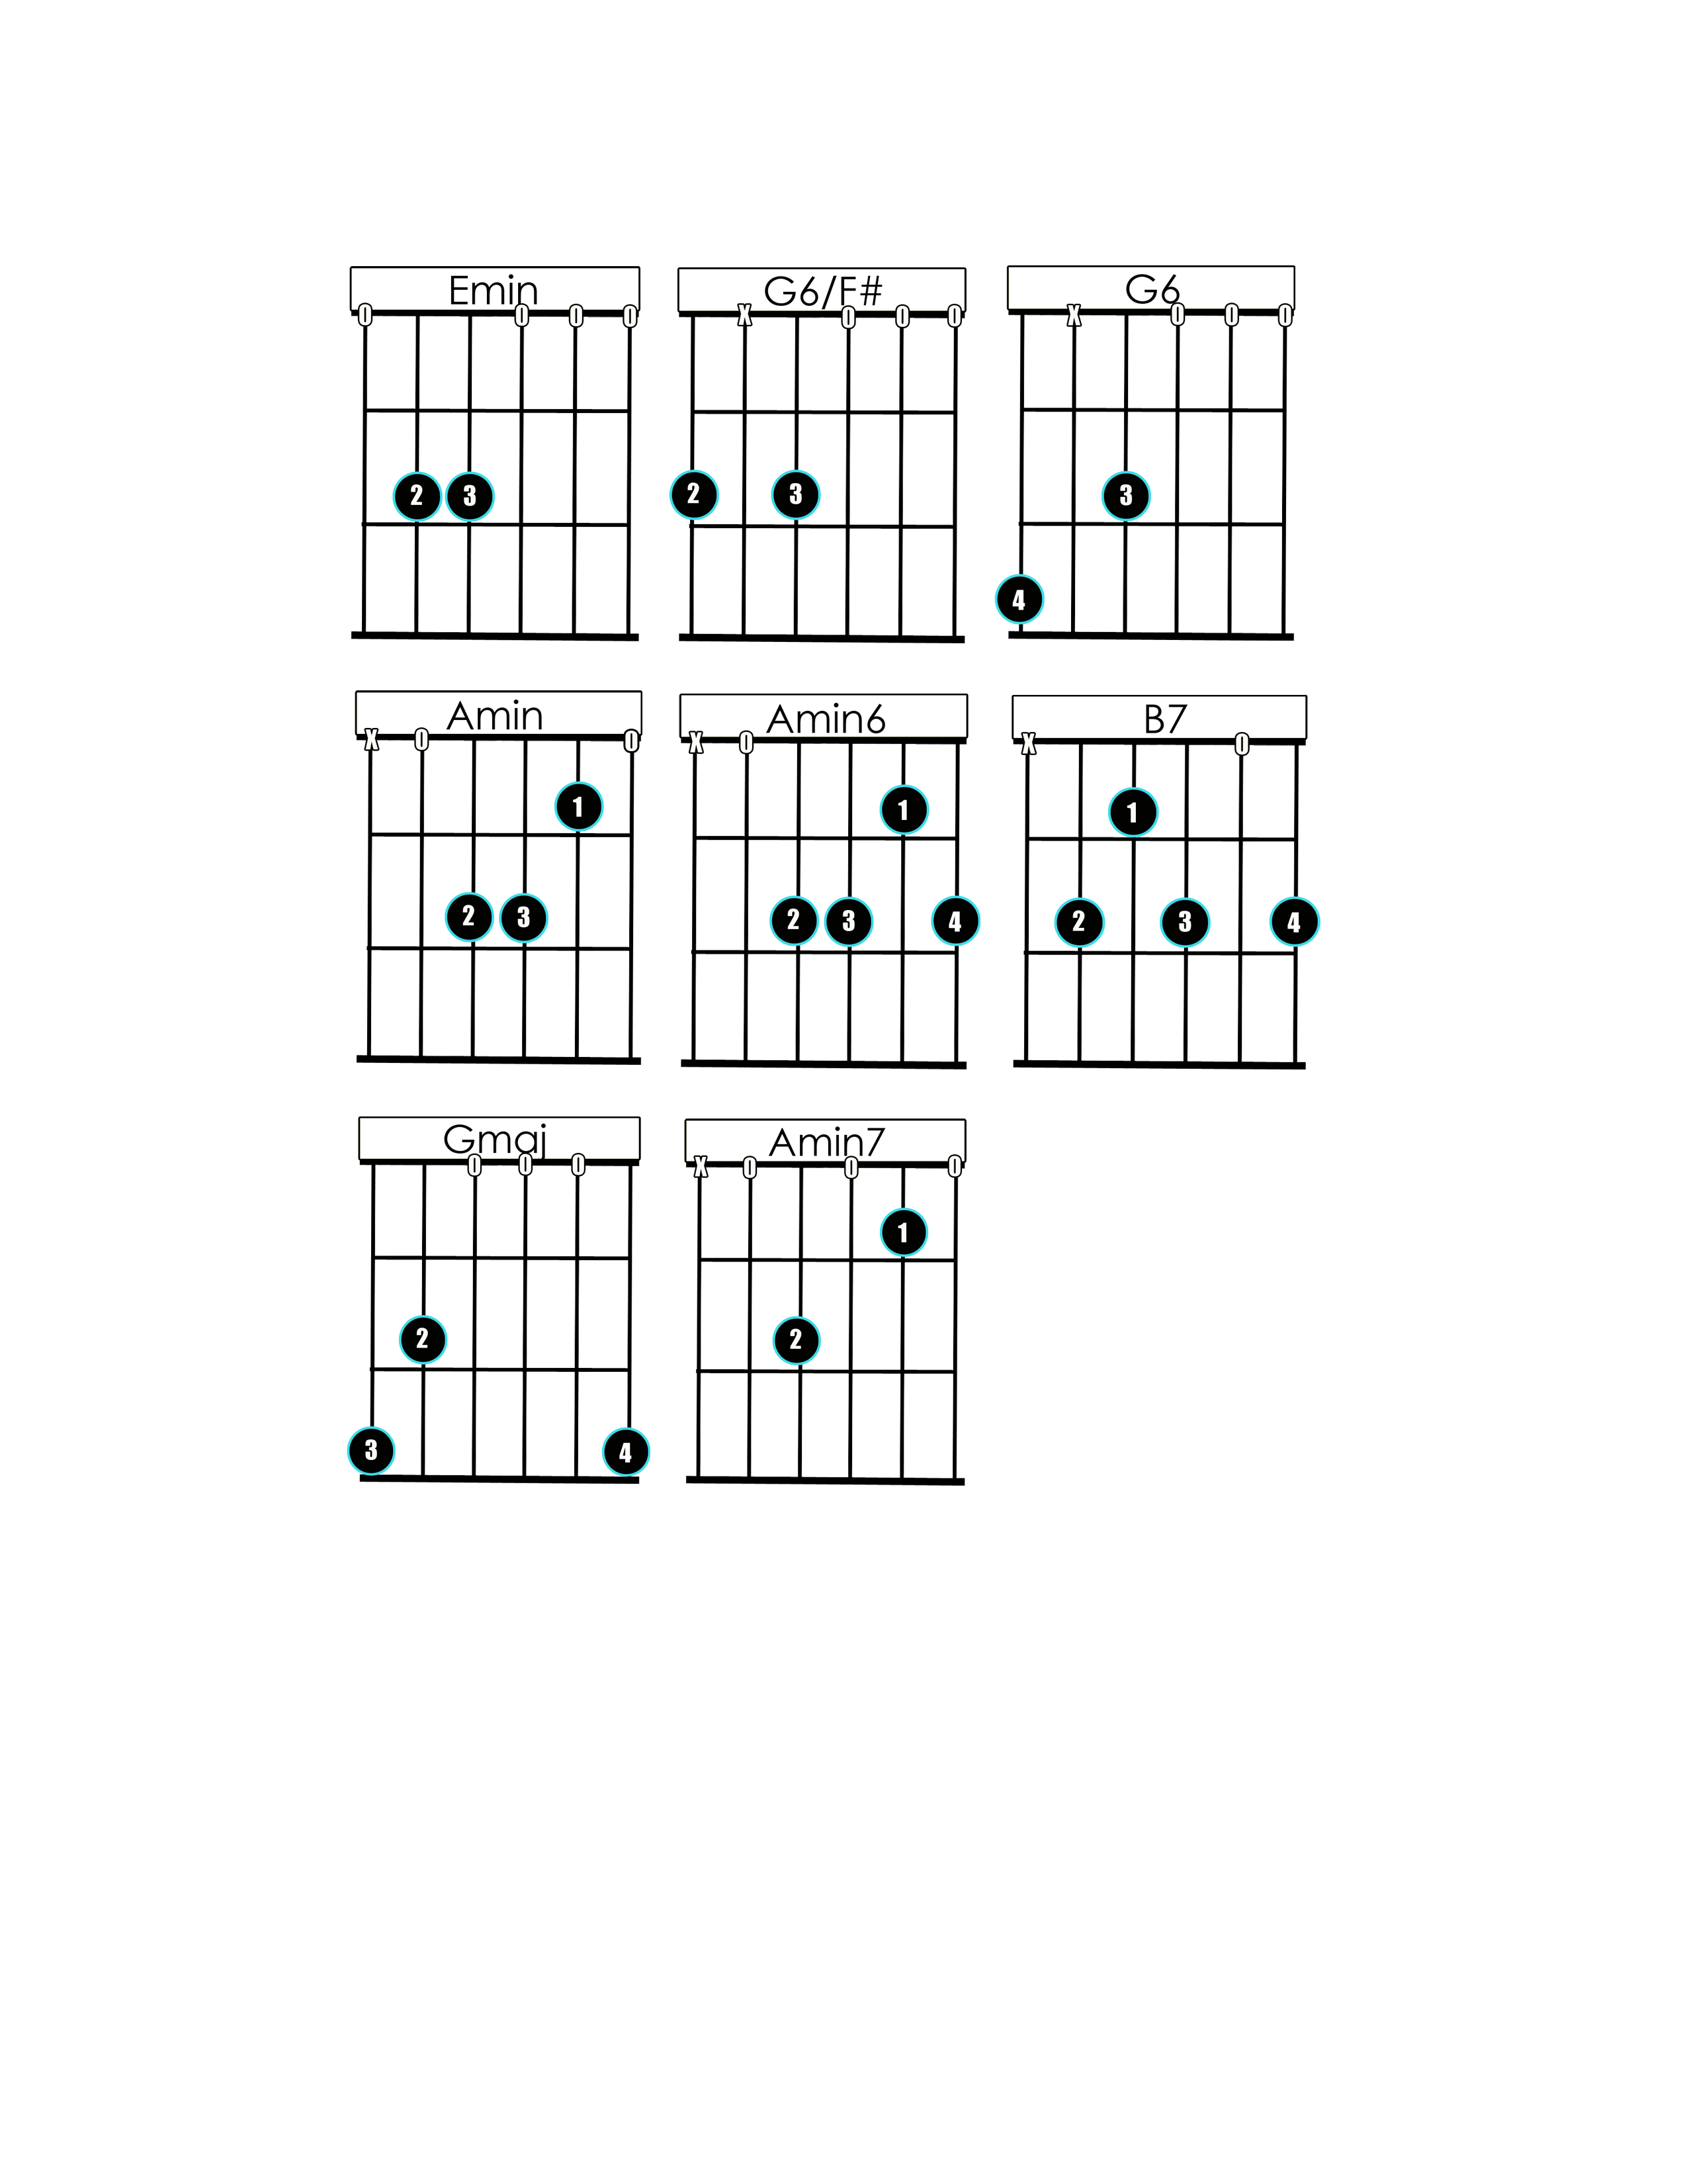Em // G6/F# // G6 // G6/F# // X2

Am //// Am6 //// B7 ////|////

**Verse:**

Em G6/F# G6

Summertime

G6/F# Em G6/F# G6 G6/F#

And the livin' is easy,

Am Am6

Fish are jumpin'

B7

And the cotton is high.

**Verse #2:**

Oh yo' daddy's rich

An' yo' ma is good lookin'

**Chorus:**

G Em

So hush, little baby,

Am7 B7 Em

Honey Don't---- you cry...

One of these morning’s,

You gonna rise up singin'

Then you'll spread yo' (AM) wings...

An' you'll take the (B7) sky.

**Verse #3:**

(High) Until that Day,

You can hush up your crying

**Chorus #2:**

With your Daddy an' Mummy

Standing by

**Solo**

**Repeat 1st Verse**