PLANT-BASED STAYCARE
JULY 2021 REQUEST STORY
BY CHALDEACHANGE
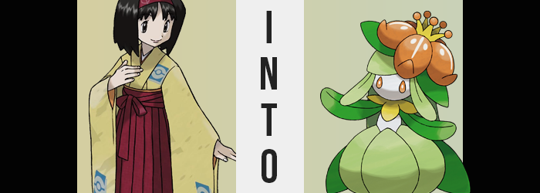

LEAVE YOUR POKEMON WITH YOUR LOCAL DAYCARE TODAY, THE FIRST ONE IS FREE OF CHARGE! ALSO, ENJOY A FREE TOUR OF OUR ESTABLISHMENT!

It was a flier that became a quite common sight across the Pokémon world. From Kanto to Galar, there had been a sudden push to revitalize the Pokémon Daycare initiative worldwide. There were some that found it suspicious, but for trainers it became something of a godsend. Time was limited for those in certain professions, and being able to level one’s favorite Pokémon for free was certainly appealing.

And so, it drew in even Gym Leaders. A brand-new Daycare Center had been erected near Celadon City, and as she was working on a brand-new team for high-leveled challengers, the local Gym Leader Erika had visited to make use of its services. She had a male Vileplume that could have benefited from the extra levels while she was busy helping spruce up Celadon’s gardens that week.

“I wouldn’t mind taking a tour if that’s alright? I’ve never seen the inside of a Pokémon Daycare, so I’ve been wondering what it’s like.” As the clerk took her Vileplume’s Pokéball, Erika requested a tour that she would soon regret. For these daycares were just a front for a new operation staged by Team Galactic. One that had resulted in a series of disappearances that no one had been able to solve.

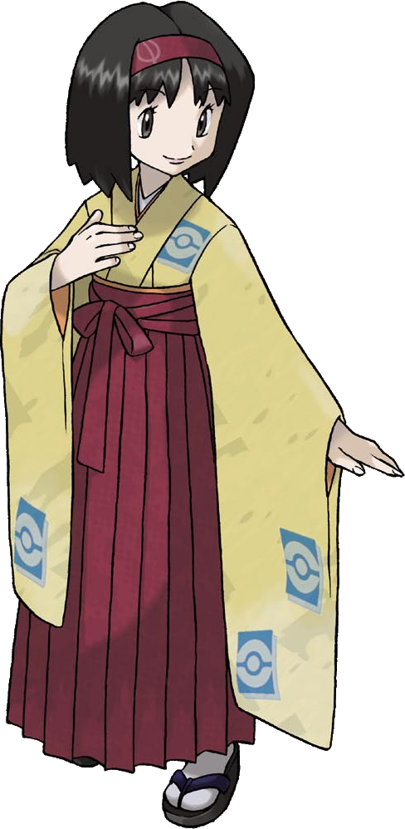
The clerk behind the counter merely smiled and led the Gym Leader into the back rooms, which all looked fairly standard. What Erika had been most interested in seeing was the outdoor area where the Pokémon were meant to frolic in the back, seeing as Vileplume was a Grass-type and she was hoping there was enough vegetation for him to be happy during his stay.

What she was led into was a room she hadn’t expected to see by any stretch of the imagination. A room done up with white steel, with only two doors and no windows – vacant short of an unusual pedestal in the room’s center. It almost looked like something you might find in a lab. “Excuse me? What is this room used for? It looks a little out of place…”

“Oh you’ll see, Miss Gym Leader.” Erika was immediately put on guard by the clerk’s change in tone. It was far too ominous, far too conniving. She reached for a Pokémon in her sash, only to find that all of her balls were missing. What!? Since when!? “Your Pokémon? I took those when you weren’t looking. But you won’t need them in a moment~!”

The woman then dashed into the second door before Erika could react, and before the Gym Leader could even strike the door with her hands in a panic, the pedestal in the room’s center began to emit a strange, green light that locked the woman up entirely. “Why!?” She understandably couldn’t fathom what was happening here. Why had the seemingly kind lady at the desk trapped her in here? What was the device in the middle of the room? And why did she suddenly feel so tired?

If it was something related to an illness, then the woman’s complexion had certainly begun to support that theory. For the base color of her skin was looking rather off. From head to toe she was robbed of her healthy, human pinkish hue, color drained with such an intensity that her skin looked to be pure white. It was certainly an eerie sight; no human should have possessed a complexion like that.

But, fortunately, color did return. Just not a human color by any stretch of the term.

Green of varying shades sprung up against the white, most of it hidden by the elegant kimono that Erika always adorned herself with. Her legs took on a paler tone, while her feet shifted to take on an almost yellowish green coloration. Meanwhile her arms and hands began to turn a much more vivid green, while the skin around her neck took on a yellow similar to her feet. Was it even proper to call this ‘skin’, though? Every part of her that turned green appeared glossier to the naked eye, and a little rougher to the touch. It was only her torso and face that retained the white color.

“What is… Gant? H-Huh? Lilli! What am I saying…?” Erika’s body felt unusual cold, but even so she’d yet to notice how aesthetically different its flesh now looked, huddling her arms to herself in place. More shockingly from her perspective was the occasional sound she made in the place of an intended word or phrase. Almost like she was unintentionally mimicking a Pokémon. “That couldn’t be…” Such a thing should have been impossible.

The color change, in the end, was not isolated to the woman’s skin alone. Green, the paler sort that had consumed her legs beneath her kimono, drifted through her locks of hair while once darker eyes soon shone with an illustrious gold. Yet it was in these two areas that things began to suggest that there was a little bit more than a palette swap going on here.

For example? The strands of Erika’s green hair began to bind together, gradually becoming a single piece of green on top while two other green growths framed the sides of her head. Perhaps it was a little disingenuous to not refer to these things by what they truly were, though. They were leaves. The Gym Leader’s hair now resembled plant-life – somewhat befitting of the one representing Kanto’s Grass-type gym.

But, from the left side of this new ‘hairstyle’, something promptly emerged. Taking the same vivid green as her arms, a tiny nub protruded and swelled, not taking awfully long to resemble the bud of a plant looking to bloom. This bud grew and grew until it was taller than Erika’s head was big, but it remained sealed, nonetheless.

It weighed enough, at least, that the woman could not ignore its presence. “Lilli— I mean, h-huh?” She blinked in confusion thanks to the weight, her golden eyes stretching not from surprise, but through the transformation as they not only took on teardrop shapes but bulged out slightly. Her sclera was removed entirely, leaving nothing but vertical golden drops where her human eyes had once been.

And the condition of her face would only worsen from there. Her nostrils appeared to close as the bump of her nose flattened into her white face, while the woman’s pink lips followed a similar pattern – leaving her mouth to be nothing but a series of tiny holes that could not be seen, but were enough for her to make noise through. In fact, most of her mouth had closed up inside and her teeth had all but disappeared.

Erika’s transformation was strange in the sense that the more it wore on, the harder it was for her to note anything was awry as it happened. In fact, her intellect was being compromised in general, rendering her incapable thinking about anything overly complex. It went along with the fatigue she was feeling, and she couldn’t sort out the reason why.

In fact, she hadn’t even noticed that her mouth was missing until she went to talk next. She strained herself trying to force sound through the tiny holes that now functioned as her mouth, and the most she could muster was an awry “…Gant?” Why is it so hard to speak? The woman raised a hand with the intention of touching her face, and it was then that its green color struck her – just enough to distract her from her wonderings about her mouth, which still blended into an increasingly circular face.

Why is my hand green? She raised both her arms, allowing her kimono sleeves to fall back towards her shoulders. This revealed that it wasn’t just her hands but her arms in their entirety. And, before her very eyes? Her limbs had begun to flatten. Almost like they were being crushed inside a press, flesh and bone thinned and spread out, everything beneath her skin ultimately being squeezed into a point where it no longer existed and flat, leafy green remained in its place.

Her hands weren’t spared, of course. As her fingers flattened with the rest, their sausage-like shapes wrung out of them as if they were playdough under a heavy book, the green digits inevitably blended together and took rounded ends. Again, like leaves. “Lilligant!? I mean… I… Gant!?” Speak! How do I speak!? What am I saying!? Her beady eyes strained, panic growing. Why do I have leaf arms like a Pokémon!?

In fact, hadn’t she just said ‘Lilligant’ when she’d attempted to speak? That was a Grass-type Pokémon she was familiar, though not one native to Kanto. Could she be becoming…? “GANT!?” Her leaf arms fluttered beneath her kimono as her clothes suddenly grew tight – both at her neck and around her hips.

Beneath her neck, the yellow skin from earlier was showing signs of growth. Skin pushed out into four directions, two covering either shoulder while one passed down her back and the other across her breasts, propping up her kimono’s front until it was a golden sepal. It didn’t really need to hide Erika’s breasts though. After all, there wasn’t really much of them left. Their shapes had regressed, and nipples merged with the white, leaving her chest completely flat. Even her bellybutton had filled in!

The tension around her kimono’s skirt, on the other hand? The situation there was much more drastic. Already dyed pale green, each leg had shown signs of prominent bloating. Thighs grew thicker and thicker, but so did her lower legs as well until they were perfect tulip shapes. Despite looking bloated though, these were merely hollow leaves – and two more appeared, covering her front and back. “Gant!? Gantgant!” And so, Erika’s posture wobbled thanks to the layer of leg beneath these leaves quivering, becoming lanky yellow growths with little feet that had curled toes.

And then? The Gym Leader fell.

Not literally, but her height plummeted with reckless abandon. The shrill cries of a Pokémon grew even shriller as her voice shrunk along with her, and any discomfort brough by her kimono was lessened thanks to it becoming much bigger than herself. Before long, Erika was hardly even three feet tall, wearing her once properly fitting kimono like an oversized blanket. “Lilli…” My clothes are so heavy! Did I really become a Pokémon? Did I really… Ooooh. “Gaaaaaant….”

She’d only just barely pulled her leafy body free of the cloth prison when her body suddenly felt stimulated. She couldn’t fathom why logically, but her body understood on a more instinctual level. That bud atop her head? It had begun to bloom. Slowly and sensually it opened, plump crimson petals spilling open in five directions before resting atop the Pokémon’s head like a hat. In the very center of the flower was where the nectar was made, and an overly sweet scent drifted out from around golden filaments that resembled a crown. Behind her, darker lives lengthened and fanned out behind what was one a butt, giving others the impression that she had long hair.

“Lilli!? Lilligant!” No longer able to communicate in human tongues whatsoever, the Lilligant once known by the name of Erika danced around in confusion. She was a Pokémon? No! She was supposed to be a human! But her leaf arms and bulbous body spoke to the contrary! She was so confused! That confusion only worsened when a beam of red light shot down from the ceiling and another Pokémon took shape from it. “…Gant?”

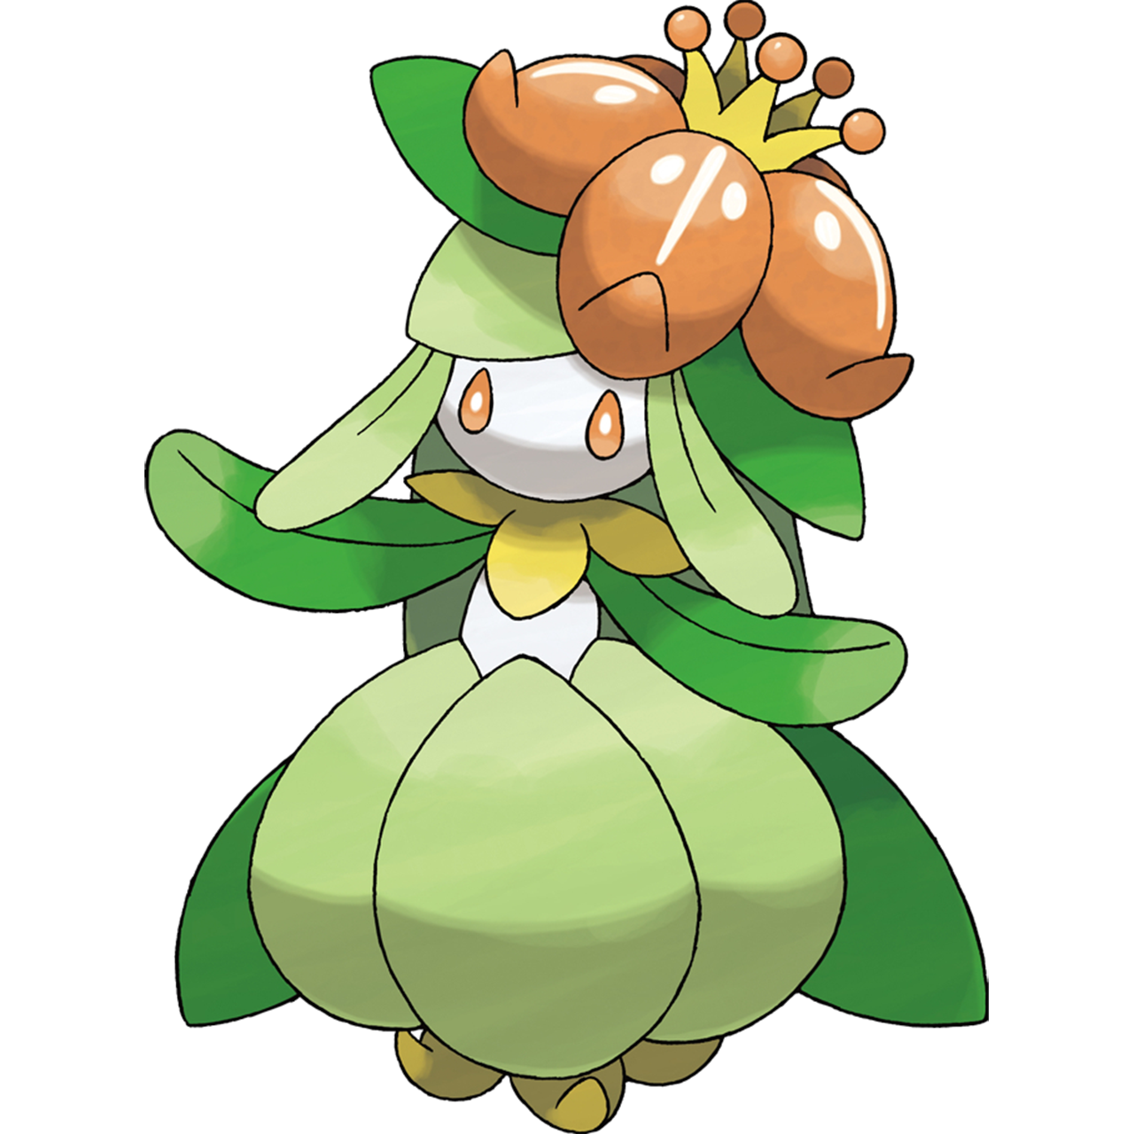
A Vileplume. The very same one that Erika had decided to leave with the daycare in the first place. It looked around perplexed for a moment, but eventually turn its attention to the Lilligant – attracted by the sweet scent wafting from the flower atop her head. “Lilli?” Erika tilted her head to the side, confused. And her confusion only worsened when the light coming from the pillar turned pink.

The very moment her body was basked in its glow, she felt weird. Her plant body grew warm, and she could feel the flower atop her head beginning to produce a sweet nectar that smelled even stronger than scent it had originally been giving off. “Lilligant… Lilli… Lilli…” She was dizzy and her heart was racing. And the Vileplume? It drew awfully close to her and began to produce a pink pollen from its petals. Erika knew what this pollen was!

It was how Vileplume mated! And that pollen was mingling with the flower atop her head and stimulating her body. It felt good! Far too good, so much so that she fell to the floor in an enamored tizzy. It became difficult to think of much else other than the Vileplume in front of her. Memories of being human? Gone. Instead, she was simply fixated on her new mate, instincts having taken hold.

She was going to lay so many eggs for him.

