Integrated Rate Law Problems
Worksheet

Organic Chemistry Tutor

1. Which of the following could represent the units of the rate constant k for a reaction that is 3rd order overall?

A. M² s⁻¹ B. hr⁻¹
C. M⁻² min⁻¹ D. M⁻¹ days⁻¹

2. Which of the following straight-line plots correspond to a first order reaction?

A. [A] vs t with a slope of -k
B. ln [A] vs t with a slope of +k
C. 1/[A] vs t with a slope of +k
D. ln[A] vs t with a slope of -k
E. [A] vs t with a slope of +k

3. Which of the following statements is false?

A. The half-life of a 1st order reaction is independent of the concentration of the reactant.

B. The rate constant k is inversely related to the half-life of a 2nd order reaction.

C. The half-life of a zero-order reaction is directly proportional to the initial concentration of the reactant.

D. The half-life of a zero-order reaction is constant.

E. The half life of a second order reaction is inversely proportional to the initial concentration of the reactant.

4. The initial concentration of a reactant in a zero-order reaction is 0.75 M. The rate constant k is 0.015 M/min. (a) What will be the concentration of the reactant after 15 minutes? (b) How long will it take the concentration to be reduced to 0.06 M?

5. Calculate the initial concentration of a reactant that took 4.7 minutes for it to reach a final concentration of 0.15 M. The rate constant k is
2.5 x 10⁻³ M⁻¹ s⁻¹.

6. The data table below shows the concentration of a reactant with respect to time for a zero-order reaction. What is the value of the rate constant k?

[A] | time (s)
0.800 M | 0
0.720 M | 5
0.560 M | 15
0.320 M | 30
0.160 M | 40

7. What is the half-life for a reaction with a rate constant k of 0.0045 s⁻¹?

8. Which of the following straight-line plots correspond to a first order reaction?

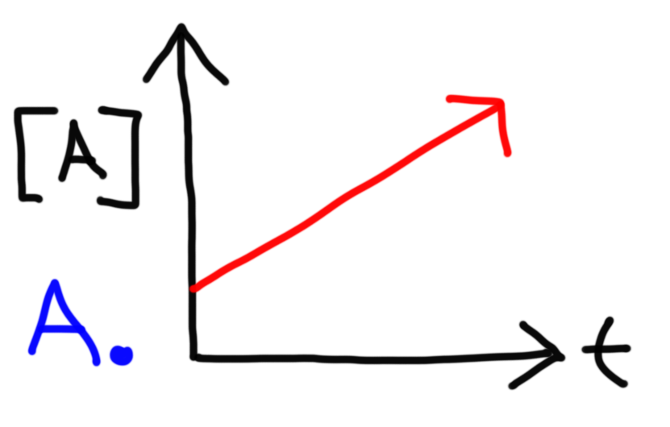

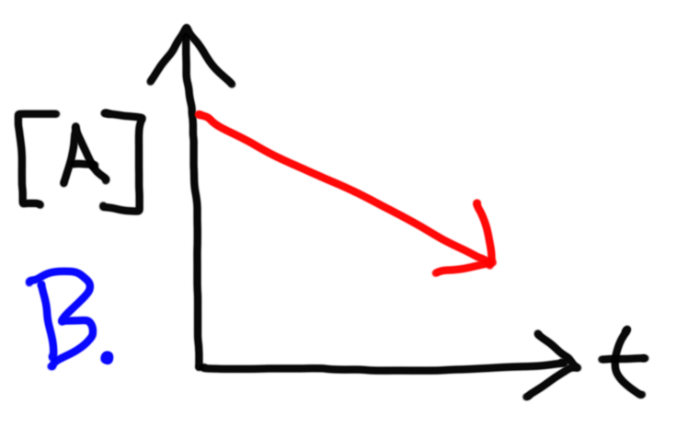

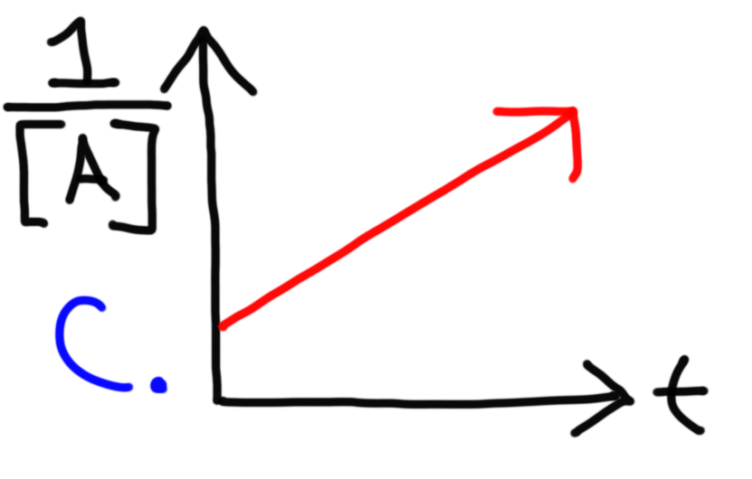

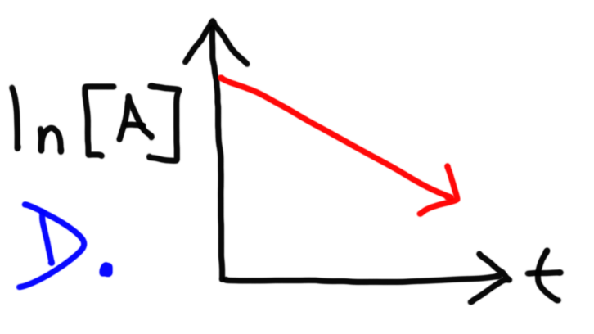
9. The rate of a certain reaction with units of M/s increases by a factor of 4 when [A] doubles and increases by a factor of 27 when [B] triples. Which of the following represents the units of the rate constant k for this reaction?

A. L³ mol⁻³ s⁻¹
B. mol³ L⁻³ s⁻¹
C. L⁴ mol⁻⁴ s⁻¹
D. mol⁴ L⁻⁴ s⁻¹
E. M⁻⁵ s⁻¹

10. What is the overall order of a reaction with the units L³ mol⁻³ s⁻¹?

A. Zero order
B. First Order
C. Second Order
D. Third Order
E. Fourth Order

11. It takes 12 minutes for 100g of a substance to decay to 25g. The graph of ln[A] vs time produces a straight-line plot. (a) What is the value of the rate constant k? (b) Calculate the half-life. (c) How many grams of this substance will remain after 20 minutes?

12. What fraction of a reactant remains after 4 half-lives of a first order reaction?

A. 1/4
B. 1/8
C. 1/16
D. 1/32
E. 1/64

13. The half-life of I-131 is 8 days. How long will it take for isotope I-131 to decay by 87.5% through a first order reaction?

14. Calculate the half-life at t = 0 of a reaction with a rate constant of 0.0625 M⁻¹ s⁻¹ given an initial reactant concentration of 0.80 M. (b) Calculate the final concentration of the reactant 300 s later. (c) What is the half-life of this reaction at t = 300 s?

15. Calculate the half-life at t = 0 of a reaction with a rate constant of 0.01 M/s given an initial reactant concentration of 0.80 M. (b) Calculate the final concentration of the reactant 75 seconds later. (c) Obtain the answer in part b conceptually using the initial half-life at t = 0.

16. The table below shows the progress of the reaction as A B. (a) What is the order of this reaction? (b) What is the value of the rate constant k along with the appropriate units?

Time (s) | [A]
0 | 1.6000 M
5 | 1.1310 M
10 | 0.8000 M
15 | 0.5657 M
20 | 0.4000 M
25 | 0.2828 M

Answers:

1. C
2. D
3. D
4a. 0.525 M
4b. 46 min
5. 0.17 M
6. +0.0016 M/s
7. 154 s
8. D
9. C
10. E
11a. 0.116 min⁻¹
11b. 6 min
11c. 9.92 g
12. C
13. 24 days
14a. 20 s
14b. 0.05 M
14c. 320 s
15a. 40 s
15b. 0.05 M
16a. 1st order
16b. 0.0693 s⁻¹

