When Garden assassin; Yor Forger had received an urgent assignment from the organization to go after a lone dissident threatening to sew discord within the Ostania, the Thorn Princess had expected the mission to be over in record time considering how her target had apparently been acting on his own if the intelligence hounds over at the SSS were right on the money as they usually were when it came to matters concerning the continued stability of the government.

But even still, the training she had endured to become an agent of Garden alongside the knowledge accrued while on the field told Yor that she’d best be on her guard all the more for this particular assignment. For a lone animal cornered could fight harder than a pack combined, and the fact that they chose her must’ve meant they really wanted this man dead if his records about being a simple defector were to be believed. Then again, there were many she had slain who had never seen or held a weapon before in their short lived life. And from the looks of things, this man was simply the next unlucky soul to find himself on that list…or so she had thought.

For all she had seen, Yor and many others like her had long since given up on the childish notions of magic and other fantastical concepts ever being a real thing. She would still entertain them, true. After all, it wouldn’t befit a mother to be so cold and embittered toward her children even if said maternal role was a cover. But the tides that someone could conjure fireballs? Manipulate bodies of water? Nothing more than works of fiction. Something that she hadn’t thought of until now because what else was an assassin supposed to be focused on besides the target and their surroundings during a mission?

The tip of Yor’s signature golden stiletto had come within inches of spearing right through the base of the man’s spinal cord and out through the other side across the jugular in a move intended to keep the suffering to a minimum while ensuring a swift death for the target, a move not often available to her when it came to suppressing groups or engaging with a capable close combatant who could match her hit for hit. So when the chance had presented itself in the form of her target being holed up in an easy to access hotel without hired muscle to protect him, the Garden assassin went straight for the kill. Hoping for a swift resolution so that she could be home on time before Loid or Anya began to grow suspicious of what she was up to, only to find herself rooted to the spot. Unable to move an inch while her target had begun to shift around in his seat with the energy of someone being annoyed by a fly, only to back away into the corner as if he hadn’t been the one to trap the Thorn Princess herself in some invisible net. Looking Yor up and down at first with fear while patting himself down with flurried hands around the neck to check for wounds…only to take on a more arrogant air once he realized how the tables had turned with a wry smile overtaking the stupefied look on his face.

“T-This thing actually works! I knew they’d send people after me one day for what I found…but one of the Garden’s best? The hyper lethal Thorn Princess herself? What mythical deity out there shines their blessed eye over me on this night I wonder?” Walking over toward a paralyzed Yor, the target walks a slow circle around his would-be assassin. Inspecting her with a gaze so strong that were she capable of movement, Yor would’ve wasted no time in showing such a creep what the punishment was for ogling women. But under the influence of whatever this was, only her hair was left to sway in the still air. Unable to change the steeled expression on her face despite her inner will struggling to regain control over her own body, feeling as if all control over it had been cut like a hapless puppet relieved of its string. Turning what should’ve been a quick and easy job into a nightmare scenario when her target had finally gotten the better of her through scrupulous means the veteran had never seen or heard of before.

There were no chemical agents in the air, nor had she been injected with anything. Her system had been toughened against poisons and biochemicals that would leave a bear bedridden for days. And the way the target reacted when he knew she was behind him, ready to strike…this was something new…

And from the look on the man’s face as he finishes his inspection, Yor dreaded to know what else this wild power protecting him was capable of as he extends a hand, tracing a careful finger over the polished edge of her gilded weapon like a nobleman inspecting the work of his underlings. Only to pull away with a sigh and a resonant clap that applies an unnatural weight over the imperiled woman’s head as if a herculean hand had descended from the skies above to grasp at Yor’s skull with an unshakeable grip. Eliciting no response from her thanks to the enduring stasis keeping her silent and still in the midst of such a terrifying display of power from someone so unlikely. “I’ve heard about that little gig of yours; that you’d gotten…married? And to someone very peculiar indeed…I bet they don’t know about your dirty little job right? Fits the bill if you ask me…Forger…now that’s a right fitting surname for someone like you.”

While the man continued to gloat, Yor herself would not stand idly by despite the impossible conditions she had been caught up in. Doing her best to break free with nothing more than sheer force of will, struggling like a rabid animal caught in an invisible cage. Raging to break free especially after the insinuating words the man had thrown her way, all while her surroundings would begin to warp and darken into an abysmal torrent as a black hole tears itself into existence in a confounding manner incomprehensible to the human mind. Appearing as a dark maw opening beneath Yor’s dangling feet when viewed at a certain angle or a backdrop of nothingness behind in others.

“So I’m…new to all this but let me help you out a bit, hm? Rather than me letting you go just for your Garden masters to try again and again to kill me. How about I give you a nice cushy new life somewhere else hm? Somewhere you’d be happy forever, living as many facades as you like; girlfriend, housewife…hell, you could be a tramp for all I care. SSS thought they could try and take what’s mine? Well, once their precious little Thorn Princess if out of the way, they’ll get the message…I hope.” Try as she might however, Yor would come to realize too late how fruitless the endeavor was when the man’s eyes close shut in apparent concentration. Strengthening the invisible handhold over her mind as phantom fingers clench inward with titanic strength, probing at her vulnerable mind in a way she had never experienced before; an indescribable sensation that felt like someone had jammed ten syringes into the soft tissue of her brain before depressing the plunger to inject liquid ecstasy into her very being, not the overwhelming pain she had expected to be subject to when the pompous man had begun boasting about what he’d do to her…

And with each passing second since the procedure’s start, the lithe figure of a still immobile Yor would gradually begin to lose physical definition in the middle of the quiet hotel room, starting with a loss of rigidity in her extremities as if her bones were being liquified followed after by a lengthening of her body; stretching slender limbs until they looked like beige-black snakes as they looped around the distorting assassin. Her grace and ephemeral beauty lost to the unseen forces once her steely eyed visage had been lengthened and muddied into a flat strip of flesh before it would be sucked into the the heart of the void like a merciless maw lapping up the spaghettified form of the Thorn Princess as if she had been nothing more than a simple meal. Leaving the man alone in the room once the anomalous void had vanished after consuming its target with no trace left of Yor Forger besides the fading sigh of an Ostanian woman in the wind, cackling at the incredible display of the mysterious powers he commanded.
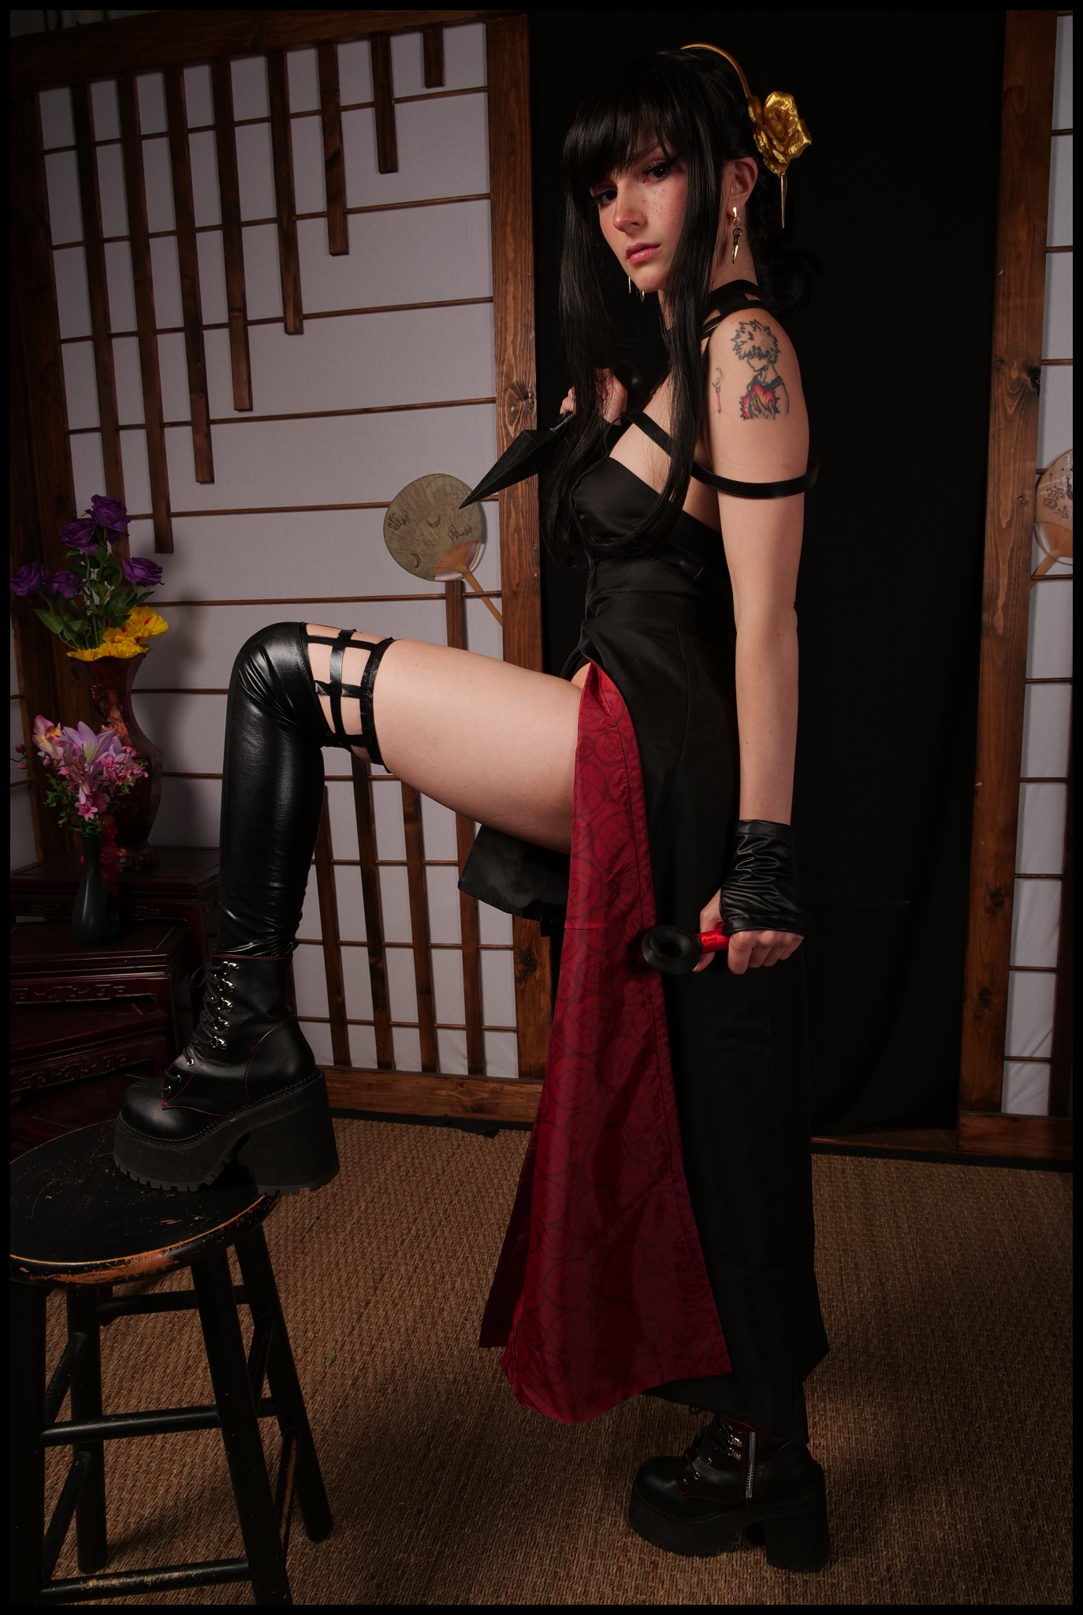
If the SSS had at least been upfront about the target’s possession over a relic that allowed him access to a variety of supernatural abilities, maybe the Garden would’ve sent someone else more capable to handle that sort of thing instead of dooming Yor to a fate she had not expected. Hurtling through the fabric of space-time in the span of only a few seconds while the white hot fury of unabated bliss conjured forth from those accursed hands over her mind had kept her down and compliant. Unable to resist even when memories of her time in Ostania from a tumultuous beginning to the equally distressing events plaguing her right now began to grow hazy and distorted before ultimately vanishing altogether, making way for new ones to resonate with addled synapses in preparation for what awaited her on the other side of the rushing void as a deluge of physical sensations return to rock the stunned woman alongside the freedom to move as she saw fit once again in a body that was no longer the same one she had been born into the world with…heck, she didn’t even look the least bit like a local born Ostanian anymore…

A body plastered in tattoos ranging from cartoonish caricatures to vivacious ‘artwork’ like the heart -shaped symbol etched inches below a belly stripped of it’s toned allure in favor of sinful pudge now present across the rest of Yor’s bastardized body once it all come back together. Sporting a slightly reduced bust that had evidently seen plenty of rough play despite it all, bearing the faint marks of a man’s teeth around swollen nipples that flared to hardened erection beneath a cheap mockery of her standard dress. Hardly the physique of a master assassin skilled in the arts of espionage and murder and more like the body of a cheap wench any man could find for a good price in any seedy bar. Wielding strange daggers that were a far cry from her signature golden stilettos…in fact, they weren’t even weapons at all, just cheap props…

Without the intent of carrying out a mission she could no longer remember a lick of, Yor would be left confused once her blurry eyed vision adjusts to a darker setting within a room lined with Japanese themed decor mixed with an assortment of other styles that made the place look like a mess…but that was to be expected of a studio of course. A place meant for photographers to create a vast number of backdrops for whatever it was they were there to do…but…of course she would know about such things. She was a resident of the modern world after all where the internet was a thing. Egyptian, Japanese, Greek, she’d seen many styles of architectural design before she even knew what the term meant! Even moreso since she’d secured this well paying gig for herself… “Eyes front! We’re about to take the shot!”

Instead of questioning the stranger’s words, Yor would comply. Turning to face the dark lens of the high grade camera being positioned by her side and armed with new knowledge, the woman would strike a provocative pose. Knowing just how to position herself to show off plentiful amounts of skin and the tight contours of her fuckable body without being so upfront about it thanks to the related information popping into a thoroughly dumbed down brain that had all but lost the ability to resist the steadily growing stream of perversions flooding the former assassin’s mind to replace what had been taken from her without her notice.
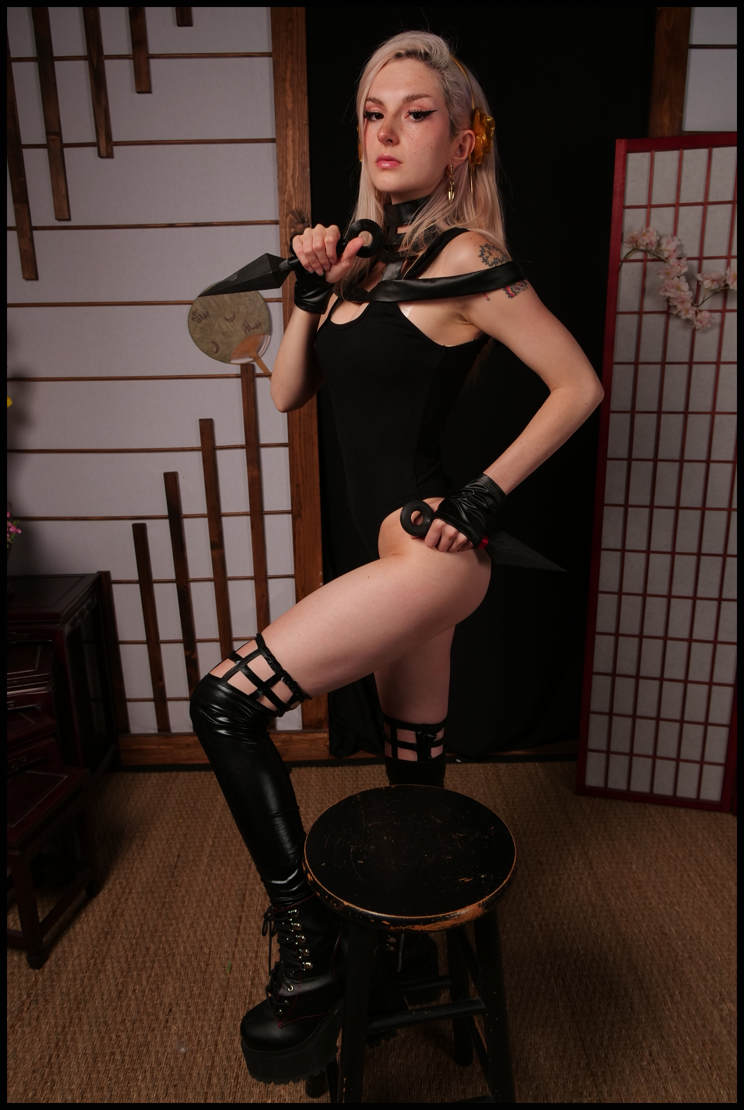
In exchange for a mastery in close quarter’s combat and other such combat techniques, Yor could only ever remember the myriad ways to doll herself up; from makeup techniques to glitzy clothes and titillating getups. And instead of a meek persona who could barely hold her own weight in drink with reservations about being ogled at by strangers, Yor felt empowered…delighted even, at the thought of a man looking her up as if she were a juicy cut of meat. It meant they desired her, and if they did, then that meant they were open for a little chat…and then a free drink…and once she got them thoroughly hazed, then they’d be ripe for a little rifle through the pockets. A lesson for trusting in such a pretty little thing upfront.

On the off-chance that they could hold their own however…and provided they were handsome enough. A subtle purr of joy escapes the woman’s lips at the sudden recollection of the many studs she had shared a bed with over the years. Feeling her vulgar snatch tighten in the wanton throes of need as a non-existent hymen takes its leave once her vaginal walls stretch and flex around the length of many an ethereal cock lucky enough to ravish her insides. Biting at her lower lip as she loosens the clasp holding her skirt together, leaving a skin-tight leotard that covers scant little of the American woman’s buxom form as the last hints of a forgotten self fade from dull, piercing eyes housing a soul as corrupt as the body that housed it. Earning a whistle of approval from the cameraman as he shifts around the studio for a better shot of his beautiful subject. “Finally ready to move on huh? How’s about the wig huh? I like you blonde Nisha…and I think the boys do too, don’t you think?”

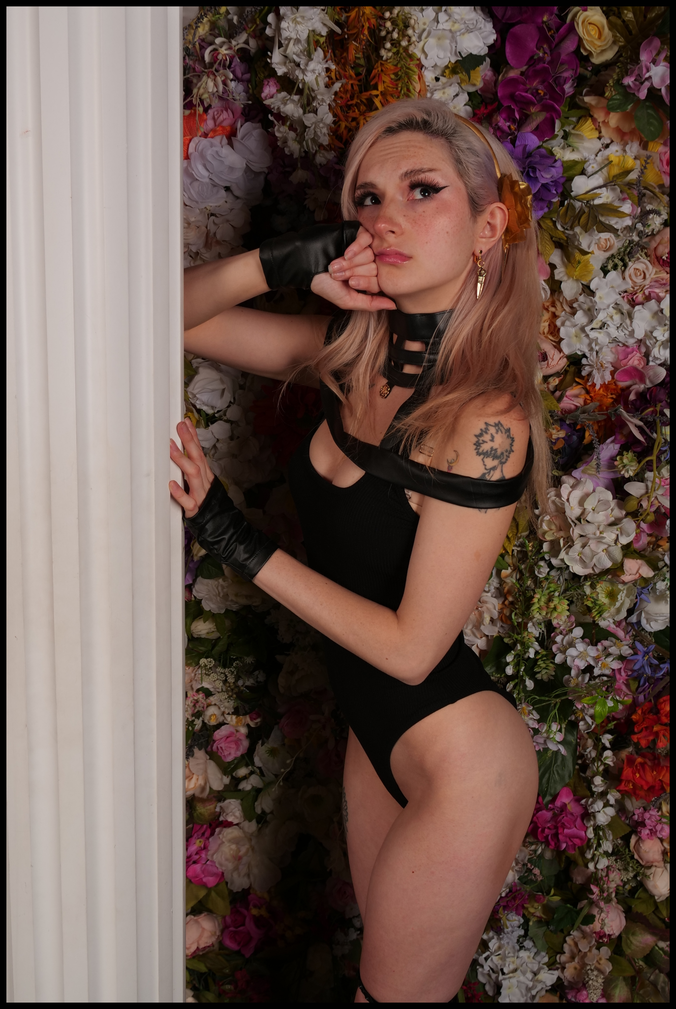
The significance of the name ‘Yor Forger’ had been all but lost to the reborn woman at that point. Not when there was nothing left to anchor her to a life she couldn’t be bothered to care the least bit about. No longer was there a growing love for a Westalian man nor the maternal desire to care and raise for a peculiar girl as if she were her own daughter. Instead, there existed the simple, debauched life of Nisha; professional cosplayer with an infamous reputation for her sexualized takes on fictional characters alongside being an E-girl who had no reservations when it came to what her ravenous fanbase desired of her. Whether it was a naughty shot of her without clothes on to cover up her naughty bits to live recordings with ‘lucky viewers’, nothing was off the table for Nisha. Whose seedy lifestyle and lack of morals had all but guaranteed her a cushy life with the earnings she had raked in. Discarding the vestigial remnants of the assassin she once was as a firm hand peels off the wig that had once been a normal head of hair before tossing it aside and out of frame, leaving a drab mane of platinum blonde to pour down over shapely shoulders and a supple spine in the process. Completing the utter ruination of Yor once Nisha had settled in completely, hoping her trusty cameraman wouldn’t notice the little wet spot staining the front of her leotard while she continued to send daring poses and provocative looks his way. She wasn’t usually the frisky type to bag any man who came her way, but for some reason her head was feeling really...itchy today. And that was making her horny, eager for the quick fuck she usually reserved for her nightly prowling across the streets of New York, desiring a bellyfull of hot spunk dribbling down between her legs far earlier than anticipated. A thought that makes Nisha’s vulva spasm in desire alongside an inadvertent shot of ejaculate that squirts out of an eager urethra before splattering across the floor of the studio.

“Hot damn…what was that all about Nisha? You didn’t get to fist yourself before the shoot or what?” No reply would come from Nisha, instead, the minx would saunter over toward a nearby pillar with an expression of wonder upon her cheeky visage. All while glistening trails of womanly nectar would run down each curvy leg with every step she took until arriving at her destination; a faux marble pillar nailed down to the floor of the set. A sturdy thing that would hold her weight nicely as she comes to rest on it with a post hinting toward something more as evidenced by the way Nisha twists her flexible hips around so that the sight of her leaky vagina was barely hidden between warm thighs while the hand she was using as a headrest would extend a salacious finger to probe at pouty lips. A not-so subtle invitation the cameraman was sly enough to have understood as he waltzes over with the setup for one final picture before leaving to join Nisha against the pillar with the camera now set to record the juicy proceedings that were soon to come as a scandalous moan fills the after a forceful hand comes to rest upon a perky ass.

While the last, dirtied dregs of Yor’s devastated dress-turned-slutwear would be peeled off of Nisha’s body to expose a nubile young body for her stud to get at. Garden’s target for assassination would once again vanish without a trace. Or rather, it’d be more accurate to say that no one had been assigned the bounty yet. With the complete removal of Yor Forger from that continuity and the birth of Nisha in another, Garden would send another assassin to complete the task, only to find out that they had been too late to catch the target unawares. All while Loid would be left to deal with the incessant advances of Fiona Frost after having succeeded the non-existent Briar as Twilight’s ‘wife’. Something Anya would unfortunately have to struggle with…

THE END

Cosplayer Busy B : https://twitter.com/busybasmr

