LADY FURINA CASE FILES
COMMISSION STORY
BY CHALDEACHANGE
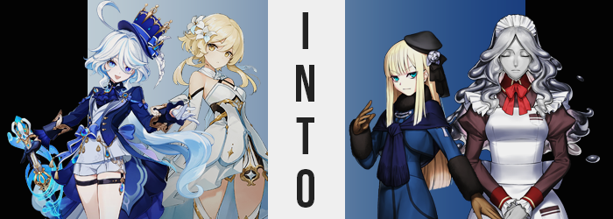

“Wow, Furina is really slacking behind us again!”

“I am NOT!”

This… had been going on for a while, and truth be told the Traveler, Lumine, was getting a little tired of it. She didn’t necessarily blame the second voice at all. Furina was Fontaine’s ex-Archon and a woman who had been through a lot of traumatic experiences. This trip out into the Fontainian countryside had been something that Lumine had suggested herself. Furina had recently received a Hydro Vision and was still trying to learn the ins and outs of using it. So they were traveling her homeland with the intention of teaching her how to fight foes and even use her new powers for more practical things.

And so if Lumine wasn’t the one causing problems, and Furina wasn’t the one causing problems, there could only be one individual that the blame fell on. “Paimon, cool it for a little bit. She’s not used to traveling like we are.” The Traveler hadn’t been able to figure it out. Paimon wasn’t usually all that tactful with her words and yet for some reason whenever Furina was around the fairy was just meaner. The floating girl whined about it for a moment but eventually shut up, much to the appreciation of the blue-colored woman who was trailing behind a little. But Lumine waited patiently.

“Strange… I don’t remember this building being here the last time we passed through this area?” Lumine had waited until the were already in the front foyer to comment this aloud. It was a pretty sizable estate that they might have avoided if not for a sudden turn in the weather. They could traverse regular rain, but a whirlwind of a thunderstorm was too risky if there was no necessity in pushing through it. “What do you guys think? Paimon? Furina…?” But turning around? There was no one else there. “Huh?”

Where had they gone? They’d only walked in towards the foyer’s main staircase and she’d heard them arguing just seconds prior. But now there was no one else in her presence. Wondering if she missed something she decided to double back towards the front door. There were hallways stemming in either direction when they first walked in, maybe the two had gone back towards the door and down one of those halls?

SPLASH!

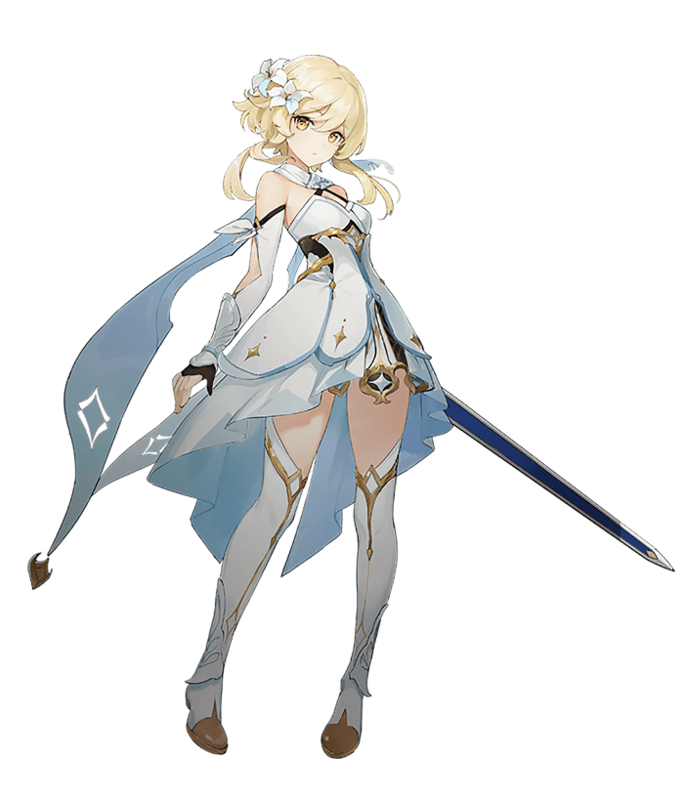
It was a quiet sound but one that prompted Lumine to look down at her foot, nonetheless. “Crud…” It felt like she had just stepped in a fairly deep puddle. She could feel the water seeping into her boot, after all. But trying to lift her foot out made her aware of a problem. Not only was it hard to raise that foot out of the water, but it wasn’t water at all. It was thick, viscous, and silvery in color. Like a slime? “Come on, get off!”

But it didn’t. She eventually managed to pull her foot ‘free’, but just her foot. Her boot had been absorbed, and the silvery goo? She could feel and see the entire puddle being absorbed itself… into her body with this foot as an entry point. “Uh…” That probably wasn’t good, right? The foot that it had bled into felt awfully cold, in fact. Like it wasn’t producing heat. Or like whatever had slipped into her was absorbing that heat?

The sensation spread up her leg and into the rest of her body. She felt very, very cold and yet she didn’t understand why that was. Was that silvery liquid making her sick? No, there had been a lot of it. If it was doing anything to her body it would probably be fatal. Lumine gulped at the thought of her travels coming to an end because she had stepped in a puddle, but… “Urp!?”

Before she could call for help she found herself unable to do anything but gag. A liquid had gargled up from the back of her throat and she had been unable to keep it down. It bore a strong metallic flavor as it filled her mouth and even leaked from her lips. But after wiping it away? It was the same silver substance that her foot had absorbed. And it was absorbed right back into her body. She wanted to gag but she couldn’t. There was nothing in her stomach.

She technically didn’t have a stomach anymore. Her heartbeat had stilled. Her brain had been liquidated as well. Her interiors, everything beneath her skin, had all become silver goo. So how was she standing? How was she thinking? How was she alive? Lumine didn’t even have a full enough picture of what was happening to even ask these questions. In fact it felt a little difficult to think in general.

The silver began to leak from between her eyes like tears, forcing her to clench those eyelids of hers shut. She felt so soft and malleable, and what had been happening internally had begun to show external signs as well. Her skin had thus far retained its normal coloration but now with nothing else biological contained within it, its color shifted and shone with the same silver brilliance as the ooze she was now composed of. What’s more, it was clear that this body was somewhat wet and it had begun to absorb the clothing that touched it. All became one with her body, one that was now somehow gooey and metallic simultaneously.

The slimiest of it all seemed to spurt from the woman’s ‘scalp’, absorbing blonde locks and her floral headpiece as it flowed down past her shoulders in a way that strongly resembled a woman’s long, flowing hair. She even had parted bangs around a face that was undergoing a restructuring, as if the liquid metal had been pressed under a mold. Her youthful face showed signs of maturity such as heftier lips and a more defined nose, but that face was likewise stretched longer vertically until any resemblance to her previous life was erased.

Lumine felt no desire to open her eyes. It was odd. It was as if she could perceive her surroundings even without them. What’s happening? I’m… different. What am I? It wasn’t a question she had the answer to. No, it was more like she seemed to understand fundamentally but could not put a word to it. It wasn’t her responsibility to think about such things. I am supposed to be a tool.

Whether or not that was true, the transformation her body underwent had not ceased. But that said? The changes from this point on were merely a product of the appearance she believed herself to have. The liquid metal creature could mold her body in any way, and the changing shape was responding only to what it deemed ‘normal’ in the most basic sense. A small burst of height was observed among these changes, one that made her glistening form a few inches taller.

While she no longer possess nipples she still possessed breasts for some reason. Lumine continued to perceive her gender as ‘female’ even if her body no longer had a specified gender. So it wasn’t all that strange that her breasts swelled larger – only a couple of inches, mind you, but they were still weightier in shape than they had been.

This was true of her figure as a whole though. The curvature of her ass was enhanced, cheeks swelling fuller and firmer behind her with the slightest indentation of an ass crack between either cheek. Still, each step would see these cheeks bounce heartily. It would be a waste of a perfect peach shape if they didn’t! Just as it would have been a waste if swollen, silver thighs didn’t at least appear to be plusher. This had all led to a substantial widening of her gait, because what was meant to represent her ‘hips’ had grown wider.

Wait, of course. My purpose… She could vocalize her thoughts but Lumine continued to choose not to. It seemed she had realized something, even though the act of thinking had become quite strenuous for her. It wasn’t that she couldn’t think so much as the process was different. It was more limited. But she’d still remembered something. And from within her silver body a maid’s uniform was pushed out of her, shaping around arms and legs while the slime on the outskirts was absorbed back into her body without harming the brown top nor the apron, much less the headpiece.

Within her body her old outfit had been reconstructed in this shape.

Not a single atom of the ‘woman’s body was biological in the end. From the inside out she composed entirely of a silvery goo with a Mystic Code with the name of Volumen Hydrargyrum at her core. And while she was sentient? That sentience was vague and purposeful. The ‘thoughts’ the Traveler had made over the course of her transformation had been simplifying for a reason. Because Trimmau, as she was now known, only existed to loyally serve. There was no need for any thoughts that couldn’t do just that.

“What time is it?” In service of her to desire to, well, provide a service, the silver golem turned to look up at the large clock on the foyer’s wall. She was checking to see what job she had to do next. Based on how she was dressed she was a maid after all. Even if she sometimes believed herself to be a ‘killer robot from the future’ that much didn’t change.

Ascertaining the answer, she began to move down one of the hallways.
She knew where she had to go now. Her master had a meeting to attend to, and it was her job to make sure that everything went smoothly.


“Erm? Hello? How long do I need to stay here…? Did that stupid Paimon play a prank on me!?” Around the same time that Trimmau had been ‘born’, Furina had begun to lament her present circumstances. She had been following Lumine closely behind when they had first arrived in the estate when Paimon had told her that she had needed to speak with Lumine privately and had asked her to wait in the first room down the rightmost hallway.

Paimon had been messing with her. A few minutes had passed and she had been walking around a rather fancy bedroom that seemed to belong to a young woman. It was strange though. Had this small manor always been in Fontaine? She couldn’t recall a permit being filed to build all of the way out on this plot of land.

Still pacing around, she perked up as the sound of the door opening hit her ear. “Lumine—?” But she was rendered both disappointed and alarmed when the one who walked in was not Lumine, but a maid. A maid who was… silver and shiny? She didn’t look like a human at all! So what was she?

“Lady Reines? I believe it is time to get dressed.”

Lady Reines? That was odd. “Oh, I believe you have the wrong person. I’m… not…?” What she wanted to say should have been obvious. She was not the girl that the golem was referring to. But Furina began to freeze up when the inconsistencies in her thoughts struck her. How did she know Reines was a girl? How did she know that this maid was a golem? “My head feels… strange…” It wasn’t a comment aimed at the golem so much as it was herself, her hand coming up to remove the little hat she was wearing to try and take some of the pressure off. Perhaps it was just a blood flow thing? But she could recognize that her memories somehow didn’t make much sense.

And yet things had begun to occur that made even less sense with her body being the canvas for those changes. Wincing a little from distress, the expression made it a touch more difficult to notice the normalization occurring to her abnormal eyes. Her heterochromia was eased for both light and dark blues shifted to the very same teal coloration. Whereas her teardrop irises shrunk and darkened to the more mundane, dark dots you might expect in a human’s gaze. Even those teardrop lashes of hers thinned until they were indistinguishable from another human’s.

Furina’s troubled expression did not change. She felt a touch woozy and for some reason the presence of the silver woman nearby had become the least of her concerns. That troubled expression may not have changed in nature, but it very much did change in shape. Furina’s lips thinned a touch and her nose developed a sharper hook. Her eyes weren’t even entirely free of change just yet, for they narrowed to give her a sharpened resting expression beneath thinner eyebrows. All in all she didn’t resemble Furina de Fontaine all that much. She even looked younger, perhaps around the age of fifteen or so.

“I… I, hm…? Was I supposed to be doing something?” There was no clarity, only added confusion once the sound of her voice no longer aligned with what she could recall. It sounded a touch flatter to her ear, but that difference was quick to get brushed aside. Her memories were shifting along with her appearance so that what changed was then seen as factually correct according to her own recollections.

It was a little odd though. Despite her face showing that she was more youthful? Her figure didn’t exactly change all that substantially. There was a very clear and obvious reason for that of course, that reason being that Furina didn’t have all that much of a figure in the first place. She may have been a young adult who had inhabited that body for 500 years, but that body had always been quite tame in terms of a woman’s curves.

There were places where she became smaller still, of course. Her thighs were a good area of note in that regard. The meat of them thinned away several inches, but then again Furina’s thighs and perky butt had been the most pointedly ‘mature’ regions of her body in the first place. It was a real shame that her cheeks compressed in kind, leaving her not with an ass that was flat, but an ass that didn’t quite have the same hump that it had before. Much more suitable for a girl of her new age, as were her thighs and vaguely narrowed hips.

On the other hand? Furina hardly had much of a chest right out of the gate. To say they were ‘petite’ would surely have been an understatement as despite being an adult woman they had only been A-cups. Surprisingly enough? This didn’t bother her at all. They were easy to dress and didn’t get in the way. Plus she always had something of a boyish charm that she was quite fond of. And yet? No longer.

Teal eyes blinked and pointed downward. “Erm…?” Was it just a trick of her mind? Her jacket felt a little tighter than she remembered? But it was no trick. Those A-cup breasts had grown about half a cup size. Nothing substantial but surely enough to be felt. “Wait.” Just as it seemed like she might finally realize something was happening, though? “What am I even wearing? This is way too flashy.” And why were her thighs exposed?

The young woman shook her head and begun to strip down until she was standing in a plain, white nightgown. How was it possible for that gown to have been hidden beneath that outfit? Apparently the girl didn’t think to question it. Instead she was becoming far more aware of the pair of eyes watching her from the doorway. Trimmau’s.

And Trimmau’s eyes were fixated on the hair of her master. It was the only piece of Furina’s old appearance that had remained until the end, but now it had begun to join the rest of her in assimilating with the new identity she was developing. Wavy locks of white and blue grew lengthy and straight, thickening while lengthening to just above her flatter rear whereas bangs straightened and fell on the sides to frame her face. In the end even their color was compromised, with a soft blonde merging the colors into a singular, even shade.

Signaling the end of the endeavor she didn’t even know she was facing.

“Mm… Trim? Why are you staring at me so intently?” When all was said and done, Reines El-Melloi Archisorte shot an uncomfortable glance at her maid golem. It was in the golem’s nature to stick close to her, but it wasn’t like her to stare at the girl while changing. Having stripped all the way down to her small clothes, she had been just about to pull her outfit for the day out of her nearby dresser. Not realizing that the old outfit she’d been wearing, Furina’s outfit, had been transformed into a nightgown now neatly folded on her bed.

Trimmau didn’t have an answer. Why was she staring? It was as if she had just seen something peculiar, like a woman turning into another woman? But such a thing couldn’t be possible of course. “I apologize. You have a meeting in twenty minutes, however. I urge you to hurry.” Not having an answer, she instead urged Reines to pay attention to her schedule.

Which prompted a sigh and a handwave from the mage. “Right, right.” It was difficult being the head of the entire El-Melloi faction at her age, but it wasn’t like she had any real choice in the matter. It didn’t take long at all for her to get ready, and before long she was heading to the door of her bedroom with Trimmau in tow. Neither recognized that they were in modern day London instead of Fontaine. But how could they recognize that when they didn’t remember their old lives at all?

But they had forgotten about Paimon too, hadn’t they?

No matter. There was still an important, hooded girl in Reines’ life that had yet to make an appearance.

