YOU DONE MIRKED UP
BIWEEKLY STORY #97
BY CHALDEACHANGE
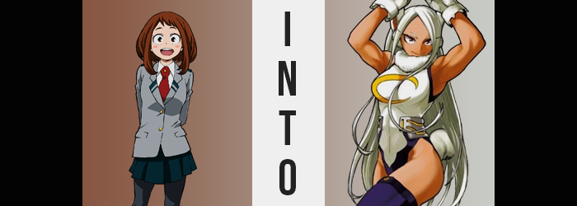

As of late, things had been very serious.

Recent attacks from villains had become much more dangerous, and death followed in the wake of pretty much every assault, even if the heroes of the city managed to push them back in the end. It was becoming so severe that the student heroes of U.A. had become worried themselves. Most of them were bound to hero organizations that would deploy them when necessary after all, which meant depending on the teen they likely had their own anxieties about what was going on.

Some were fearful for their lives; others were worried that they would be a burden on the battlefield. Perhaps the more selfless of these concerns came from those who just wanted to be strong enough to protect the people they cared about. Such was the mental state of Ochaco Uraraka. She naturally wanted to protect everyone after seeing what the villains were capable of, but at the same time the bonds she had formed in school were the most important things in her life short of her bonds with her family.

If she wasn’t good enough and was unable to save a friend, then she would never, ever be able to forgive herself. That was why she had committed herself to training more vigorously than ever. Day after day, night after night. Whenever she didn’t have classes nor other responsibilities, she could be found training her body and Quirk. But in the end?

“I don’t feel like I’m making any progress at all…” Despite how hard she had been working, Uraraka felt utterly defeated. Such was human nature in the end. If we don’t see the progress we want to see then we automatically dismiss the progress we have made as nothing. A trend that often inspired people to give up. But she couldn’t give up. Not when so much was at stake.

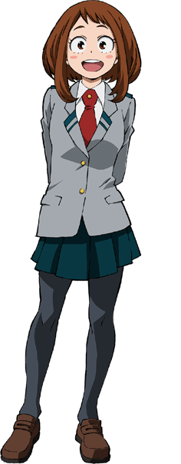
Having retired to the changing room of the gym she had been frequenting, Uraraka was confused when she found a bottle in the locker she had been using. “I didn’t put this here…?” It was a bottle filled with what looked like an energy drink – yellow in color. But it had a name on it, too. “Mirko…? Like the hero, Mirko!?” Wasn’t this a crazy good find? Mirko was famous and like really, really strong!

The odds were higher that it was a prank, though.

“Well…” She felt a little bad about it, but she popped the bottle open and took a swig, only pucker in the end. “It’s so sour!” If a Pro Hero drinks it, then it must be good, right!? That was the logic that had led to her taking a sip, but in the end she closed the bottlecap and put it right back where she’d found it. “Why is this even here…?” Sighing, she went to reach for her U.A. uniform at the bottom of the locker, only to pause. She felt… unusual.

Uraraka hadn’t really taken notice of it, but the pigmentation of her skin had suddenly begun to change. Splotches of a tan rose like freckles across her face, arms, legs, and torso, and while they were sparing in number at first, before long they had become so many that they had begun to merge together into an even coat of tan. Mind you, there was nothing fake about this – it was born from a change in her natural melanin levels, and it had even darkened her nipples to a deeper brown.

The girl shook her head. “I feel weird. Was there something funny in my drink?” The teen had evidently noticed that something was awry, but she hadn’t quite been in a position for her to properly note just what it was, unfortunately. Even though she was now looking down at her arm, an arm that was undeniably tanned, the issue just didn’t click with her.

Which was a shame because it was spreading. The darker colors of Uraraka’s irises brightened to an undeniably red, while the hair of her brows as well as the hair atop her head began to lose their luster. Or maybe it was better to say that they were being robbed of all of their color altogether? All of the hair on Uraraka’s body had been brown since birth, but now that brown was being sapped away like energy by a ghost. Before long all of her hair was a ghostly white, including the hair on her ears.

…Wait a second.

There absolutely shouldn’t have been any hair on Uraraka’s ears seeing as her Quirk didn’t cause any mutations short of the pads on her fingers (which had, in fact, gone missing). Yet white fur had begun to wrap itself around her earlobes, and wasn’t there more of those earlobes than there had been originally? They were growing quickly, extending up past her hairline as a softer, pink fur formed inside. Reaching about a foot past the tip of her skull they ultimately went crooked near the tips. Yet they were undeniably the ears of a bunny. Like those a certain Pro Hero possessed.

In terms of ‘traits that were undeniably those of a bunny’, there was another. In the teen’s rear, between the tank top and exercise shorts she had been wearing from training, a white tuft seemingly blossomed and exploded in size over the matter of a few seconds. A white and fluffy bunny tail had emerged, and the second it did Uraraka felt full of a boundless energy.

“Whatever, there’s no one that can take me down anyways.” She shrugged, and in doing so all of the feelings of inadequacy that she had been carrying practically melted away. That said, the girl’s voice sounded a little gruffer than normal, didn’t it? A little deeper, too. As if it was choreographing some manner of growth that was destined to come.

In terms of height, mind you? There wasn’t much growth at all. Uraraka did become taller, but it was only half an inch in the end. But because she didn’t really grow all that much taller, the other areas that grew ended up seeming much more substantially so in the end.

Take her bosom, for example? While already quite pronounced, at least for her age, additional weight ultimately settled into place and forced them to malform the cups of the tank top around them. Bigger and heftier than ever, you could definitely make out some sideboob with how it was stretching the cloth, and it had even lifted the bottom of her shirt to show off a tanned tummy.

This maturity wasn’t seen in her figure alone, mind you. In tandem with her bust growing bigger, her facial features warped so that they appeared older and less like herself. All in all, a full ten years was applied to her overall age, and that was seen in narrowed eyes, pronounced lips, and a longer face – yet a sharper nose and narrower forehead left her resembling another woman altogether. The woman whose bottle she had sipped from in a moment of insecurity.

“Even after workin’ out, I still wanna go for a run!” Uraraka couldn’t deny that she felt good, but maybe not so good that it would force the way she spoke to change entirely. Nonetheless her words were coming off much more casually, and her expression was much more serious.

And if she really did choose to go for a run, she would very quickly be helped in that endeavor by an enhanced physical condition. All of the muscles in her body rippled and tightened, skin struggling to properly encapsulate the raw power that took shape around her limbs and exposed tummy. There was no denying that she had become incredibly buff at a dizzying speed.

But looking at her lower half, it might not have been as obvious as when it came to her rippling arms and firm abs. This was because the area had bloated in a manner similar to her breasts, with her ass jiggling into a round and appealing heart sharp that could hardly be contained by the back of her shorts. In fact, some of her ass cleavage couldn’t help but peek out from the top of it. This all bled into her thighs as well, making them rounder and shapelier – and with the legs of the shorts gripping them so tightly, they looked even more appealing than ever. But this all forced her hips to pop wide, and so tears inevitably formed in the cloth.
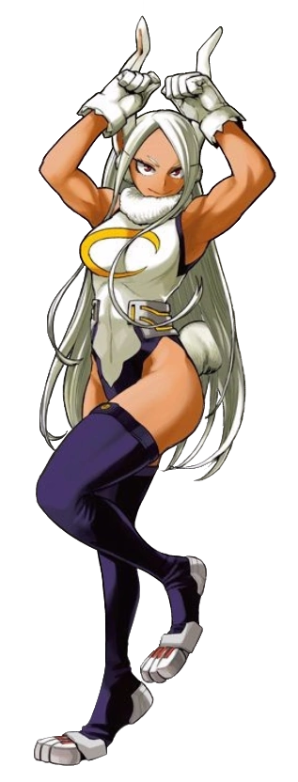
“Damn I’m thirsty! That’s what I get for workin’ out six hours straight!” No longer even batting an eyelash at what had become of her, Rumi Usagiyama aka Mirko reached for the bottle of her favorite energy drink and practically poured all of its contents down her throat. Her strong muscles practically glistened under the dim lighting in the locker room, and she used those muscles to toss the empty bottle across the room and into a garbage bin. Why reuse when you were so well off you could just buy a new bottle every time?

Compared to the small and uncertain teenaged girl she had been prior; Mirko had an overbearing confidence and swagger to herself. There wasn’t a single doubt in her mind that she was hot shit and that there wasn’t much that could ever stand in her way. And honestly? Being that confident felt good. Not that she could really recognize a difference, being a different person and all.

“Guess I should hit the hay and come back in the morning. None of those asshole villains better cause any problems in the meantime!” Leaving without changing, the bunny-eared hero lived in a loft just down the street. That was why she frequented this gym in particular. She simply waved off her own musing in the end, though.

“Not that any villain stands a chance against me. Hah!”

She didn’t even seem to care that her body was bursting out of a teenagers gym wear.

#confidence

