Triplets

A Short Story

Following on from “What did the Twins Say?”

By Maryanne Peters

Is it not every guy’s fantasy? To have a threesome with a pair of gorgeous twins? My only problem was that there was only one difference between Meghan and Moira Spillane, and it was not an obvious one – Moira is a lesbian.

They do everything together. And I mean everything. Moira told me that the only thing that they could not do was share a sexual partner. Meghan had the hots for me, but she said that without Moira agreeing to participate, it was not going to happen.

I needed it to happen. I wanted both of these girls.

It was my mother who came up with the idea. It would be crazy coming from anybody else, but my mother had always wanted a daughter, and we all know that she was disappointed that her third child (me) was another boy. She always told me that I was too pretty to be a boy and had always nagged me to parade before her in one of her dresses or wear a girl costume for Halloween.

She knew Doris Spillane very well and she knew that I was besotted with the twins. So, when she learned that Helen Beadle had broken a leg and would not be able to join Meghan and Moira as the third of “The Three Witches” tableau on the Halloween parade, she suggested that I fill in.

“Don’t be crazy Mom,” I said. “These girls have been planning this for weeks. It is not three ugly old witches, but three beautiful witches in long black dresses with glamorous hairstyles.”

“You could do glamorous Bobby,” she insisted. “Your hair is long enough, and you are small enough to get into Helen’s dress. We would just need some padding, and we will need to give that face a makeover.”

I never would have done it, but my mother blabbed to Doris about the idea and she loved it. And then I had a call from Moira. “I think that you would make a really pretty girl,” she said. “The kind of girl I could really go for.”

“But Meghan would never go for me in a dress?” It was supposed to be a statement, but it ended up a question.

“Oh, I think you are wrong there,” she said. “She might be more interested in what’s under the dress. And I might even be able to pretend it’s a strap-on if you act girly enough for me.”

She sounded so sexy I almost came in my pants on the other end of the phone.

“What do you want to do with my face and hair?” I asked my mother. She was thrilled for the opportunity to dress me up at last.

Mom and I went round to the Spillane’s place on the day. Mom and Doris were both skilled amateur beauticians and hairdressers, although Meghan and Moira had already had their hair done at the local salon.

The mothers sat me down and went to work plucking my eyebrows. It was only when I saw what they had done that I realized I was in real trouble. How would I be able to hid this tomorrow?

And then my hair. Once they had straightened out my natural curl it seemed as if my hair was really long. They used curlers and setting solution to style it to curl under. That was supposed to hide my wide neck and Adam’s apple.

“She looks gorgeous,” said Mom. “We need to get a photo”.

And with that the twins stood either side puckered up and whispered to me together, in perfect unison as they often did: “It’s going to happen tonight, after the Halloween party, a threesome.”

What a thrill. It was everything that I dreamed of. After that, dressing up seemed easy. I mean, being one of the girls became easy. It was like the Spillane twins had become the Spillane triplets, with me the third girl.

And it turned out that their mother was open to me staying over after the party.

I never knew it before that evening, but I found out that Doris is a lesbian. She has never been with a man. The twins are the product of IV treatment. I was the first male that she had ever had into her home, and I was only acceptable on the basis that I would be leaving for the party as a female, and if I was coming back in, it would be as a female.

The party was a great success, but maybe the best thing about it was all of the people who said “Who is the pretty chick with the Spillane twins?”. Mom and Doris Spillane had done such a good job that people I knew well, did not recognize me. Some I left alone, but the guys that I wanted to know, I sidled up to them with a smile, and told them who I was. A few jaws dropped I can tell you, and when I told them that I would be one of two girl threesome later on, those jaws dropped some more.

I still did not believe that it was going to happen when I got back to their place, but it did. The girls had a nightie for me to wear and we played around just using our tongues. Moira stayed away from my dick, but not Meghan. It was fantastic. I slept between them front on to Meghan with Moira pushed up against my back.

And it did not end there.

Meghan and Moira told me that Doris had never been one for long term relationships, and she certainly did not like butch women. She loved everything feminine and as she worked for a major supplier of salon products, she was able to set up her own salon in her home, just to service friends and family, and that would now include me.

Doris said that she now had triplets – Meghan, Moira and Maeve, which was the name she gave me. Of course, she knew that I was a boy, but I could never present myself at her house unless it was as Maeve. And I wanted to be there. I had two girlfriends who were ready to take turns on me. Who would want to be anywhere else?

Most afternoons after school I would go home and then get dressed for the rest of the day. That meant taking off my boy clothes and becoming Maeve, from the skin up. That means checking myself to see that I was smooth and soft, and then slipping on feminine underwear. Under my panties I would wear a gaff that my mother made for me. I suppose as a joke, she had embroidered pussy lips on the bottom of it – very artistic. Then she had helped me stock my closet with dresses and other outfits that were the height of style for a girl of my age. It was what my mother had always wanted.

I started to understand what it was about clothes that was so special for my mother, and that helped me to understand why she longed for a daughter before all this started. Girls’ clothes are really interesting. There is so much variety in colors and styles. And each outfit makes the wearer feel so different. Try it. Put on a white blouse and a pencil skirt with heels and look at yourself. You feel in control and sensible. No take that off and put on something bright or floral, with – a dress with a full skirt that makes you want to twirl. How different you feel.

And I realised that I really liked my legs being bare. Bare and shaved, just like they first were at the Halloween event. Jeans seemed so restricting, and sometimes clammy and smelly. I got so I looked forward to getting my boy clothes off, even without thinking about Moira and Meghan.

Once I was dressed, I could then head over to join them. It was not far to walk. To start with I was cautious about appearing in public, but I became very confident with my appearance and presentation. I enjoyed the walk, in skirts and heels, with my bag over my shoulder and my growing hair around my face.

The downside was that people who saw me might get the wrong idea. Doris insisted that I could only be with them if I was Maeve. I had to keep the long hair and the plucked eyebrows. I had worn my hair long for ages, but I never thought it looked gay, until I had those eyebrows. My friends at school knew my I looked this way, because I told them about my sexual adventures. Who wouldn’t? All the guys were jealous of me. I don’t think that there was a one of them who would not be prepared to look like a fag to have what I had.

But yea, to strangers I looked effeminate, and I suppose I acted that way too. Not just that walk after school, but in other ways. Both Doris and my mother were always correcting me when I was dressed, so some feminine mannerisms became automatic. It was more than metrosexual, it was girly behavior.

To most I would just have looked like a regular girl walking down the street. I used a little makeup and a slide in my hair, and maybe even a bangle on my wrist, to confirm that I was female. It was just easier to do that.

But I had nothing to prove to anyone. I was a guy with two hot girlfriends. One on each arm. Every night I was at their place for a threesome.

Sure, maybe the games we played were not exactly what you might expect for a one-guy-two-girl threesome. The first time that Moira suggested that I should be penetrated as well, I objected strongly. But it was two against one, and we were playing around – right? And as it turns out, when you get used to it, it can be great fun. What we really liked to do was triple penetration with me in the middle. So, I would fuck one of the girls and the other would behind me with a strap on. Wow! When the one on my cock came, all three of us would go off.

It seemed like sex like this could continue forever. Then things started to change. Or rather, I started to change.

I found out later that it was Doris who was responsible. It was not enough that I presented myself as female in her home, or even when I went out with the twins, it was the maleness in me that she could not abide. She told me later than she could smell it on me, ever when I wore the most feminine perfume. She felt that she had to root it out, and she found that drugs would do the job. Drugs in my drinks, drugs in my food, even some sneaky injections when I fell asleep with my girls.

To Doris Spillane, any man, or even a trace of man, is a threat.

I never really noticed the softening of the skin and the body hair loss – it was the problem with erections that started to get me worried. That and the tears. I started to find myself getting very emotional. I had never been one for chick-flicks but when we went out as the triplets, it was two against one. Now we were all sobbing. It was kind of nice that we shared that I guess. When the lights would come up and we would all look at one another with tears and tissues, we would laugh at ourselves. But I knew that I was not the same person I had been before.

The droopy cock was something the girls were very good about. They said that it was nothing to worry about, although had no idea what their mother was doing either. They would make sure that I experienced orgasm whether or not I ever achieved a full erection. I just found myself on the receiving end a bit more. We still had plenty of fun, so I was not too concerned.

|  |  |
| --- | --- |
| And then the breasts arrived!  I have heard plenty of people say that breast tissue cannot grow that fast, and that hormones take months or even years to produce breasts like those that sprouted on my chest. But I have learned that it is all about your hormone receptors. Everybody reacts differently, and there are people who are extremely sensitive to this kind of change in body chemistry.  In the photo I am pushing out a bit, but I am not wearing any bra or supports. That flesh is all me.  How do you hide a pair of bazongas like those puppies? The answer is that you cannot. So I needed to present as female full time. |  |

Of course, I went to see the doctor, and he confirmed that I had very high levels of female hormones in my system. I had the option to have the breasts removed surgically, but he said that the first thing to do was to find the source of the hormones and stop them. I think that he thought that I was taking them and lying to him about it to make excuses to my parents. After all, even when I went to see him dressed in male clothes he could see from my hair and my eyebrows, that I was a cross-dresser.

He was careful not to say anything in front of my mother who was with me, but he made it clear that fixing the state of my blood was my responsibility, and when I had resolved that he would refer me to surgery.

It would be nice to say that my mother was confused about the whole thing, but the truth is that she was thrilled. She had been behind the whole dressing as a girl thing, right from the Halloween thing. Now that I was keeping the breasts (for now) and had to try living full time as female, she could have the daughter that she always wanted.

She went to the school with me to explain. She said that at the beginning of my final term before graduation I would be coming to school as Maeve.

There was a school policy that applied, and transgendered students could expect to be fully protected. I was not transgendered, but nobody needed to know that.

I guess that all my friends at school were just confused. It was like I was the guy with the twin girlfriends, the guy all of them wanted to be. Now, I was a girl. Of course, if any one asked me I would say that it was just “a sexual experiment” and that I was still a guy underneath, but that was sort of a lie. I was no longer a swinging dick. My dick could barely emerge from my crotch.

But I did not have to talk to the guys, because suddenly I was one of the girls. The triplets got involved in all the girl activities in school. As a trio we were a force. I never had any feeling of being rejected by other students because we were such a tight team.

People said that we even started to look alike. Can you guess which one is not a Spillane?

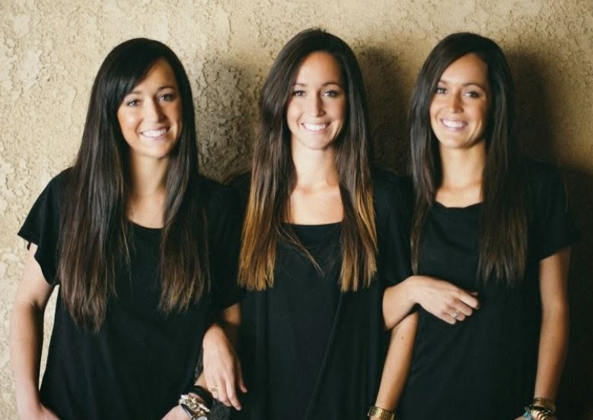

That is me on the left.

I still spent at least half of my nights at the Spillane house, and we all slept in the big bed that the twins had shared since they became teenagers. We still enjoyed doing what we did, but as I said earlier in this story, Moira and Meghan are not lesbians. Neither am I. I mean, as long as I am a man, I can’t be.

They started looking to go out with guys. Because I was one of them, we would do things as a trio. So that meant a guy for me too. It had to be somebody who was happy to go with me. The right kind of guy or no deal. If you want Meghan or Moira, you have to find somebody to partner Maeve. Maeve, the girl that everybody knew was really Bobby - a guy.

That was when Richie Mayberry came into my life.

Richie was the older brother of Thomas Mayberry who was angling for a date with Moira, along with his friend Gary Troup who was keen on Meghan. He was the kind of older brother who would do anything for his younger brother. I like that. Neither of my older brothers would do anything for me.

So it was duty rather than pleasure that had him go out with us that night, but it was pleasure that made him do it again a few nights later. Then again. Then again. I guess it started as duty for me too. I knew that I was failing my girlfriends as a guy, and they needed something more, but as long as I was involved, I still felt that they were still mine. And you look after what is yours.

Richie and I just talked. And we talked and we talked. And while the others were kissing, we were still talking. And then he kissed me. And then he was all over me. When he discovered my breasts I think that he must have realized that all that stuff about me not being a real girl was bullshit. I was a real girl. I was.

He made me feel that I was.

I never thought that it was possible – that a guy who was only interested in girls could suddenly fall for a guy. I guess that all it takes is a pair of large breasts and a pair of twin sisters encouraging you.

|  |  |
| --- | --- |
| Richie took me to the prom. All three of us were prepared by our loving mothers. Which one is me?  No more threesomes for me. I am strictly a single partner girl these days. Richie is all I want.  I know that my sisters have got their husbands involved in some kinky stuff. There are no secrets between triplets, after all  The End  © Maryanne Peters 2019 | http://www.sarajevotimes.com/wp-content/uploads/2018/05/sisters-200x300.jpg |