Stepbrothers Girl  Inspired by a Captioned Image  By Maryanne Peters  I have to say that when my Dad married Dawn, I was a bit unsure. I could see why he did. She is a good-looking woman, and I mean a really good-looking woman. The problem was that her son Mark looked just like her – a younger version that is.  Every time I looked at Mark, I could imagine him with tits. Is that weird? He had long hair and he was scrawny, and he acted like any other guy, but I just could not see him as a guy.  I didn’t feel that I was gay. I am only into girls. I just wished that he was one. Like, all the time.  I had to do something about it, and that is what led to the bet. | 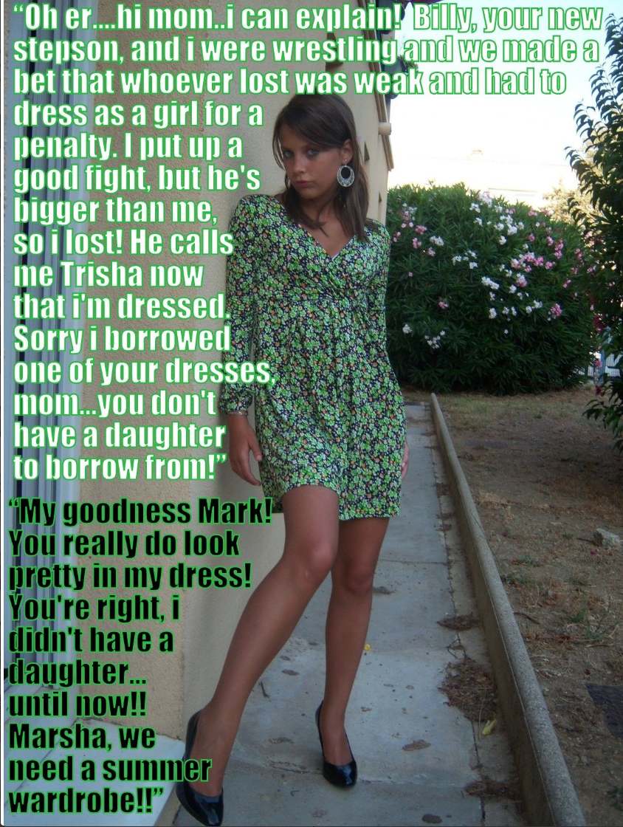

I am bigger than him so the bet was that if I could wrestle him to the ground with one arm tied behind my back, he would have to dress as a girl for the weekend.

“If you can’t win a wrestle against a one-armed guy, then you don’t deserve to be a guy,” I said.

“And if I win, you promise that you will stop constantly stop staring at me,” he said.

Well, he lost. I guess I am still entitled to stare, especially after the shave down and slipping on that dress over the stuffed bra.

I called him Trisha and I told him that we were going out, so he had better get himself looking as feminine as possible.

“I don’t want to be walking around with a tranny,” I said. “And you don’t want to be laughed at by everyone, so put some effort into your appearance and practice some lady-like moves.”

She pouted, but somehow that made her even prettier. I couldn’t think of using “he” to refer to her from then on.

The dress was from Dawn’s closet, and he raided it again for shoes.

“Everything seems too small except these heels,” she complained.

“They are perfect,” I said. They made her freshly shave legs look a mile long.

She found earrings and makeup, and a hairbrush and a clip for her freshly washed hair. Then I drove us across town to the Northside Mall so that we could hang out, with her looking like a woman.

To me it seemed the way it should be. As I said, I was unsure as long as I had strange feelings for my stepbrother. Now he was gone, and this was a woman that I desired. I was relieved. I was not gay. I had just fallen for one of those transwomen.

Trisha started out a little scared, but as time went on, she became more relaxed. It seemed to me that she was a natural woman, but it took her some time to come around to that way of thinking. But by the time we were ready to get home before dinner, she seemed fully accepting of her female status.

The first person to find her out was her own mother. She was sneaking in around the back while I was parking my car and her mother caught her. When I came around that corner, I could see them talking. Her mother was not screaming at her – just talking.

I thought that I was going to get hell, but when she turned around Dawn said to me: “Thank you Billy for allowing Marsha to be herself”.

I was thinking: ‘Who the hell is Marsha?’ But it seems that Dawn had always felt a bit like me – that Mark was never supposed to be a boy.

She can call her what she likes. To me, my girlfriend’s name is Trisha.

What surprised me was that when she was lying there later on that night, repositioning me for a more comfortable penetration, I realized just how strong Trisha was. She was stronger than I can remember, like from the time we wrestled. Had she let me win?

Whatever, when she wailed with pleasure, I knew that she was happy she had lost.

The End

Replacement  Inspired by a Captioned Image  By Maryanne Peters  What makes a guy decide to sleep with the girl of the meanest gangbanger in town? Simple. There was no decision. My cock lead and I followed. There is no brain in your cock. If you let it take the lead then it will drag you into the shit, sure as shooting. Which is exactly what I faced when she high tailed out of there.  I don’t know why I was wearing her nightie. We were just playing around. He just pulled off the sheets and I was lying there, looking down the barrel of his pistol. Too scared even to shit myself.  “WelI, well, what do we have here?” he said. “It looks like she’s just left, and I guess she won’t be coming back, so you will have to fill in.” | 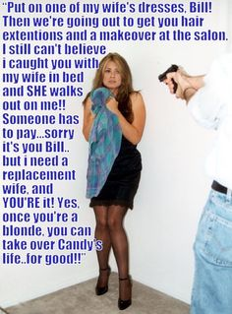

It turns out that when he gets angry, he gets hard, and when the girl in front of him gets scared, he gets harder. And when he gets that hard, he is not so fussy about whether “she” is a girl or not.

He fucked me then and there. Just a little Vaseline and he took my virgin ass and pushed a cock the size of my thigh into it. I howled like a bitch, but that just seemed to encourage him. He went at and he filled me with his mustard.

“Somebody’s got to clean the kitchen,” he said. I could hardly walk, but he had me scrubbing floors in that nightie. But I came to understand that it was probably that nightie that kept me alive.

I said he was not fussy, but that was not so true. If I was going to fill in for his wife, he did not want me to look like Bill, the town mischief-maker. He sent me down to the salon with a wad of cash and clear instructions on what needed to be done, and what clothes needed to be bought and worn.

He still likes to use the gun before we have sex, except now it’s not loaded. I have to pretend to be terrified, just like he pretends to be angry, to ensure that his erection is the best it can be. I only pretend that it hurts now, because it doesn’t. He pretends to abuse me, but now he loves me. We both know it when we both cum together, and when we fall into one another’s arms afterwards.

Sometimes the replacement can be so much better than what it replaced.

The End

Witness Protection Duty  Inspired by a Captioned Image  By Maryanne Peters  The Deputy Director was at pains to dispel the joke doing the rounds. “You are not her live-in boyfriend, you just have to appear that way in public, for the time being”.  The disguise, I was told, was so good that it was foolproof. But to me it sounded impossible that you could take a guy and have them look and act like a woman, even somebody as small and slight as Nate “Runt” Ryan. But that was before I saw Nancy Newberry – you must say “she”.  If there was somebody more surprised than me, it was Nancy herself. She kept on looking at herself in the mirror like that. It was no like she as admiring herself (maybe as she should be doing looking like that) it was more a look of sadness. It was as if she realized that Nate was dead, and in his place was somebody else entirely. Which was true. | 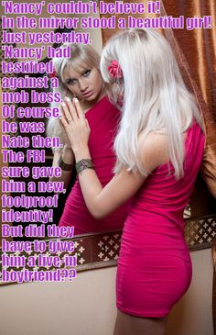

She had finished her testimony, but as a part of a plea deal that would see her do no jail time despite a string of crimes, she had to cooperate with an ongoing investigation. To be able to do that she needed to be free, but so changed nobody in the mob would be able to find Nate Ryan. The mob knew that a deal was in place, so their “Liquidation Contractors” were watching my division of the FBI – the Organized Crime Division.

I loved working in OCD. Witness protection duty was not my thing. But she needed to be available. She needed to be watched until the job was done. When she came to the office, I needed to be for a reason. My girlfriend would be demanding, and a constant visitor. Plus, I could take stuff home for her to look at in my apartment.

She had her own room. She could sleep there and enjoy the wardrobe that the FBI had paid for. And provided that she reported stayed in with me, or in my company, and reported in through her tracked phone every few hours, she was free to roam the city.

“It’s because I am so small that they had me looking like this,” she said. It was true. She was even smaller than the average girl and was clearly noticeable as a very small man. Somehow the guys in Witness Protection figured surgery to make her look female was easier than surgery to make her bigger.

“I think you look great as a woman,” I told her.

“Do you really think so?” she said, checking out her look. “Then why are you not prepared to take me out after work? I want to go out at night. What kind of freedom is this if I cannot go out at night in this great city of ours?”

“If you want to, we can go out,” I said.

She wanted to be a similar height to me so she got herself some high heels and she was clinging to my arm as we went to the show. “Maybe just put an arm around my back?” she said.

It was a great show and we went for a drink afterwards to talk about it. I guess we had one too many.

“They do this too me so I can hide, but they don’t think about my feelings,” she said. “Every human being needs a little intimacy in their life. How am I going to get that? Here we are stuck together like Siamese twins. Neither of us can be with another human being.”

She was right. I felt the same way. We sat staring at one another over the quiet restaurant table. Two people wanting a physical relationship. It occurred to me that I was looking at a woman, but she had to be looking at a man. Runt Ryan was not big but according to the profile that guy had fucked plenty of women.

But that was not a guy looking at me. Or not looking at me as any guy would.

“You’re a beautiful woman,” I said. “Any guy in this joint would love to get with you, if you were into guys that is.”

“I have already got a boyfriend, and you’re it,” she said. But it was not sad or angry. It was just a fact. I was Nancy’s boyfriend.

I held her hand on the way home. Two people holding hands – that’s all. I thought that everybody who saw us would be thinking: “There goes a nice couple”. How could they know who Nancy was, or had been? How could they know my real role in this charade?

We got back and Nancy was headed to her room, and I said: “Would you like to spend the night in my bed tonight?” Imagine that! I just looked at her butt in that red dress and the words just spilled out. She just looked at me and then she went into her bedroom and closed the door.

I guess that I felt relief. Like: “That could have been embarrassing. At least she has walked away. I have dodged that bullet. Forget I ever said it. Do not mention it in the morning.”

But after I had washed up and was lying in bed, the door opened softly, and Nancy walked into my room and to the empty side of my bed. Somehow, I was beyond pleased. I pushed the covers aside to let her in. She slid in a cuddled up close to me.

Now I cannot imagine a night without her beside me.

The End

Hello Diane  Inspired by a Captioned Image  By Maryanne Peters  Biff took this photo of me when he walked in and saw me for the first time. We laugh about it now. He says that it captures the moment when I first realized that my future was with him. All I remember is that I was terrified when I first saw him, just after I came to and was supporting myself against the door. But maybe he is right? I don’t look so scared, do I? More curious, perhaps?  My ex was shouting at me, calling me Diane instead of Dave, and going on and on about me calling her a bimbo. I was just coming to grips with what she had been able to do me while she had me unconscious – tear the hair from my body, tape up my dick and nuts, stick fake tits on my chest and fake hair into mine, and put me in a mini-skirt and patterned stockings. Quite how she managed to do all of that is something I still don’t understand, but it doesn’t matter now. | 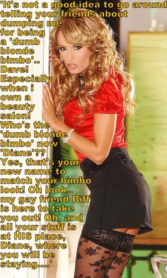

“Hello Diane,” he said. There was something about his voice or maybe just the way he said it. It just made me feel weak and vulnerable, but not so afraid.

He says it to me every morning now. He rolls over and says to me: “Hello Diane”, and he smiles, and I know he loves me, as I love him.

It is all he needs to say to make me grab his cock and pull him to me and on to me.

I have a pussy now. He used other parts before I was modified and fully healed, but now I have some part of me that is just for him. It has no other purpose. It is just for him, so I keep it clean, and sweet smelling and always lubricated at ready.

I have boobies too. Just the way he likes them. A cleavage he can bury his face in.

When he is inside me, and his hands are on my tits, I cannot think of anything at all. My mind is just full of pleasure. Does that make me a bimbo? During the day I think of him all the time, and how to make him happy, and how to make him want me even more. Does that make me a bimbo?

The End

