LARVALOUS
COMMISSION STORY
BY CHALDEACHANGE
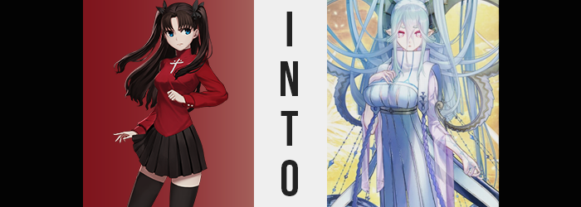

“Not even a return address, huh?”

Rin Tohsaka clicked her tongue impatiently as she turned over the package that had randomly shown up at her doorstep that day. It was unusual for an entire swath of reasons, honestly. The first of which being that it was a Sunday and mail usually wasn’t delivered on that day of the week. Monday to Friday, sure, but this was back in the early 2000s. There was no special “weekend delivery” readily available. Which meant, of course, that someone had gone to the trouble of leaving it on the doorstep of her manor themselves.

Not seeing any other option other than to leave it on her steps to get stolen, she did eventually bring it inside. Being a survivor of Fuyuki’s Fifth Holy Grail War as she was, there was no shortage of people that were trying to get at her as of late. Some that wanted records of the battles that had transpired, others who wanted her dead because their loved ones had perished in the war. It was simply something that she had already steeled herself to deal with.

After all, she’d lost family members to past Holy Grail Wars. She knew how it felt.

Dropping the small box on the kitchen table once she had stepped in, Rin had initially intended on simply leaving it there until she could think of a way to dispose of it. That was, at least, until she had an idea. “I guess I could try that to see if it’s dangerous, right?” Her understanding of it was rudimentary, but Shirou had taught her a little about Tracing Magic. Enough to identify the parts inside of something to a meager extent, but it was probably enough to figure out if it was a bomb or something, right?
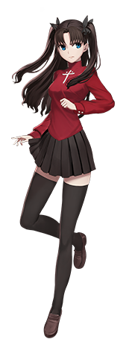
“Trace… on!” There was a soft fizzling sound that came from Rin’s fingertips as she uttered the enchantment, fingers wrapped firmly around the box in question while green lines glowed up her arms. It really was an inadequate showing of the technique, but as she kept her eyes closed… “Huh? It’s just a gem? What the heck was I worried about then!?” She disengaged the spell maybe a little too soon, her previous look of worry having become something a little more enthusiastic.

In the end, fingers made quick work of the box that had been disguising the contents, freeing the tap within a matter of seconds as selfish glee could be observed in Rin’s face – not to mention the little hum she was giving off. The magus loved jewels and gemstones more than anything, so how could she not be a little excited? As for where it had come from, well… She had learned to appraise gems herself to an extent, she could probably figure out.

“Wow! That’s a really pretty color!” About the size of the girl’s palm, she removed a sky blue gem from the depths of the box and the paper padding that had surrounded it. The color was striking, and wasn’t it a little translucent? It almost resembled a blue pearl more than anything. “I wonder how much a stone like this is valued at? Not that I’d sell it.”

Rin was practically dancing with the blue orb around her kitchen, but stopped very, very suddenly. “…Eh?” At first she thought she had been seeing things since it hadn’t been there before, but there was a tiny, black spot on the side of the gem. No bigger than a pin prick. “What the hell!? Where did that come from!?” She was honestly hoping it was just dirt, so she began to aggressively rub it off. But the spot grew bigger, and bigger, and bigger… “No, no, no, no, NO!” Until the entire rock was black and then?

It exploded.

“BLEGH!?” It didn’t explode in the volatile fire and flames sense, mind you. It was almost more like a pimple popping? Rather than something dangerous, a very dark mud had splattered all over Rin – and all over her kitchen. She’d even got some in her mouth and was violently trying to spit it out. “WHAT THE HEEEELL!?” But really wasn’t this just her luck? It was certainly the sort of thing that would happen to her of all people.

It was all over everything! It was going to take… forever… to clean… up… “Eh?” That was what Rin had been thinking, but before her very eyes all of the mud dried up in her kitchen. Even the mud that had cast itself across her body! But… that wasn’t actually true in the latter case. What she had misinterpreted as the mud drying away and disappearing was actually the act of her body absorbing it. And since this wasn’t normal mud, that probably wasn’t exactly a good thing.

“Just what the heck was all that about!? Was it just some stupid prank!?” It was more comforting to dismiss the explosion as some sort of joke. After all, sometimes it was difficult to try and recognize when you might have put yourself in harm’s way. But while Rin was subconsciously trying not to think about it? There was a part of her that could tell. That the mud had been magical in nature, and now that magic had breached her skin and was inside of her.

And her stubbornness would lead to tragedy in a sense. She might not have been able to prevent what was to take hold by herself, but she most certainly could have sought help before it was too late, while things were still in their earlier and less damaging stages. There was already signs of damage being done, though.

One needn’t look any farther than Rin’s twin tailed hair style. From birth, she had always had that natural, dark brown hair color that she had understandably inherited from her late father. But due to her feigned ignorance she did not bother to investigate any potential issues with her – although to be fair, she didn’t really know what the magic mud was doing in order to know what to look for.

But there were streaks of color. Not only among the hair atop Rin’s head, but likewise in her brows and pubes. Strands of a light blue that most certainly didn’t belong at first, and yet as time wore on? It was her birthed brunette that began to look out of place because the blue became more common. A few moments later? And Rin’s original hair color was gone altogether, instead replaced entirely by this pastel aquamarine.

“Well, I guess I should clean up… the rest? Eh? Where’d it all go?” Rin had dismissed how all the mud had just disappeared off her body, but she soon realized that all of the mud in the room had ‘dried up’, and there were no remnants of what had just happened whatsoever. The part of the magus that was in denial prompted her to scan her surroundings more thoroughly though, and she did so with a set of eyes that had begun to glow pink as opposed to their usual turquoise.

Pink irises, mind you, were not as alarming as how black pupils turned white and immediately dilated, expanding into a pair of white Xs midst her gaze. Something that was utterly supernatural by design. Not that any of this was particularly grounded in norms anyways. But Rin’s eyes also changed shape, losing their Japanese appeal and rounding out into a set that were bigger, wider, and decidedly more Middle Eastern despite her complexion remaining pale – and even seeming a touch paler.

Rin clicked her tongue upon finding no muck to speak of, but when she did go to speak of it? “Aaa. Aaaa? AAAAAA!?” Although remnants of her personality were there, the only sound she could seemingly make was a melodic AAA-ing noise, almost like she was singing instead of speaking. Communicated through lips that were demonstrably thicker upon a face that not only widened at the top, but narrowed near her chin, it was becoming as difficult to tell who she was as it was to tell what she was trying to say.

Her arms flailed about, obviously panicked. Trying again and again, the singsong voice was all she could sound regardless of her intentions. Though while flailing about? Several additional changes occurred. The first was a very dramatic change in the length of her now pastel aquamarine hair. Almost like someone was showing a video of a Chia Pet growing at high speeds it all pulled out, falling not only down her back but likewise pooling on the ground behind her.

“AAAA!?” Her bangs were no exception, and once they were cast over her eyes she hastily grabbed them within her fingertips, now noticing their color just as she did their volume. Mind you this hair was eventually hoisted from the ground so that it dangled slightly off of the ground, but the help in this case was just as alarming as anything else. “AAAAAAAA!?” Because after all? It began with a dull throbbing on either side of her head.

The girl couldn’t make heads or tails of what was happening, but she knew the gemstone was the cause. Fingers gingerly prodded the points on her head where she could feel the throbbing grow, pressure ultimately building above where her ears had unknowingly lengthened and drawn into monstrous points – as had the teeth within her mouth. But these weren’t the only monster-like things about her as the pressure ultimately revealed, for what emerged from her skull other than a pair of hefty, hard horns.

Weighty as all hell, Rin was quick to almost fall forward as they grew into full splendor in just fifteen seconds. Their bases were thick, but they reached up and curled in behind her, before expanding out and curling in once more. As they were attached to her head? She couldn’t see them. But they were as green and pastel blue as anything, hoisting up some of the hair they had grown under so that it didn’t touch the floor. “AAAAAA…? AAAAA!?!?!?” Why did she even have horns? Was she some kind of beast?

Of course I am. Literally. How silly.

Pink irises were glowing, unknowingly indicating that Rin’s old personality that was now being pacified by the arrival of something else. Something invasive to her ego. But it cooed at her into gradually accepting what was becoming of her while easing her identity into something else. Something greater. Something powerful. Whether her body gave off that impression, on the other hand? That was up for debate.

There was no denying she had inherited some blatantly monstrous features. Horns, fangs, and to a lesser extent pointed ears. Another eventually arrived in the form of a scaled tail, pained with greenish blue itself, that tore out from above her skirt and twitched back and forth behind her. But when it came to how imposing she looked? Her face was a warm as a kind mother’s if you looked past her eerie eyes. A mother in her late twenties.

But Rin’s height? A mere inch was added to her overall frame, making her a human-sized monster if anything. That said, this didn’t mean that Rin was done growing. She just wouldn’t grow taller. But sporting gentle, maternal appeal of a mother with her resting expression, well… Her figure ultimately needed to match.

“Aaaa?” No longer screaming her song, at least, the woman made a confused cry as fingers drifted down to her shirt, both hands hovering over her breasts. They felt warm, sensitive, and full. A series of feelings that didn’t make a lick of sense up into the moment she suddenly felt them press into her palms, lifting up the base of her crimson shirt in the meantime to show off her tummy.

Fingers unintentionally sunk into her bosom, its mass swelling so substantially that no effort was required at all to break the back of her brassiere’s strap. Swelling greater still, the cross on the shirt’s front was crumpled even further once they ballooned to a size even greater than her head, almost tearing the fabric. My breasts aren’t this big! …But as the mother of all life, why wouldn’t they be?

She made a good point to herself!

And naturally, a woman with such a title would have the hips to bear these hypothetical children, wouldn’t they? Well that was exactly what happened, for her skirt lifted due to hips pulling almost six full inches wider. The fit of this skirt certainly wasn’t helped as her ass and thighs bloated next, with her rear lifting up the base of her tail once it reached its heart-shaped potential, and even pushing up the front and sides due to creamy thighs becoming so rotund that they pushed into each other between her legs even with her widened hips.

Not that the matter of her clothing’s fit was one destined to linger. Because all of the cloth that clad the woman’s body soon erupted into golden particles that danced around her dining room, exposing her ample flesh to the air briefly before they reconverged into the form of a white dress with a raised neck that appeared to be cut into ribbons to show slits of her bare flesh beneath them.

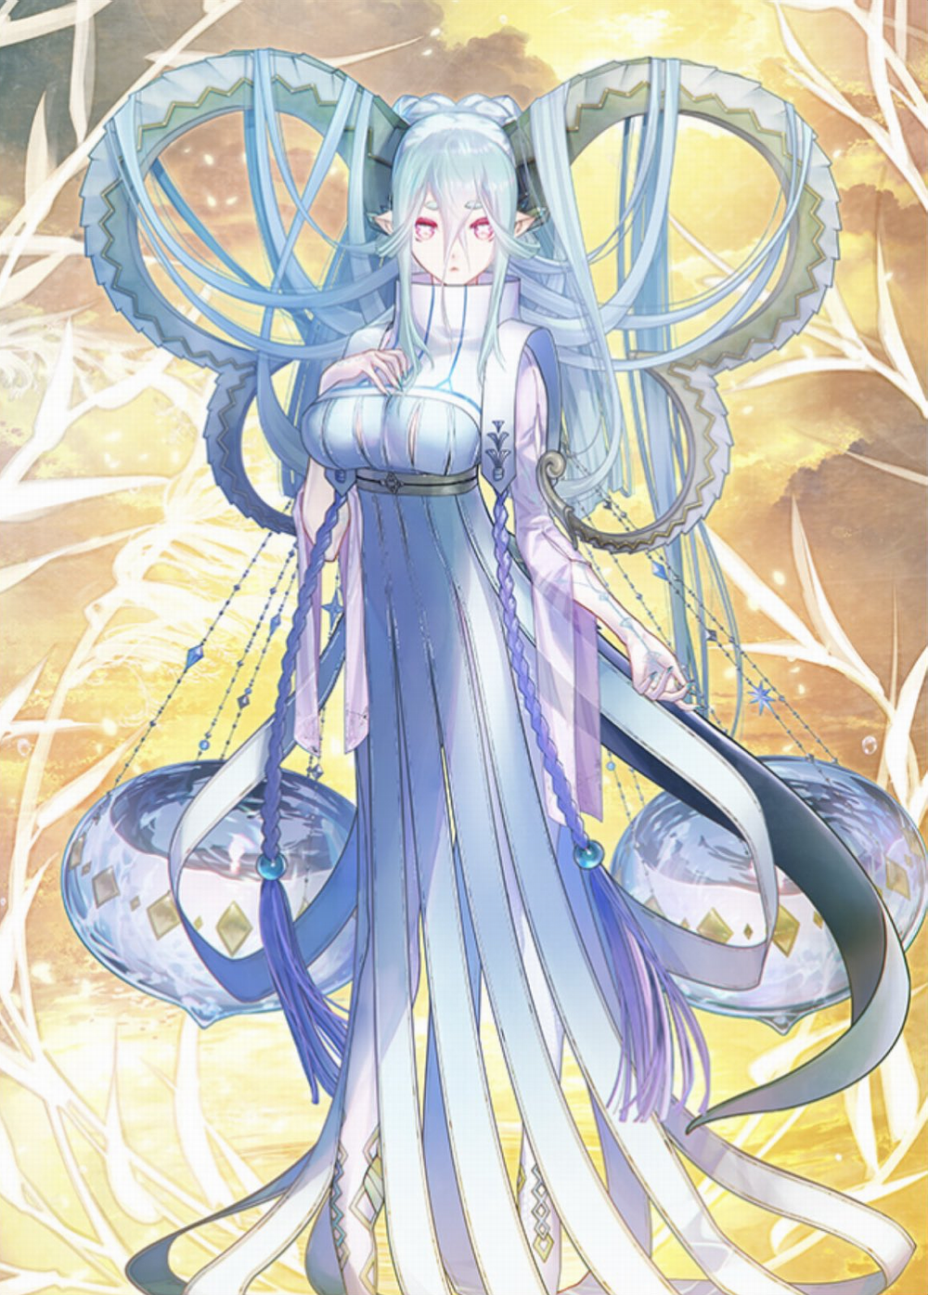
“AAAAAA… Ahn? Oh…” While her words had been distorted into naught but a lovely singing voice midst the depths of her transformation, the woman now found herself able to murmur in the human tongue once more. That didn’t exactly mean that she held any recollections of being able to do so in the first place, mind you, that knowledge was long gone. What she had lost in memory however was made up with something maybe even more important. Maternal desire.

She certainly had the look of a mother. Well-endowed, a soft voice and face, evidently a woman at least in her thirties. But of course her features as a monster cast some doubt as well. No human mother had horns, ears, nor eyes like hers. But Tiamat was undoubtedly no human. Yet she was simultaneously the mother of all. A primordial deity to whom the life of every person on Earth was technically owed in the grand scheme of things.

“…Hm? This is… Japan?” Being one with the planet itself in a sense, it did not take the monster mother long to identify her location even without looking outside of the house she was in. This was the homeland of the Master that had defeated her, so she would at least treat it with some respect. Yet while the memories of a past life had almost all but fizzled away? There was a vague recollection of a boy. One that didn’t look all too unlike Chaldea’s female Master.

It stirred something within Tiamat. A desire? A yearning? A stronger version of what she had been feeling ever since she had begun to reawaken as ‘herself’. Her maternal instincts, feeding on Rin’s affections for Shirou Emiya, had evolved into a desire to dote on this one human. And thanks to the vague recollections that continued to affect her, she could even vaguely recall where he was. “I need to go… see him.”

Admittedly the Alter Ego hadn’t thought much of how or why she was in Japan in the first place, but this singular thought helped motivate her into what she needed to do next. She needed to find him, dote on him, and make him feel happy. Just as any good mother should towards one of their favorite children.

Whether or not Shirou would want this was a completely different matter, of course.

