SCOUTED
JUNE 2021 REQUEST STORY
BY CHALDEACHANGE
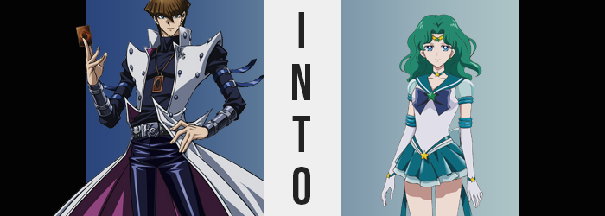

“Augh. I keep telling Mokuba not to leave his things laying around.”

The chartered flight Seto Kaiba had taken aboard his private jet to Domino City would soon be landing, and as he always did, he was doing his once over of all of the cabins. One might not expect this of a man who acted like he was the only person in the room at any given time, but he was something of a neat freak. Of course he had staff to clean the plane, but his standards were quite high.

There was also the added benefit of being able to make sure his kid brother didn’t leave things aboard that he should have taken with him, as was the case here. In Mokuba’s private cabin, Kaiba had found his brother’s tablet. He’d taken a flight on the same jet the day before, so he must have forgotten it. Since he was meeting Mokuba in Domino City though, he decided just to grab it and give it back to him once he’d landed though.

“Hm?” While picking it up, the young man must have hit the power button on the side, for the screen lit up to display whatever the younger sibling had been viewing on it last. From what he could tell it looked to be a game? The background was bright and colorful, and there were what looked to be anime girls scattered about with a big button in the center that read ‘SCOUT’. It was a gacha game, and a Sailor Moon one at that. “Is he really wasting his time with stuff like this?”

Trying to figure out how to close the app, or at least turn the tablet off again, he ran his index finger over the screen. In the process though, he accidentally hit the ‘SCOUT’ button, which turned the screen alight. “What the!?” Said light grew so intense that it filled the cabin entirely, and by the time it faded? The tablet fell to the ground, Kaiba nowhere to be seen.

Kaiba didn’t understand what had just happened. From his point of view he’d just been aboard his private jet, his brother’s tablet had suddenly glowed, and the next he knew he was standing in what looked to be the bedroom of a teenaged girl, based on how delicate and vibrant everything was decorated. “How did I… When did we land!?” He’d just been aboard a plane. There was no way he could end up in an apartment this quickly other than falling from the sky, which absolutely hadn’t happened.

But, in actuality? Kaiba was no longer even in his own reality. He’d been sucked into the world of the game that had been on Mokuba’s phone. He was in the world of Sailor Moon. And soon?

He’d become a permanent part of it.

“This is impossible!” The duelist’s flair for the dramatic coming out in his tone as always, he cast a hand out to the side as if there were someone actually there to witness his little outburst. People didn’t just suddenly end up in completely different places! Well, okay, it had actually happened multiple times during his duelist career, but somehow winding up in a girl’s bedroom was in a different ballpark from being flung back into Ancient Egypt… somehow.

However, this would be the first experience of this kind where the world itself would bend him to its standards, beginning with a very sudden, and an extremely dramatic fall from statuesque grace. Kaiba was a notoriously tall fellow, his height having peaked at 6’1” at a noticeably young age. In fact, his very figure was based around just how lanky his frame was.

So one could only imagine what kinds of issues it might have caused for him to drop to a meager height of, say, 5’4”? “WHAT!?” There was no shortage of anger conveyed through Kaiba’s tone, the man powerless to stop what had been thrown in motion while every bone in his body shortened. From his jacket to his tight t-shirt (which he had purposely chosen to show off his abs), to his equally tight, leather pants; it was all disheveled in the most inconvenient ways imaginable, dangling off of him at ever level thanks to the seven inch height loss.

“Grr… Under what power is this happening!? I swear if this is some kind of Egyptian magic being used with another Millennium Item…!” At one time, he would have rejected this as ‘fake’ altogether. He hadn’t believed in magic at all, at least until he’d witnessed the power of the gods themselves. Now he was something of a more reluctant believer. In this case though, there were no Millennium Items involved. Just an uncanny game virus.

The man fumbled around in his outfit, but before he could even adjust to what had befallen him, he was subjected to a costume change that could only be seen as embarrassing. After all, said clothing suddenly began to sparkle and glow green, and when that light had faded? He was left dressed in an ill-fit sailor uniform, one with a short, teal skirt, white top, blue bow, long gloves, and even a circlet atop his forehead. It looked like a costume made for a girl!

And, in fact, it was a costume similar to those the characters on Mokuba’s tablet had been wearing.

“Rr! What the hell!?” He was quick to enrage once discovering just what had befallen his visage. Not only was he a dramatically shorter version of himself, but he was also dressed like a girl!? Maybe I should play the violin a little to calm down? Wait, what? He had never once in his life played the violin, and it certainly wouldn’t help calm him down!

Nonetheless, Kaiba was still under the assumption that things couldn’t get any worse, even though there were active signs across his body that this absolutely wasn’t the case. Strands of a rich green had already bled into the hair atop his head as well as his eyebrows, his hairdo lengthening at an alarming rate that went unnoticed now that a seed of personality had taken root in the man’s ego. His own mind was dissuading him from taking notice of anything bizarre in no small part because he was being forced to acknowledge it as normal.

And so, even as green hair spilled past his shoulders, wavy as could be, Kaiba was instead struggling with an urge to… play the violin? Or perhaps he could calm himself with a walk by the beach? Since when had he become so fixated on calming himself?

The man’s legs, exposed by his dangerously short skirt, were promptly shaved from their once excessively hairy states as it seemed the changes in hair were not limited to those upon his head alone. Even the hair around his balls dyed green, fleeting as its existence all was before Kaiba squirmed in the midst of her supposed rest and relaxation moment, a girl’s sexual counterpart taking root. It was actually a relief, really, because the panties she’d been forced to wear had been strangling her men’s junk. There was no excess hair down there at all now, and the girl could remember shaving it to her partner’s preferences.

Partner!? Since when did she have a…!?

There were occasional lapses like these where Kaiba’s anger boiled up and she questioned her circumstances, but they were always so fleeting. Either way, her figure was in the midst of folding in upon itself, the sailor uniform ultimately fitting more comfortably as a result as her frame twisted to better suit her new sex.

This included a deep in her waistline, one her top readily embraced, as well as a widening of her hips that brought her skirt to fit more naturally. Beneath the teal skirt, one could witness her posture buckle from her altered hip size, knees practically tapping each other down below while her smooth thighs became ever so slightly plump. Her ankles narrowed as well, and as feet collapsed several sizes, they no longer felt like they were being crushed by her dainty, little boots.

“Am I forgetting something?” Stripped of her Adam’s apple, the girl’s voice had grown as soft and sweet as her face soon conveyed with her big, round, anime eyes and daintier lips. Her cheeks round and her ears both small and pierced, she certainly now gave off the impression of a proper, young woman. That anger she had irrationally felt before? Kaiba had brought it all under control now. But even that name… “Kaiba? That’s an ugly name.” It didn’t suit her at all! When did she start thinking of herself that way?

All while pondering this final point of identity, the final changes brought peace to her Sailor Scout costume. Hands became smaller and ankles thinner so that her gloves fit without an issue, as did her shoulders narrow so that her sleeves weren’t so tight.

All that remained was a chest that rested flat without any real definition to speak of, for her muscles had all diminished the moment her mind had begun to reprocess her tastes towards the arts. Playing the violin, painting… It all sounded so wonderful, didn’t it? Almost as wonderful as the perky bosom that swelled forth, breasts small but perky – certainly to someone’s tastes.

Well, that had to be true! She had a girlfriend after all!

“That’s odd. Why did I transform in my room?” Sailor Neptune, otherwise known by her real name, Michiru Kaiou, was left perplexed by her current state of affairs. It was late evening, and she could recall returning from Mugen Academy after doing her extracurriculars, but then…? She’d wandered into her room and transformed? She couldn’t make much sense of why she’d felt compelled to do such a thing, and so she dismissed her Sailor form so that she was in her Mugen Academy uniform once more.

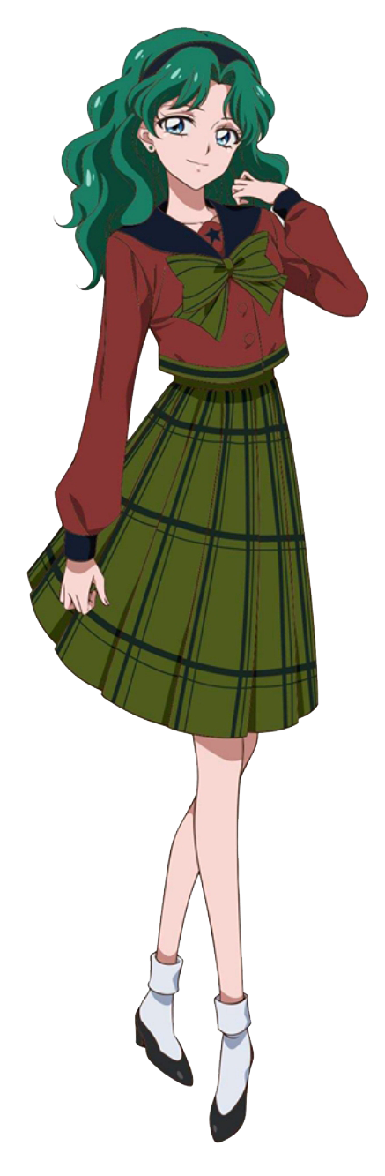
Today was so tiring, but if there’s any silver lining to be found… Sighing as she reflected upon memories of a day now past, memories that had only just now fixated themselves within her psyche, Michiru could find her thoughts wandering to only one comfort. A comfort that would be arriving soon, so she knew she had to change her clothes. “But what should I wear for our date tonight? I should have picked up something new on the way home…”

Her girlfriend Haruka would be stopping by soon, and apparently, she had a very fancy dinner at an equally fancy restaurant in mind. She’d been looking forward to it all day, so much that it had become the most important thing to her at this juncture.

Much more important than any memories she might have lost of a hypothetical past life.

