*It Ain’t Like Magic*

*Siggy Commission for TheQuelch*

Alex had lived a rather normal life, born to a loving mother and father as the eldest in a family of four including himself. Smart, athletic and eagle eyes, it seemed as if the future had already been set in stone for the vibrant boy who had quickly become the apple of his parents eyes and a role model they had been quick to compare his younger brother Damien to, always telling him to be like Alex and study hard, causing a wedge to form between the brothers because of it, with Damien understandably feeling left out, inferior and vile, stewing in his own mire of self pity and hatred for his 'ideal' big bro.

But that wasn't the only wedge to form in Alex's life going forward as he inevitably entered high school. It was there when he began to feel insecure about his Identity, struggling with the podium his parents had propped him up on as the prodigal son of the family and his own internal feelings on what that meant for his life. Did he really have to become some upstanding, manly individual with a heart of gold? He wasn't planning on doing anything bad per se but Alex's goal in life was simple; to lead a peaceful quiet life making paintings. He was an excellent artist after all and with abit of time and effort, he could most certainly make a name for himself out there.

His father however, seemed to want him to go down the path of his predecessors as yet another enlistee in the navy, talking about all the tours he and his forebears served and the thrill of a gunfight out on the seas. He never once interrupted his father whenever he went on about these tales of his out of respect, even though he knew he'd have to break it to him someday that he had no intentions of becoming a glory seeking soldier leading a life out on the seas with barely any time spent on dry ground. It just wasn't his cup of tea. Thankfully for Alex however, his mother seemed to be more open minded on things, basically chiding him whenever he fearfully asked her if his father would freak out if he said no to the life of a seaman.

**"Relax dear! I'm sure your father will understand if you tell him! And if he doesn't, well, you can count on me alright?"**

That was what made Alex love his mother dearly, feeling as if he could rely on her whenever he felt down in the dumps about things.

What Alex felt most insecure about himself besides his future however, was his own identity. His gender specifically. He'd seen girls being so carefree, so cheerful while hanging out with each other that he began to grow intrigued, wondering why there were concepts like things girls could do that boys couldn't and a perception that boys should just stick to their guns, with anything else seen as weird or 'wrong', as if wearing a dress, putting on makeup or having girly hobbies was a taboo. That along with the empty weight in his chest whenever he gazed upon his own masculine form had led to him developing a cross dressing habit, saving up to buy dresses, skirts, even girls underwear. It had begun as a curious venture, but the more outfits he wore, the more 'alive' he felt.

But that could never change the fact that he was still a man physically, even if surgery was an option, he was still afraid of that dreadful cold he felt whenever he looked at his own reflection; sporting a sleek slender frame and shoulder length hair in an effort to imitate what he could never be.

Unbeknownst to him however, Damien had been spying on him for quite awhile now, sneaking cameras in secret spots around the house once he caught wind of his elder brother's habits…

Which would soon lead to an angry confrontation one fine Saturday afternoon, interrupting Alex's painting session as his father storms into his room, reading down the secret compartment under his wardrobe to find the stash of clothes he'd hidden away before receiving one of the most grueling, cruel scoldings in his entire life with words he never thought he'd hear coming from his father's mouth. All while being leered down upon by Damien as he watches their father trashing Alex's room, flipping paint palettes and wrecking the easel he had been painting on in a fit of rage, ruining the calm image of a serene sunset by the beach as it clatters to the floor in a heap.

Even his own mother, the same woman who said she would defend him from any reprisal by her husband made no attempt to stop the fuss, watching from the corridor with Damien in her arms, shooting her distraught eldest son a look he'd never think to see on her face.

*A scowl of disgust, eyes narrowed into spiteful slits…*

It was a blur from there. All Alex remembered was the overwhelming pain he felt in his chest as he pushes his father to the ground before rushing out of the room, falling for a moment after tripping on that scumbag of a little brother who had stuck his foot out at the last moment, but that wouldn't be enough to stop his mad escape from the household he no longer felt 'at home' in, slamming open the front door while ignoring his parents cries as he sped out into the street, away from curious eyes and the fading sunlight, moving as fast as his legs could carry him until he could run no longer, collapsing under the cool shade of a giant willow tree at the very end of the suburbs. He felt exhausted, sorrowful, and betrayed. All he wanted right now was to just fade from existence, curling into an unresponsive ball as a shadow falls over him. Unaware of the figure that had been watching Alex the very moment his family had set foot in this town, spying from the shadows and working to ensure the strange young child that had caught it's attention nurtured into a suitable inductee into a secretive group that worked in the cover of night as the ordinary folk slept. Standing over the limp body of Alex panting for dear life while weeping his eyes out, a pitiable sight indeed.

By the time the being had seen fit to take a seat on the grass while shrouding the vulnerable young man in its enveloping cloak, the sun had fully set over the horizon, and judging by the absence of a pursuing party, his family didn't seem to care one lick about him, something that made the figure's cyan blue eyes glimmer with hope as Alex's shivering form slowly grows still, entering into a deep sleep under the comfort of the warm cloth over him…

**"W-Where…wh-who are you?!"**

Coming just as the clock passes midnight, Alex awakens to the sight of a slender figure sitting right next to him, pushing off in a panic and kicking up leaves, assuming her to be either a vagrant or some creep that had nestled next to him for some unknown reason.

But she made no move to answer or respond to the highschoolers fit, remaining still with cool blue eyes locked on him, watching him intently as Alex begins to calm down, halting a good few feet away from her before she rises to her feet, letting her cloak flutter in the faint wind to reveal alarmingly green skin no normal human should have, with a giant hat reminiscent of a witches concealing a well maintained head of fiery crimson hair, tracing the moonlight across the lustrous strands like a gemstone. It was an incredulous sight to behold

**"Umm…I'm sorry ma'am but…isn’t it a little too early for Halloween?"**

She offered nothing to retort Alex's joke, striding over towards him until he found himself backed up against the rough trunk of the willow tree, staring up at the behemoth of a woman sporting thick eyeliner, lipstick and smelling strongly of rosemary.

**"I see you're alright enough to be cracking jokes, you're either a tough nut or an incredibly easy to distract dolt…but which are you really young man…or should I say…young lady?"**

Hearing that forces Alex's mind to relive the recent events of the day, remembering his father's furious yelling, his brother's smug taunting face and his mother's betrayal, stifling his words for a moment before he realizes what the strange woman had used to address him.

**"Young…lady? B-But I-"**

**"-am a man? Do not delude yourself with those lies Alex…the clothes…the desire to experience a girl's life…to be free of the restraints you feel binding you suffocatingly so! You feel these pains correct?"**

Snapping in her shrill, sing-song voice, the woman had planted a soft finger over Alex's lip, shushing him mid way through his depressed words, surprising him further with just a short sentence that revealed the scope of just how much this stranger seemed to know of Alex and his hidden desires. This was much more than a simple case of a creepy stalker however, he'd be more inclined to run if she had simply told him she knew of his crossdressing habits, but describing how he felt down to a T with a passionate fire behind her eyes and a confident look, that was what told him she wasn't entirely untrustworthy.

**"B-Butt how do you…know all this about me ma'am? I-I've never even seen you before!"**

**"Oh, but I have, ever since you were a babe in your mother's hands, I've been there, keeping my watchful eye over you. Protecting, nurturing and guiding you Alex. You were born with incredible potential…and it just so happens this tumultuous moment in your life was when it peaked, heightened by the trauma you no doubt felt…feel…when your parents had all but disowned you…"**

**"Wh-d-Disowned?! B-But they'd never go that far?!"**

Laughing without a hint of joy in her tone, the green hued lady turns away from Alex, looking down the street with a hint of scorn in the direction of his family home.

**"Maybe not now…but in the future? When you're done with high school? They'll have that worthless brother of yours groomed to take your place, and you? They could care less what happens to you…already that idiot of a father is sleeping without a care in the world, and his wife along with him….do I even need mention the joy that rat feels as he sleeps curled up in the sheets?"**

As much as he wanted to deny it, Alex could already envision the words the lady spoke of in his mind to be true; seeing his father and mother curled up next to each other in bed, his spiteful little brother sleeping just as peacefully and with a smile on his face, and his empty room, left broken and abandoned with nary a lick of concern for their missing eldest son.

**"Your family has had a seasoned history of despising what they don't understand…queers…gay…whatever society labels it, they've shunned them all this time…and you were thinking of revealing it to them like some well meaning secret?"**

Alex was at his wits end, already having fallen back onto his rear on the cool dew soaked grass in a trembling mess, feeling that same awful feeling from earlier return in force once more. If his own parents despised him so much, then he wasn't sure what to do anymore, he was on his own against an indifferent world…

Until those same hands return to his shoulders along with the crackle of disturbed ground, looking up to see the green lady now kneeling on the grass with a gentle hand extended and a calm calculated look on her face as she stares into Alex's swollen eyes, as if she knew what was going on in that head of his and the roiling argument on what to do next steaming away in his brain.

**"You don't have to treat yourself like the scum they see you as Alex…If you allow me, then I can show you who you were really meant to be, that potential in you is at its peak tonight, we don't have a second left to waste!"**

**"Disagree however, and I won't stop you…and you won't see me again. It will be as if I never met you, and you will truly be on your lonesome…so what will it be, young lady? Make your choice!"**

Alex was in no mood to believe in the words of who he was beginning to see as an attention starved crazy woman and wanted her gone, but another, more vocal part of his psyche was telling him to say yes. What if she really could fulfill his wishes? To show him what it was like to be on the other side of the fence? To fulfill the so-called calling she could see he was meant for?

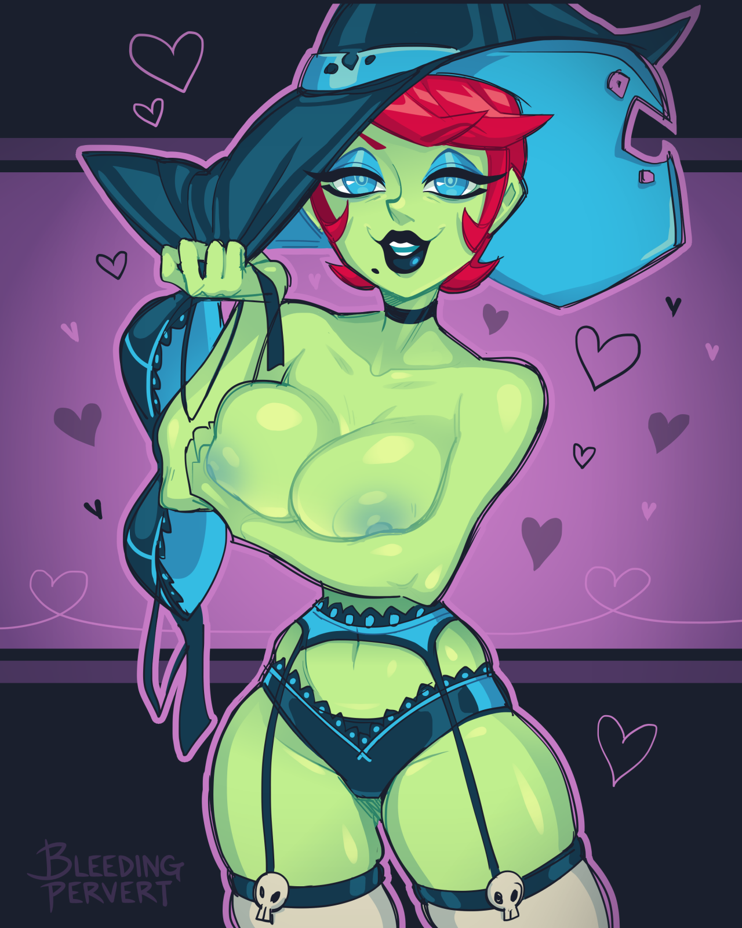

*'What do I really have to lose anyway?'*

Leaving nothing to chance and seeing no harm in it, Alex sighs deeply before nodding his head, accepting the strange woman's offer as a smile splits her thick lips, rising up to her feet once more before throwing off her cloak in dramatic fashion…

To reveal the mature body of a stunning beauty clad in indigo blue lingerie beneath, dripping with sexuality and with a healthy bounce to the twin mounds swinging in Alex's flabbergasted face as the woman pounces on top of him, unclasping the hooks on her lace bra before tossing it to the side as it vaporizes in a puff of ethereal green fire. But with a purring cougar on top of him, Alex's mind was more preoccupied on other things than magically vanishing clothing.

*What the hell had he gotten himself into?*

**"W-Woah! Lady?! M-Ma'am? Isn't this going way too fast?!"**

**"Call me Lyria dear, and like I said, we haven't a second to waste! Now hurry up and give yourself to me!"**

Shredding his worn clothes off of his slender body, Alex's uncomfortable grunts turn into panicked cries as the green flames that had consumed the Lyria's bra spark to life around the pair, casting their bodies in an eerie pale green glow, dancing among the beads of sweat adorning both their bodies. Alex, in embarrassment and fear. Lyria, in lust and anticipation.

With the supernatural fully in play before the high schoolers wide eyes and a sexy woman riding him, Alex's mind was struggling to process what was even going on right now, oblivious to Lyria raising herself off of him while muttering strange incantations in another tongue under her breath, before bringing her hands up in a display of worship before slamming herself down on Alex's member, enveloping him in her warmth with a hearty grunt.

It was an indescribable feeling, something Alex had never felt before in his short life on this world with the only thing he could think of that even stood a modicum of measure against the mind wracking pleasure he was engulfed in being the strange tingles he felt whenever he dressed up in his collection of women's wear.

**"Enjoy this moment while it lasts my dear! Follow in my stead, and soon, this pleasure you feel right now will be but a drop of what you will soon experience once the ritual is complete!"**

The boy could no longer hear Lyria's voice as his limp body continues to rock against the cool blades of grass beneath him, simply going with the flow as she gyrates her hips while continuing her chanting, encouraging the flames around them to grow like the blush on her face was, doing the heavy work as she pushes herself off of Alex before slamming down again with a wet slap.

But with each pound, something peculiar was beginning to happen to Alex's body, beginning with a green tint emanating from the erect pecker lodged within Lyria's tight folds, spreading outward from the point of impact where her firm ass landed against Alex's groin. Accompanied by the soft gurgle of shifting flesh and bubbling skin as his body begins to contort and expand, growing larger in more ways than one as body hair and callused fade under a spreading ride of creamy smooth skin as radiant and green as Lyria's were. Something she was more than happy to see as she hefts the growing young man up to stand with her with a sigh, hugging him close with his member still lodged tightly inside of her.

Standing in the fires, the most noticeable change was immediately apparent. Where Alex once had to crane his neck upwards to get a good look at Lyria, he was now standing comfortably with his face staring eye level into hers thanks to the fat and flesh that had surged downward to fill the extended frames of his legs the bones had restructured themselves into. Pumping up supple calves, plump thighs and an ass so thick and firm it could almost rival the beauty of Lyria's own were it not for their slightly less perky heft as they sag down Alex's shapely new legs, jiggling as a harsh slap from his partners hands land over the gelatinous mass.

**"Mmm~ You're almost there now…I can already see your lovely face taking shape~"**

A warm coo was all Alex could manage as his body continues to warp and bend under the intense glow of the flames around him, already drastically altered from his previous form, the word 'young man' was soon becoming an ill fitting one to describe Alex; gaining inches in height that now had him standing as an equal to Lyria in addition to a curvaceous lower half that was slowly spreading upward with gaunt hips cracking into hypnotic handlebars that swayed gently to the rhythm of Lyria's chanting and a tight navel sporting a compact layer of soft flesh and toned muscle, nothing like the hollow belly Alex once sported.

And as their hips part to reveal a slick trail of drool hanging between two plump hairless lips with a tiny trail of flesh sucking up into the slit between the former man's legs, the fate that awaited Alex was made evidently clear as her freshly formed snatch wastes no time in lubricating the ground beneath them with her wanton lust, trailing reflective drool down her lengthy legs grinding against Lyria's.

**"Mmmng…Lyria…am I-Mmmm~"**

Silencing her stutters with a loving kiss, Lyria's chant continues down Alex's throat, filling her internals with magical incantations and fire, boiling away in his throat as the tender skin above begins to take on the same like green coloration that had already consumed over half of her body, crunching shoulders inward into narrow smooth joints connected to lengthy arms tipped with delicate fingers sporting polished midnight purple shells of calcified hide. The same color her hair was beginning to take on as the shoulder length cut extends downward in a curly wave of silk, tickling her hearty derriere as Alex's spine curves inward against the orgasmic pleasure rocking her body and soul, unwilling to fight back against the changes now that they had progressed so far with her face taking on years worth of aging; inflating cracked lips pressed up against Lyria's info tantalizing cushions as cheeks fill in along with a widening set of eyes sparkling an ominous violet before taking on a mysterious purple shade matching up with the Gothic coloration the rest of her body seemed to be taking after. Not to be outdone, makeup of her own soon cakes her mature visage, adding some gloss to her fuckable lips and mystique to her sleek almonds with gentle pink eyeliner in time with a generous fringe cascading down to shroud the left side of her face with a pert pair of D cups blooming forth from her chest, pushing and rubbing against Lyria's in a battle for dominance.

*'That's it my dear, open your eyes, look upon your true self…and bask in it!'*

With Lyria's voice ringing loud and clear in her vapid mind, Alex's eyes glaze over as a soothing sensation washes over her, envisioning herself in an empty void and staring at her own reflection…not Alex…but a green skinned woman much like Lyria was…but unlike the cheeky air her appearance radiated, hers was of a more charming nature; like that of a mature minx who knew her way around life like she had total control of it. A woman who wasn't afraid, a woman of action…the woman she now knew herself to be; **Alexandra, newest member of the Witches Coven, and loyal partner to Lyria…**

And so, as the last mental image of Alex's old self reaches out to connect with her reflection, the teary eyed effeminate boy blips out of existence as his fingers grace the cool surface of the mirror, instantly subsumed by Alexandra's buxom physique now matching up with the reflection she cast into the mirror with her emotionless face taking on a ditzy smile as she eyes up her own body with the ire of lust now sparked and burning in her eyes as a hand cups a jiggly breast before squeezing hard, moaning in her sonorous new voice as a dribble of nectar leaks forth from hardened nipples, sliding down her porcelain smooth skin while her other hand drifts downward past a hairless incline to the void between her legs, it felt so liberating to have her fingers finally grace the twitching lips of her labia, so right to feel them rubbing her slick innards and so good to tweak that aching nub she could proudly call her own clit with a dexterous thumb. Unaware of Lyria performing her ministrations back in reality, still enveloped in their exciting kiss while tweaking Alexandra's nubile body with expert flicks and twists that were rewarded with animalistic moans and uncontrolled jets of precum spraying out from below.

With a final pinch and an escalating scream of pleasure, Alexandra's mind is overwhelmed by her first female orgasm, eyes rolling into the back of her skill with the whites fully exposed as the last mental changes begin, flooding her empty mind with an unrelenting assault of information, feelings and changes as an entire millennia worth of knowledge ingrains itself into her very being. From how to perform parlor tricks like conjuring clothing to casting a hex on someone to looking her best at all times in addition to a bevy of skills related to the bedroom, all of it was rapidly becoming common knowledge to the second witch standing in the embrace of the first. Knowing of her new lineage in the Coven she now belonged to with an entire generations worth of experience, lore and purpose filling her mind with a familial loyalty to her sisterhood.

By the time Lyria's lips part from her lover's with a wet pop and a bridge of sweet nectar hanging between her and Alexandra's, the liberated man no longer saw her as a stranger and something more than a sister.

***Her lover…***

But it wasn't just her perception of Lyria that had changed. Everything, from her morals down to her ambitions, all of it had been warped into something more sinister as emotions she kept bottled up inside of her weak old self came spilling forth in a vitriolic wave of anger, instantly plotting suitable means of vengeance on all that had wrong her in life. From the bullies that made fun of her identity as a transgender individual to the parents that had thrown her away like a worn out rag in place for that wretched scum she could not call a brother.

**"There there dear…there'll be time to sort things out…for now? Let's get dressed shall we? Welcome to the coven sister Alexandra~ Here, you are free to be yourself, where none will ever discriminate…and if they do? Rest assured that I will be there by your side~"**

Snapping out of her murderous stupor, the newborn witch returns her attention to her fellow kin before smiling warmly into her bright blue eyes, nodding as the curtain of fire around them fades in time to a wave rushing up their nude bodies, wrapping them up in revealing garb that left very little to the imagination with how much skin it left exposed as stockings slap firmly around Lyria's milky thighs and a bevy of serpentine tattoos manifest across Alexandra's body, ending with an elaborate witches hat of her own popping into existence atop her head.

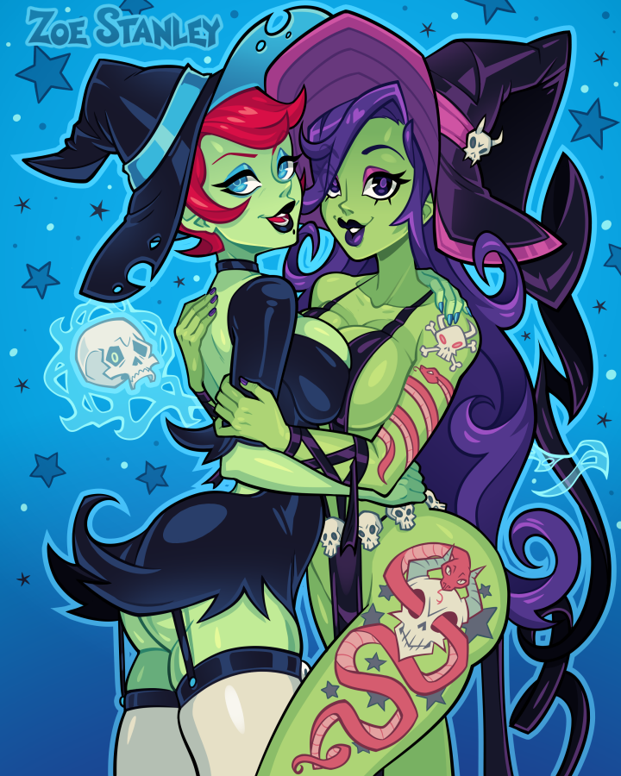

Where there once stood a boy no older than 20 and a woman old enough to his mother, there now stood two equally mature women, staring lustfully into each other's eyes with a wanton look that suggested both were raring to feel each other up, to bask in their familial warmth as lovers and to taste each and every inch of the others body. But the night was still young, and as a mischievous smile splits the raven haired cougar's face, her partner seems to get the idea, giggling salaciously as she entwines her arms around her lean shoulders into a hug.

**"Something on your mind sweet Alexandra? I see that look in your eyes~"**

**"What say we pay that miserable old household down the street Lyria dear? I've been aching for a pet, and I know just the right thing~"**

**"Oh my~ a pet hmm? I can't wait to see what you pick!"**

**"Hmmhm~ I'm sure you'll absolutely love it Lyria, let's go now, I can't wait to get back once we're done, my loins are absolutely aching right now…"**

With the two women vanishing in a plume of green fire and suffocating smoke, all that remained of the frail young man that had slept under the willow tree were the torn up shreds of his clothing left abandoned in the grass as the peaceful silence over the cool night returns once more alongside the chirping of the crickets in the foliage…

Epilogue

**"Hmm? Where…am I? Ma? Pa?"**

**"Mommy and Daddy aren't around to help you in afraid, you're all alone now little rat~"**

Awakening in a dark void, the stunned boy awakens in a shock, finding himself no longer in the safe comforts of his bedroom and instead, tied down by eerie purple chains of ethereal energy.

But something was strange, off even, about the way his body looked like in the dark. From the pale skin to stronger limbs that shouldn't have been possible to see on a boy as young as he was. Whoever it was that soft, dangerous voice belonged to had probably done something to him while he was asleep. He felt larger yet softer, powerful yet frail, scared yet-

**"Mesmerizing isn't it? That feeling within your chest…that…pleasure…you've never felt such a thing before~"**

And she was right, this thing she called 'pleasure' was slowly overtaking the fear he felt upon waking to this strange place. But looking down, the boy lets out a gasp of disbelief at what he sees; a pale set of fleshy protrusions extending from his chest, wrapped up in a shimmering layer of deathly pale skin like the one that adorned his arms, realizing he was stuck in a squatting position with a disturbing feeling of emptiness between his legs. What had happened to him? Why was he a girl now? This had to be a dream! Were the questions and excuses his mind was putting up in order to assure him that everything was alright as he continues to gape wide eyed at the nubile body of a young woman his frail, 17 year old frame had aged into, vaguely feeling the tickle of soft hair all the way down to the sagging ass she now possessed.

**"Lovely isn't it? Being a woman~ A tight, sexy girl who loves nothing more than to flaunt her body at every single turn?"**

**"B-But I…I'm a…b-bo-"**

Drowning out her whimpers in a cacophony of laughter, the voice booms out all around her as the chains binding her limbs grow tighter, forcing squeals of pain out of her as they cinch her sensitive skin and tighten around her slim, dainty neck…but it wasn't pain she was expecting to feel…

**"You? A boy? Don't lie to me dear…don't lie to yourself…would a boy make the pathetic noises of a bitch in heat? Would a boy have the body of a skank? No, no you never were a boy…you were always a girl…and you know it~"**

**"Kgh! I…"**

She couldn't even utter anything besides the arousing sounds of pleasure leaking through her salivating lips, her attempts at denying the voice's accusations only made her feel good, as if she was basking in the derogatory tone the voice seemed to address her in, that she was a girl, a bitch who would love nothing more than to be bent over and used as her owners pleased. And there was nothing she could do to deny that fact.

And as if to further the degradation and suddenness of it all, a mirror phases into existence before her, granting her a good view of the daemonic pet she had become; sporting curves in all the right places, a jiggling set of milkers tipped with gnashing teeth for nipples and a tight dripping snatch where she vaguely remembered her penis to be, no longer able to deny her fading sense of masculinity as her deep black eyes roll over in submission, gasping in a mix of disbelief and acceptance at what she had become. What she was always was; a cowardly imp chasing scraps. She no longer cared about the fact that she was no longer human in any sense of the word or that she had been rapidly aged up into a fine cocksleeve, the only thing on her mind right now was that she needed to relieve herself of the intense desire she felt to fill her shockingly empty tummy.

**"Look at yourself? What do you see? A boy?"**

**"Agh…a…bitch my lady…there is no-ahn! Boy…hungry…I need-"**

**"-What do you say if you want to ask something of another person?"**

**"P…Please…"**

**"I can't hear your whining from here pet, speak louder!"**

With an explosion of purple energy, the pale imp rises up off the floor, fighting against her restraints, relishing in their suffocating bite as a micro bikini manifests itself over her body along with skin tight leggings connected directly to tall imposing heels that were as black as her eyes were, dripping miasma down her face as her eyes roll back in submission, screaming her devotion and pleas to be fed in a jovial tone. No longer any sign of the immature, human child that gave her shape.

**"Please, my lady! I want to feed! I'm so fucking hungry!"**

**"And you may do so~ Head out and have your fill…but before the sun rises I want you home and cleaning the shelves by the time Lyria and I awaken, do you understand?"**

**"Of course my gracious lady~ Anything for you~"**

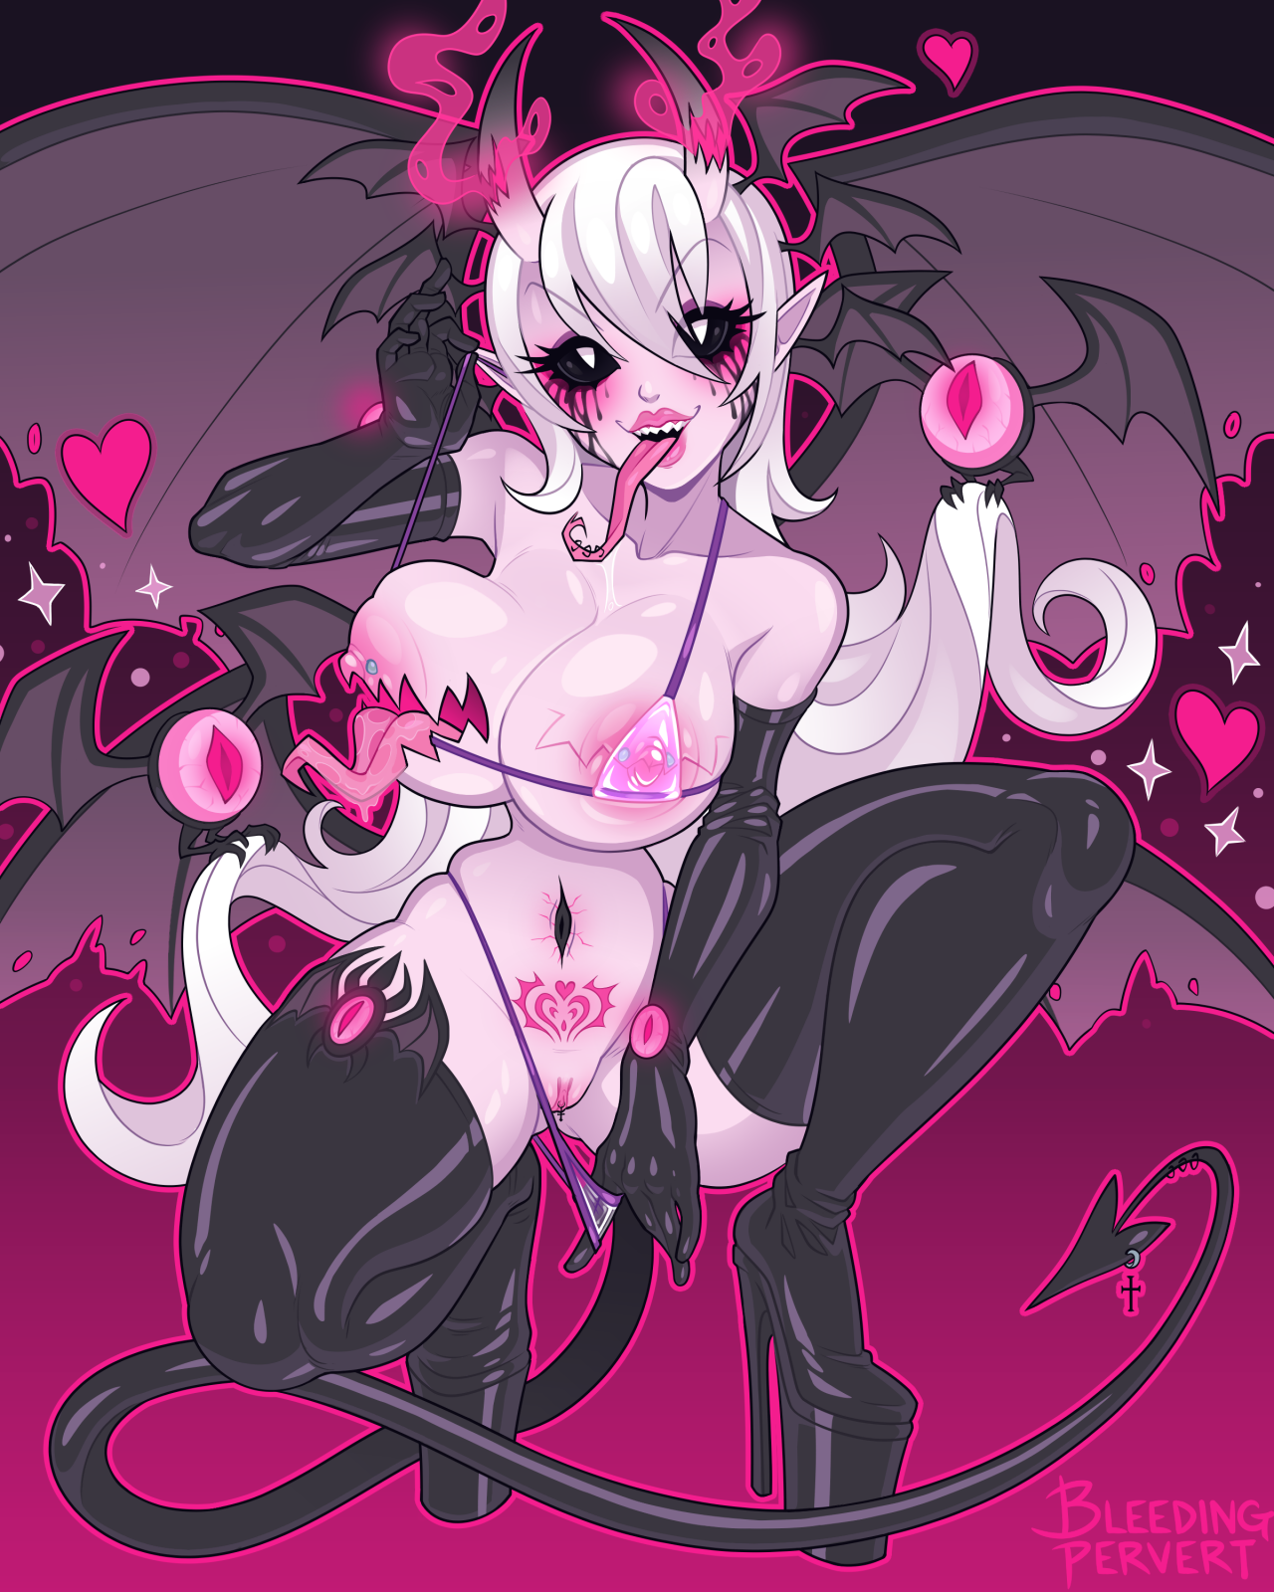

With the dimensional bubble collapsing around the daemonified human, the newborn, nameless imp rises off the sheets in an empty bedroom before raising the window and leaping out into the night without a sound, flapping her leathery wings as the pale woman soars into the night sky, heading to the still lit city off in the distance where she could already smell the stench of so many human men and the spunk they kept inside their delicious balls. How stupid of her to even think for a second she was even a man, much less a boy! Her place was down at their feet spreading her legs or clamping her succulent lips around them, not above, and she knew it now. Settling down in a deserted alleyway before taking on a human disguise, emerging from the shadows as a scantily dressed prostitute ready to have a good time.

Elsewhere in the suburbs, in a nameless locale, the two newly betrothed lovers had just finished their third round in bed together, and with plans already set in stone to spend the day tomorrow getting to know each other better, it seemed as if the romantic road ahead of Lyria and Alexandra was going to be a well paved one indeed, lying next to each other with their faces pressed closely together.

**"There we go…if she does as she's ordered…we won't need to care about cleanup from now on~"**

**"And if she doesn't? You do know imps are rarely trustworthy creatures!\***

**"Not this one I'm afraid…the rat that gave her life was grade material fit for the likes of an imp…skulking in the shadows…etcetera etcetera…shall we turn in for the night dear?"**

**"If you say so Alexandra…and yes…I think it most fitting we head to sleep…I knew it was the right thing to choose you!"**

**"And I thank you for it my love~ I wouldn't even know what to do if you hadn't decided to face me at my lowest…I love you Lyria."**

**"As do I sweety…"**

Nudging their foreheads together before shutting their eyes in unison, the two women fall asleep in each other's arms, excited for the future of the Coven and the new life they would share together.

*THE END*