HONKAI STAR RAIL: TROPE CITY
CH4: BLOODLUST
BY CHALDEACHANGE
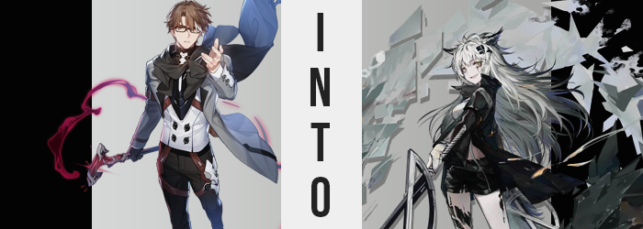

It was just your average, run of the mill day for Welt Yang.

Just himself, alone, with a good e-book that he had downloaded to his tablet, sitting alone in the passenger car of the Astral Express. He’d sip at his coffee now and again, maybe even switch it out for a tea later, but nothing all that eventful. He had lived for a terribly long time now and seen many different worlds. One of the lessons he had come away with was that there was little point in rushing anything that wasn’t an emergency and that included his time aboard the intergalactic train.

“Hm… I suppose I should get another book ready, I don’t have much left of this one.” Himeko was still in her room, Pom-Pom was off cleaning, and the rest of the Nameless were visiting Jarilo-VI to aide with some matter involving the IPC. He basically had the passenger car all to himself and so he was catching up on some reading. It was difficult to get peace and quiet when everyone was out and about.

With absolutely no personal ties to the Stellaron Hunters you might have assumed he was the furthest removed from the power that had emptied their ship elsewhere in the universe. And yet there was a singular, indirect connection. He was on the contacts list of Stelle, the Trailblazer. A contact list that also included the names of all of the Stellaron Hunters, Silver Wolf included. The effects had jumped from Silver Wolf’s phone to Stelle’s and then from Stelle’s to… Welt’s.

Well, he had his phone services connected to his tablet at the time. “What?” And so it was the screen of his tablet that had lit up instead of his phone – while he was holding it at that. Somehow the light grew so strong that it engulfed much of the car, and when it finally faded? The tablet fell to the floor. Welt was nowhere to be seen.

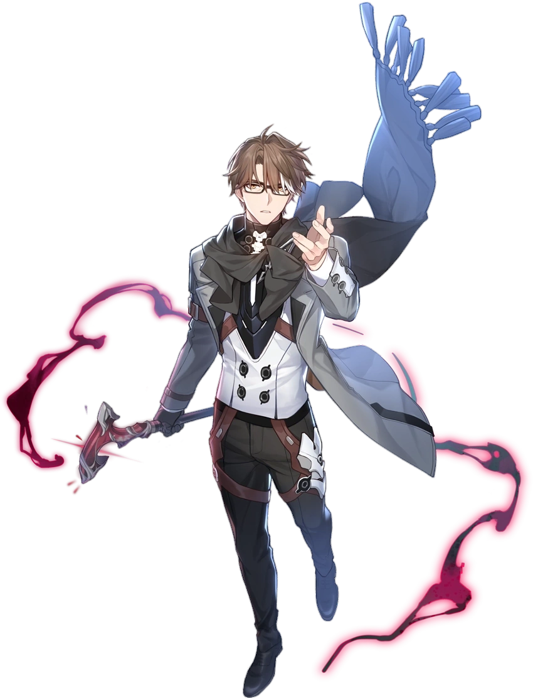
“Well this is a predicament.” The man pushed up his glasses upon the bridge of his nose once the world had come into focus around him once more. While Welt had been sitting before he was now standing. Standing in what were clearly the ruins of a city. The walls of nearby buildings had holes in them, cracks had formed in the ground from what were clearly nearby artillery impacts. It was like he had just stepped into a warzone. “And there’s gunfire nearby…” It would have been difficult for him not to hear it.

His cane didn’t appear to have made the jump to where he was either, leaving him unarmed. Not that he didn’t have other means of defending himself but this was troublesome. “I suppose I’ll need to figure out where I am and then figure out a way to contact the Astral Express.” Welt had enough experience under his belt that he didn’t panic because of the change of scenery. He’d have to table his relaxing day for another time, but…

Then again who was to say that he’d still want peace and quiet in a few minutes?

“Hm. I can’t say I feel like my situation is improving.” He had a bad feeling. There were plenty of observations he had made already that had already done as much, but something else was tugging at the back of his mind that he could quite place. Like there was some type of danger he was in that he had yet to even realize. He was, in fact, proving himself correct in this regard and didn’t notice. Because he didn’t seem to be capable of acknowledging an issue right in front of his very eyes.

The issue in question? The brown of his hair that had long since begun fading in color as he had grown older had begun to fade all on its own, losing any semblance of ordinary color as a silver was beset in the original color’s place. This became true of all of the hair on his body and, in the end, this color change wasn’t even limited to his hair alone. Golden eyes soon sparkled with silver instead, contained within lashes that appeared to be a touch longer somehow.

This silvered gaze was pointed in the direction of the gunfire as more rounds were fired off. It was odd. Welt had no reason to seek that conflict out, but something about it was making him restless. He couldn’t stop thinking about it. “No. Putting myself in harm’s way wouldn’t serve any benefit.” He had to go as far as to sternly remind himself of how little he had to gain. But that didn’t satisfy the feeling.

Making matters worse, his body was on the decline. In a sense you could say it had been on the decline at his age, but that wasn’t really the context in this case. His body was shrinking in every imaginable capacity. His height was part of this, with his arms, legs, and torso all crunching downward to peel the inches right off of his frame. It was quick, in fact, and before long he’d been reduced to a mere 5’3” after once standing at the six foot mark.

Yet Welt’s form was simultaneously narrower. Both in more predictable places like his shoulders, giving him a leaner shape, and in a place where his form shouldn’t have narrowed. Namely around his waist. For how much smaller he had become overall, you wouldn’t think that his waistline might dip in anymore excessively. But it did, giving his silhouette a shape that was pointedly effeminate, giving his body an androgynous appeal with masculinity still present in his features otherwise.

“This is pissing me off!” It was rare to hear Welt lose his cool, but really? This didn’t sound much like Welt at all. What was he even frustrated with? His oversized outfit now that he had shrunk so much? No. The fact that when he had shrunk, his body had become more youthful until he was physically in his twenties again? Nope! He was mad at himself for not giving himself permission to run to the scene of the gunshots. Why did he want to go so badly? It was eating him up inside.

The man tapped his foot, not acknowledging the feeling of shrunken toes sliding around inside oversized shoes. Feet that seemed to be a little too petite much like his hands now were. It was clear that nothing that was happening to him would elicit much of a reaction, so his silver hair growing out wildly behind him went unnoted as well – even spilling down past his ass.

Baggy pants hid that ass, but even concealed it was possible to make out the shape of his rump. Namely because it was getting bigger? Not substantially so, but the weight those cheeks gained created a pronounced and enticing bubble with gains spread to his thighs. This newfound girth pushed his hips a little wider, and those thighs rubbed passively against his dick… at first. But it seemed to be getting smaller…

It didn’t disappear just yet though. The inside of his coat gained some added padding first. Padding in the form of small yet perky tits. They burgeoned forth from his abs (as his muscles were leaner but had remained), pooling into B-cups with perky nipples that were concealed by his fit. It was around this time that his legs squirmed together at folding sensation between her thighs, signaling the end to her masculinity.

And so she had become a young woman with Welt Yang’s face, which in practice appeared very odd. “Ugh, but I just killed a bunch though! Huh…? Did I kill a bunch?” If her memories were correct then she had just slaughtered some poor saps. Now she was looking for more? Of course I am! She thought it was the most natural thing to kill now.

The woman’s lips turned up into a smirk. A rather attractive smirk thanks to thickened lips. The remaining traces of her previous identity all melted away, presenting her with a fair and feminine facial shape that bore a tired if not intense resting expression. What was perhaps most striking about her reflection was the dark scar that ran vertically across her left eye, but it was hardly the only damage upon her person. Sharp pain radiated from her thighs and the surrounding areas, for pieces of black crystal jutted out from within.

Eventually his glasses slid off her smaller nose and shattered on the road below.

An infection. One that was wholly unrelated to the beast-like growths that took shape at her transformation’s end. Such as? A bush, silver-furred tail pushed out from the gap between her coat and pants at her tailbone, and her ears slid up to her head’s top while growing a silver fur to resemble a canine’s. A wolf, most likely.

And then came the much needed costume change, repurposing the bulk of Welt Yang’s favorite costume into a black overcoat, leather shorts, boots, and a pair of blades hitched to her left hip. Clawed fingers rested on the hilts of this blades passively and she was itching to draw them.

Having some peace and quiet was the last thing on the mind of Lappland. While the strangely shaped blade had only just appeared in her hands, bloodstains decorated it from what could be assumed to be recent kills. From bodies that would have been found in a nearby alleyway if anyone bothered to check. “Hahaha! Bene! You’ll need to throw a lot more small fries like them at me if you want to even give me a challenge!”

Rather than peace, the only thing this woman could think of was violence. Her body might as well have been a weapon for killing now and she really didn’t have much else to live for. The black crystals protruding from her body were signs of the effects of a terrible disease known as Oripathy. One day that disease would claim her life. So why not live her life to the fullest doing the things she liked most? Taking the lives of others was one of those things.

Unfortunately with her current employer, Rhodes Island, she could only kill the ones they allowed her to. Or in self-defense.

“Hmm… Now what? Guess I should make my way to where all those gunshots are. Wonder how many I could kill there?” The wolf woman licked her lips and began to casually saunter off in the direction of the next conflict, her tail swishing back and forth behind her as she did so. She didn’t remember the more peaceful life she’d had before, and honestly?

As she was now she wouldn’t have even wanted it.

