Cyprus Photography Holiday

Daily Schedule – Group 2 (23hrs shoot time)

ARRIVAL DAY (2nd October): Collection from Paphos airport, check in at the villa and welcome drinks and nibbles. Free time to explore Aphrodite Hills resort and restaurants for those arriving early.

Day 1 (3rd October 2023): “Chilla de Villa “

Morning shoot at villa and pool area-to adult (1:1) (3hrs)
Photographer | Tanya | Ashley
A | 8.00-9.30 | 9.30-11.00
B | 9.30-11.00 | 11.00-12.30
C | 11.00-12.30 | 8.00-9.30
BREAK: 12.30 -13.00 LUNCH- 13.00-14.00
Salad Nicoise – breads – olives – fruit

Afternoon shoot at villa and pool area- to adult (1:2) (1hr40)
Photographer | Tanya | Ashley
A | 14.00-14.50 | 14.50-15.40
C | 14.50-15.40 | 15-40-16.30
B | 15.40-16.30 | 14.00-14.50
BREAK 16.30
Pack for pebble beach-Leave for pebble beach at 17.15

Evening shoot at Pebble beach (Golden hour: sun set 18.42)
Shoot specifics: swimwear/beachwear up to adult /nude.

Model to photographer Ratio: (1.1) and (2:1) -times are approximate (1hr)
Time | Tanya | Ashley
30 minutes | C & Zeus | B & A
30 minutes | B & A | C & Zeus
Evening Meal: Aphrodite hills – Greek cuisine - Pithari taverna


Approx shoot time 5 hrs.

Day 2 (4th October 2023): “Aphrodite Delight” (1:1) and (2:1)

Morning shoot- Sunrise at Aphrodite beach (6.43)– to adult/nude-times are approximate. (1hr)
Time | Tanya | Ashley
30 minutes | B & Zeus | B & A
30 minutes | B & A | C & Zeus
Breakfast: 8.00 – 9.00 - Full English breakfast
Break and independent time: 9.00-10.00

Mid-morning /Afternoon shoot- to adult- 10.00-13.00- Shaded shoots around villa/indoors (1:1)(2hr)
Photographer | Tanya | Ashley
A | 12.00-13.00 | 10.00-11.00
B | 11.00-12.00 | 12.00-13.00
C | 10.00-11.00 | 11.00-12.00
LUNCH: 13.00- 14.00
Greek salad, cheeses and dips -bread- fruit- sandwiches
Late Afternoon shoot: villa and low light -Aphrodite hills (1:1)-14.00-17.00-to adult(1hr)
Photographer | Duo Tanya and Ashley
A | 14.00-15.00
B | 15.00-16.00
C | 17.00-18.00
Evening shoot (Golden hour) Aphrodite beach- Sunset (18.43)
Sunset shoot – Aphrodite beach 17.15 – leave for beach (2:1 & 1:1)- to adult/nude-times are approximate.
Time | Tanya | Ashley
30 minutes | C & Zeus | B & A
30 minutes | B & A | C & Zeus

Evening meal: Aphrodite hills , Italian or Indian
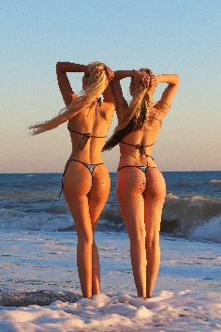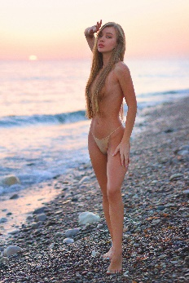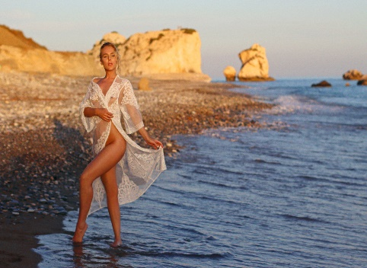

Day 3 (5th October 2023): “Ancient Kourion”

Lazy morning
Breakfast: 9.00 – 10.00– English breakfast, fruits and cereals

Morning shoot – Kourion Archaeological site- (11.00-14.00) - (2:1)- fashion & lifestyles (3hrs)
Photographer | Tanya | Ashley
A&C | 11.00-12.30 | 12.30-14.00
B&Zeus | 12.30-14.00 | 11.00-12.30
Big Lunch - 14.00- 16.00- Kourion Beach
Break- 16.00-17.00

Evening shoot: Kourion Beach-(sunset at 18.43)-golden hour – 17.00-19.00 swimwear/fashion/implied (2:1)- times are approximate. (2hrs)
Time | Tanya | Ashley
17.00-18.00 | C & Zeus | B & A
18.00- 19.00 | B & A | C & Zeus

Evening meal: Relaxed evening at villa with snacks, beer and wine

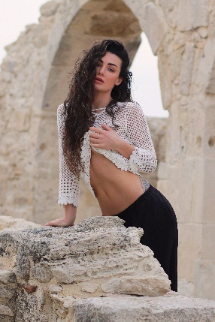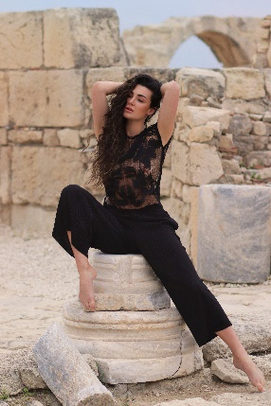

Approx. shoot time : 5hrs

Day 4 (6th October 2023): Lively Limassol

5.30 start- leave for Limassol (sunrise 6.44)

Sunrise shoot at white Stones Limassol – to nude (2:1) – to nude (1hr)
Models | 30 mins | 30mins
Tanya | A & Zeus | C & B
Ashley | C & B | A & Zeus
Breakfast in Limassol – Columbia Beach Bar and restaurant (9.00-10.00)

Mid-morning shoot – (10.00 – 13.00) Old town Limassol /harbours– Fashion and implied (2:1)(3hrs)
Models | 10.00-11.30 | 11.30-13.00
Tanya | A & B | C & Zeus
Ashley | C & Zeus | A & B

Light Lunch in Limassol (13.30-14.30) – Limassol Marina

Late afternoon shoot- Villa and pool – Open shoots to adult–1hr of your choice (1:1)plus 1 final duo (2:1) (2hrs)
Model | 16.00-17.00 | 17.00-18.00 | 18.00 to 19.00
Tanya | ? | ? | DUO C&B
Ashley | ? | ? | DUO A&Zeus

Evening meal:
Farewell barbeque, music and drinks
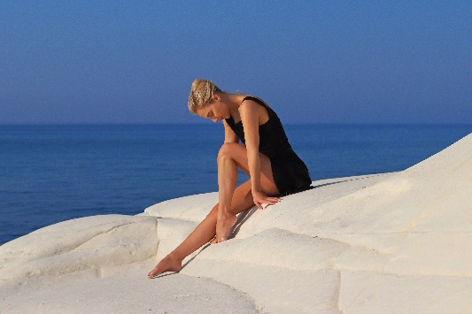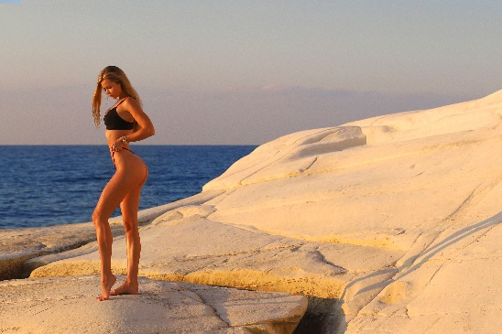

CHECK OUT (7th October 2023): breakfast, check out and drop off at Paphos airport.

Approx shoot time: 6hrs.

