NINSHIN SHITE IRU
BIWEEKLY STORY #63
BY CHALDEACHANGE
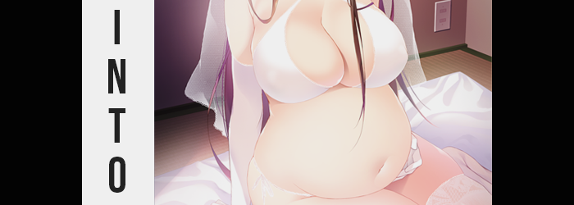

I wasn’t one to celebrate every single holiday on the calendar, much to the complaint of my family. So many of them seemed pointless; conceptualized celebrations meant to provoke the general populace to spend money on others unnecessarily. Thanksgiving, Easter, but more relevant to this incident? Mother’s Day. It wasn’t like I didn’t appreciate my mother and we were certainly on good terms, but her birthday was just so close that it became kind of unnecessary to celebrate the pair of them.

And honestly? She was fine with it. I’d never heard so much as a peep from her about it. But I’d likewise never come up on Mother’s Day with an all-powerful nekomata shoving her nose in all of my business.

Hisa. An original character of my own making brought to life. She had the power to go anywhere, do anything, transform anyone. It was a pain in the ass, and if I’d known she was going to come to life one day I certainly wouldn’t have designed her to be so overpowered. Because after all, not even I was immune to her schemes regardless of how often I tried to thwart that cat’s efforts.

“You’re not giving your mother a gift? That’s cold!” Even now she was hovering beside my computer as I worked, her child-like body dressed conservatively as per my design. Her twin cat tails flickered to and fro, my own expression twisted into disdain. I was doing my best to ignore her, but when Hisa wanted something… “You really don’t know what it’s like to experience childbirth, do you? She deserves the world from you!”

“And you do? I’m practically your mother, anyways.” A smarmy retort on my part as always, but I had a point. She knew as little about it as I did. But I quickly realized my mistake, as her eyes lit up almost immediately. “Wait.”

She didn’t wait. “My mother? I mean you designed me to be Japanese, so you couldn’t be my mom, right? Or do you want me to call you okaa-san? Hm… Hmhmhm! Actually, this might be fun!”

“Hisa.” I didn’t really know what she was planning, but I could already tell it wasn’t good. I reached up to grab her tail along with calling her name but ended up missing. Not because she’d moved, but because she wasn’t even there anymore. “Where did you…”

INSIDE OF YOU!

I could hear her voice in my head now. “What?” Before I could inquire further though, my vision began to blur. Damnit, she’d done something! I’d been sitting at my computer, but the moment my vision returned? Not only was I sitting on a bed, but the room was completely different. Plaques and pictures were hoisted up, text scrawled upon them in Japanese. Even the electrical outlet on the wall was different.

It had also been day just a moment ago, but now? It was certainly dark outside – not that I could see anything past the window from where I was sitting. “Is this Japan? What… What did you do?” My eyes narrowed at nothing in particular, my mind on high alert.

YOU SAID YOU WERE MY MOTHER, SO I’M MAKING IT SO? I WONDER WHAT IT’LL BE LIKE TO BE BORN?

“HISA!” But all I received in response was a cackling in the back of my head, one that faded out entirely. “Damnit!” Her words were enough for me to gleam exactly what she had in mind, but I already knew I was powerless to stop it. In fact, my body felt somewhat heavy, so much that I couldn’t lift my legs from how they’d buckled atop at any rate. Insurance on her part to make sure I didn’t leave, I assumed, since I could still move everything from the waist up fine enough.

I let out an accepting sigh as I felt her magic begin its work. Knowing her ways, for I was the one that created her in the first place, it wasn’t at all unexpected to feel itself running through and pressing up against my skin as if to mold it like putty. Then again, it might as well have been with how effective it was. I inhaled sharply, for example, upon feeling the energy press in on my belly. I certainly wasn’t a thin fellow, but as that pressure was applied, my rounder tummy flattened out while a similar feeling on my belly’s sides saw my waistline thin as well.

I was wearing my hoodie still, so I couldn’t really see it – but watching the front of my top deflate in real time was certainly jarring. “What’s the point?” Based on what she’d said, Hisa was planning on impregnating me anyways. Not that I didn’t appreciate her care in thinning me out. Certainly beat working out and dieting! …Maybe this wasn’t the time to try and look on the bright side?

Of course, the weight loss wasn’t limited to my belly alone. It was drawn from my face, arms, and legs, leaving me much trimmer in frame. She likely would have stolen away my muscles too – at least if I’d really had any to speak of. I did not.

With my body now thinner, what she’d probably do next was… “Yup.” I really did know her like my own daughter. My limbs and torso began to compress next, for I was typically only a couple of inches off from the six foot height range. Probably a little too atypically tall for what Hisa had in mind for me. Since I was sitting on the bed with my legs over the edge, it was difficult to tell just how much was shaved off… but it was pretty substantial in the end, and it was reflected in my posture where my feet now hung an inch off the floor.

I’m 5’3”.

Or so said my memory. How…? Had I been taller before? She was already playing with my mind, was that it? Things quickly moved along though, and I shuddered as I was greeted by a chill. “And now I’m naked.” There was no ceremony to it at all, I was just now sitting nude atop the bed. The scope of my height and weight loss were both on full display, and the extent of how androgynous my frame was already beginning to seem was apparent thanks to my pinched in waistline.

“Nnk…” While Hisa’s magic was designed to be painless, there was still some discomfort associated with it. After all, having one’s body misshaped like a toy doll wasn’t exactly a comfortable experience. In this particular instance, the magic had seized my hips and was tugging on them, forcing knees that were pointing straight against the edge of the bed to turn in towards one another. Looking down at myself, I could see a noticeable gap left between my legs as a result.

But of course, a dick was there.

“Just take it!” Evidently, she’d been planning on it. It wasn’t erect at all, but even then, I could do little but watch as it softened unnaturally and pulled inward, something in between a groan and a moan gargling up from the back of my throat as I felt what was left squirm inside of me – the lips of a pussy overlaying the orifice in its place. “Not. Comfortable.” My torso wriggled in place as I felt the effects deep within my body, reproductive organs taking shape to replace my male counterparts.

I could feel the effects of the sex change beginning to influence things I couldn’t properly perceive. “So now I’m officially a woman.” Did I sound too calm about this? Even though my voice had changed as well? Probably, but it was surprising how much stride you could take these things in once you familiar with them. Even if I wanted to panic…

Of course I’m a woman?

…Hisa had my mental state under her control as well. I forgot about my past just as quickly as I was presented with a different future. It was disorienting me, honestly. Like memories and reality were at war with one another. I closed my eyes briefly to try and cope with this, but while I did so it was my face that was remolded next.

The next my eyes were to reopen; they’d be a mix of pink and brown. Certainly not a normal, human color, but there was a reason for that. What’s more, their shapes had been stretched longer, presented with sharper angles that made me look inherently Japanese – and increasingly girlish.

The latter appeal was merely improved thanks to a jawline that both widened and softened in tandem, and as I rubbed my lips against one another? They felt much more swollen than just a moment ago. For a brief moment I even thought that I was about to sneeze, but the feeling cleared up once my nose had been repurposed in a smaller, cuter size.

Atop my head, short, brown hair soon spiralled out of control. It grew at a rapid pace, spilling to my shoulders and far down my back – tickling my ears and all of my skin as it grew. The old me kept their hair short because I found having long hair agitating, but now?

I really hate having short hair. I look prettier with it long!

Hands grazed my chest. “Next would be…” Huh? What was I saying? Why was I expecting something? No, wait? She was doing something to me, right? She was… I could picture her name and could recall her powers, but I couldn’t make sense of her intentions any longer, nor remember her name. “Ah!”

I’d only been idly touching my chest as I pondered my mental condition and the identity of this girl, but a cute, girlish gasp escaped plump lips as its sensitivity to the touch built higher. More than that, weren’t my fingers pressing into my flesh more? “Oh!” My reactions were becoming more animated, if only because my personality was being influenced now, but in this case, I was surprised to see my chest earning a certain jiggle. A pair of fat pockets had shaped themselves beneath my nipples, which were widening in kind on their own. What began as a simple pair of bumps, however, quickly inflated several sizes, their weight forcing my posture forward a little as a pair of sensitive, bouncy, C-cup breasts fully formed.

It isn’t odd for me to have breasts, is it?

This was a part of the experience I was torn on. Something told me I’d seen these breasts every day of my adult life, and the way they felt to the touch of my fingers (which had taken on a delicate manicure) just felt so new. One hand was tempted to reach between my legs and plunge into my taint, but I refrained and eventually withdrew my hands from my breasts as well.

Not yet, I need to wait.

What was I waiting for? Regardless, it wasn’t simply my chest that gained excess tissue. I could feel my seat upon the bed steadily rising, presumably because my ass was growing just as my breasts had. Rounder and more swollen my cheeks became, cushioning my posture and lifting my likes slightly as a result. Not that they were spared from this growth either, because the gap between my thighs? It began to close in upon itself. Thighs became thicker and thicker until they met in the middle, their plumpness sealing my transition into womanhood entirely.

“Am I finished?” My voice was soft, and once I spoke, I tilted my head to the side. What was finished? Why did everything feel off? Looking around, the comfort of a familiar and cute bedroom brought me ease, from the love notes written in Japanese (that I could now read) hung up on a bulletin board beside my bed, to a number of cute decorations strung up here and there. This was my home, and yet…? Why did it somehow feel foreign?

No, what about the baby?

The baby? What… “Wait! She’s… This isn’t me!” I cried out, a vague recollection suddenly overpowering the acceptance that had been guiding me thus far. I wasn’t actually a Japanese woman! I was a man! She was changing me, and I’d forgotten! She was… She was… Who?

She wanted me to be pregnant, that was all I could grasp. And unfortunately? She was about to succeed. I could already feel it, a discomfort inside of me that could only be my uterus. It was the feeling of something inside of me expanding at a dramatic rate, and my body externally began to show signs of it.

“Urk…!” My stomach churned intensely as my once flat tummy began to develop a slight bulge, the fetus within my uterus growing larger with each passing moment. Weakness and fatigue beset me, and before long I was powerless to move much of anything. If anything, my body was becoming so achy that I just wanted to fall back onto the bed. I couldn’t, though.

My belly bulge protruded farther, and I could finally see it past my breasts. “I’m really becoming pregnant!?” I certainly sounded shocked, but there was a part of me that couldn’t… stop smiling? I almost wanted to cry? What was up with my emotions? They felt like they’d been thrown into utter turmoil. Was it confusion born from the transformation… or was it simply my hormones being kicked up by the pregnancy?

Regardless, I managed to fight those tears back, even if I couldn’t stop grinning innocently as one hand gently caressed my growing bulge. The extra weight could be felt in my seat, and the springs on the bed creaked as it began to accommodate my extra girth. My belly, on the other hand, stretched farther still. This tummy began to look hard and firm, protruding a good eighteen inches out. I could feel something active inside, and it looked a little like it was about to pop.

Still, this didn’t unsettle me. Instead, I began shushing it as if it were completely natural. “It’ll be okay, little one. Just a little bit more that I need to get through…” Somehow, with what was in my belly, I felt entirely at easy. I was still… smiling. Did having a baby make me happy?

“Oh!” But I’d been so fixated on my tummy that I hadn’t even realized my breasts had been swelling all the same – at least until a little milk dribbled down my front. My C-cup breasts had been filling up, and so the skin around them was stretching until the vein-iness of my bosom was completely undeniable. Nipples stretched longer as well; plumpness accompanied by an aching pressure that felt almost like they desired release. Well, they were pretty full of milk. How close was I to being due?

Any day now, right?

By the time my breasts had finished filling, they were best likened to a pair of E’s, practically two pounds heavier compared to their old size. Goosebumps spread across both them and my belly, the effects of the pregnancy had left my aching body leaning forward, far too fatigued to pick myself up off the bed myself. “The bed is fine, right? Today is a special day after all…” It was special? How so?

As if to answer my question, I ended up clothed again. Kind of. A translucent, white veil draped across my head, I was merely wearing an elegant, white set of lingerie with matching gloves and stockings. Otherwise, my entire body was bare. I looked like I was dressed for a wedding… or like I’d gotten married earlier that day, and now it was time for…

Time to consummate my marriage with my darling, of course!

It was undeniable. I could even remember struggling to put this all on about half an hour ago. Pushing through feeling a little ill and achy from the child growing in my belly, I wasn’t about to let this night go by without honoring that tradition! On the other hand, something was still bothering me.

Memories of a girl. A girl who’d… transformed me? Could that really be true? But with this last hurrah on the part of my old self came one final tweak to my mind, seeing my language settings changed indefinitely. There was also something deep within. A power? A magic? It was hard to describe, but I felt like I was capable of much more than I once had been.

“どうして？ Why did she do this?” Fortunately, even though I was thinking in Japanese, I seemed to be bilingual and could speak English. It just took more concentration, and if I stopped thinking about it, I’d slip back into Japanese again. I cradled my bulging tummy gently, as if I completely understood the care necessary for my current circumstances. Which… appeared to be that I was very pregnant. What’s more, the bride-like outfit I’d adorned… was this my wedding day?

“え？誰のことを考えていたのですか？” Before I could tackle that particular can of worms though, I was… Who was that ‘she’ I’d mentioned before? My head was feeling so fuzzy… I felt like I was forgetting things. Like my name? Yu…zuha? Watanabe Yuzuha, wasn’t it? No, that seemed wrong! But was it?
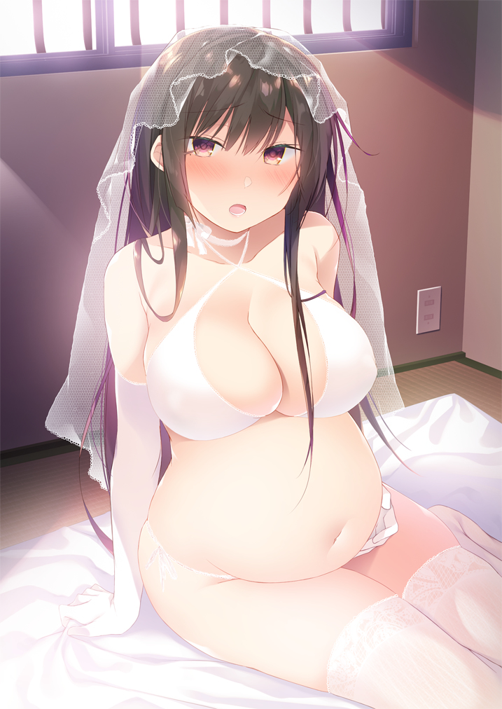
My stomach churned, pulling me away from my thoughts again. I could feel the baby kicking up against my insides. A darling little girl would soon be born, so we wanted to have the wedding before things grew too hectic. Lovingly, I caressed my tummy and began to hum a song. One my mother had taught me hundreds of years ago.

…Hundreds of years ago?

There it was again, a feeling like something was very off-base with my situation. But what did I find odd about that? We nekomata lived for hundreds, if not thousands of years! I was currently using a human disguise to live among humans, to make things easier for my partner. That was why my eyes had pink in them. But even then, my partner was also a woman. Inori… How had I become pregnant, then? Through artificial means, but we both saw the child as our own regardless.

To live the rest of my days along with my wife and child, nurturing the both of them with all my might – that was the dream I wished to see fulfilled. Some might consider it selfish, because my human standards I was a mere youkai, but Inori had accepted me anyways.

Eventually, the door to our shared bedroom swung open, and my bride stepped into the room still wearing her gown. “You look beautiful…” I cooed in Japanese but turned my gaze back down to my belly. “She kicked again while you were on the phone with your parents! I think she’s excited to be born!” My demeanor had completely shifted now, playing fully into a demure housewife and expecting mother. The things I felt like I’d forgotten? I had already forgotten that feeling. Seeing Inori just made my entire being feel at peace.

My wife sat down beside me and placed cold fingers upon my belly as well, though her free hand settled on one of my breasts to feel the beating of my own heart. “I’m sure she is, Yuzuha. With a mother as beautiful and kind as you, I’d be excited to be born as well.” She beamed, and I’m fairly certain my old heart skipped a beat. There was no doubt in my mind that once this tender moment passed that we would consummate our new marriage together, but for now? I couldn’t help but shed a few tears of happiness. Somehow, I felt as if I’d gotten everything I’d always ever wanted. “Have you thought much about a name? Your due date is next week!”

I didn’t have an immediate answer for her, but I took one of Inori’s hands in my own and continued to press the other against my swollen tummy – demonstrating the connection between the three of us. “I wasn’t completely sure until today, but a name has just been speaking to me all of a sudden. I’m not sure where I even heard it!”

“Oh?”

“Mhm! What do you think about Hisa?”

