FAE IT AIN’T SO
COMMISSION STORY
BY CHALDEACHANGE
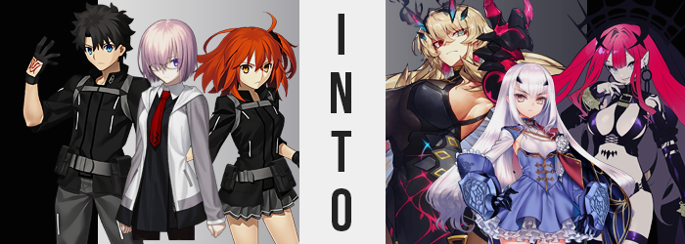

While the Lostbelt version of Morgan had made herself somewhat at home within Chaldea, there were aspects of it that she just couldn’t consider home at all. It wasn’t like she held any love for the fairies of her Britain, and yet without any around? She felt a little lost. Longing for what she loathed? Perhaps, but there was a more sensical explanation. Not every fairy in that world had been a bad person. In fact, the true nature of her Fairy Knights regardless of how they’d acted under her employ was that of three very good fairies.

But the Masters of Chaldea had not summoned her Fairy Knights. It was Morgan’s honest belief that perhaps Chaldea’s summoning system did not see them as worthy to summon. Was there a means of rectifying this situation? She could think of only one, and it might bring about some degree of chaos within this establishment.

Oh well.

“I can’t help but feel like I’ve seen this thing somewhere before. It’s kind of a strange gift to give a boy in the first place, isn’t it?” One of Chaldea’s two Masters, Gudao, had moved to the gym for training after a befuddling encounter with one of his Servants, Morgan. It had been a very brief exchange, one where she had shoved a ‘gift’ into his hand and asked him to wear it before shuffling off. It wasn’t unlike her to behave strangely, but it was actually the gift in question that struck him as oddest.

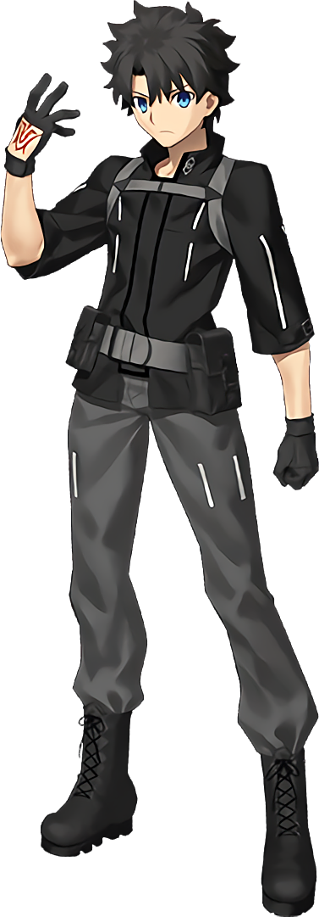
It looked like a hastily thrown together tiara of all things. A black band that was decorated with four diamond-shapes colored a mix of bright pink and sky blue. It was very effeminate – not the sort of thing he’d normally wear of his own volition. But he also felt like he’d seen those diamonds before somewhere. Of course, the boy had no reason to feel as if the item would bring him harm, so as if to entertain Morgan’s request he placed it on his head.

He immediately was met with regret.

“EUGH!? THE HELL!?” No sooner than it had been placed on his head did a crippling tension conjure from the headband itself, and yet that wasn’t nearly as painful as the sensation of the four diamonds colliding with, and into, his skull. “AAAAAH!” It was a shame that there was no one else in nor near the gym to hear him. Where pain originated, a sweltering heat soon followed while, unbeknownst to him, black flames soon radiated from what could now best be described as ‘horns’.

Gudao was at a loss though. His body had begun to burn in a way that left him immobile, and unless anyone took heed of his screams it was unlikely that anyone would find him. Was he going to die? No, something deep down assured him that this wasn’t the case. But, even so, there was no discounting just how traumatic this experience already was.

And from it, with eyes wide, it was possible to make out the colors of his irises changing. The one on the right mirrored the pink in his new horns, while the one on the left took on the same, steelier blue that was also meshed inside these growths. Accompanying them was a stark change in the structure of his face, granting him a chiseled and yet simultaneously effeminate visage that likewise benefitted from plumped lips, lengthened lashes, and thinned brows. Widened eyes suggested something dramatic all their own, for they no longer appeared Japanese. They made him appear more European than anything.

“RAAAA!” Not that Gudao himself had any idea about this. His internal heat was rising, and sweat had begun to drip from his body and soak into his clothes. While unrelated, change that had previously been focused on his face soon moved into his hair, quickly spilling messy, fluffy locks of blonde far down his back where short and dark spikes had once rested otherwise.

He’d begun to pant wildly, body lurching forward with a hand against the wall while he remained ignorant to the fact that more dramatic alterations had begun – intent on repurposing the very nature of his existence overall. After all, the lay of Gudao’s figure was bending and turning as if to present him with an undeniable effeminate silhouette to match his womanly face and long, golden hair.

“Ngh!?” Instead, the boy bellowed out an uncomfortable groan with the sides of his stomach pulling inward, and a pulling sensation on his hips inadvertently tightened the waistband of his pants around the waist in question. “What… is… happening…!?” Every word sounded more like a growl, and yet every word also bellowed out in a voice that sounded like it belonged to a mature woman rather than a young man. Teeth grit, they had even sharpened ever so slightly beyond his notice.

The girlish sway of his form became more drastic, hips pushing out the sides of his pants while the inside of his shirt felt significantly looser given a little time; brought about by his waistline dipping inwards. When it came to his hands and feet, they both became a little daintier and slenderer as well. The truth was basically unavoidable at this point, but…

As if to sign Gudao’s death warrant in that regard, soon came the fall of his greatest tree, giving way for her deepest crevice. That is, to say, she developed a pussy in the place of her cock and balls between her legs. It had been an uncomfortable feeling, but considering how her pants had tightened thanks to her widened hips, there was also some relief in the fact that she no longer possessed a dick to clamp around. Not that she even really understood what had happened in the first place, because something soon occurred that overwhelmed every single one of the woman’s senses.

RIIIIIIIIIIIIIIIIP!

It wasn’t merely a singular tear that ran out, in fact. A series of rips all over Gudao’s outfit, caused by a tension of undeniable reason. After all, how did one ignore the sight of a woman bulking up so quickly and dramatically? And, to clarify, it wasn’t ‘bulk up’ in the sense that it was limited to her muscles even though they were certainly part of it. But if it had been a muscular issue alone, it was unlikely that she would have exploded out of her clothing so fantastically.

“GAAAAAAAAH!?” Still unable to do much other than scream in agony, she remained unwilfully oblivious to everything transpiring. The heat within had reached an all-time high, and was so hot that it had burned her clothing from beneath. This had made it all the easier for cloth to tear once muscles swelled to an Amazonian state from head to toe, and once that head to toe height exploded up until she was 6’3”.

Her feminine figure quickly swelled from ‘reserved’ to ‘holy shit that’s a lot of squishy’, with the tatters of her undershirt and front jacket blown out completely by a pair of tits that were larger than her head and full of bounce – sporting nipples that were as big as her eyes. Around these tits her muscles could be seen as fit as could be, and somewhere along the line her shoulders had broadened as well.

Thickened with muscle, her waistline appeared wider than it had before, and yet this was also true of hips that finally snapped the waistband. They were incredibly broad, but hardly held a candle to the legs below that completely shredded pants and boxers alike. Each thigh became thicker than her breasts were big, muscles rippling beneath a thin layer of fat that also gave them an apparent softness. As expected, her ass could only really follow suit, with what remained of Gudao’s underwear clenched powerlessly between rock-hard ass cheeks.

She let out one finally cry of agony, and when it completed the heat just promptly faded. Or, perhaps, she instead adjusted to it. Either way, with a flash of black flame she was clothed again. Now in a skintight, black ensemble with a pair of menacing looking gauntlets.

The hulking Barghest heaved repeatedly several times once her transformation completed, body both aching and heaving at the same time from just how much her flesh had been forced to expand in every sense of the word. Now draped in proper attire, it did not at all hide that she was 6’3”, buff as hell, and bombastically figured as hell at the very same time. “Did that really just happen? I’m… I…”

Sweat dripping from her body did little to alleviate her confusion. A small part of her still recognized herself as the Master of Chaldea, and she still possessed his Command Seals. But the identity of ‘Barghest’ screamed out with dominance. The way she carried herself, the way she thought, and the name she responded to all led to the conclusion that, while Gudao was buried in there somewhere, he was not at all in control.

Or maybe he just wasn’t opposed to being a buff babe?

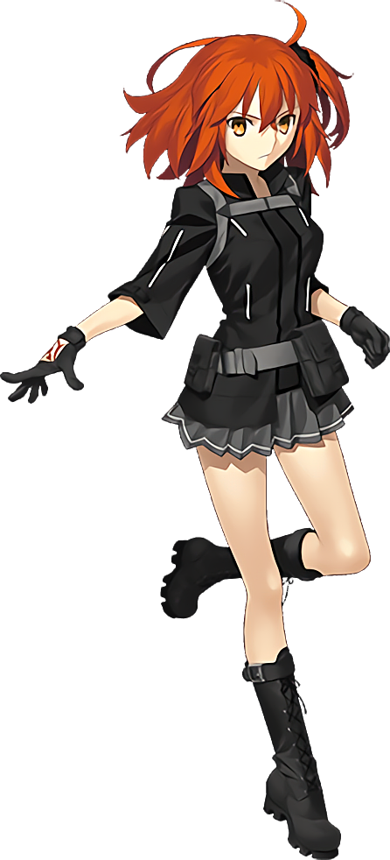
“Funny. My teef haf been feeling a little achy.” Having lifted her lips to get a good look, Gudako was in the bathroom of her personal quarters after a series of discomforts had left her questioning if maybe she was getting sick? Her mouth had felt a little sore, and she couldn’t get past a hunger that had struck her so suddenly. She’d even had a few snacks from her secret stash, and it hadn’t gone away!

The feelings had started shortly after adorning herself with an accessory Morgan had made for her and asked her to wear. You couldn’t see it since it was beneath her jacket and undershirt, but it was a stick-on of five black diamonds that she’d been told to wear above her navel. Not long after, that hunger had stirred. But she didn’t really assume they were related.

Despite the fact that she absolutely should have.

The young woman squinted at her reflection after widening her mouth to show off her teeth. “Is it just me, or are my canines a little longer? Almost like fangs?” But, really, that couldn’t be. Right? It wasn’t like she was some sort of vampire.

She squinted at her mirror again once more, too focused on her teeth to notice something was poking out from behind the bushy side locks of her hair. A pair of fleshy colored points that almost resembled the cartilage of a set of ears. No, that was exactly what they were. Her ears had grown long and pointed, just like her brand-new teeth.

“Huh? Do I have dark circles around my eyes? Maybe I really do need to sleep more…” The young woman’s eyes certainly were casting shadows, but the more she squinted at them, the more confused she was. Were those circles growing? It definitely looked like it, but she’d doubted her own eyes until they grew so big that they not only touched her nose, but the greyish tone had spread into it. “W-Wait!? Mother, what’s— Mother?”

Why, in her anxiety, had she just cried out that word!? It left her bewildered, and yet repeating in the back of her mind brought her more and more comfort. Still, it didn’t stop the grey from spreading past her nose and into the rest of her face and ears. It even moved down her neck and under her clothes, intent on dyeing her entire body in this ghastlier skin pigmentation. The only areas that were really spared in the end were her nipples and pussy, and they didn’t turn the same grey simply because they grew to an even darker shade so that they still stood out.

Shocked by her own reflect, Gudako brought a gloveless hand to cup one of her cheeks in awe. Even more awe ultimately awaited her however, for not only could she see her fingers growing longer, but the nails atop them did the same. It wasn’t just a little bit. Each nail grew several inches and appeared incredibly sharp, almost like claws. “Why…? And my ears!? This can’t be… I look a little like a monster!” The woman’s voice had certainly grown shriller, and her outburst much more dramatic than something she would have mustered before.

Glints of a dull silver shone within her irises, ultimately overtaking the yellow of them entirely as lashes flickered rapidly from shock. Those lashes lengthened, and at the same time her eyes adapted a significantly different shaping than any pure-blooded Japanese woman would certainly possess. Just as it had happened with her brother, her face was rendered looking much more Caucasian.

Not that this loss had zero gain though. In exchange for her racial features, her lengthened face and poutier lips gave her a very natural, beautiful appeal. She might as well have had a model’s face. But the face itself? She recognized it from somewhere. It took her a moment, but it was the ignition of a hot pink coloring in her orange mane that finally allowed her to remember. “I’M BECOMING BAOBHAN SITH!?”

Her voice had reached its shrillest, and the dramatics with which she cast her arms to the side in the process suggested a much brattier personality to match the identity she had just blurted out. In fact, the moment she’d done so? Gudako’s mind had immediately answered back with ‘Of course I’m Baobhan Sith! Who else would I be!?’. “No… No, no! That’s not… I’m not…!? Motheeeeeer!?” She’d done it again, crying out that title as if she was seeking reassurance. Of course, if she was believing herself to be Baobhan Sith, there was only one person that could be.

In the meantime, the hot pink had overwhelmed her head of hair entirely. Her side ponytail had come unraveled, and with newly bestowed length it all fell down far past her shoulders, fanning out around her hips by the time it reached her upper thighs. Yet, strangely, near the tips of this new length the color lightened to white. “I can’t be becoming her, but I am her? But I’m not, but… GAH!?”

All it took was the slightest bit of discomfort around her chest for Gudako to not only rip open the front of her jacket, but shred her undershirt and brassiere with her claws so that her breasts were completely bare among the tatters. Pressure had built beneath her bosom, and before her very eyes she watched grey flesh and greyer nipples swell with sensual weight that roughly doubled them in size. Slightly aroused, she gave one a quick squeeze.

“But is it really a problem though?” The Master posed this question while her skirt tightened around widened hips and the base of her jacket scraps rose from them to show off her navel. She’d grown to almost 5’7”, and it showed. Just as the fact that she appeared to be a woman in her mid-twenties showed in her face, and in how plump and enticing her thighs and rear soon became. “I’ve never really felt this confident before…”

With a finger raised to lips where a more mischievous expression was now on display, her old outfit disappeared into smoke a moment, leaving her completely naked. Her old self would have reeled at suddenly being exposed like this, but she just felt so damn proud of herself that she wouldn’t have cared if someone walked in at that moment. Not that it mattered anyways, for born from that same smoke a very revealing costume covered her instead. Leather straps that ran across and between her breasts. A leather bikini bottom. Matching, fingerless gloves. Extremely tall heels. An eerie, black veil tied to a menacing looking crown.

Okay, so maybe she was some sort of vampire. With an attractive figure that left little to the imagination and heels that looked like they could impale someone if she tried just a little bit, the woman’s fangs shone as she smiled at her reflection with unrivaled confidence. She was some sort of vampire, but not literally so. If that had been the case, she wouldn’t have been able to see her beautiful body at all!

Instead, Baobhan Sith was exactly that. A vampiric sort of fairy that consumed blood for sustenance. Like her brother before her, Gudako’s ego still remained somewhere within the new personality and memories that had surfaced, yet… It was easier to simply recognize herself as the woman that would be called ‘Fairy Knight Tristan’ in the end. A knight loyal to her mother, Morgan. A knight that had fun at the expense of the safety of others.

“Oh, where is mother anyways!? I need to thank her for her thoughtful gift!”

Much like Gudao, Mashu had suddenly found herself in the possession of a headband at Morgan’s behest. It was very simple – a black piece that wrapped under her hair in the back and poked out of the front. She hadn’t really intended on wearing it, but the Berserker had insisted she do so before leaving Mashu to her business in the otherwise empty cafeteria.

“Huh? What…? Why… won’t it come off?” Only for shock to claim her when she realized not long after the Lostbelt King’s departure that she could not pry the headband from her head. Almost like it had taken root. Surely that couldn’t have been an intended effect? For what reason would Morgan employ such an unusual accessory? It certainly didn’t make any sense!

“This is so… H-Huh!?” It took Mashu a moment to process whether or not she was seeing things, but once she’d been given that moment she came to realize that it was, in fact, the case. An undeniable and extremely unusual truth. “I’m shrinking!?” More than seeing it with the naked eye at first, it was easier to feel it in her Chaldea uniform. Her dress, her tights, and her hoodie; all of them felt very loose against her frame, of course because her stature was diminishing at an uncanny speed.

She threw her arms out to the side in hopes of stabilizing a balance that was increasingly off put, what with limbs shortening and the weight distribution of her body rapidly changing. She was growing thinner on the whole of course, but her arms and torso were standouts in just how twig-like her frame was actually becoming. ‘Childlike’ was perhaps the best descriptive adjective to use in the end.

This was no better demonstrated than with the young woman’s chest. Once, perhaps, one of her greatest charm points, the weight of Mashu’s bosom wasted no time in emptying. The front of her dress emptied, leaving only the awkwardly placed, unfilled cups of her bra to push it out in any capacity in the front. What they were limited to in the end was little more than a pair of perky A-cups, decorated with a pair of nipples that were no bigger than small coins.

“How could this be…? But haven’t I always been small? No! I’m usually… I… I’m small? Of course I’m…? ????” A back and forth had ensued with Mashu’s psyche as the battleground in question. What was truth? What was fiction? Could both be true? Could both be wrong? Her puzzled expression grew cuter and cuter, for a youthfulness claimed her facial features that not only rounder out her cheeks but made her eyes appear much bigger. What stood out was actually her eyebrows though, because they thinned and forked at the ends almost like a set of Vs.

It had only been a few moments, and yet the Demi-Servant had already dipped below 5’ and was close to bottoming out at around roughly 4’10”. Much of her body’s figure had gone the way of her breasts, what with shoulders pulling in to give her the waifish frame deserving of a younger girl. Her dress was not only at risk of falling from her shoulders, but her panties had slid down her legs and her skirt had fallen all of the way to her knees.
Comparatively, her butt and thighs? They did retain some of their meatiness. Her rear end was very perky, and her thighs were certainly thicker than any children rightfully should have been, plump and spread wide by rounded hips. This created the impression that perhaps, instead, she was barely still a teenager. Barely.

“My name is Ma… Ma… Mel…?” Mashu was still struggling with her ego, and even finding her name was no simple task with tiny fingers holding her head from rocking from side to side with confusion. The skepticism in her expression almost looked pained, and it came across in a higher voice that also felt more serious fundamentally. Surely, her cuter features hardly left her looking like Mashu any longer. The gold that sparked in her eyes had stolen her even farther from that identity.

Finally, this three-part saga entered its final stage. Marshmallow white had made its way into her mauve locks, stripping them of their color almost immediately. It didn’t take long after that for hairs to lengthen with an astounding speed and towards an astounding length, separating into a trio of chunks behind her that were soft and silky for the most part. Yet, on the other hand? Near their tips the white waned in slight, darkening to grey as the quality of hair here became extremely soft and fluffy.

And then, in a flash, the dress that hung from her frame like a series of blankets just up and disappeared – only to be replaced. Avoiding any potential indecency, she was ultimately clad in a blue, ruffled dress with a white chest portion, skin-tight in how it revealed her cup sizing. It was all bound to a collar, including the long, white sleeves that housed her pencil arms while white lace thigh highs demonstrated the thick appeal of her legs even more plainly.

The small girl blinked, certainly at a loss of what to make of her current predicament. Within the depths of her soul a voice still believed herself to be Mashu Kyrielight, and yet the name that came to the back of her throat whenever she thought to sat her name? It was Melusine. The true name of one of the Fairy Knights of the sixth Lostbelt. But that couldn’t be true! Sure, she was small, and her body was all different, and there was undeniably a powerful strength housed within, but she knew that this wasn’t who she was—

“Oi, pipsqueak! Come on, the king’s summoning us!” A familiar voice immediately prompted Melusine to drop this line of thinking immediately, and her posture perked up into a much more proper state. It had been Barghest in the cafeteria doorway, standing with a disinterested Baobhan Sith? Well, if her fellow knights were beckoning her…

All of the girl’s internal resistance faded immediately. Morgan was her king. In Aurora’s absence, it was Morgan that she should listen to. That thought alone was enough to clear her of any doubt, and so the ‘pipsqueak’ promptly moved to follow the other two knights without a second thought.

“Affirmative!”

