FATE / ALIENATION
CH2: HER OWN NEMESIS
BY CHALDEACHANGE
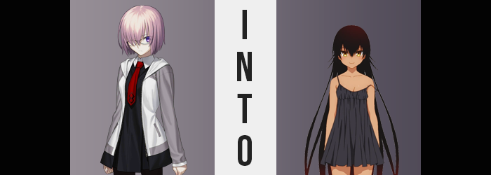

Admittedly? Mashu Kyrielight had noticed something strange about Abigail Williams recently. That girl was always doing her best to help out others, always trying to be involved and make friends with the rest of the individuals that served Chaldea. But recently she had appeared a little dejected. Like she wasn’t quite herself? Or maybe it was more like she wasn’t as happy as she usually was? Mashu wasn’t really sure what to make of it, but any attempts to ask her about it had ultimately been avoided.

Of course, the Shielder didn’t have any suspicions about the child possessing a Holy Grail. Nor that she might use it to make a wish that would potentially address the situation that ailed her. In fact, Mashu had been going on about her evening completely like normal. She’d eaten an early dinner, helped pitch in with some farming with Gudako, and then had chosen to retire for the rest of the night in her room with a good book after taking a shower.

Mashu didn’t make it to the showers, however.

“Oh?” By the time the farming missions had been completed the halls of Chaldea had already been rendered incredibly quiet. Most of the staff, or at least the ones that didn’t work the night shift, had already retired to their chambers. House rules were that Servants could only move discreetly after a certain time as well and many of them just chose to traverse in Spirit Form, accessing the facilities that were available to them at these hours.

They definitely shouldn’t have been up to no good. Which was exactly why Mashu had been given pause. She’d sensed a concentration of something in the air. Something that wasn’t as mysterious as she tried to play it off as. At its core it definitely felt like the air had become thick with mana, but… “Is that mana?” Her Servant class was more resistant to magic than the woman was adept with it. But something about the energy felt off if she was to label her concern.

“Maybe I should change course to da Vinci-chan’s workshop…?” It was definitely a wise decision, but the Demi-Servant soon realized that she was going to have a difficult time attempting to follow that through. The ‘mana’ had grown so thick in the hallway that she could perceive it. Translucent enough that she could still see through it, the air was tinted with a very dark purple that appeared to bog her down.

She was having a hard time moving her legs, much less her arms and neck. “H-Hello!? I’m in a bit of trouble here!” Her natural instinct was, of course, to cry out for help. But anyone who would have been in earshot of her to listen was likely suffering the same symptoms. Mashu was left to tough it out whether she liked it or not. But she could deal with a touch of paralyzing mana poisoning, couldn’t she? It would eventually wear off and she would be able to seek help?

The issue was that it was doing more than freezing her movements.

And the Demi-Servant wasn’t in any position to do anything about it. If she could even properly comprehend what was transpiring. Unfortunately that didn’t seem to be all that simple, especially with her full range of motion completely sapped away from her. It would have been near impossible for Mashu to make out, say, a change in her skin color.

Which was actually happening. The pale pink of the woman’s complexion had been compromised by what appeared to be freckles at first. A series of tanned spots that ran across her face, arms, chest, legs, and just about every area of her body in its entirety. While they could be mistaken for mere freckles at first, it became clear as the seconds ticked by that this wasn’t exactly the case. The spots were becoming too numerous, fusing to and overlapping with each other until her skin was a consistent tan. Strangely enough, even her nipples were turned a dark brown beneath her top.

Yet when it came to Mashu’s nipples and the tits they rested upon? The changes didn’t stop with a mere change in color. “Erm…?” Mashu could feel that something was wrong down there but she couldn’t angle her chin down to look. The best that she could guess was that her bra was loose? Her top felt baggy? “That… can’t be right.” Because she didn’t have the knowledge that her body was changing.

But it was. She was right on the money that her bra felt loose. There simply wasn’t as much mass for it to wrap around since her ample bosom was… significantly less ample. It was almost like her breasts had been deflating like a pair of balloons having the water released, skin tightening and nipples shrinking around them as they regressed all the way down to perky A-cups. A showing better designed for a girl than a young adult.

That said this wasn’t the only part of her body that was downscaled in a similar vein early on. While she was paralyzed, Mashu could still feel what felt like her legs sliding closer together? Something that could only be made possible because her hips were narrowing. This probably should have been impossible with so much abundance to her thighs and ass… if that abundance had persisted, anyways. The narrower her hips became, the more deflated the surrounding area became in kind. Thighs and butt thinned and flattened until they retained some definition, but were considerably lacking compared to their prior state.

“I… something is wrong with my body?” Even saying it, voice cracks and all, the woman felt unsure? She had every reason to believe that her body’s size had changed and yet… and yet… a voice deep down reassured her that nothing had been altered. And if it had? It was better now, so she didn’t need to worry about it. She shouldn’t worry about it. And little by little Mashu was beginning to agree with that sentiment.

The glasses slid off of Mashu’s face and she hardly blinked at this fact, their loss prompted by changes to her facial structure that, along with her previous melanin level inflation, appeared to suggest a different ethnicity for the woman. Her nose was smaller and shorter, her lips wider but smaller, and her eyes more expressive – now showing off irises that glinted with gold instead of their usual purple. Aside from ethnically different though, there was a soft youthfulness that played with it all. Almost more fitting for her shrunken chest and rear.

As she changed more and more, it felt more and more correct. The sensation of her hair, once a short bob, now tickling the base of her neck and flowing farther down her back wasn’t registered as strange. It fanned out, continuing to grow until it reached her ankles. But the soft violet color of her locks were weaved with a darkness that dyed them all a brown so dark that the coloration bordered black. This applied to her eyebrows and it would have applied to her pubes if not for the fact she had been shaved all of a sudden.

It was a step that had simply prepared her for her final physical change. Her figure had already diminished, and so she had appeared lanky as a result of the rest of her body not following suit. Well now it did, with Mashu’s height collapsing in on itself so that her attire became baggy upon her frame in a way that should have felt heavy, with arms swallowed by her sleeves and her flesh compressing in a way that made her thighs and bum look fuller now that she wasn’t as tall.

Her tights had bunched up, her sweater was falling off, her shoes were much too big, and her dress skirt reached down to her feet. “I’m tiny!” Or had she always been tiny? Regardless she didn’t appear much older than twelve physically, but deep down she knew the truth about her body. That it wasn’t limited to her form. This form just felt comfortable? It felt right.

The weight of her clothes didn’t bother her at all, ultimately. The young girl in fact felt stronger than she had ever been, even with her height having dropped down to a mere 4’8”. She still felt more powerful than a human even as a child, and if she changed her body to capitalize on that strength? Then she could be unstoppable. Because she wasn’t a denizen of this planet.

Because she was a creation from beyond the stars.

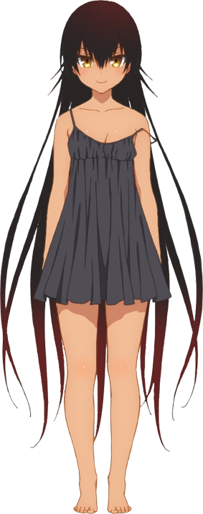
“Hehehe! I feel so strong! So free!” There had been a vague fretting about her condition throughout her transformation that had slowly dwindled, but now that it was complete? Nemesis seemed to care very little about the fact that she had just transformed. In fact? She appeared to revel in it, giggling in a way that felt a touch… unstable. In many ways she had been fashioned to be the perfect playmate for Abigail, or at least her naughtier side, with Nemesis being a small-bodied girl with a penchant for mischief. “Oh, but this outfit!”

Clapping her hands, Mashu’s old dress appeared to slither and shrink around her, ultimately becoming a black nightgown that she could wear freely. The girl possessed the ability to transform her body, hair, voice, and even clothing as she saw fit! So was this really a problem? Technically she could have changed right back. But Nemesis liked this body of hers. She could recall being Mashu but there was no desire to be Mashu again. This body was way better! Less stuffy too!

“Now what should I dooo…? Hm, I wonder if there’s anyone I could tease around here?” Someone as teasable as Yuuki Rito? It felt impossible, but the alien biological weapon hadn’t abandoned hope just yet. There were other avenues she could pursue! “I suppose I could just visit the girl who summoned me. Abigail, right? I bet she’s funny!”

