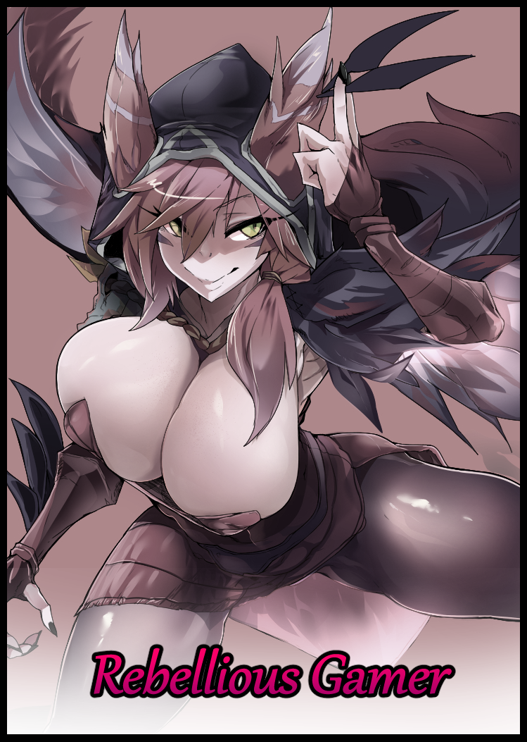

**"Jesus Christ man, who the hell did you piss off this time?! There's a fucking glitter bomb in the mail!"**

Ignoring the incessant yelling leaking in from beyond the locked oak wood door barring entry, a lonely individual sits nestled away in the darkness of his isolated den. Lax fingers slowly moving across his keyboard without stopping for a second, beady eyes fixated on the bright computer display in front of him, too busy playing to care about the bad-mouthing going on outside, much to the dismay of the man grumbling under his breath in the living room as he struggles to clean up the mess left behind by the faux Amazon delivery that had exploded into a glittery cloud of dust and shimmering plastic upon setting it down on the table.

**"Seriously…this shit's gotta stop…no more chances…"**

Tossing aside the used rag in his hands, the irate man stomps over toward his phone lying forgotten on the couch, snatching it off the leathery surface as dexterous fingers moved open a strange application that looked like a simple manager to link with another compatible device…except this seemingly innocuous app hid incredible abilities behind an ordinary facade. And today, its creator had a grand purpose in mind for it as he linked his phone to the only other desktop in the house besides the one stashed away in the living room.

Not even a second later, and he was immediately greeted by the sight of a live feed taken straight from the computer he had discreetly hacked into, watching what that reclusive bum was using it for with unsurprising fury burning in his narrowed eyes.

But like he had insinuated earlier, today was the last straw. Chances had been given and spent, and now it was clear that if he wasn't going to fix his behavior despite being warned time and time again, then he would have no choice but to take things into his own hands.

And with this application, he had the means to dole out punishment *and* force him to make amends for his atrocious habits. An admittedly risky act he didn't want to resort to without reason…but after sending him for counseling, scolding him, trying to warm up to him…he knew it had to be done lest he go crazy with one useless housemate who was starting to become a pain on his ass despite their decorated history together. Sighing in disappointment as his eyes gravitate instinctively toward the framed photo displayed beneath the television upon the remembrance of a memory from long ago, before they became the distant strangers living under the same roof. That memory was about a decade old now, but in it, both he and his problem housemate were at the top of the world. Living their lives like kings, making a living through the playing of a certain game that to this day, remains relevant and popular all around the world despite its place in the MOBA genre of games. Small in number but supported by massive fan bases with a stigma for toxicity.

To cut a long story short; they had been young and stupid. Making the choice to enter into the E-Sports scene, only to fizzle out in a few years after they made their splashing debut. Not because of a lack of interest or burnout but a far more scandalous issue relating to a member of their team using illegal software and modifications to cheat…

While George had seen enough sense to move on and try to redo the lost years of his life now that he was on his own in an adult world, Kevin hadn't. Still desperately trying to prove himself capable in League to no avail. No other team would even consider taking them on now that their names were besmirched, but still he would throw himself against the metaphorical wall of denial, again and again. Trapping himself inside the stuffiest room in the cheap rental flat and only ever leaving for a bath or to keep himself fed.

Until it started to affect George's livelihood. Since the two lived together, anything Kevin involved himself would inevitably affect his roommate. And when Kevin was in an online lobby, George knew more than anyone else how annoying he could be sometimes.

Now that he was in such a despondent state, the man was a literal embodiment of someone with nothing left to lose. Provoking fights by insulting others in the chat throwing games if his brooding mind judged his team inadequate for a win, even going so far as to turn what should've been simple rounds of casual fun into chaotic sweatfests where no one came out happy. Anger would invite toxicity, and in the field of MOBA, that was a surefire recipe for a mind boggling hellhole no one in their right mind would willingly involve themselves in…unless of course, they relished in the vile act of stirring up unnecessary trouble.

Unable to help himself, Kevin had doubled down on his bad habit after falling from grace, starting feuds that grew so bad, the people he chose to anger were spiteful enough to track him down. While some were satisfied with spamming his personal cell with vitriolic messages and calls, others went a step further…and because George was usually the one to answer the door and check the mailbox, he'd been the one to suffer the brunt of pranks meant for Kevin.

Nonexistent orders that needed to be paid for, incessant calls to the house phone, rotten packages containing unmentionable items and now; a glitter bomb. It had to stop before either of them got hurt…and to stop a problem, George knew he had to nip it at the bus. Plus, there was also the prospect of admitting late into college to consider and prepare for. Unnecessary distractions like these could not be allowed to distract him. So busy to the point where he’d forgotten something he used to look forward to every year set for the very next day.

*'And if this really works…I wanna go with someone I know like the back of my hand, and I can't think of anyone else I'd have by my side~'*

No stranger to his wilder side and even more versed with the lore side of things when it came to that particular game he once played, George's idea for the application had been set in stone for quite awhile now after feeling the longing every man his age would've felt in one way or another; the innate desire for a significant other…and as his eyes return to the screen of his phone, the mischievous deviant knew exactly what to base his wanton lust on as he zeroes in on the low polygon representation of the young woman he'd soon make real, setting to work like a madman as his thumbs fly across the screen. Inputting values, setting parameters, modifying text in a long line of word vomit until he was finally ready to hit the big red button that would initiate whatever it was he had in mind to help 'reform' Kevin.

**"Sorry bud…but I can't have you banging your head till something worse than messy glitter happens…to me or you…"**

With a final apologetic nod towards the photo frame, George's thumb falls over the red circle, causing a noticeable spike in temperature as his meager hardware works overtime to send unknowable energies zipping through the air, phasing past solid walls and doors until it hits Kevin's desktop, causing a reaction that ends with a static burst up through the hand gripped tightly over the mouse wired straight to the bugged computer. All in a split second with barely any noticeable changes…for now, at least.

Because even its creator had no concrete evidence that it would even work. He'd resorted to techniques ranging from logical science to megalomaniacal magics the likes of which would be enough to make George sound like an idiot for believing in them…but after everything he'd done to try and help a man who didn't want to help himself…the least he could do was give it a try before the worst case scenario; striking it out on his own and leaving Kevin to his own devices.

But despite his bullish, self centered personality. Despite the repeated grievances he'd wrought upon him. George just couldn't bring himself to abandon his friend, not after years of being close enough to feel like the younger, asshole of a brother he never had. So after coming across some bogus rumor that were basically the instructions toward the creation of a mobile app that could 'turn your target into the object of your desires'...the admittedly dim witted man had simply shrugged his shoulders before following along since he had nothing else to go on.

Whether or not George was fully aware of the consequences behind the decision he'd made was a mute point at this stage of the proceedings, because while he watched for signs of disturbance in the gameplay being streamed through the screen of his phone, Kevin was already starting to fall under the effects of whatever it was his friend had unleashed upon him. Starting with the hands that rattled the keyboard and tortured the mouse as they began to lengthen, slimming into dainty digits tipped with polished claws grown from the unkempt nails they had subsumed in their wake, dyeing themselves a moody ebony from the flesh itself as the dark color spreads in veins until pale, cracked pink was no longer visible. Producing a notable shift in tone once his lengthened nails begin to crash and scrape against the keyboard instead of the soft tips of his fingers.

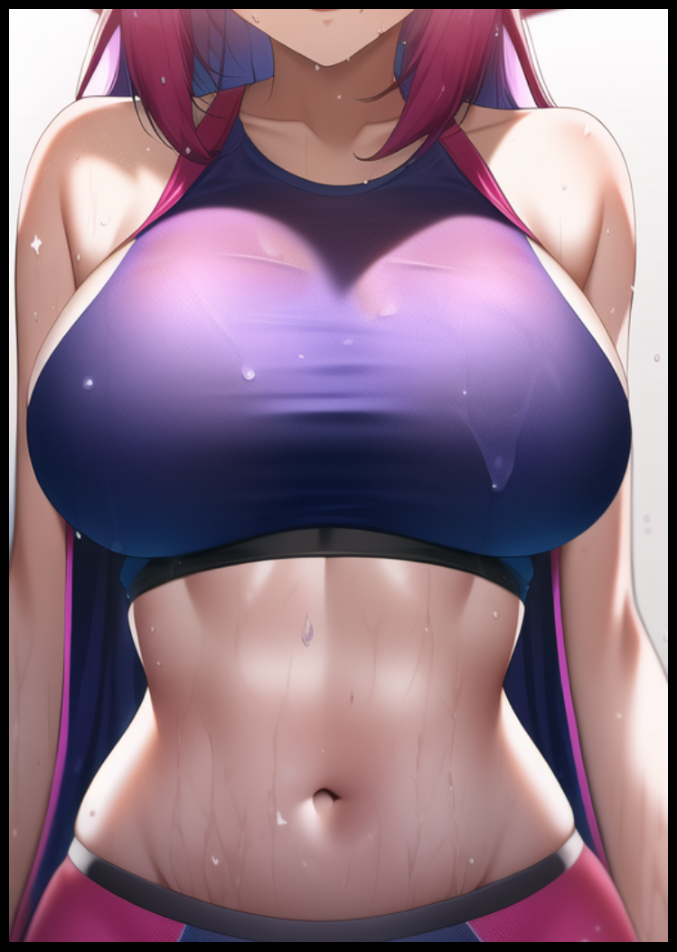

From there, the changes only seemed to progress at a hastened speed as a visible line of hairless hide painted in the colors of untouched marble bleeds from his wrists all the way up and over his forearms before converging on his shoulders like a pair of fitting gloves. Except everything it touched begins to bubble and shift, forcing obese limbs to reform, taking on slender, lithe shapes to fit the dexterous hands that were moving faster than ever before, increasing reaction timing as the focused gamer continues to slay digital Minions by the handful alongside player controlled characters thinking him an easy target to go after.

By the time he'd cleared a small horde of the oddly adorable misshapen monsters, Kevin's once flabby arms had become lean and curvy, lined with ample layers of muscle that leant well to his complexion, adding depth and tone alongside the supple pudge of baby fat giving the finished ensemble as soft, rosy exterior masking awe inspiring strength behind it. Connected to compact shoulders that had snapped inward to provide an overall smaller silhouette, leading to a core that wa likewise beginning to tighten in certain areas like the navel while extruding outwards like a can of beans being crushed by an invisible force, producing an oddly alluring sight once what were undeniably breasts began to sag forth before plumping up into pert pears tipped with areola and nipples tingling with activity as Kevin's biology begins to succumb, triggering inert glands that waste no time in producing something no man should ever be able to do without outside stimuli as the shifting fabric of his tank top stains with sweet smelling fluid excreted from the burgeoning bosom tenting his top. Worsened from the way his spine was curving; inward near the middle, outwards at the top and bottom, producing a permanent S-shaped posture that resulted in the man unintentionally bringing focus to his feminine bits. Including a heart shaped ass whose pearly skin was already brushing up against the leathery seat of the chair he rested those amazing peaches on, growing far too large for the boxers that could no longer contain them.

And down between increasingly fattening thighs, the struggling bulge of Kevin's pecker was beginning to grow increasingly small, shrinking every few seconds while the rest of his body continued to change, brushing aside a tuft of dull magenta hair framing the sleek contours of a shapely visage that was well on its way toward ditching what remained of Kevin's visual identity.

**"Damn hair…need to get a haircut or something after this…totally gets in the way…"**

Muttering in an uncharacteristically higher voice that was beginning to radiate a sultry air while shaking off yet more silken strands hanging down to invade his vision, Kevin's efforts only manage to make the newly added muscles over his shoulders sting as they scream in protest against the massive weight of his double D sized boobs swinging wildly to the momentum, barely supported by the dark purple tank top that had overtaken his inadequate singlet, exposing smooth skin glistening with beads of sweat from the exertion of his bodily affliction, fresh musculature pulsating like rising landmasses beneath a tightened tummy that was the centerpiece for an hourglass figure to take shape from. Forming sizable hips perfect for one to grab ahold of before cinching inward for a lean waistline a man could easily slide his arms around, all while lustrous hair continues to fall down Kevin's back in a dark purple-pink curtain atop a face that was clearly that of a foreign beauty revealed after shedding the mask that was the blemished face of a depressed American man. Trading gaunt eyes for bewitching slits inlaid with lime green gemstones, flanking a cute nose line before ending off with succulent suckers painted a bright pink that went well with the creamy vanilla surrounding it. A definitive seal of approval for the man's irreversible transition from male to female once the remnants of Kevin's penis finally gives in, slotting itself neatly into a freshly formed blanket of moist flesh set above a puckered hole that couldn't help but release a tiny driblet of transparent fluid, moisturizing the chubby folds of a woman's labia. Defenseless gates that barred entry to an untouched virgin tunnel that could only be filled by one man. A passing memory in the newborn woman's brain that had her biting her lower lips in wanton lust in an effort to focus her thoughts on the game…not her ***~~housemate~~*** boyfriend…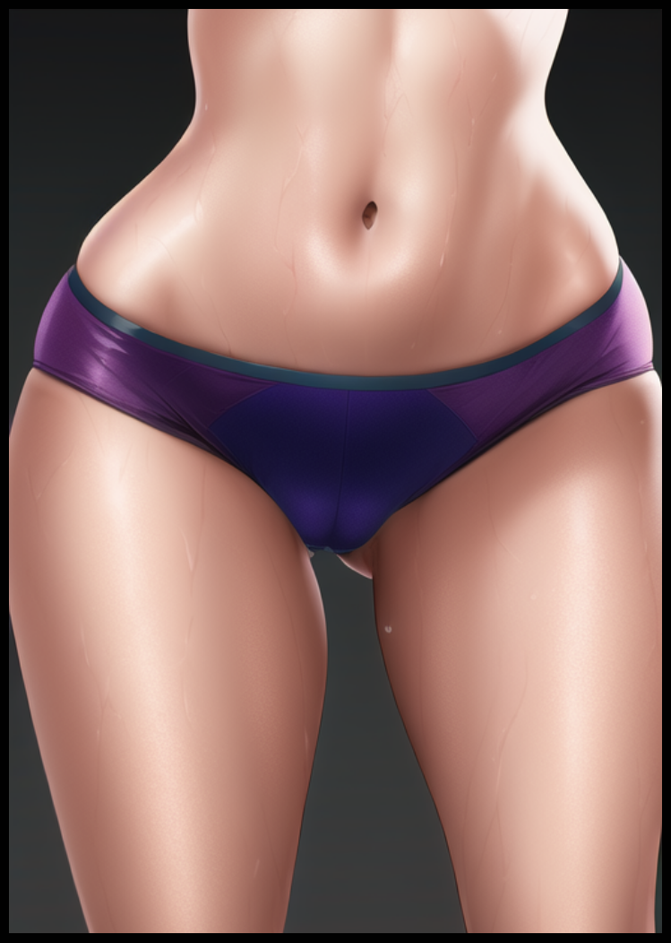

Fidgeting in her seat while rubbing her thighs together now that her boxers had finished conforming to the physical features of it's altered wearer in the form of skintight, rubbery panties that did little to hide the growing spot originating from a visibly throbbing cameltoe, Kevin was beginning to make mistakes in her play, slipping on button presses and missing enemy advancements she should've been able to predict and counter…if she ***~~wasn't so angry all the time~~*** goddamn horny of course.

**"Damn it, why can't I stop thinking about that** *~~nosey asshole~~* **deliciously handsome hunk all of a sudden? Wait…that's not…what I was gonna say…was it?"**

With her thoughts beginning to muddy themselves with the old and new, her teammates idle encouragement dies away once their ace player loses her steam, struggling to keep herself focused and level headed despite her head beginning to pound and ache, as if there was a miniature drummer band performing their greatest hits inside of her tingling brain, stimulating nerves while firing up synapses in rhythmic pulses that slowly but surely begin to rewrite her memories of a life lived as Kevin, the former E-Sports star who didn't know to exit stage left with grace until it was too late.

Instead of the rowdy life of a young boy, Kevin…or rather, ***Kayla***, in accordance to what her rewritten memories told her had always been the name given to her by her mother upon the moment of her birth, remembered living like a pampered princess as the sole child of the family. A song she would sing without change until her early years in middle school where her outlandish behavior in preschool would mellow and round out, losing the parts that made her an insufferable pain but retaining enough pomp and confidence that made her gel well with the right folk.

And by the time for highschool rolled around, Kayla had become a popular figure in the student body in stark contrast to the rather plain and nerdy youngster in a distant life long lived and forgotten as the pleasant wave of positive memories and emotions stemming from Kayla easily washes away the spiteful and bitter persona of Kevin, gathering up the scattered residuals to reformat and incorporate into the new whole that was the woman whose exciting life was slightly more different than the one George remembered, only realizing something was wrong when the gameplay on his phone had come to a halt, as if the player had abruptly left their seat to do something else. Unaware that his estranged friend…wasn't quite so distant anymore as his adrenaline fueled brain masks the faint humming of a husky maiden coming from behind the door he hasn't seen open in a long time.

But before he could do anything, a sudden text notification from his mother of all people snags his attention further away. He remembered his parents cutting off all contact after he had vehemently denied their wishes for him to further his studies, tagging along with Kevin to take their first steps into a doomed future. Surely they hadn't thought to draw him back into the fold after all this time, could they?

**"No way…it can't be coincidental…wait…*'how are you doing…hope studies aren't proving hard’?*"**

Scrolling up past that initial shocking revelation, George was stunned to suddenly find a veritable history of chat messages of constant greetings attached to updates sent back and forth between him and his mom. And it wasn't just her. His father, new faces he'd never seen before that sounded like the names of professors he thankfully didn't seem too familiar with if the messages were anything to go by. And at the top of the list, below a very implicating message sent by his mother, was another name that was both foreign and familiar to him at the same time…

While George struggled to get a grip on reality, Kayla busies herself in the privacy of her room, a room that had cleansed itself of garbage and pests, refurbished in the colors of what one would expect from a massive nerd like herself, tinted with effeminate highlights of course. Bright wallpaper, boy band posters dotting the wall amidst the many video game related paraphernalia and most glaring of all; a wardrobe laden with outfits ranging from normal house wear like a singlet or a blouse to eccentric outfits that were styled after famous characters from across the field of entertainment media.

Drying her sweaty body off with a towel before sauntering over to said wardrobe with the game behind her all but forgotten, Kayla's hands gravitate toward a feathery outfit that matched her hair in color, slipping it on without trouble as if she'd done so many times before. A fact cemented permanently into her magically addled brain as memories of attending cosplay events despite her boyfriend's protestations came to mind. It wasn't as if the outfit itself was scandalous, far from it.

If anything could be considered 'scandalous', it would be the wearer herself. Delighting in that fact as she clasps shut the straps holding the cowling of the hood together, leaving a spacious curtain for her immense cleavage to show through, naughty bits barely hidden by twin flaps of altered fabric she had adjusted after the original had ripped in two during tests to see if it could safely contain the unsupportive weight of her immense bust.

Shimmering leggings emphasized the girth and thickness of her sturdy legs. Fluffy accessories modeled after bird-like extensions like ears came into play, drawing the eyes toward the thirsty face of a young vixen applying makeup in the style of whisker like slashes under her enchanting eyes, smacking her lips while doing a once over in the mirror, feeling more alive than she ever had before. Cooing in delight from the feel of her shoulder length armwear biting down around the hypersensitive skin near the rounded edges of her shoulders, shivering in unbridled lust as her libido continues to climb to a level she'd never seen before, furrowing her brow in confusion as she wondered why she was even putting on her Xayah cosplay outfit in the first place despite going through the motions so naturally for the past few minutes or so. She'd been playing League so hard to the point she'd managed to work up a sweat while seated, only to abandon it…but for what? Kayla's foggy mind could not recall a thing.

Until it all comes back to her. Hitting her like a truck as the significance of this particular Sunday registers itself in her head upon the clock striking midnight. Giggling with a ditzy smile on her vapid face, natural eyes of intoxicating sulfur burning with salacious intent upon the reminder of what it was she had planned to gift George for his birthday while she continues to lather her promiscuous form in cosplay attire. Knowing the game was as good as won even without her presence on the field, an act that served as an unconscious submission on her part. A sign that Kevin had been fully assimilated into Kayla's psyche, becoming a confident woman who wouldn't hesitate to lend her efforts in supporting her best friend in more ways than one instead of the broken shell of a self centered man who didn't much care about the harm he was bringing to George and himself…not like it mattered anymore.

And so, while Kayla finished putting on the finishing touches to her erotic getup, George would be just about done with his own conundrum, panting for a breath of fresh air after that mind boggling explosion of new information that had stuffed itself inside his head without warning. One moment he'd been struggling to comprehend the implications behind his mother's message about 'finally doing it with his girlfriend' before it all came crashing down like a flaming meteor, enlightening him to so many years worth of new knowledge that was basically an alerted rendition of his current life…except Kevin never existed, replaced by Kayla, a bubbly girl he'd met in highschool before becoming an item through the same medium that got him and Kevin together.

In yet another unexpected change in direction, the pair never set foot in the E-Sports scene. Side stepping that entirely for a few years worth of part time work and study before finally entering university, a step ahead of what he had in mind for college. As a result, both their families remained intact…but their relationship as simple friends had spiraled out of control, turning into what he'd hoped it to be…but not in the way he had expected it would when setting the parameters of the outcome for the application to work towards. He thought it would simply alter Kevin right then and there, not rewrite the entirety of reality of itself to make that fact fit…and according to this new life of theirs, Kayla was a renowned cosplayer in addition to her skills as a grade A gamer…which meant-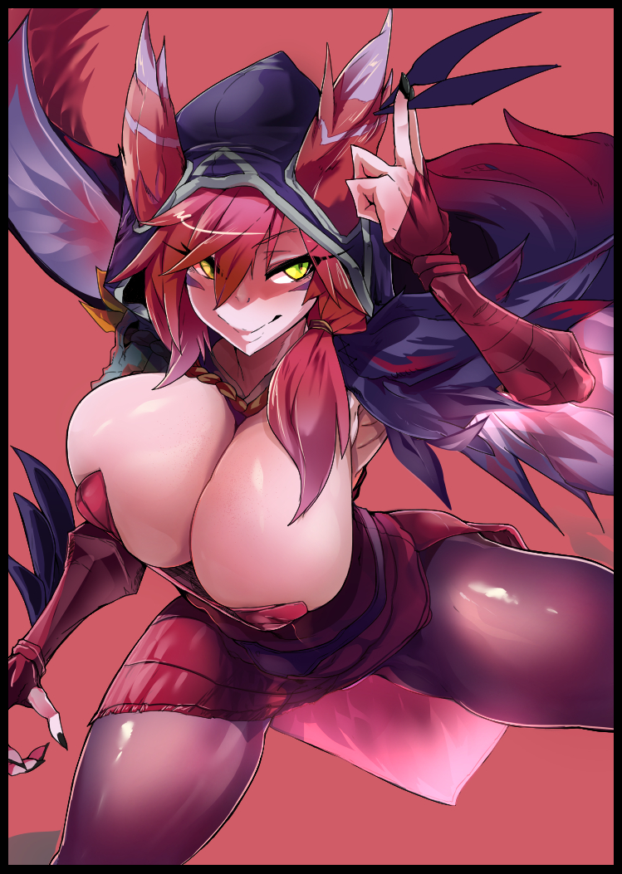

**"George? Could you come in for a sec? I need a lil help with something~"**

**"W-What the…o-oh shit, I-I'm coming!"**

Tossing his phone to the side upon hearing the eerily similar imitation of the character he loved, George Rosie's shakily to his feet, struggling to keep his breathing steady as he approaches the door to Kayla's room…pursing his lips like a SWAT agent preparing to breach before twisting the knob of the door…

Only to be pulled inside by surprisingly strong hands, getting a strong whiff of heavenly perfume and soothing scents before landing on his back on the soft sheets of a well kept bed, knocking the air out of him as another heavy weight, descending from above this time, crashes down on his waist, preventing him from moving anything besides his arms and neck, looking up into the hypnotic eyes of what should've been his friend…except all he could see was a sexed up version of Xayah from League, blushing furiously with her heated pussy pressing against the soaked fabric of her rubbery panties rubbing up against his equally eager manhood kissing them through his jeans in return, almost forgetting the fact that this stupidly sexy babe had once been his portly friend with a vile mouth…except that part of Kevin seemed to stick in some form upon hearing the words that slipped free of Kayla's vulgar lips.

**"My, my! Isn't *someone* eager tonight? You weren't jerking off already were you? Happy Birthday George! Like your present?"**

**“H-Happy…birthday?”**

**“Duh! I knew you’d forget…so…I made a lil effort, dolled myself up to look like Xayah’s spitting body double so I make sure you put in your very best effort to make my…no, *our* first time fucking a-ma-zing…"**

George was at a complete loss for words against Kayla's dominating presence. Her intentions were obvious but the manner with which she conducted herself held with it a level of mystique, an unpredictable woman he could never anticipate. She was everything he could ever hope to look for in a soulmate, and that was something he could only hope Kevin would forgive him for…this truly was for the better after all…even if he was about to sleep with his former gamer buddy, and that was a fact, not something up for debate.

Because in their relationship, he could remember going out on dates, sharing a romantic moment or two, studying together. All the traits that defined a loving couple…except for one critical thing; they hadn't taken the next step yet, and that was something the two of them now shared in agreement on as George's lax hands move to scour her hips, letting Kayla ravish his face while he undresses her lower half, pulling down her crumpled underwear to reveal a clean shaven vagina drooling all over the front of his jeans, gyrating her hips in a slow, purposeful manner to grant her aching clit some reprieve before the inevitable as he coils his tongue around hers, nibbling on it whenever he could when he realized it made Kayla moan in the sweetest voice he'd ever heard.

It wasn't perfect…but this was more than he could've asked for to set not just his life, but that of his best friend as well, back on track.

**"Kayla?"**

**"Mnahh~ What is it dear?"**

**"Thank you…for this…”**

**“Oh you softy…”**

And as the freshly minted couple continue their lovey dovey session undisturbed in the private comforts of Kayla's bedroom, George's phone would likewise go unnoticed as deletion protocols from the all powerful application triggers, wiping the memory of it from George's mind right as his swollen sausage pushes past the right entrance of Kayla's virgin snatch, holding her tight in her arms as her lithe back arches in a mix of pain and euphoria, struggling to hold back an orgasmic scream from her first time being taken by the man she would love from now till the end of days. Uncaring of a life that had become a faded dream to the world as new love blooms in the once dreary suburban home down the street…

THE END