Applications of Derivatives – Formula Sheet:
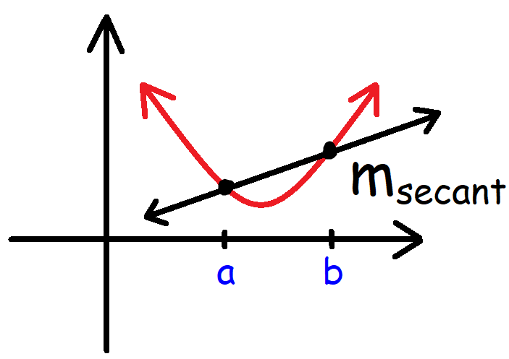 | Average Rate of Change:  $$m_{secant}=\frac{f\left(b\right)-f(a)}{b-a}$$  Tangent Line Equation:  $$y-y_{1}=m(x-x_{1})$$
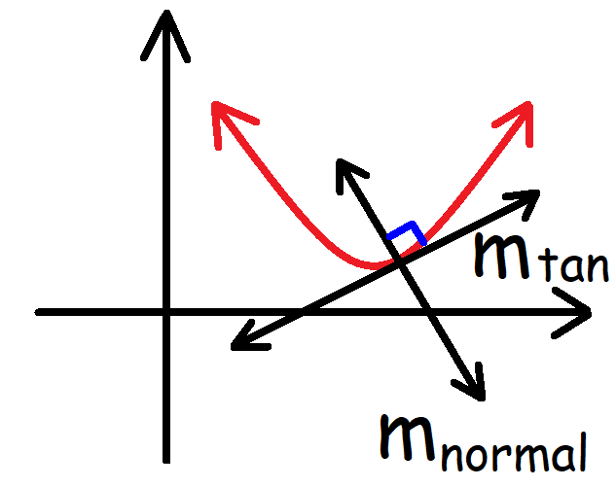 | Instantaneous Rate of Change:  $$m_{tangent}=f^{'}\left(c\right)$$  The Normal Line:  $$m_{normal}=-\frac{1}{m_{tangent}}$$
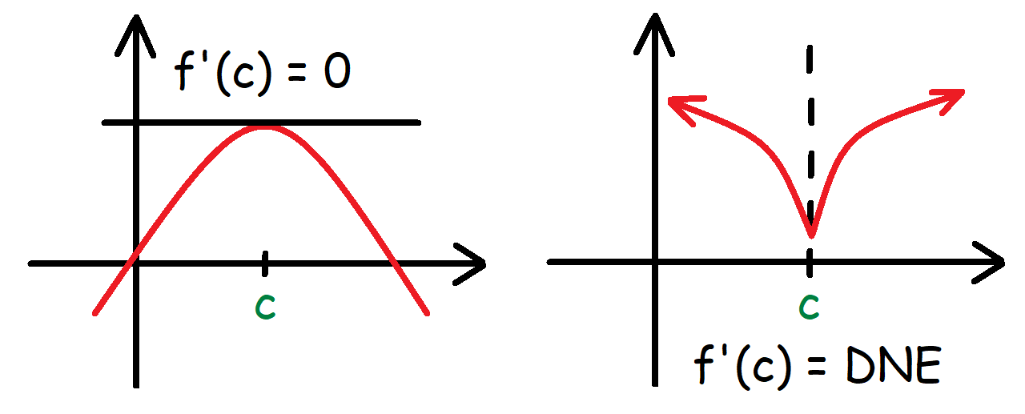 | Critical Points:  $$f^{'}\left(c\right)=0 or f^{'}\left(c\right)=DNE$$
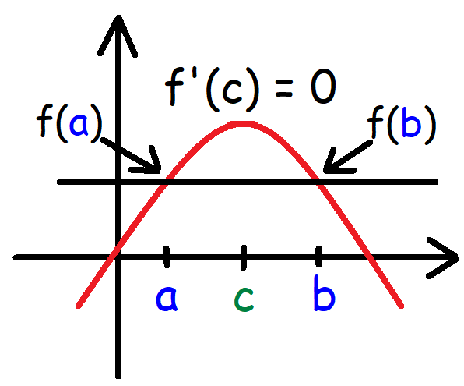 | Rolle’s Theorem:  $$1. f\left(x\right) is continuous on [a, b]$$  $$2. f\left(x\right) is differentiable on (a, b)$$  $$3. f\left(a\right)=f(b)$$  If the 3 conditions above are met, then there is a number c in (a, b) where $f^{'}\left(c\right)=0.$
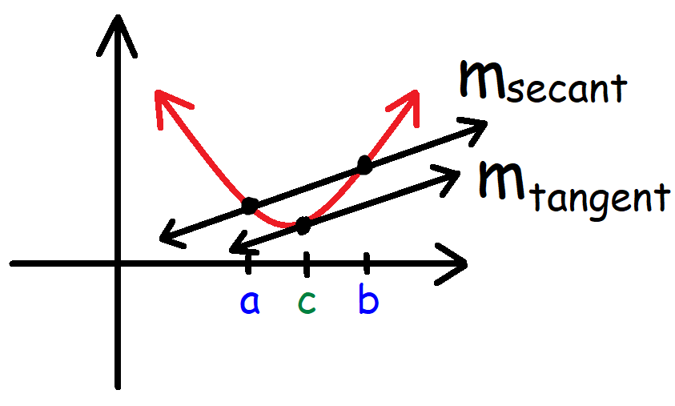 | Mean Value Theorem:  If f(x) is continuous on [a, b] and differentiable on (a, b), then there is a number c in (a, b) such that  $$f^{'}\left(c\right)= \frac{f\left(b\right)-f(a)}{b-a}$$  $$m_{tangent}= m_{secant}$$

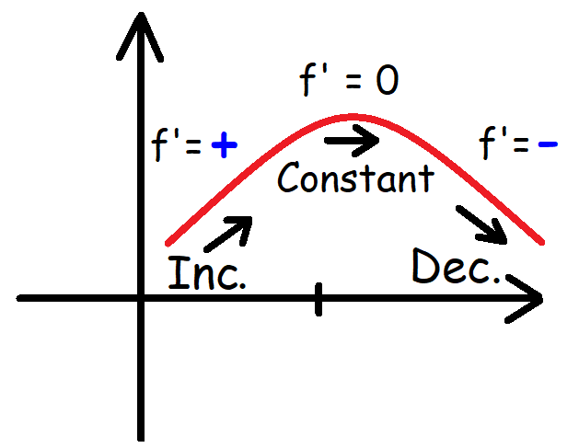 | Increasing/Decreasing Test:  $$1. f\left(x\right) is increasing when f^{'}\left(x\right)>0.$$  $$2. f\left(x\right) is decreasing when f^{'}\left(x\right)<0.$$  $$3. If f^{'}\left(x\right) does not change sign at c, then f\left(x\right) has no$$  $$relative minimum or maximum at c.$$
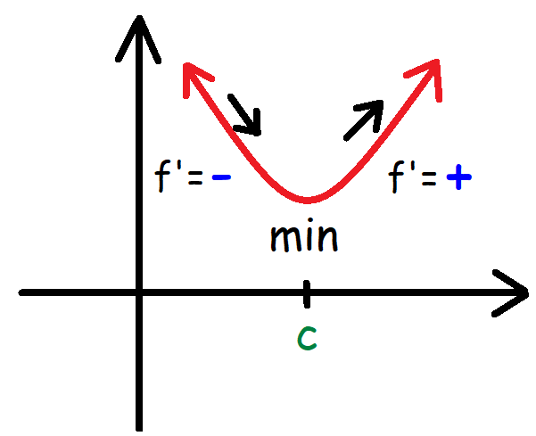 | First Derivative Test:  $$1. If f^{'} changes from+to-at c, then f has a local max. at c.$$  $$2. If f^{'}changes from-to+at c, then f has a local min. at c.$$  $$3. If f^{'}doesn't change sign at c, then f has no local min. or max. at c.$$
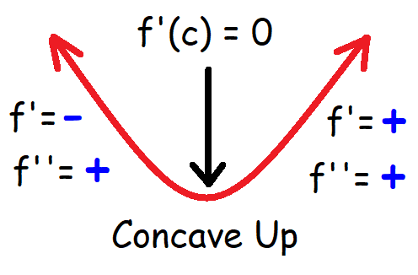 | Concavity Test:  $$1. f is concave up when f^{''}(x)>0 or when f^{'}(x) is increasing.$$  $$2. f is concave down when f^{''}(x)<0 or when f^{'}\left(x\right) is decreasing.$$
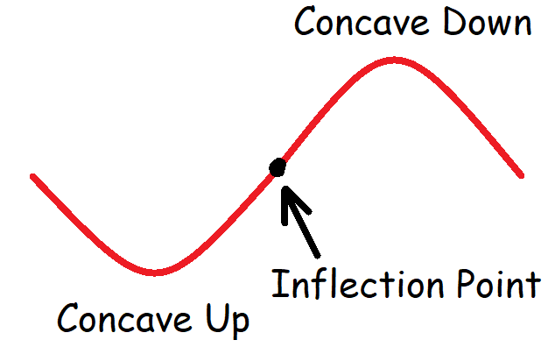 | Inflection Points:  $$If f^{''}\left(c\right)=0 or f^{''}\left(c\right) does not exist, then there is an inflection$$  $$point at c if the concavity changes at c.$$  Note: $f must be continuous near c.$
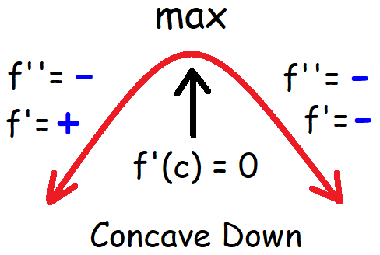 | Second Derivative Test:  $$1. If f^{'}\left(c\right)=0 and f^{''}\left(c\right)>0, then f has a relative minimum at c.$$  $$2. If f^{'}\left(c\right)=0 and f^{''}\left(c\right)<0, then f has a relative maximum at c.$$  Note: $f^{''} must be continuous near c.$
L’hospital’s Rule:  $$\lim_{x →a}{\frac{f(x)}{g(x)}}=\lim_{x→a}{\frac{f'(x)}{g'(x)}}$$  Note: $g^{'}\left(x\right)≠0 near x=a.$ | Newton’s Method for Approximating the Zeros of a Function:  $$x_{n+1}= x_{n}- \frac{f(x_{n})}{f'(x_{n})}$$

Differentials:  $$dy=f^{'}\left(x\right) dx$$  dx Differential of x  dy Differential of y  Note: $∆x=dx and ∆y≈dy$  $$∆y=y_{2}-y_{1}=f\left(a+∆x\right)-f(a)$$ | Tangent Line Approximations: $Point (a, f\left(a\right))$  $$y=f\left(a\right)+f'(a)(x-a)$$  Linear Equation – Point Slope Form: $Point (x_{1},y_{1})$  $$y-y_{1}=m(x-x_{1})$$  Note: $m=f^{'}\left(a\right) a=x_{1} f\left(a\right)= y_{1}$
Description:  C(x) Cost Function  c(x) Average Cost Function  C’(x) Marginal Cost Function  Note: $c\left(x\right) is a minimum when C^{'}\left(x\right)=c(x)$ | Average Cost Function:  $$c\left(x\right)=\frac{C(x)}{x}$$
Revenue Function:  $$R\left(x\right)=x∙p(x)$$  Note: $p\left(x\right) is the price \left(demand\right)function.$ | Profit Function:  $$P\left(x\right)=R\left(x\right)-C(x)$$  Note: $Max profit occurs when R^{'}\left(x\right)=C'(x)$
Description:  R’(x) Marginal Revenue  P’(x) Marginal Profit  C’(x) Marginal Cost | Marginal Profit:  $$P^{'}\left(x\right)=R^{'}\left(x\right)-C'(x)$$
Average Velocity:  $$\overline{v}=\frac{s\left(b\right)-s(a)}{b-a}$$ | Average Acceleration:  $$\overline{a}=\frac{v\left(b\right)-v(a)}{b-a}$$
Instantaneous Velocity:  $$v\left(t\right)=s'(t)$$ | Instantaneous Acceleration:  $$a\left(t\right)=v'(t)$$
Displacement:  $$d=s\left(b\right)-s(a)$$ | The Position Function:  $$s(t)$$

