WITNESS PROTECTION III.
COMMISSION STORY
BY CHALDEACHANGE
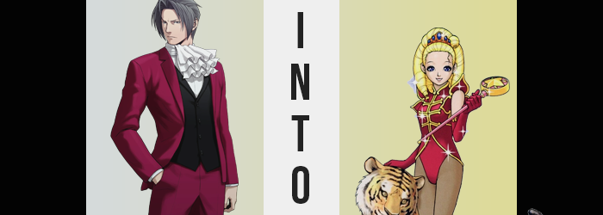

Miles Edgeworth had seen his fair share of mysterious events over the course of his career as a prosecutor.

But really? That went without saying when your closest friend and greatest rival was the Phoenix Wright. Edgeworth could only assume that the defense attorney had some sort of ‘strangeness magnet’ that had been active ever since he’d been born. Even when they had been kids in the same class, unusual things had followed that man around. And ever since their clashes in the courtroom had begun, things had gotten even stranger. Edgeworth hoped that he would never again see a parrot on the witness stand.

Though when it came to Phoenix Wright, that name carried had only been uttered with concern as of late. A few days prior, the defense attorney had mysteriously gone missing along with his assistant, Maya Fey. Law enforcement had looked high and low for any sign of them, but it was almost like they had just disappeared without a trace, as impossible as that might have seemed.

It had reached the point that Edgeworth himself had taken time out of his busy schedule to aid in the search, leaning on Detective Gumshoe for whatever leads they could find. “Of course I’ll help. Wright is my friend. I couldn’t just abandon him after everything he’s done for me.” While prosecutors didn’t typically get involved with cases like these, upon hearing these moving words there was just no way that Gumshoe could say no to him.

Well, honestly? It probably would have taken less than that to win over Gumshoe of all people.

But Edgeworth’s personal investigation had taken a surprising and mysterious turn. He had been investigating the Wright and Co. office when the next thing he knew? He found himself falling unconscious. It wasn’t normal. He wasn’t fatigued, nor had the prosecutor been struck by anything. It was more like he had been drugged. Was it something in the air? A gas? Those were his final thoughts before darkness finally consumed him in full, granting him rest for who knew how long.

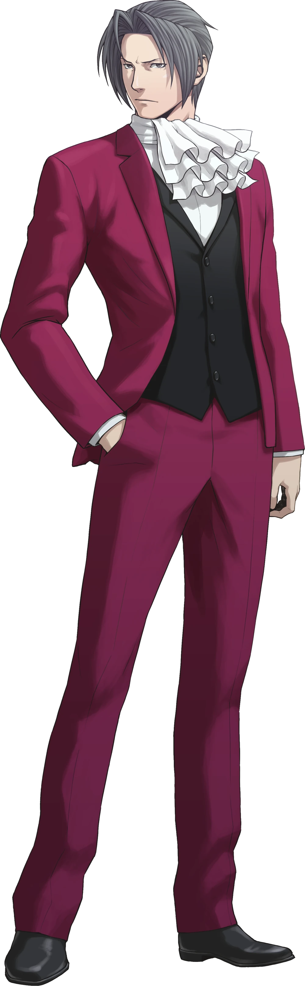
“Ugh… My head.” Miles Edgeworth could be a dramatic fellow even at the best of times, but when he finally awoke he had plenty of things to bemoan. His head was throbbing, but his entire body felt stiff and weak. Like he had been sleeping for longer than normal. Because his head felt so heavy, it took him a little bit to bring himself back up to speed, too. “Sleep? No, I don’t remember falling asleep. I was looking around in Wright’s office, and then…”

Too out of it, he hadn’t spared much of a look for his surroundings just yet. He pulled himself up not off of the floor or out of a bed, but upright in a couch where he sat and rubbed at his temple roughly with firm fingers. “That’s right! I fell unconscious! Was I gassed!?” Eyes went wide and he finally looked up, which allowed his current location to sink in. This didn’t look like Phoenix Wright’s office whatsoever.

At least not unless he had been attending a clown academy recently.

He had been lying on a couch, but it was blue with red polka dots. Strange, but not all that bizarre on its own. The more he looked around, the more certain Edgeworth became that it was a dressing room of some sort? There was a vanity with a mirror and a chair, likely used for doing hair and makeup. Not to mention a closet in the back corner that appeared to be overflowing with clothes that weren’t… conventional.

The ’clown academy’ comment hadn’t been for nothing. Clothes that you might find a clown in were sticking out, along with other pieces of glamorous cloth and accessories that looked as if they would be worn by someone at a circus. “Didn’t Wright have a case involving a circus once?” He was so groggy he couldn’t remember for certain. Rather, Edgeworth rose with a groan rather than pursue that thought further. It was probably just a coincidence, right?

“Who brought me here? Why?” Once he ascertained the fact that the only door to the room was locked, he had to wonder how his circumstances had come about. Wright’s room must have been boobytrapped, or at least that was the only thing that really made sense. Had he and Maya been kidnapped by the same people? Who were they? And what was their purpose? He didn’t have nearly enough information to go on. “I need to escape…”

Escape? But I need to get ready for my show! I need to look my absolute cutest after all!

There weren’t enough words in Edgeworth’s vocabulary to describe how wrong that thought was.

He squinted, not verbally addressing the thought that had just crossed his mind at first. It was honestly easier to just write it off as a side effect of potentially being drugged than to assume that there was something more sinister at work. A lack of rest, or having that rest impeded on, could most certainly lead to your mind doing some strange things, drugs included. That said, not even a seasoned lawyer like Miles Edgeworth had ever thought about wanting to appear cute, not even while tired or intoxicated.

Not only did he not care much about how he was perceived in terms of his appearance in the first place (else why would he dress like that?) but wasn’t that the sort of thought that you might expect from a girl? Not a grown woman, and certainly not a grown man. He shook his head. “I shouldn’t waste any time getting caught up in things like that, I need to focus on getting out of here.” Edgeworth turned his attention back to the door. If it was locked, then there was still another way, wasn’t there? He could just bust it down with his own body if he applied enough strength.

At least that was the solution he believed would work. He approached the door once more and pulled back, essentially winding his body up with the intention of crashing through the door with all of his strength. But in the few short moments between that windup and launching himself? Something unusual befell the prosecutor.

His tall, 5’10” stature began to crumble with haste. His suit quickly began to bunch up with bagginess as the man inside of it both slimmed and shrunk downward. Inch after inch was robbed from the man’s height overall, with arms and legs narrowing in tandem. In the end? He had lost an entire seven inches of overall height, and any muscle to his body had been robbed all the same, leaving him incredibly lithe.

But if you were to examine Edgeworth’s face, it was more than a little obvious that his loss of height and body mass had been accompanied by a different yet related change. As his body had shrunk? His face had become a little rounder, a little fuller. The odd marking was present to indicate the side effects of teenaged acne, but they weren’t so substantial that a little but of makeup couldn’t hide them away. And that was the long and short of it, really. He looked like a teenager.

Yet proportionally? It didn’t match up with what pictures of what Edgeworth had actually looked like at his present age of seventeen. He was too short, too thin, too free of pronounced muscle mass. All things that would foil his attempt to crash through the door when he finally lunged forward and, instead of hitting the door, tripped over suit pants and boxers as they slid down his legs, his tinier shoulder colliding with the door with an underwhelming THUNK.

“Ow! Oh no, I didn’t hit my face, did I!?” Recomposing himself, now pants-free, the prosecutor’s priorities seemed to be a little out of whack. So much so that even he noticed, because why was he so worried about his face of all things? Even if it was the cutest part of his… “What is going on here!?” For a brief moment there was a glimmer of it. A realization on the man’s part that he had become a boy, that his body was far smaller than he remembered it. And yet his mind was being pulled in two different directions simultaneously by two different sets of priorities, two different personalities, two different sets of memories.

On the subject of his face, it was promptly subjected to the changes needed to make it just as adorable as that other side of his mind seemed to believe that it was. Already much more youthful than it had been, his complexion smoothed away further and its inherent shape was altered. His jawline narrowed as it ran into a smaller chin, while the nose in his face’s center became smaller and more button-like in shape.

Bangs were pulled back as part of a change in hairstyle that would soon be addressed, but this allowed the sight of his eyes widening and brightening to be all the plainer. Irises shone with blue instead of grey, and lashes danced long and cute. His face was fair and feminine, undeniably presenting a timeless cuteness that would steal the hearts of any that gazed upon it.

He was squishing his own cheeks now, fears that he had hit his maw during the fall still running rampant despite his attempts to reason with this train of though. “No, no. It seems to be okay! That’s good!” Suiting his new expression, his voice was soft and airy, but the energy it presented with was a touch… bouncy. Perhaps not as bouncy as his hair was, though.

It had been changing as his face had shifted, brown locks pulled behind him as locks lengthened in kind. More than just lengthen, however? Those hairs spiraled. Round and round they went, forming an unbelievable quartet of thick hair drills that reached down to his shoulders as hair ties manifested to bind them. A single strand fell above his left eye, but oddly? It was of a yellow, blonde color. But it wasn’t that odd a few moments later, not as the color permeated throughout the rest of his body’s hair.

Edgeworth didn’t realize, but his poutier lips were passively smiling now. “But what was I…? Is something wrong here…?” Something certainly felt off, but the ship had long since sailed on him taking note of what that might have been. His past memories were fewer and quieter, new memories of growing up at a circus and performing on stage while looking his cutest took priority.

But in these memories? Edgeworth wasn’t a man. He wasn’t even a boy. She was a teenaged girl, and thus her innate biology was shifted so that reality matched this memories. What dangled between her legs softened and shrunk and eventually disappeared, a girl’s counterpart left in its place beneath a now shaved crotch. Why shaved? Well, it’s hard to wear a cute leotard and tights with hair down there!

She also didn’t really have the body shape to wear something that cute just yet, but the forces that were changing her saw to it that this would inevitably be the case. Even now, her waistline was dipping inward and her hips were flaring out a few inches. This gave the girl a more feminine body shape, and the soft weight of a young woman’s body soon made sure that this was capitalized on. Her thighs became fuller as a part of this, not that it could really be seen with how the top half of her suit hung down to her knees.

Similarly, it concealed the swell of her butt cheeks, making sure they would look great in a leotard. Nice and pronounced. And while the same couldn’t exactly be said about her chest? What grew from nothing in terms of bosom wasn’t really all that lacking. The B-cups that blossomed were nice and perky, not that the suit she was wearing did them any justice. They were just big enough that in costume they would still stand out since that costume was tight enough. But in the end? All of her appeal was in that cute little face of hers.

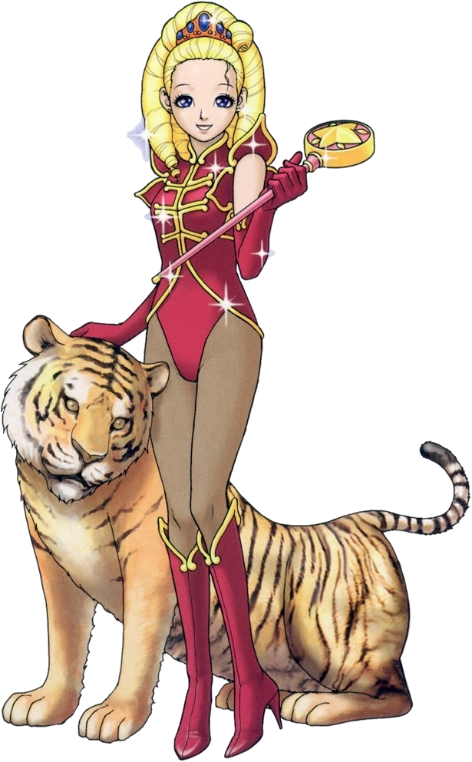
“Hmm… I can’t say I’m my cutest dressed like this, am I? Come to think of it, why am I even wearing this? It looks like it belongs to some old man!” Not only did it look that way, but it reeked of a man’s cologne. Strangely enough, though? She was pretty sure she had seen these clothes on someone before… Oh well! It probably didn’t matter, right?

It didn’t take long at all for Regina Berry to pull herself free from the suit. It had certainly helped that the pants and underwear had already fallen off! But had she been wearing a man’s boxers? That was extra gross! If anyone had seen her like that, they definitely would have gotten the wrong idea! Like does Regina Berry have a boyfriend? And that would be horrible for her image! Men and women alike were infatuated with her beautiful cuteness after all!

“If I recall, my outfit is… Aha!” She managed to find her outfit in the sea of costumes within the closet, and in the end it had taken more effort for her to get her animal tamer costume out of its grasp with that small body of hers. But she put it on effortlessly, eventually clad from head to toe in a glittering, red leotard over black tights, red heels and gloves, and with a crimson tiara in blonde locks now styled in ample curls.

Still, she still felt a little off. Like something just wasn’t right about her situation. Her reflection in the mirror looked just as adorable as ever, but it wasn’t that. It felt like there was a more fundamental issue? Maybe if she rehearsed her usual introduction for her performance. “Heya! I’m Regina Berry, the animal tamer here at the Big Berry Circus! Don’t ya think I look cute? Don’t ya? Don’t ya?” She’d lived a sheltered life her, but she really had no complaints. She loved the circus! Even despite the horrific murder that had happened there recently.

If it wasn’t obvious, Regina put a lot of stock in her cuteness. The adults were always telling her how adorable she was, and it had developed into something of a harmless ego. Aside from the people that were jealous of the attention she received, that is. But she still felt like something was wrong. At least up until the moment she felt something soft and furry rub up against her right thigh. Looking down at it? “Oh, Regent! There you are!”

It was a tiger. Her tiger. And on sight any doubts that Regina had held cleared up. Nothing felt wrong anymore. She was Regina Berry! She was a performer at the Big Berry Circus! And she was going to go on stage and woo the crowd like she always did! Not just for herself, but for everyone who put in hard work for the circus’ success!

“Are you ready to perform, Regent? We’re going to be the cutest duo just like always!”

