BURNING BRAVE
JUNE 2021 REQUEST STORY
BY CHALDEACHANGE
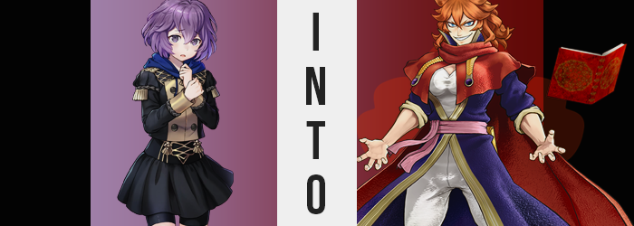

“I wanna die. I really wanna die!” Okay, so Bernadetta von Varley didn’t actually want to die, but becoming emotionally numb at the moment felt like a stupendously amazing idea. Too bad she couldn’t just shut off all of her emotions like blowing out a candle! It was days like this that honestly solidified her resolve to stay in her room and never come out under absolutely any circumstance. Too bad her peers and the teachers of Garreg Mach wouldn’t allow her to remain within her fortress of solitude.

On this particular occasion she had been forced out into a private training session with Catherine, a Knight of Seiros that also helped with whipping the military academy students into shape here and there when not out on missions. Apparently, she’d received special instructions from Bernie’s professor, Byleth, to give her some remedial training. Since she never showed up to class, she was naturally falling behind everyone else.

That had certainly been demonstrated during their training session. Bernadetta could recall a moment where Catherine hadn’t been yelling at her, and when they’d sparred at the end, she could have sworn the moment had been swinging her training sword with the intention of cutting the student’s head clean off! A lot of this was just in her imagination, though. Catherine was strict, but she wasn’t cruel.

ARE YOU LOOKING TO IMPROVE? THEN THIS TOP OF THE LINE POTION WILL IGNITE THE WARRIOR WITHIN!

As she ducked into the alleyway behind the dormitory buildings, the words of the merchant Anna rang through Bernie’s mind as she looked down at the red potion held in a glass bottle in her right hand. Frustrated as she’d been, she had fallen for such an obvious lie meant to push whatever strange concoction this actually was. “Will this really make me stronger? Doubt it…”

Yet even though she was doubtful and reluctant, she popped the cork off of the bottle and downed what turned out to be a very spicy tasting substance. She had already paid the coin for it, and Anna had an extremely strict no-returns policy. Likewise, she doubted the merchant would sell her anything harmful so… Drinking it trumped throwing it out. Maybe it’d make her stronger for a day or something?

Rather than making her feel stronger from the outset, it merely made her feel very warm.

Not uncomfortably so, or even erotically (not that Bernadetta would know what to do with the latter feeling), but instead it was just a little pleasant? Like it wasn’t bad but was instead quite comforting. “Is… Is this all it does?” She wondered this aloud, still holding the glass bottle in her hand. It really hadn’t seemed like much, but…

SMASH!

“WAAAAAH!?” The glass bottle in her hand? It had suddenly exploded! That was that Bernadetta had assumed, but after recoiling and looking down at the hand that had been holding it? Now balled up into a fist, completely free of any wounds, once opened she revealed shards of glass resting in her palm. “W-Wait, did I…?” Had she crushed it!? With a single hand!? “No… No, no! That’s impossible! I’m not that strong, something must have happened!”

Still staring at her fingers, wondering if the potion truly had made her stronger, Bernie ultimately did not catch sight of the fact that there were legitimate physical signs of the potion’s effects from the outset. Of them, the purple of her eyes having their red removed to become blue was the more minor and less noticeable, but otherwise?

It was exceedingly difficult to not perceive the fact that the student’s hair color was shifting away from purple as well – to a vastly different, yet very complimentary color instead. A fiery orange, one that bronzed slightly at her tips as the coloring worked its way through a head of hair that was so typically short and fluffy. The latter feature remained, but its shortness? Locks, once dyed, then grew shaggier. Inches were added to the length of her hair, falling slightly past her shoulders but no farther than that; on top, it stuck up in various directions almost like a bonfire.

Meanwhile, Bernadetta allowed the glass to fall from her hands. The warmth within was growing even more pleasing, so much so that it was getting hard to not smile, of all things? Gods, when was the last time she had smiled? “N-No, this feels really weird, but… HAHAHA! EEP!?” Where had that laugh come from? It didn’t even sound like the way she normally laughed! It sounded too… erratic!

Even so, the teen couldn’t erase the smile from her face. It practically stretched from ear to ear and revealed that the angle of her lips had shifted upright along with their girth. These lips were more abundant now, carrying a maturity about them that they hadn’t once possessed. But then again? The same could be said about much of her face.

Orange swept through her eyebrows just as it had the hair upon her head, brows both shortening and growing fluffier so that angled down like a pair of tangerine teardrops. The eyes beneath them, colors already altered, merely narrowed. Bernadetta’s sheepish, rounder gaze was sharpened as a result, her resting gaze rather intimidating along with that toothy smile she was now passively showing off. Cheekbones rose, and with this her apparent age seemed more probable to place her in adulthood going on her face along – helped further by the sharp hook of her nose.

“Did I really break that? Well, I mean… That’s awesome if I did! Pretty damn cool, actually!” It was weird. The more she thought about it all, the less uncertain she felt? Was this… confidence? Considering she’d never had much of any growing up considering her parentage, it was very strange to feel this way. She almost felt willing to rip off her own dad’s dick and shove it up his ass— “No… I wouldn’t do something like that! Would I?”

In a way, she was a little drunk on this new feeling. She felt powerful, which felt great! And reveling in it, she didn’t so much as bat an eyelash as her figure began to grow upwards at the cost of her Garreg Mach uniform. Height and muscles alike graced her visage, seeing the buttons of her jacket open while shoulders and pecs broadened, the bottom of the top eventually lifted enough to reveal a tummy that would shortly be defined by the strength of the abdominal muscles that surrounded her bellybutton.

The added length to her legs saw the nylon shorts she wore beneath her skirt pull up against her thighs but tears eventually did form from the muscle that settled along Bernie’s lengthened bones while her hips swung wider, likewise tearing the sides of those shorts and risking the loss of her skirt.

Now, skittish as Bernadetta was, she absolutely should have lost her mind with clothes tearing and her skin exposed. She was bashful as could be, after all! Yet, she didn’t even bat an eyelash at it all, and instead? “This is a pain!” Now 5’10”, she saw it fit to simply tear the scraps that remained from her flesh.

…No, she burned them away. Flames erupted from her skin, engulfing all of the cloth, and leaving her body bare – all while exposing those patches of her skin that had turned a pigment or two darker, eventually expanding to become her consistent skin tone. Above, a book of sorts had appeared and was floating over the girl – woman – as if waiting for everything to finish.

“That’s better! I hate the feeling of clothes digging into my skin!” It made it hard to move! She preferred to wear looser, comfier clothes. Things that restricted her ample breasts? They just wouldn’t— “Hah!? I don’t have a big chest!?” If not careful, you might not have caught that this was actually a question. Rather than stating that she did not have a large bosom, as Bernadetta did not, she sounded more confused that what she was looking at could barely fill her hands.

Not to forget, she was currently fondling herself in a back alley without a care in the world.

“Oh!” But her confusion was short lived. The flesh her palms had cupped around suddenly surged out in every direction, forcing her fingers to part as a soft fattiness tenderized a bosom that had been overcome with muscle during her earlier growth spurt. Nipples expanded as well, but Bernie was more distracted by just how good squeezing them felt on the whole. So soft and supple, she could never have fathomed having breasts of this new, D-cup size. Or perhaps she couldn’t imagine having anything smaller? Why was it so hard to keep her head on straight?

Not to be outdone, everything beneath her firm, little tummy was touched softened growth as well. Her thighs, muscular as they were, lightened in appeal thanks to the soft fat that laced between her skin and her strength, making those thighs look more ample while not losing their fit appeal entirely. Additionally, her butt cheeks were cushioned in a similar fashion, seeing them rounded to the point that it certainly would be much more comfortable to sit upon.

Not that this new personality of hers lent her to sitting down very much.

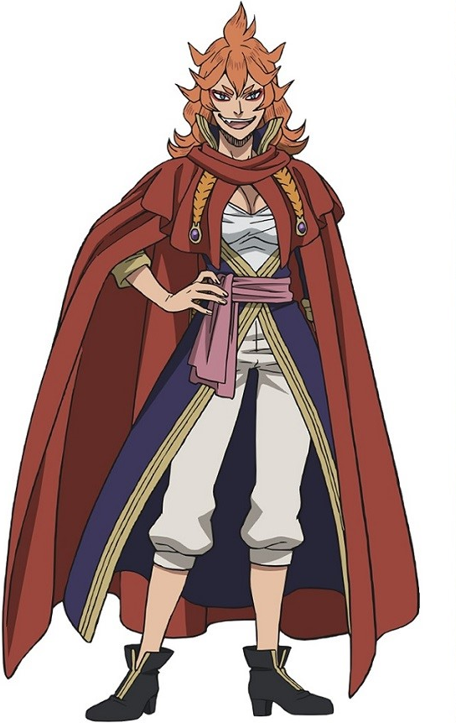
Mereoleona Vermillion grit her teeth together as from the flames that had gathered around her once more, a brand new outfit had taken shape – clothes in pristine condition as if she were a phoenix rising from the ashes. “HAAHAAHAA! THAT’S BETTER!” Not that she would have minded all that much walking around in tatters. She didn’t have much shame. Loud and boisterous, the confidence she emitted bordered utter arrogance. But she felt strong as hell and knew it to be true. There wouldn’t be anymore days cowering alone in her room!

…Since when had she practiced such a thing anyways? She was no coward!

But this was troublesome. The sun was setting in the sky above, and she was supposed to have a bout with Catherine in the training area around this time. Both Knights of Seiros, the two had developed something of a rivalry during the time serving Rhea. Both were incredibly strong, incredibly talented, and incredibly hard-headed, which made them the perfect pair if you thought about it.

Yet they spent most of their time squabbling and competing like an old married couple. Then again, you could sometimes find them drinking alone together. Maybe there was more to their relationship than met the eye? With the political climate as it was, neither of them would share if there was something going on in secret. It could jeopardize their posts when the world felt like it might go to war at any moment.

The fiery, orange-haired warrior cracked her neck audibly twice, and then bolted off in the direction of the arena. “Oh well, if I’m fashionably late, she’ll forgive me! And if she’s mad? Haha! I’ll just beat the anger out of her!” The two of them were just good like that.

