PARTY TIME II.
BIWEEKLY STORY #120
BY CHALDEACHANGE
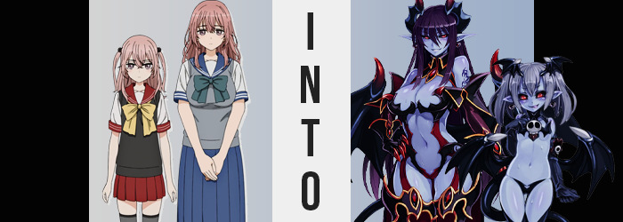

“Mm… She better not be dragging her feet over there!”

Sajuna Inui had mixed feelings about her plans for the evening. She was going to a party hosted by students from a school that wasn’t even her own, and a Halloween party of all things! As the professional cosplayer she was, such simple gatherings weren’t exactly her regular scene. She’d rather be hitting it up with some big wigs in her field of artistic expertise… or something to that extent.

But truth be told? Her difficult to work with persona had met a snag. Well, a pair of snags in the up and coming cosplayer Marin Kitagawa and her cosplay maker, Wakana Gojo. The duo had been soaring through the popularity ranks as of late (and if you were to ask Sajuna she would say it was partially because of her all) and Sajuna had taken a liking to them – especially Gojo.

It was on an invitation from Marin that she’d even been asked to attend this party, and after mulling over it she had decided to attend so long as she could bring her younger sister, Shinju. The two siblings had wanted to surprise the two that had invited them though, so on the day that Marin and Gojo had gone to purchase their costumes? Sajuna and Shinju had tailed them, sneakily noting which rack they had bought their costumes from and waiting for them to leave before purchasing their own from the same series.

Sajuna could recall her little sister wondering aloud if Gojo had accidentally purchased a woman’s costume somehow and at the time she’d joked about how funny that might have been if it were true. And it had been true. He was actually putting it on around the same time that Sajuna had fished hers out of the bag in her bedroom. “I still don’t know why I chose something so revealing…”

Shinju and herself had picked out a matching set. A Devil costume, which was meant for Sajuna since despite being the older sibling she had the much more petite figure, while her bombastic younger sister purchased the Demon costume. Both amounted to little more than somewhat spooky bikinis at the end of the day.

“Wait, isn’t this too…?” Having taken her own costume out of the bag, the sizing looked wrong? But her thoughts trailed off while examining it in detail until, before she realized what was even happening? “…big? H-HUH!?” The teen wasn’t holding it in her hands anymore. It was as if her mind had trailed off a moment and the next thing she knew she was wearing the costume.

Perhaps ‘wearing’ was a little generous though. The bat wing bikini was way too big and left tiny breasts exposed, while the straps that connected to the bikini bottom were loose as she was clearly much too short. She hadn’t even put on the fake gauntlets and faux armored boots yet – because they would definitely fall off her arms and ride up her pelvis respectively. “Th-This is the costume Shinju picked out, isn’t it?” Had they mixed up the bags!?

But that still didn’t explain why she had put it on!

Her first instinct was naturally to take it off and put on what she was wearing before, but that was odd… Why couldn’t she see her old outfit laying around? Oh well, she could just put on something else from her closet, right? Because there was no way she could venture out wearing a revealing bikini that didn’t even hide her nipples and hung so loose around her loins!

Perhaps it was fortunate for Sajuna that this wasn’t a problem for long, though? Well… subjectively. “H-Hey!?” Because out of nowhere the teen lurched forward, almost flying face first into the floor if not for the aide of the nearby desk she’d caught at the last moment. Her short body felt like it was being weighed down all of a sudden, and with a panicked look down at herself she quickly understood why – even if it was utterly unbelievable.

“M-My tits!?” Her shock was blurted out in a manner obscener than the girl typically would have uttered, but at the same time she just excused herself because it was alarming. Her A-cup breasts had swollen – no, they continued to swell – before her very eyes. “Wh-What!?” She felt like her brain was short-circuiting! That couldn’t be possible, right? But she couldn’t deny what she was seeing before her very eyes! The skin of her breasts stretching, her nipples engorging as they became erect. Inch by inch they pushed forward, slowly filling to costume bikini she had adorned to the point that either breast was as large as her head!

And considering she was only 4’8” it left her looking very goofy. Like one of those ‘oppai lolis’ since she had such a childish face. “No, no, no! These big tits… I must be dreaming, right? I look ridiculous!” Sajuna had, of course, always wondered what it would like to be bigger. But not like this! She could hardly even stand up straight! She kept tilting forward!

She did eventually find help in that area, but only because her body changed more. Now she was wobbling backwards, and craning her neck behind her (since she couldn’t see straight down past her huge breasts) she let out another surprised squeak. “My fat ass too!?” Why did she keep electing to speak the most inappropriate sounding term imaginable? Nonetheless, the sight of her ass cheeks swelling to fill the bat-shaped bikini bottom filled her with equal parts confusion, fear, and… arousal.

Perhaps she was getting horny because the front of the bikini was being wedged into giving her cameltoe, each cheek stretching to rival her tits in size. Because they were so big though, her hips were uncomfortably forced to widen a full handful of inches which made her appear even more ridiculous… not helped by the thigh gap that was left filling promptly with the flesh of her thighs jiggling to life. Each thigh was wider than her waistline!

“I look like a short little slut!” Sajuna was beginning to feel like one too. She was still a virgin, or at least she was supposed to be, so why had thoughts of sex become ever present? Gone unnoticed with everything else happening, it seemed that the stronger those feelings became the darker a series a tattoos began to etch themselves beneath her shoulders and on her hips.

Her thick and short body was so wobbly – and considering the distribution of weight being what it was that could only be expected. She was so wobbly in fact that she didn’t immediately notice that the straps connecting the bikini top to the bikini bottom had begun to tense. Something that could only be possible if there was more distance between the two pieces. And short of the girl being cut in half the only thing that could cause that was a growth spurt.

Sajuna blinked. “Hah!? Was the desk always that fucking low?” She spoke flippantly and deeply about it but it did eventually dawn on the girl. No, on the woman. For her body had grown taller, limbs and torso alike stretching so that she was 5’6” – a very substantial departure from her previous height, and a helpful change that made it so that her buxom form didn’t look ridiculous. In fact, when paired with matured facial features like swollen lips and widened eyes, she looked like a sexy, adult woman.

“Mmn…” Her height was noted. It helped make her feel strong, powerful, sexy. Sajuna’s more inappropriate desires were bubbling up and becoming difficult to contain as she licked her lips. But with her tongue sticking out, it revealed itself to be longer, forked, and a dark blue color. Pointedly inhuman; jarringly so. Yet such was her fate now that she was a buxom woman who yearned to satiate her need. That arousal quickly developed into something else. Something like a hunger.

Sajuna’s ears began to poke out from behind pink hair. Just slightly at first, but they soon erupted into a pair of long and pointed ears that seemed elvish. Or at least they would have if not from the hefty protrusions that pushed out from the sides of her head. “Horns, hm?” Fingers had reached up to touch them, their black bulk curving in with an ebb and flow to their design that almost resembled a bat’s wings with red tips. Why did she not find them alarming? They simply added to that feeling of power she had so quickly been drunk on.

The coloration of the woman’s skin was altered; not so that it remained a human shade, but so that it became something a touch more ethereal. An undead blue replaced paled pinks from head to toe, nipples and her pussy a darker blue than the rest. It all contrasted eye that lit up red, sclera robbed of their white so that the crimson was instead surrounded by black.

And in a similar vein her pink hair darkened. With a rich purple that was almost black in tone, these locks spilled gratuitously over her shoulders, lengthening down to her ass before stopping. It help bring a certain menacing feel to her appearance. Once that was followed up on.

A lustful moan bellowed from the creature’s lips while she arched her back backwards. She could feel a pressure growing both around her shoulder blades and above her ass. As if Sajuna knew, a pair of black wings and a forked tail erupted from these locations, completely her transition into a downright demonic form. Her long tongue licked her lips once more.

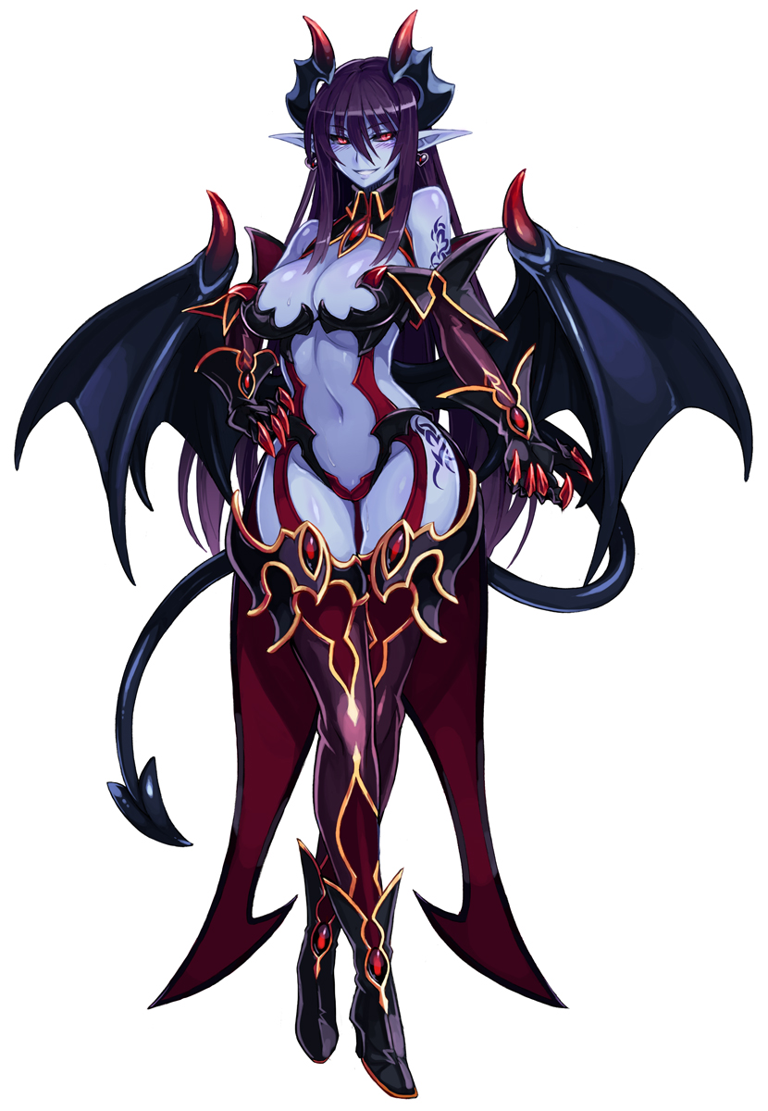
“Oooh, I fucking love this.” The blue-skinned fiend couldn’t help but lick her lips playfully as hands ran up and down her body. They groped her big tits and slapped her full ass, the Demon having wholly embraced her new nature as a monster even if Sajuna’s identity was still attached to it. She eyed the gauntlets and thigh high, steel boots that rested on the bed still – though they had become solid metal now – and she sauntered over to them. Each step brought a bountiful jiggle to her cheeks, and she moaned sensually as she slid cold steel against her warm body.

Once she wore them properly she felt satisfied. “I’m sure we’ll kill it at the party tonight.” Tons of partygoers that were likely down to fuck? The Devil couldn’t ask for a better bounty. She was ready to straddle some humans and milk them for whatever life energy they were worth. Of course she wouldn’t be going alone. In the bedroom beside hers, Shinju must have been… And then, of course, there were the two that invited them.

“I wonder which costumes those two picked?”

It almost felt a little too atmospheric that it was thunder storming outside of the Inui household that evening. Or at least that was what Shinju Inui believe. The storm had whirred to life just moments after the middle schooler had returned to her bedroom from the shower, unaware that its appearance seemed to be tied to a phenomenon that was altering her older sibling in the room next to hers at that very moment.

“I suppose I should get dressed now… Ugh… This is going to be so embarrassing!” Why had she agreed to Sajuna’s costume idea? She wasn’t a seasoned cosplayer who was used to showing off her body and that Devil costume she had purchased was so revealing! She had to hope that there wouldn’t be anyone at the party that recognized her! Seeing as they were all from a different school? That fortunately seemed likely. It was the only reason she hadn’t bailed. Well, that and she legitimately did want to see Marin and Gojo there.

Upon removing the costume from the bag, however? “Erm… isn’t this the one onee-san bought?” Shinju hadn’t been paying attention to the names, but it was obvious that the bikinitop, panties, gloves, thigh highs, and boots in the bag were much too small for her. There was no way that they’d— “HWHA!?” And yet, after what had felt like a mere blink from the girl’s perspective? The bikini was on her… kind of. It was certainly digging into her flesh if anything!

“…Way… too… tight!” A logical understanding of physics would have suggested that the very small top would have snapped from both the broadness of Shinju’s shoulders and the heft of her tits. It was so small, in fact, that hooked over her nipples it was pulling her breasts up and back towards her neck. It was uncomfortable and embarrassing, and she didn’t even want to ask how the panties had stayed on without snapping, not that she could see past her chest to see.

…At first.

These clothes were already extremely tight, but moments later she found the discomfort even more unbearable. It was like the skull and bat wing top and the black panties were applying force against the curves that the struggled to mount. A feeling that didn’t really make much sense, and yet Shinju could witness firsthand… the sight of her breasts getting smaller!? “WH-WHA—!?” There was nothing slow or egregious about it. Like the top was pushing all of the air out of a pair of balloons, the excessive mass of her bosom was forced away while the top became closer and closer to her ribcage and beating heart. Halved in size in just a few moments, a moment later? They were barely A-cups, now properly hidden aside from some underboob.

For the first time in years Shinju could see her feet past her breasts. She could see the leggings and boots barely fitted to her long legs and big feet, but she could also see her hips and thighs now. They too had been narrowed. Her hips had been pulled narrow by the waistband of those black panties? She didn’t know how that was physically possible, but considering what she’d witnessed with her chest it wasn’t that surprising. Nor was that her bum and thighs had become much more compact.

“H-How is this possible? I don’t knooooOOOOOOOW!?” Making matters worse a vertical decline came next. The tall fourteen year old’s body looked like it was collapsing in on itself, her big body sinking properly into her tights and boots and her shoulders narrowing so that there was no longer any discomfort with the upper bikini piece. Her body shrunk until she was around 4’2” – shorter than her big sister and younger looking than ever.

Shinju wasn’t younger though. She may have appeared more childlike, but the costume was just feeding off the genes that already existed in her DNA. She was eighteen now, but it had all seized on the part of her DNA that she shared with Sajuna. The DNA that had made her sibling appear so young looking despite being older. She was just small-figured now. “Heeheehee!” This was all so alarming, and yet she giggled so joyously. Shinju found herself grappling with the fact that this felt kind of pleasant now.

More monstrous traits took shape now that her figure fit snugly into the costume. Her skin paled to a blue that was a touch lighter than the demons, and much like her big sister Shinji sprouted a pair of demonic wings along with a forked tail – though they were more of a dark bluish color. Her eyes turned red, her sclera black, and shorted pointed ears shot out from behind hair that that had shortened to her shoulders and were dyed a greyish blue. Rather than sprout horns on her head though, a pair of small bat wings erupted from her forehead while she grabbed the gloves from the nearby bag to slide them up her arms.

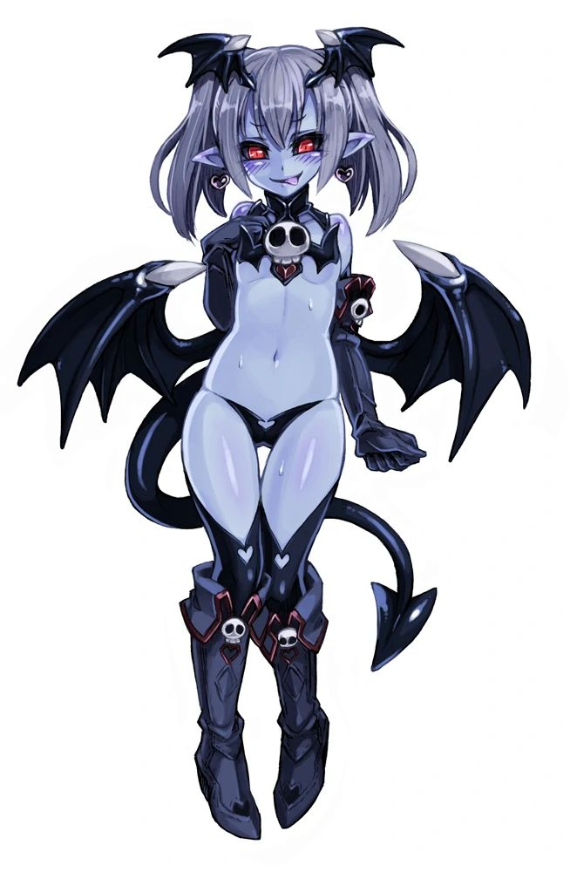
“This feels kinda nice!” The Devil wasn’t complaining, however. Ever since Shinju had endured her very early growth spurt she had felt uncomfortable about her body, but this smaller and more compact form? It suited a girl of her age a little better, didn’t it? Even though the part of her that was a monster now yearned to have the curves that she’d possessed prior. It would have been much easier to attract her prey that way, wouldn’t it?

But otherwise? The monster girl didn’t have any complaints. “Heeheehee! I can make this work though! We’re going to a party, right!?” She may have been small, but she was certainly full of energy! Shinju couldn’t help but ponder about how fun it would be to seduce someone at the party, pamper them, make them hers. And of course she would have her big sister alongside her to do so, wouldn’t she?

“I can’t wait! I hope my demonic big sis is ready to go!”

It would certainly be a party to remember.

