**Nanami and the Mask of Izanami – Chapter 3 A new Foxy friend**

A Month later after Akira’s visit Nanami was sitting in her Room and she was surfing on the Internet and then she saw that the new Album of Kasumiko Takahashi has just came out sadly it was already sold out everywhere.

**“Aww I’m too Late it’s sold out everywhere.”** said Nanami

**“Hmm sadly I can’t help you with that my cute Nanami-chan. But maybe your big Sister has an idea why you don’t call her.”** said Inari

**“Oh, that’s a good Idea Inari.”** said Nanami

Nanami then picked up her smartphone and she called her big sister Akira.

**“Hello this is Akira Miyasaki.”** answered Akira as she picked up the Call.

**“Hi Akira it’s me Nanami. I have a question.”** said Nanami

**“Oh, hi little Sis sure just tell me. ^^”** said Akira happily.

**“The new Music Album of Kasumiko Takahashi just came out here in Japan today but it sold out everywhere and as clumsy as I am, I have forgot to preorder it. Now I would like to ask if you know a store where I can pick it up still?”** asked Nanami

**“Sure, that’s pretty easy just go into the Kitsune alley in Akihabara and there you will find a little Music and Merchandise Store called Ayako’s Music Shop and more. Ayako is the sister of a good friend from me I’m sure she should have some copy’s left.”** said Akira

**“Thank you, big Sis, you’re the best! I will go right away. Bye!”** said Nanami

**“No problem Nanami-chan and bye! ^^”** said Akira.

Then the call ended.

**“Ok Inari-chan it looks like we go to Akihabara for some shopping.**” said Nanami

**“Oh, I love shopping maybe we can get a nice Nendoroid figurine for me too.”** said Inari

**Later the Same Day in Akihabara**

**“Ok here is the Kitsune Alley so the shop should be around here. Ah, there it is!”** said Nanami.

Nanami entered the Store and instantly she was greeted by a young Kitsune Girl **“Welcome to my cute Store! My name is Ayako how can I help you?”** said the Girl.

**“Hi I’m Nanami-chan and I’m in the search for the New Music Album from Kasumiko Takahashi called Kitsune Magic.”** said Nanami

**“Oh! You’re a fan of my Big Sis! You’re lucky I have some Copy’s left.”** said Ayako happily

**“D-d-did you say K-Kasumiko is your Big Sister?”** asked Nanami surprised.

**“Yep! She is my Big Sister and lives in Fringe City. And for a very big Fan like you I have saved a Special limited Version here with a cute Nendoroid Figurine of Kasumiko.”** said Ayako

**“Oh, that’s cool! I didn’t know this Version existed!”** said Nanami

**“It’s a very limited Version that is only for Good friends of my Big Sis and since Akira is your big Sis, and a good Fried of Kasumiko I can give it to you.”** said Ayako.

**“Oh, wow! That is great but how much do you want for it?”** asked Nanami

**“Not much you must me done only a favor”** said Ayako

**“Ok what kind of Favor?”** asked Nanami curiously

**“See my big sis has this old looking Mask but she never let me try it on and it appears you have a similar looking Mask and so I want to wear your Mask. If you agree then we are in the Business.”** said Ayako

**“Hmm… let me think a bit”** said Nanami and goes out of the Store then suddenly Inari talked to Nanami

**“Oh Nanami-chan I like this Girl please let me have some Fun with her.”** said Inari to Nanami

**“You’re sure about this? I mean were here at her store and after the Transformation it will be a mess.”** said Nanami to Inari

**“Yep I’m sure and by the Way I really would like to have this special Nendoroid of Kasumiko and you want the new Album so it’s a Win-win situation for all.”** said Inari to Nanami

**“Ok, fine you won Inari-chan”** said Nanami to Inari

Then Nanami goes back into the store and she said to Ayako: **“Ok Ayako we have a Deal. You can wear my Mask. But be warned that the Store will be a mess after the TF is Finished.”**

**“Yaay! And that’s no problem. Ok give me the Mask and I give you the Special Edition.”** said Ayako

Nanami handed over the Mask of Izanami and Ayako handed over the Special edition of Kasumiko’s New Music Album.

**“Finally, I can wear one of these Masks but first let me close the Shop for now.”** said Ayako

Ayako locked the door of the Shop and she put the Mask closer to her face and then SNAP! The mask jumped out of her Hands right into her Face. **“W-what!”** said Ayako in shock

**“Hello Ayako-chan! I’m Inari and I’m sure we will have much Fun!”** said inari excited.

**“Umm… Th-This feeling is Amazing!”** said Ayako then her breasts start to get bigger. Her Breasts grows from a B-Cup to a massive E-Cup and shortly her Ass followed as it grows bigger and Firmed Up to a well-trained Sexy Ass.

**“He he! I hope you will like your new Upgrades my little Kitsune.”** said Inari.

Then Ayako’s waist gets slimmer her hips a little bit wider and her legs much longer and shortly after that her belly gets from smooth and well-shaped to smooth and perfectly Trained with a nice Sexy Six-pack.

**“Ahhh! T-this fe-feels awesome! More Inari! I want more!”** said Ayako

**“Oh, if you say so my sweet Kitsune then I will give you all I got!”** said Inari

Suddenly behind Ayako’s back are growing seven more Fox Tails but that’s not all she also grows one pair of Angel wings and one pair of demon wings also her Hair Color changed from lavender to a mix of Green hair with Lavender colored hair tips also four of her Tails changed in color too. Four tails stayed lavender colored with white Tips but the other four are green with lavender colored Tips.

**“I-i-I c-can’t hold back anymore!”** screamed Ayako in full pleasure then a mini tornado suddenly engulfs her and she bounced around the Room and while she was in the Twister, she hits a massive Orgasm.

Then the Twister comes to a stop and before Nanami stands a completely new and much sexier looking Ayako in a sexy Red evening dress which shows the bigger cleavage of her now Massive breasts and her well trained sexy abs perfectly.

**“A-A-Ayako! I-is that really you?”** asked Nanami.

**“Of course, it’s me! Thank you for letting me try this Mask! I’m feeling Awesome and look at this I’m an eight Tailed Kitsune now! And not mention a Sexy one too!”** said masked Ayako.

**“Y-you’re welcome but what will we do now?”** asked Nanami her new Friend.

**“Oh, silly why don’t have some Fun at the Arcades and then we will go to a special place and have some Girl fun!”** said Ayako in a sexy sounding voice.

**To be continued…**

**Thanks to all Patreon supporters you’re the best!**

**Special thanks to RubyFox**

**Bonus:  
  
Smug Ayako:**

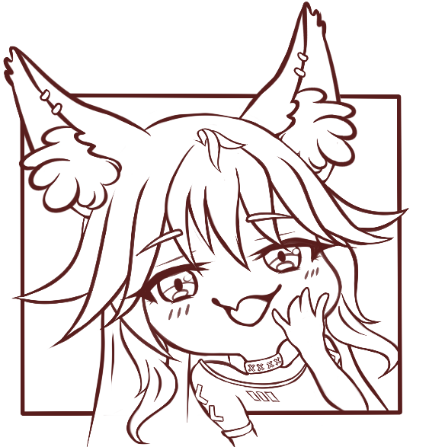

**Ayako’s reference Sheet:**

