IDOL RESTART II.
JUNE 2021 REQUEST STORY
BY CHALDEACHANGE
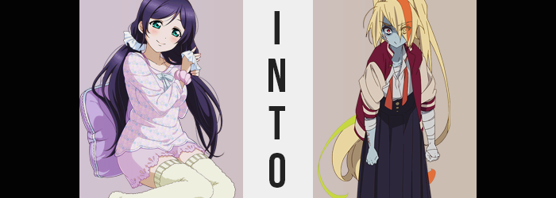

“Hm? Why am I in the bathroom? This isn’t even my bathroom?”

The last Nozomi Toujou could remember, she had been sleeping? Feeling a little sluggish after a full day of classes, followed by a full evening of practice for their school idol group, some nights she just felt extremely spent by the time she returned home and crashed immediately. The comfort of a cool pillow could be the most rejuvenating feeling of all when all was said and done.

But this room? It wasn’t her bedroom, nor was she laying in bed. She was upright in a very cramped bathroom, one dimly lit by a single lightbulb with a chain dangling from it to turn the light on and off. Otherwise, there was a perfectly clean bathtub and toilet, and a mirror that looked very out of place considering how broken it was. She couldn’t even make out her own reflection, not that she had any need to.

THUMP THUMP THUMP THUMP THUMP

“Am I dreaming? Could this be some kind of vision of my future?” The thought made the teen a little giddy. She was keen on supernatural phenomenon, so the idea that maybe this was some kind of paranormal vision she was receiving in her dreams? That was sort of exciting! “Ow!” Upon pinching her cheek and feeling some rather convincing pain though, she decided to re-evaluate her assumption. “Wait, is this reality? Could I have been… teleported!?”

That line of thought had some relatively exciting implications of its own, such as the idea that she’d been abducted by aliens, or perhaps spirited away by ghosts? In truth, she really had been spirited away by a paranormal force, but she didn’t have the foggiest idea that it had been through the actions of her friend, Nico. Nor that she would soon become a living example of the supernatural she was so very fond of.

…Un-living example?

THUMP… THUMP… THUMP… THUMP…

Huh? Wasn’t that a little peculiar? Excited as she was by this bizarre turn of events, her own heartbeat was slowing? Nozomi was the type of girl that liked to keep track of her heart rate because it told more about your health than most things did. “Wait… I feel a little…” Groggy? Slow? Her body didn’t feel very cooperative all of a sudden!

THUMP…… THUMP……

Until finally? Her heart beat its final beat. Nozomi remained oblivious as she suddenly blacked out without a pulse to sustain her, and her now (technically) deceased body crashed against the bathroom floor. But it didn’t take long for things to reboot so to speak, and her bright eyes eventually flickered open with confusion. “Hm? What… Wh-What happened!?”

At first, she had been willing to chalk it up to just passing out, but a look of horror spread across her facial features as the scene in front of her became clearer. After all, she was looking at herself. Not in a mirror, not in the water – her eyes were pointed at her own body, which was laying on the floor on its belly… without a head. Almost like said head had just popped off.

And it had! The very moment she’d fallen, her chin had smacked off the floor and her head had bounced off, landing just a few feet away with her chin on the ground. “H-How is this possible!? It’s almost like I’m…” Even more bizarre, she could still feel and move her body. Subconsciously, she had reached out towards her head with a hand, revealing fingers that initially looked normal, but…

Her fingertips were blue, and the nails looked like they’d seen better days. “Almost like I’m a zombie…” It was the only thing that could remove its head and be fine that she could think of, and while she could feel her body, she could not feel her beating heart. Had she died? She was dead? She was undead? Under normal circumstances she might have found this concept to be intriguing, but for it to actually happen to her!?

Nozomi’s lower lip trembled with horror as she watched the ghastly blue travel down her fingers, hands, and beneath the cloth of her pajamas to catch her arms as well. Other than her neck, she couldn’t make this out with her eyes anywhere else, but she could certainly feel it. After all, that bluish color could only be from a lack of blood flow – and she felt very dry? As if there was no blood in her veins in the first place. That left darkened veins to stand out against this blue, and without any liquid to pass through them they felt and looked shriveled out.

It was a phenomenon she felt spread through her face too, as her skin grew cold, and her mouth became parched. It wasn’t something she could see, but there was no small manner of change in her eyes either. Her bright turquoise faded, and in its place an eerie crimson took root.

What was she supposed to do? If this really were real and not a dream, she supposed there wasn’t much that could be done laying on the ground. Could she reattach her head? Wondering this, she began to move her body with the intention of getting it up and onto its feet again. It was really strange watching your body move without a head attached, but speaking of that head?

“Pfft! PFFFFFT!” Nozomi’s bangs had fallen across her left eye, even though they usually parted in the center and were evenly distributed. Her hands were busy pushing her body up, so she couldn’t brush them aside normally, nor pinch some to check, but… Did their coloring look off? Her hair had always been considerable dark, cast with a purplish tiny. But the hairs she had no choice but to look at were blonde with an orange center. They also appeared very frayed, as if they hadn’t been treated in years.

Or were no longer healthy enough to be repaired completely even with treatment. The truth of the matter was that her hair largely had been dyed a golden blonde from top to bottom, but the scrunches that had been holding it in tails had come unraveled, and it cascaded far down her back. Both longer and rougher than the teen usually wore it, a bright orange streak did run down the center of her sideswept bangs.

By the time the changes to her hair had finally completed however, Nozomi had all but forgotten that something was even strange in the first place. Her panic had been easing in no small part because she was adjusting to the new reality dealt to her, and this very much included being a zombie. No longer did the sight of her headless body rising to its feet strike her as all that strange, almost like she’d seen it a million times before. Instead?

“Hurry up, would ya? I don’t got all night!” She’d begun to verbally berate her torso for being so slow, words communicated in a rougher voice and via a pair of dried out lips that seemed thinner than Nozomi’s usual pair even if they hadn’t shriveled. Her face had lost its softness, her eyes had narrowed, and her brows had ended up arched downward. Through it all? The girl completely lost any facial recognition of who she had once been. Instead, she had the face of a little punk now more than anything. “H-Hey! Wait a sec! What’s goin’ on with my body!?”

Now that her body was standing, the idol was able to make out the damage that had been done from her head’s perch on the ground. Not only did her pajamas look a little looser on her frame (something that could have easily been chocked up to how her body had dried up like a prune on its own), but she could see them growing looser still. She could feel it.

Nozomi’s signature curves were being drained away, and that put her in a foul mood. “Wait, I don’t wanna be all flat! Hey!” Even though she was saying this, wasn’t she actually pretty curve free? Altered memories spoke to a paltry figure that would never grow more abundant because, well, she was dead. It didn’t really bother her all that much; she was used to it. But watching it happen in real time? It really rubbed her the wrong way!

Not that it really mattered how it rubbed her. She could not stop what was already in motion. Even as her body leaned forward, blue hands extended to grab her head, she could see the chest of the pajamas getting looser. Her breasts had emptied out and shaped themselves as lacking but perky A-cup pairing, while the pants only held on by the mercy of her drawstring thanks to her ass deflating similarly. Hips crunched inward, losing her child-bearing thickness, while thighs emptied out until they were rather scrawny.

By the time she’d raised her severed head to her neck, the girl more or less knew how to reattach it, as well as how doing so would feel. Weird as hell, as it turned out. “Yah! That feels better!”, she cried with relief, stretching her arms out to either side while bandages wriggled around her left arm in its entirety. They weren’t the only ones, either. Every wound hidden by her clothes was soon concealed by cloth bandages, stealing away whatever grotesqueness would have been exposed were her loose fitting pajamas to be shed. A scar, unconcealed by any bandages, found itself etched across her right cheek, beneath her eye.

But Nozomi? After it all, she felt a little lost. “Huh? What was I doin’ in the bathroom anyways? I feel like I shouldn’t be here, or that I came from somewhere else?” It was a valid line of thinking to pursue, but it was too bad that she wasn’t allowed to follow it up. Not before another person crashed through the bathroom door.

“Hah!? Sakura!? You should knock before you come burstin’ into the bathroom!” Whatever breakthrough Saki Nikaido had just been on the verge of reaching, it was promptly interrupted as another zombie threw the bathroom door wide open, delivering the biker gal quite the start.

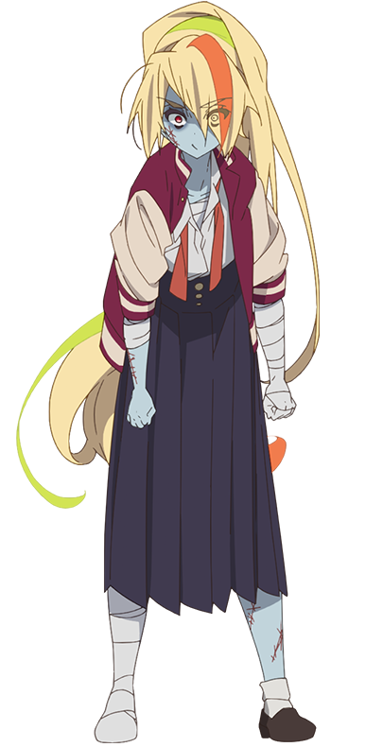
The red-head also appeared surprised. Fresh from the changing room, now done up in her own pajamas, she was shocked to find Saki in a similar situation to the one she’d been in earlier. “It happened to you too, Saki? I totally found myself wearing pajamas that didn’t fit me, they were way too tight, but you…” Looking Saki up and down rather dramatically, it was clear that hers were too big. The top and shorts were both so loose, and…

“HEY!” Saki had realized. “I know what you’re thinkin’! ‘Saki’s figure is so thin, I guess it isn’t weird that pajamas made for a more endowed woman would hang off of her’, right!?” Ah… Yeah, that had been exactly it. Sakura knew full well her figure was among the shapeliest of Franchouchou, next to only Yugiri. But she didn’t really see it as something to lord over the others!

Sakura gulped. “N-No! I wasn’t thinking that at all! I was just thinking they looked really, uh… cute!” As always, she was terrible at covering up her tracks. It didn’t help that Saki was so keen. Debatably so, because all it had taken was this incident for her to forget that she wasn’t this ‘Saki Nikaido’ in the first place.

“Come here! I’ll show you who’s small!”

“SAKI, I’M SORRYYYYY!”

