**FEAR FACTOR**

**Imagine a world where your greatest fears become reality**

**Welcome to Fear Factor**

**Each show's six contestants come from around the country to battle each other in three extreme stunts**

**These stunts are designed to challenge the contestants both physically...**

**and mentally**

**If a contestant is too afraid to complete a stunt, they're eliminated**

**If they fail at stunts, they're eliminated**

**But if they succeed, they are one step closer to the grand prize: one million dollars**

**Six contestants, four stunts, one winner**

**Fear Factor**

**I'm Joe Rogan**

**Welcome to Fear Factor**

**The stunts you are about to see were designed and supervised by trained professionals**

**They are extremely dangerous, and should not be attempted by anyone, anywhere, anytime.**

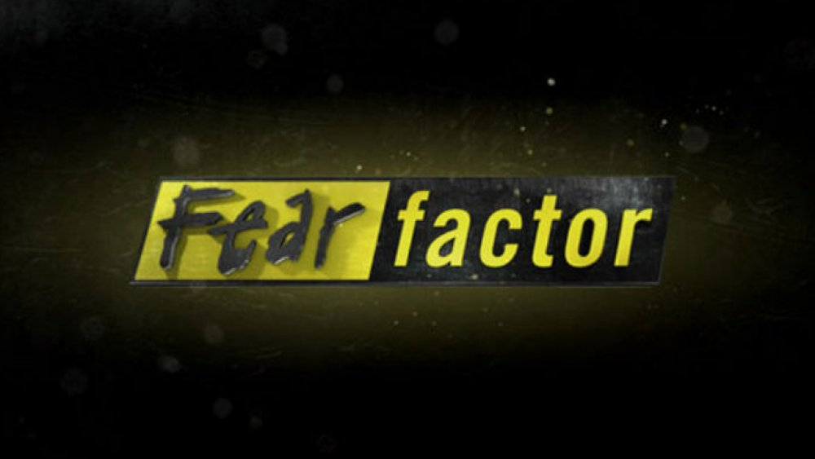

**“Hello everyone! And welcome back! To the return… of Fear Factor! It’s been a long time since we have been on the air, but we are happy to be back, bringing you the most EXTREME, GRAPHIC, DISGUSTING, HEART POUNDING ACTION! In this PREMIERE episode of our return to television, we are having a special Women’s Rights event! Three Men And Three Women will compete for a prize of 1 MILLION DOLLARS!! The first events teams will be chosen at random, after that, the winner of each event will get to choose their partner for the next round! NOW… let’s meet our contestants!**

John was seated on a wooden bench where he waited nervously! He had his hands together in his lap and he picked at his fingernails a little, it was a terrible habit but one he had never managed to kick! To his left were two men that made him look like a child! Both of them were twice the size of John in the muscle department, they looked like they lived at the gym, while john on the other hand was like a grown-up gumpy! He had seen more than a few episodes of Fear Factor and knew there was always one wild card, all the contestants were supermodels, but they always let one… freak, I guess you could say, onto the show, just to keep things interesting. John didn’t like being the odd one out of the group, but it didn’t matter, he was here with a purpose!

It was only a year ago that he had met Allison, and he instantly knew she was the one for him! She is so beautiful but so demanding! He worked day in and out trying to provide her with all the things she wanted, but as soon as he made one massive purchase, she would just demand another! And another! And another! Everyone of his male friends warned him not to propose, but John didn’t listen! He had to make her his wife, but he would need a ring, and his salary would never cover the kind of engagement ring she would demand! John knew his only way was to win the money! When the ad for Fear Factor contestants came up in a pop-up ad online, he had thought it was a joke, but here he was, the first day of filming! If only it wasn’t so damn **HOT!!!**

John looked to his left and both the other men were fanning themselves too, trying to cool down! They were waiting on a sunny beach in Mexico, it was just past noon and the sun was directly above them, high in the sky and beating down like liquid fire! It was the kind of heat that made the ground in the distance look hazy and manipulated. One of the show managers came by followed by one of the producers and handed out some cool bottles of water to all three men.

“Get ready! Your introductions are gonna be in a moment! Just like we went over with you before! Walkout, say your name, where you’re from, and your tagline! And then back up to your spot, they are all marked on the beach with paint so you know where to stand! Don’t mess this up!” They began talking to one another and then walked a few steps down the beach as to not be in view of the camera.

John and the other three men instantly became unaware of the blistering heat as the first female contestant came walking out onto the beach! They had been kept separate up until this moment! She had tanned skin, dark hair, and a thick fat ass that wriggled left and right! John could not keep his eyes off of her! She reached up gathering her wavy thick hair and then turning to smile at the camera while standing next to Joe Rogan.

“Hey there America! My name is Mira, my parents immigrated here from Turkey, but I’m 100% American and grain-fed!” she smiled and turned showing off her ass to the camera, and then slapped it lightly!

“I’m an Instagram model, Professional Yoga Teacher, and Competitive Eater! So I have an “appetite” for winning!” she smiled and then backed up taking her place in line on the beach where the production managers had told them all to stand!

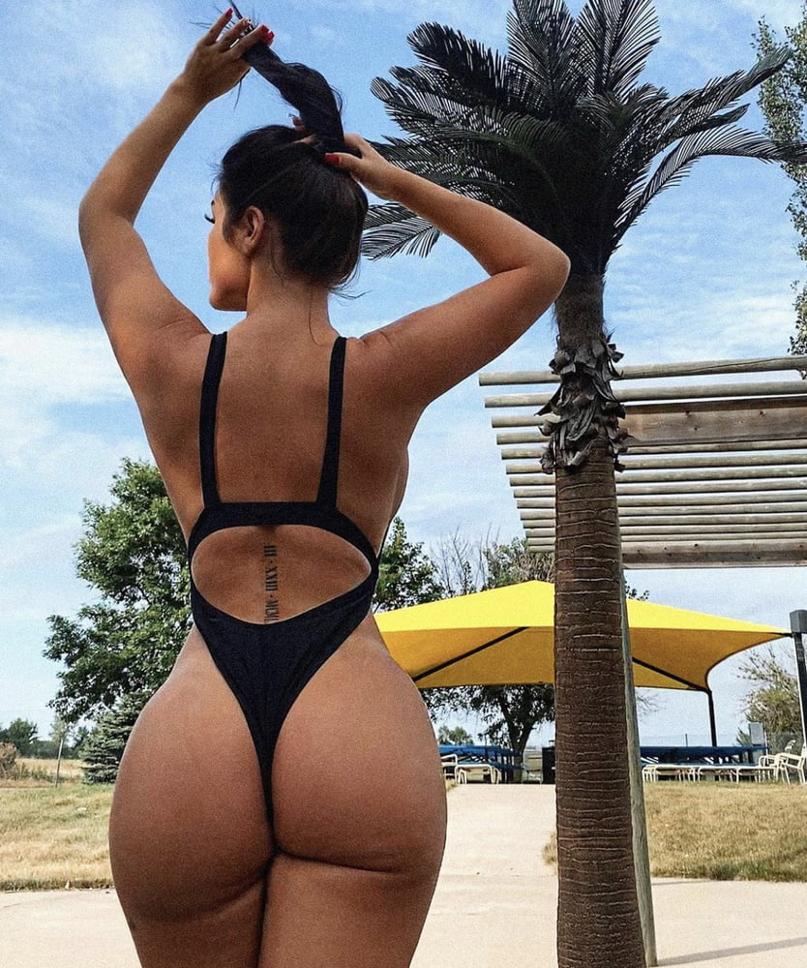

John started to blush, feeling guilty, Mira was so beautiful and he already started wishing that she may be his partner for whatever challenge was presented! Allison would be so jealous if she knew where he was, and the type of women he was around! He had to contain himself! He could see that Mila was dripping head to toe with sweat in her tiny bikini! The beads were running down her skin and she was constantly wiping her forehead to keep it out of her eyes!

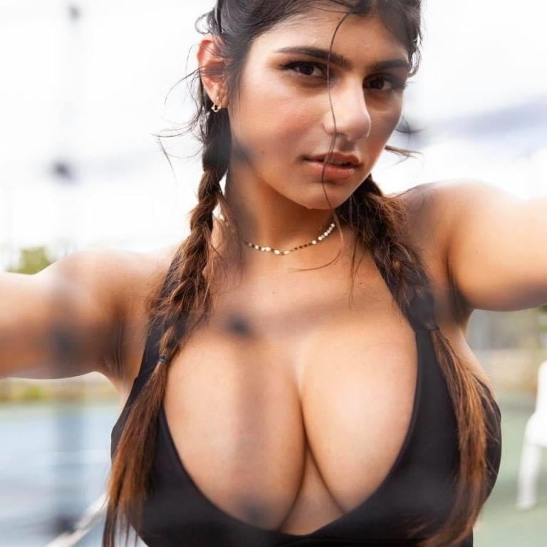

All three men watched as the second female contestant walked out onto the beach! She was a very beautiful blonde with shoulder-length hair and an incredibly curvy body! She spun to smile at the camera which coincidentally was right in front of the men giving them the perfect view! Her ass cheeks clapped together in her bikini as she smiled! She had a very bratty look with a bit of a chubby face! She blew a kiss to the camera and bent over a little towards the lens before standing back up straight and dancing a bit!

“My name’s Chelsea and I’m from the Delta Gamma Gamma sorority Texas Chapter! I’m studying to be a nurse! And if I win the prize money! I’m gonna take **ALL MY SORORITY SISTERS** on an **ALL INCLUSIVE VACATION!”** she cheered and clapped a bit before adding on at the end…

“And we would donate the leftovers to charity! Of course! We are not spoiled mean girls!”

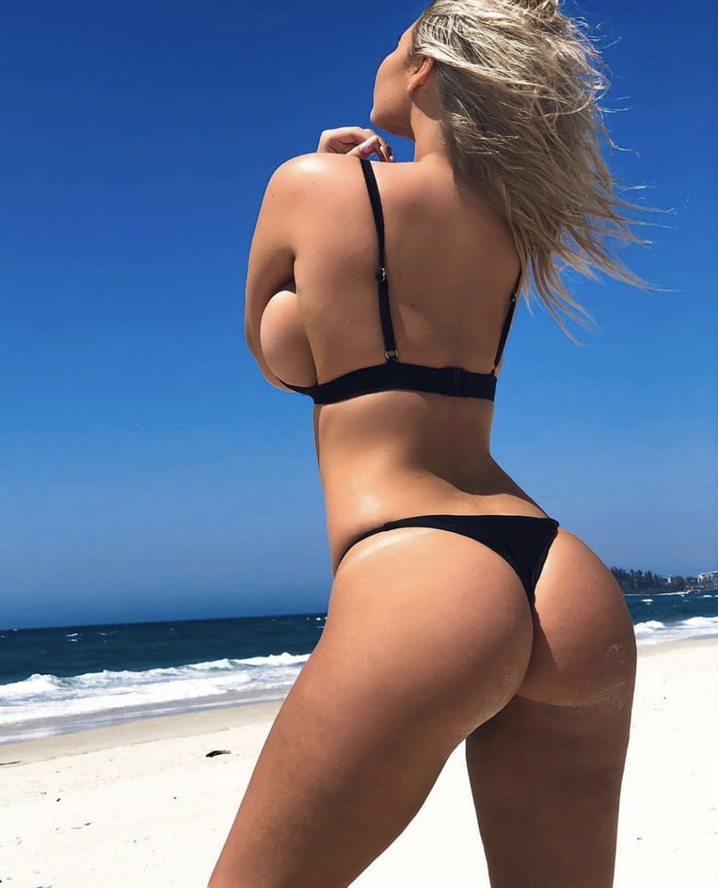

John laughed to himself at how thoughtless and stuck up this girl must be, the idea that she was being kind by donating a little to charity **AFTER** bringing all her rich sorority sisters on an expensive vacation. He doubted there would be any cash left over by the end! Suddenly he realized, he was not much better, he wasn’t donating any of his winnings to charity, it was all going to Allison.

All three men froze as they laid eyes on the last and final female contestant! She paused while coming down the stairs and posed off-camera seemingly just for the male contestants. They all watched with mouths watering! She was a thin and stunning brunette with almond-shaped eyes and a devious smile! Her body was so thin and it was like all the fat that existed just accumulated in her tiny fat ass!

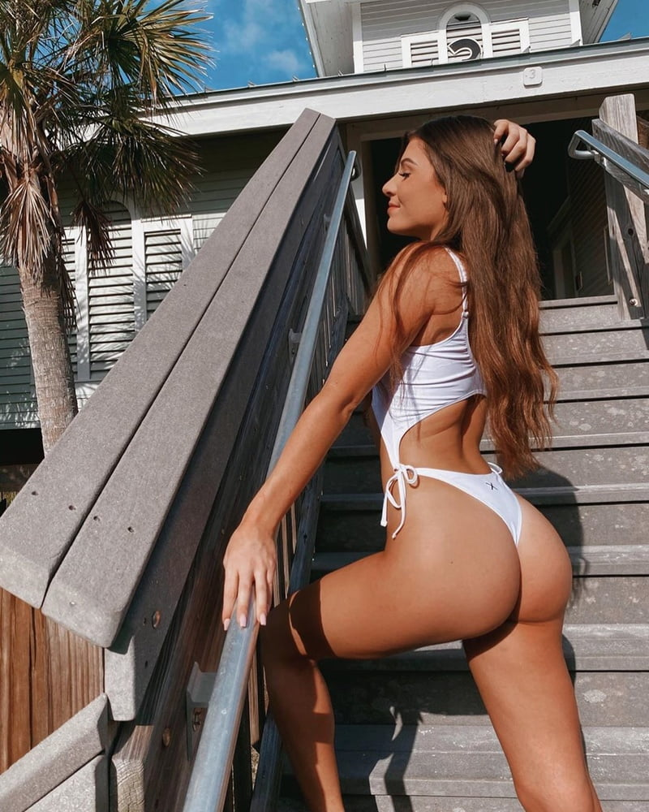

She walked out to the beach and wiped the sweat from her forehead before turning to the cameras!

“My name is Angelica but I’m far from an angel! I’m a professional trainer and an amateur kickboxer! If I win today I am going to put the money towards opening a women-only boxing studio!” she raised her fists and did a kick in her tiny bikini pausing with her sole to the camera! John could see even from a distance that her sole was small and soft! Her skin was so pale and pink, it was so rare, he would expect someone who spent time at the gym to be even a little calloused! She turned and took her place in line beside the other two women!

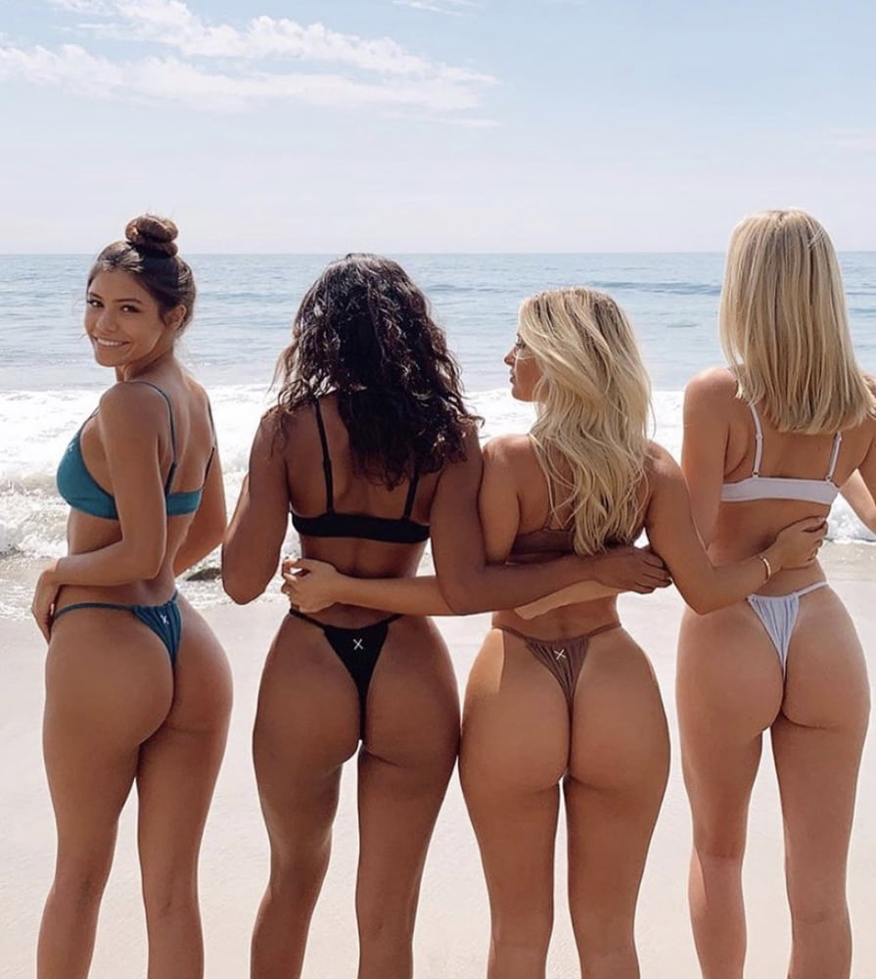

**“Now let’s meet our male contestants!”** Joe Rogan introduced both of the ripped muscular guys before John and coincidentally their names were Brand and Chad. John could not help but laugh to himself at how fitting the names were for the two of them. Both guys introduced themselves with some douchey intro before taking their place beside the women on the beach, waiting in line. John could see Chad was already flirting with Angelica who was having none of it.

**“And last but least… sorry, pardon me, last but not least! John”** Joe Rogan corrected himself but John couldn’t help feel like it was on purpose! He walked out onto the beach and could already hear the women behind him giggling and laughing at him, it was clear he was a shrimp compared to the other male contestants! He faced the camera and blushed a bit…

“Hi, my names John, and I’m here to buy my uhmmm…” He suddenly froze realizing he shouldn’t give away his proposal plans for Allison on live t.v what if it aired before he could pop the question. He tried to think of something to say when suddenly Joe Rogan walked in and put a hand on his shoulder, forcefully pushing him off-camera with a smile on his face.

“I guess the competition literally takes the words from some people’s mouths!” he joked as John took his place next to the other contestants on the beach. He felt so stupid, he had barely been on television for a moment and already he was embarrassing himself!

**“For today’s VERY SPECIAL competition, we will be focusing on the women while the men compete! BUT FIRST, let’s pair up our teams. These pairings were chosen at random! Angelica, you will be with Chad!”**

John watched as she groaned and then took her place beside the steroid-fueled guy! He smiled and put his arm around her shoulder which she quickly pushed off!

**“Chelsea! You will be with Brad!”**

John watched as the bubbly sorority girl bounced over beside Brad and put an arm around him, she seemed happy with her teammate for the first round! Mira was already heading towards John to stand beside him and he could see the disappointment on her face, she looked like she had just been convicted to a life sentence in prison! He felt a bit insulted! He knew he wasn’t nearly as muscular as the other two guys, but he wasn’t that bad! She stood beside him and let out a tiny groan.

“Hey, I’m John” he whispered a bit to her…

“I know, you just introduced yourself on camera, do you think I’m deaf?” she responded quietly but in a very bitchy and aggressive tone.

“I… I… I’m sorry, I was just, trying to be polite” John apologized feeling like an idiot, why was he apologizing to her?

“Ugh, let’s just get this over with quickly, the food here has been giving me terrible cramps! And by getting this over with, I don’t mean lose, I need this prize money! You hear me?” she said in a strict fashion

**“The first challenge today will be a test of ENDURANCE for both the men and the women!”** Joe Rogan announced while turning his attention to the left. The camera panned as the contestants looked in curiosity! There were three stools on the sand but the area where you would sit looked like a padded bowl!

**“Our three male contestants will be placed in front of these stools, with their heads tilted back and inside of the seat! ONCE THEY ARE READY… the women will HAVE A SEAT on their faces! SMOTHERING them under their asses!”**

“Oh! How fun!” Chelsea said in a bright and cheery tone completely interrupting Joe.

**“The women will sit for as long as they can with their FULL WEIGHT and without raising up at all! The challenge will only end when ONE MALE CONTESTANT taps out, at which point, the other four contestants move to the next round! Also, for our viewers at home…”** Joe smiled and held up a thermometer to the camera before taking a swig of his cool water bottle!

**“It’s SCORCHING out here today, and on top of that, the women were instructed not to shower this morning!”** he turned back to the six contestants and smiled!

**“ARE YOU READY?”** he asked… John had to swallow the ball of nerves in his throat.

All three men walked up to the metal stools on the sand and got on their knees. John was already sweating from the heat, his mouth was parched, his lips dry, he had just drunk a few minutes ago and was already dehydrated! He had no idea how long he could last, he knew Mira would kill him if they lost though! He put his head back onto the stool and was surprised at how comfortable it was, the seat was indented to the shape of a skull with a ton of padding, maybe this wouldn’t be so bad? John thought to himself.

“Oh, yea! Back it up!” Chad said to Angelica, making her groan in disgust and aggravation again.

“I actually really like facesitting! It’s one of my favorite things to do with my boyfriend!” John could hear Chelsea say with excitement as she stood with her back to Brad, her big fat ass jiggling above his face.

John watched as Mira walked over and stood in front of his stool, she was a little bit thick, but from this view and angle, she looked so much heavier! Her ass cheeks were devouring her thong, sucking it in deep with no chance of escape! She reached back and pulled it from her crack only for the fabric to be sucked back in! It wasn’t until this moment when John realized, how were they supposed to breathe?

**“All right ladies! Are you ready?”**  Joe asked as all the cameras focused on the contestants. All the women smiled and nodded their heads…

**“And gentlemen, are you… oh, who cares! Have a seat ladies!”** Joe said with a laugh as all three of the women jumped pack onto their stools, each of them had their own cameraman focusing on their ass as it crashed into their stools seat! They all came down hard and with all their weight! The wet slapping impact of skin on skin could be heard for a mile down the beach!

**“Legs up ladies, remember, sit with your full weight on the stools, and if your feet TOUCH THE SAND or you raise from your partner’s face at ANY MOMENT… YOU LOSE!”**