Related Rates – Formula Sheet:
The Square:  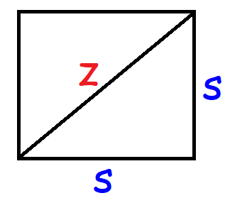 | Area:  $$A=s^{2}$$  $$\frac{dA}{dt}=2s\frac{ds}{dt}$$  Perimeter:  $$P=4s$$  Diagonal Length:  $$z^{2}=2s^{2}$$
The Rectangle:  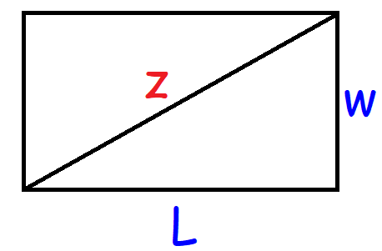 | Area:  $$A=lw$$  Perimeter:  $$P=2l+2w$$  Diagonal Length:  $$z^{2}=l^{2}+w^{2}$$  $$2z\frac{dz}{dt}=2l\frac{dl}{dt}+2w\frac{dw}{dt}$$
The Rectangular Prism:  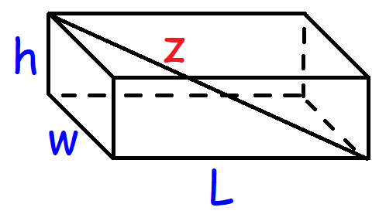 | Volume:  $$V=lwh$$  Surface Area:  $$SA=2lw+2lh+2wh$$  Diagonal Length:  $$z^{2}=l^{2}+w^{2}+h^{2}$$
The Cube:  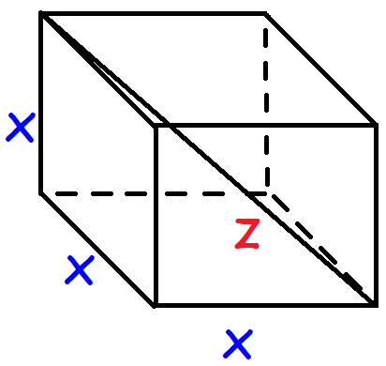 | Volume:  $$V=x^{3}$$  $$\frac{dV}{dt}=3x^{2}\frac{dx}{dt}$$  Surface Area:  $$SA=6x^{2}$$  Diagonal Length:  $$z^{2}=3x^{2}$$

The Right Triangle:  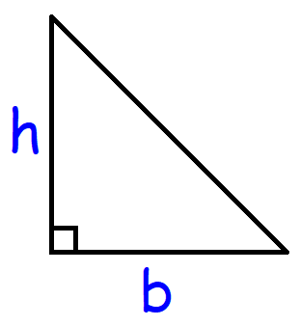 | Area:  $$Area= \frac{1}{2}bh$$  $$\frac{dA}{dt}=\frac{1}{2}\left(b\frac{dh}{dt}+h\frac{db}{dt}\right)$$
The Pythagorean Theorem:  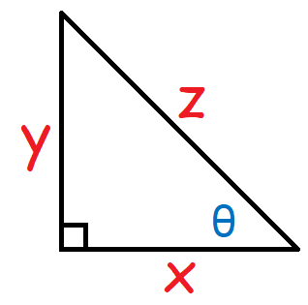 | Side Lengths:  $$z^{2}=x^{2}+y^{2}$$  $$2z\frac{dz}{dt}=2x\frac{dx}{dt}+2y\frac{dy}{dt}$$  The Angle of Elevation:  $$\sin{θ}=\frac{y}{z} \cos{θ}=\frac{x}{z} \tan{θ}=\frac{y}{x}$$
The Scalene Triangle:  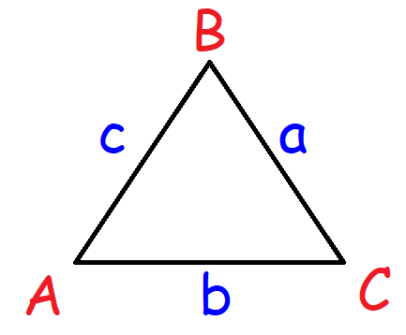 | Area:  $$A=\frac{1}{2} ab\sin{C}$$  If ‘a’ and ‘b’ are constant:  $$\frac{dA}{dt}=\frac{1}{2}ab\cos{C} \frac{dC}{dt}$$
The Equilateral Triangle:  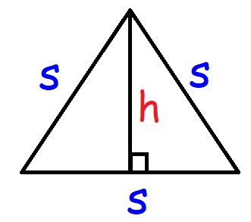 | Area:  $$A=\frac{\sqrt{3}}{4}s^{2} A=\frac{1}{2}sh$$  $$\frac{dA}{dt}=\frac{\sqrt{3}}{4}(2s)\frac{ds}{dt}$$  $$\frac{dA}{dt}=\frac{1}{2}\left(s\frac{dh}{dt}+h\frac{ds}{dt}\right)$$  The Height:  $$h=\frac{\sqrt{3}}{2}s$$

The Circle:  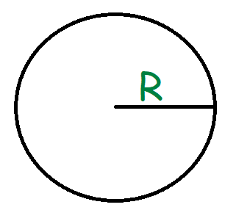 | Circumference:  $$C=2πR$$  Diameter:  $$d=2R$$  The Area:  $$A=πR^{2}$$  $$\frac{dA}{dt}=π(2R)\frac{dR}{dt}$$
The Sphere:  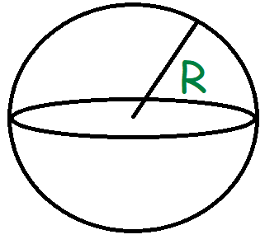 | The Volume:  $$V=\frac{4}{3}πR^{3}$$  $$\frac{dV}{dt}=\frac{4}{3}π(3R^{2})\frac{dR}{dt}$$  Surface Area:  $$SA=4πR^{2}$$
The Ellipse:  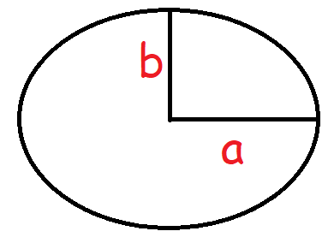 | The Area:  $$A=πab$$  $$\frac{dA}{dt}=π\left(a\frac{db}{dt}+b\frac{da}{dt}\right)$$
The Hexagon:  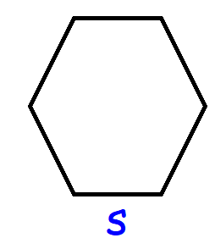 | The Area:  $$A=\frac{3\sqrt{3}}{2}s^{2}$$  $$\frac{dA}{dt}=\frac{3\sqrt{3}}{2}(2s)\frac{ds}{dt}$$  The Perimeter:  $$P=6s$$  $$\frac{dP}{dt}=6\frac{ds}{dt}$$

The Cone:  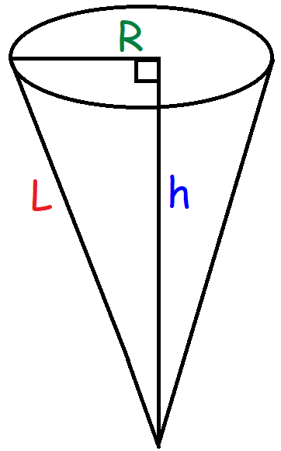 | Volume:  $$V=\frac{1}{3}πR^{2}h$$  $$\frac{dV}{dt}=\frac{1}{3}π\left(2R\frac{dR}{dt}h+R^{2}\frac{dh}{dt}\right)$$  Lateral Surface Area:  $$LA=πRl$$  Surface Area:  $$SA=πRl+πR^{2}$$  The Slant Height:  $$l^{2}=R^{2}+h^{2}$$
The Cylinder:  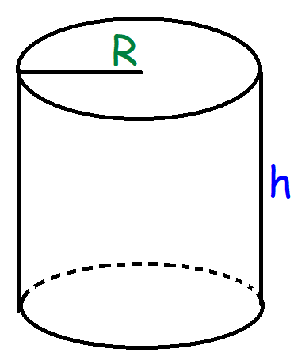 | Volume:  $$V=πR^{2}h$$  $$\frac{dV}{dt}=π\left(2R\frac{dR}{dt}h+R^{2}\frac{dh}{dt}\right)$$  Lateral Surface Area:  $$LA=2πRh$$  Surface Area:  $$SA=2πRh+2πR^{2}$$
The Trapezoid:  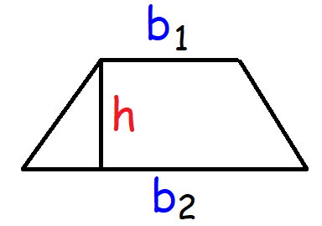 | Area:  $$A=\frac{1}{2}\left(b_{1}+b_{2}\right)h$$

